CSS Tutorial

* CSS là ngôn ngữ chúng ta sử dụng để tạo kiểu cho một trang Web

# CSS Introduction

* CSS là gì?
* CSS là viết tắt của Cascading Style Sheets
* CSS mô tả cách các phần tử HTML được hiển thị trên màn hình, giấy hoặc trên các phương tiện khác
* CSS tiết kiệm rất nhiều công việc. Nó có thể kiểm soát bố cục của nhiều trang web cùng một lúc
* Các bảng định kiểu bên ngoài được lưu trữ trong các tệp CSS
* Tại sao nên sử dụng CSS?

CSS được sử dụng để xác định kiểu cho các trang web của bạn, bao gồm thiết kế, bố cục và các biến thể hiển thị cho các thiết bị và kích thước màn hình khác nhau.

CSS đã giải quyết được một vấn đề lớn

HTML KHÔNG BAO GIỜ có ý định chứa các thẻ để định dạng một trang web!

HTML được tạo ra để mô tả nội dung của một trang web, như:

<h1>Đây là tiêu đề</h1>

<p>Đây là một đoạn văn.</p>

Khi các thẻ như <font> và thuộc tính màu sắc được thêm vào đặc tả HTML 3.2, nó bắt đầu trở thành cơn ác mộng đối với các nhà phát triển web. Việc phát triển các trang web lớn, nơi phông chữ và thông tin màu sắc được thêm vào từng trang, đã trở thành một quá trình lâu dài và tốn kém.

Để giải quyết vấn đề này, World Wide Web Consortium (W3C) đã tạo ra CSS.

CSS đã loại bỏ định dạng kiểu khỏi trang HTML!

CSS tiết kiệm rất nhiều công việc!

Các định nghĩa kiểu thường được lưu trong các tệp .css bên ngoài.

Với tệp biểu định kiểu bên ngoài, bạn có thể thay đổi giao diện của toàn bộ trang web bằng cách chỉ thay đổi một tệp!

# CSS Syntax

A CSS rule consists of a selector and a declaration block.

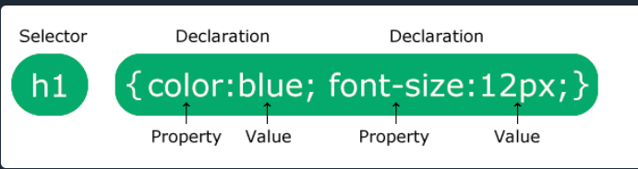

Bộ chọn trỏ đến phần tử HTML mà bạn muốn tạo kiểu.

Khối khai báo chứa một hoặc nhiều khai báo được phân tách bằng dấu chấm phẩy.

Mỗi khai báo bao gồm tên thuộc tính CSS và một giá trị, được phân tách bằng dấu hai chấm.

Nhiều khai báo CSS được phân tách bằng dấu chấm phẩy và các khối khai báo được bao quanh bởi dấu ngoặc nhọn.

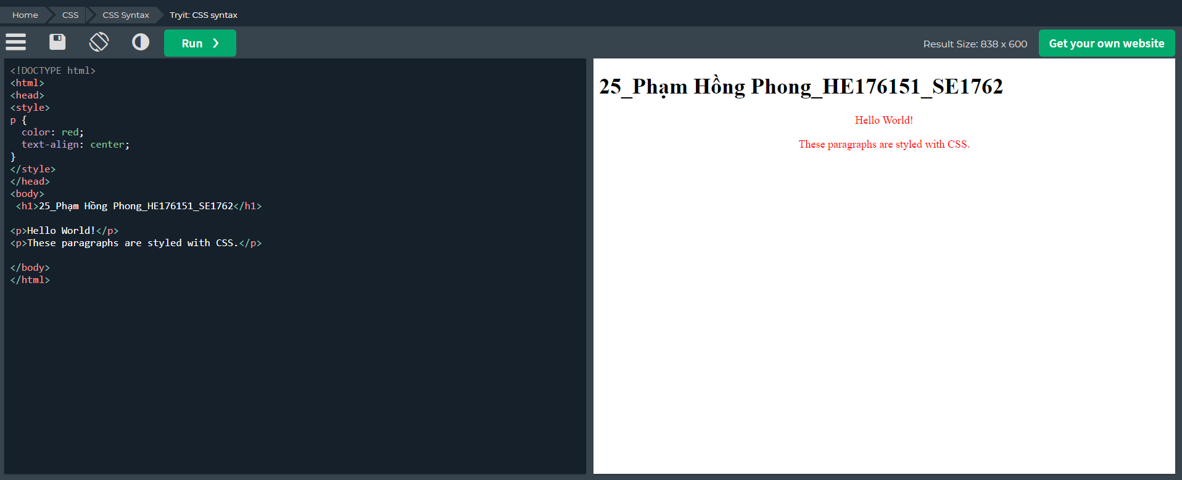

p is a selector in CSS (it points to the HTML element you want to style: <p>).

colour is a property, and red is the property value

text-align is a property, and centre is the property value

# CSS Selectors

A CSS selector selects the HTML element(s) you want to style.

## CSS Selectors

CSS selectors are used to "find" (or select) the HTML elements you want to style.

We can divide CSS selectors into five categories:

+Simple selectors (select elements based on name, id, class)

+Combinator selectors (select elements based on a specific relationship between them)

+Pseudo-class selectors (select elements based on a certain state)

+Pseudo-elements selectors (select and style a part of an element)

+Attribute selectors (select elements based on an attribute or attribute value)

## The CSS Element Selector

The element selector selects HTML elements based on the element name.

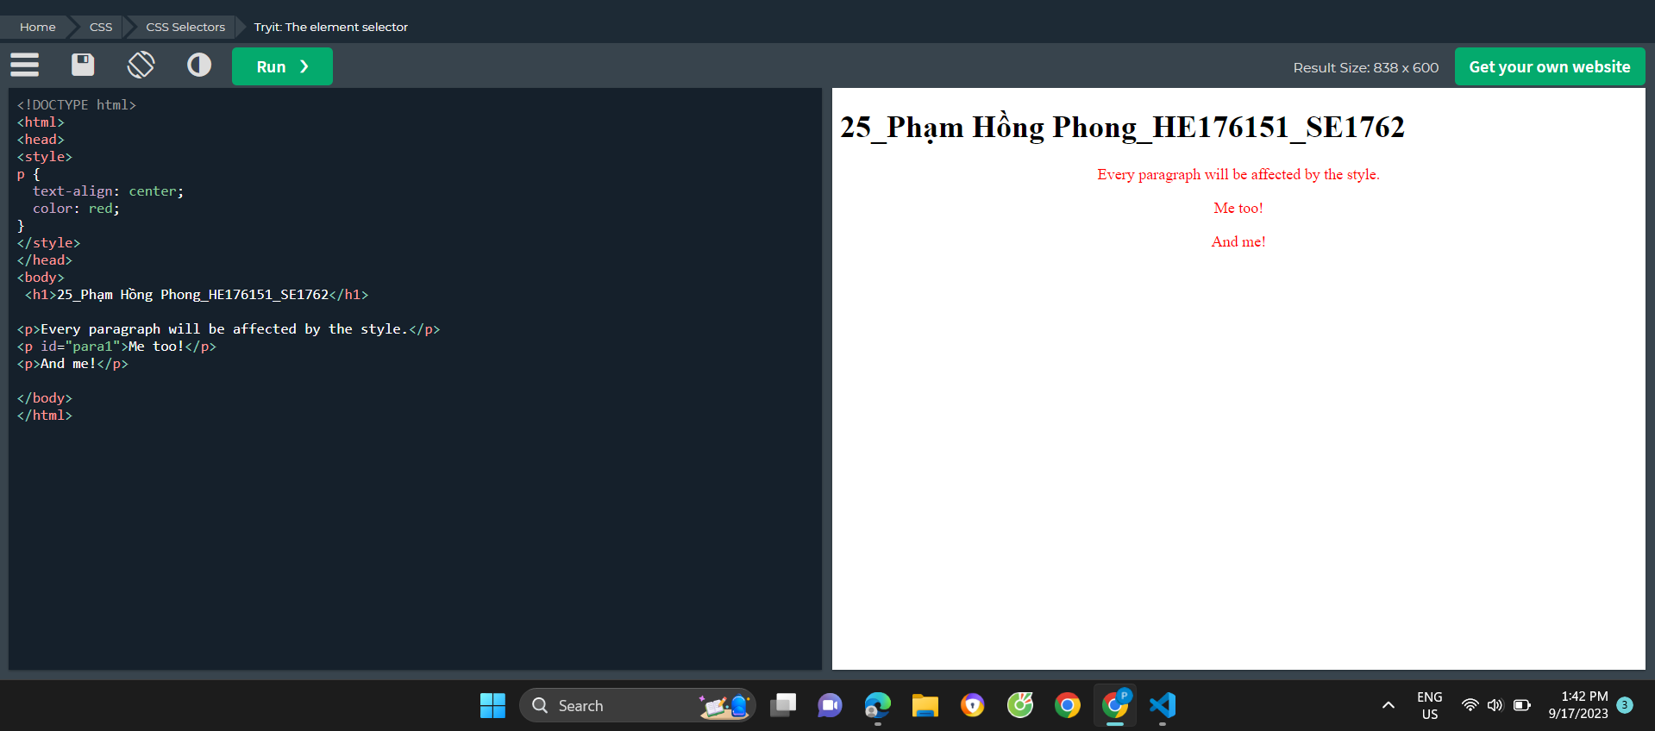

## The CSS Id Selector

Bộ chọn id sử dụng thuộc tính id của phần tử HTML để chọn một phần tử cụ thể.

Id của một phần tử là duy nhất trong một trang, vì vậy bộ chọn id được sử dụng để chọn một phần tử duy nhất!

Để chọn một phần tử có id cụ thể, hãy viết ký tự băm (#), theo sau là id của phần tử.

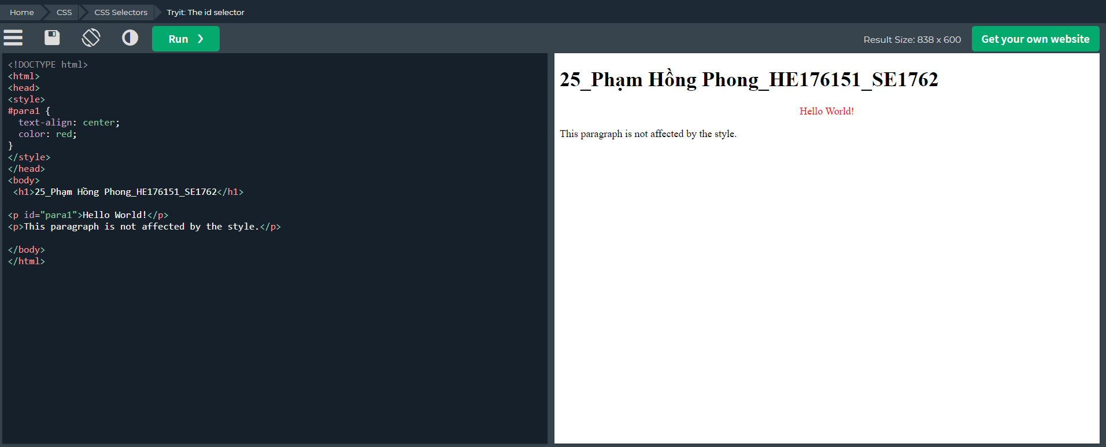

Note: An id name cannot start with a number!

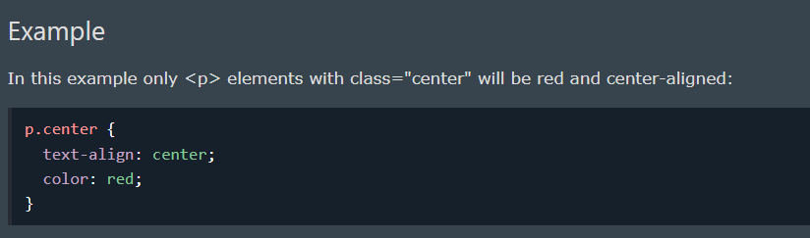

Chỉ những thẻ <p> có class=”center” mới nhận code

Các phần tử HTML cũng có thể tham chiếu đến nhiều lớp.

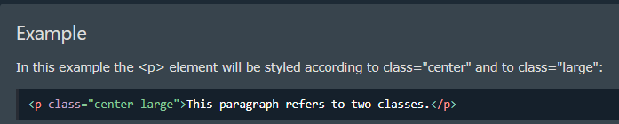

Note: A class name cannot start with a number!

## The CSS Universal Selector

Bộ chọn phổ quát (*) chọn tất cả các thành phần HTML trên trang.

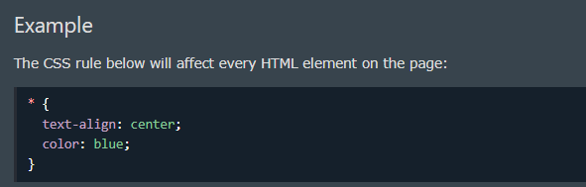

## The CSS Grouping Selector

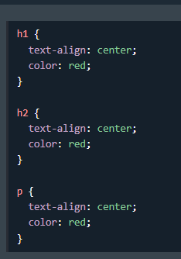 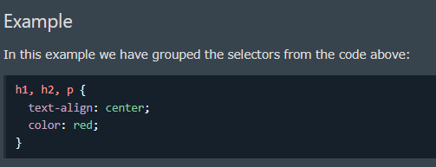

Group selectors sẽ giúp tăng hiệu năng code, giảm dòng code

**Khuyên dùng Group selector**

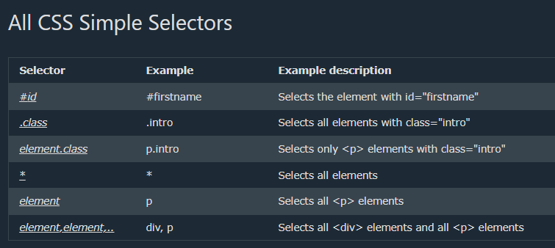

# CSS How to

* There are three ways of inserting a style sheet:
* External CSS
* Internal CSS
* Inline CSS

## External CSS

External CSS, bạn có thể thay đổi giao diện của toàn bộ trang web bằng cách chỉ thay đổi một tệp!

Mỗi trang HTML phải bao gồm một tham chiếu đến tệp biểu định kiểu bên ngoài bên trong phần tử <link>, bên trong phần đầu

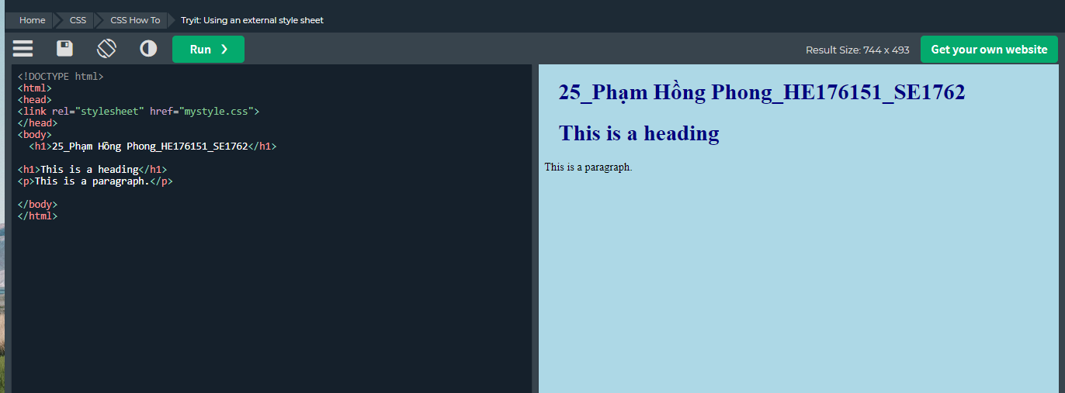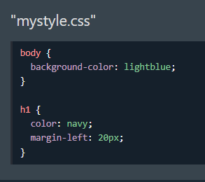

External CSS có thể được viết bằng bất kỳ trình soạn thảo văn bản nào và phải được lưu bằng phần mở rộng .css.

Tệp .css bên ngoài không được chứa bất kỳ thẻ HTML nào.

**Note**: Do not add a space between the property value (20) and the unit (px):

Incorrect (space): margin-left: 20 px;

Correct (no space): margin-left: 20px;

## Internal CSS

Internal CSS có thể được sử dụng nếu một trang HTML có một kiểu duy nhất.

Internal CSS được xác định bên trong phần tử <style>, bên trong phần đầu.

Internal styles are defined within the <style> element, inside the <head> section of an HTML page:

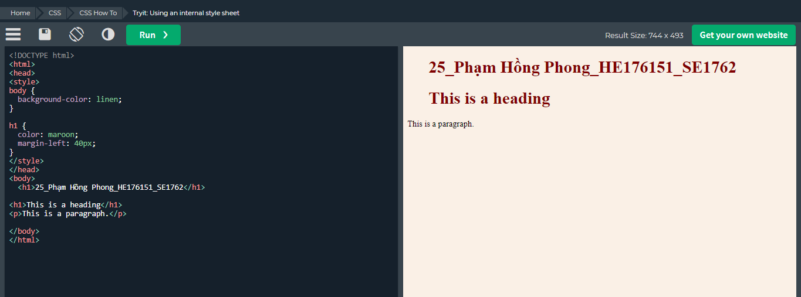

## Inline CSS

An inline style may be used to apply a unique style for a single element.

To use inline styles, add the style attribute to the relevant element. The style attribute can contain any CSS property.

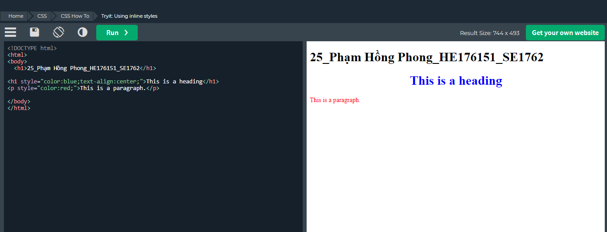

Tip: An inline style loses many of the advantages of a style sheet (by mixing content with presentation). Use this method sparingly.

## Multiple Style Sheets

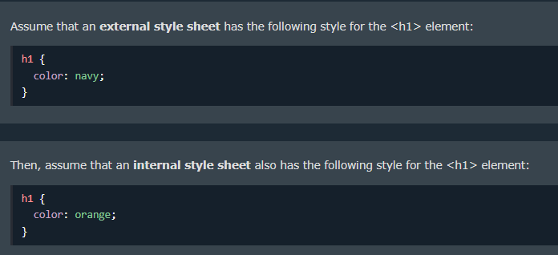

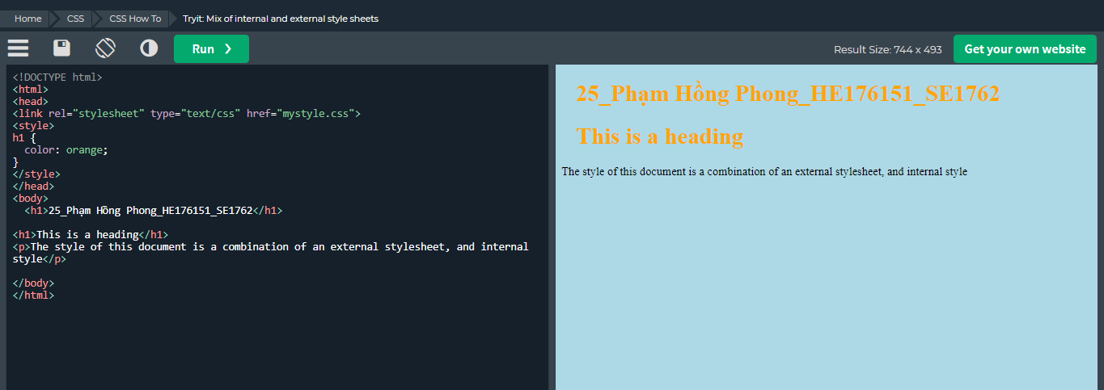

Colour: orange ghi đè colour vany

## Cascading Order

All the styles in a page will "cascade" into a new "virtual" style sheet by the following rules, where number one has the highest priority:

Inline style (inside an HTML element)

External and internal style sheets (in the head section)

Browser default

So, an inline style has the highest priority, and will override external and internal styles and browser defaults.

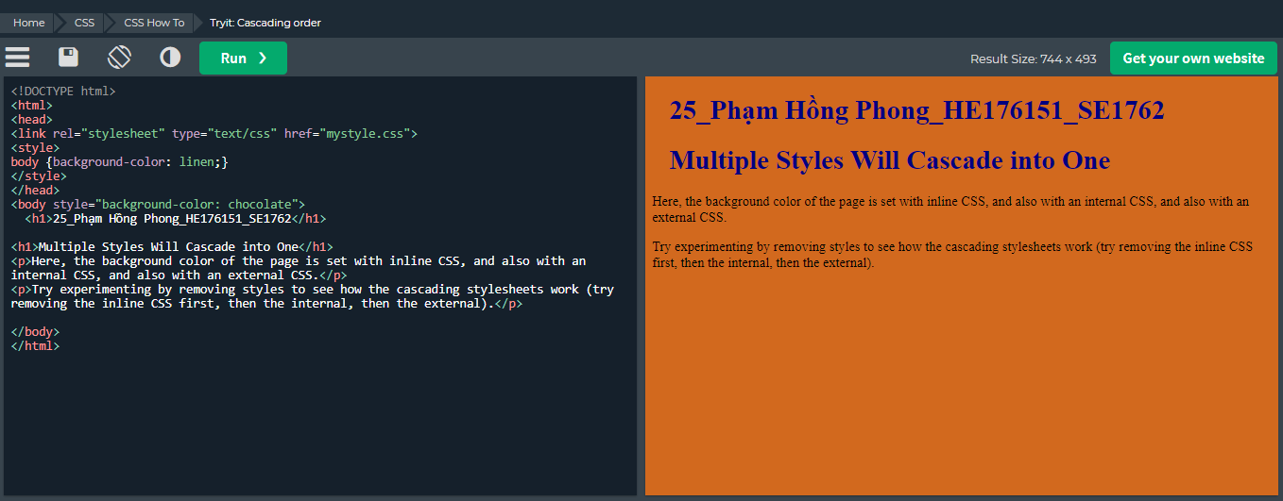

**Ta có thể thấy được thứ tự ưu tiên chính là:**

**Inline > Internal > External**

# CSS Comments

Css Comments không được hiển thị trong trình duyệt nhưng chúng có thể giúp ghi lại mã nguồn của bạn.

Comments are used to explain the code, and may help when you edit the source code at a later date.

Comments are ignored by browsers.

A CSS comment is placed inside the <style> element, and starts with /* and ends with */:

Các demo về comments trong CSS

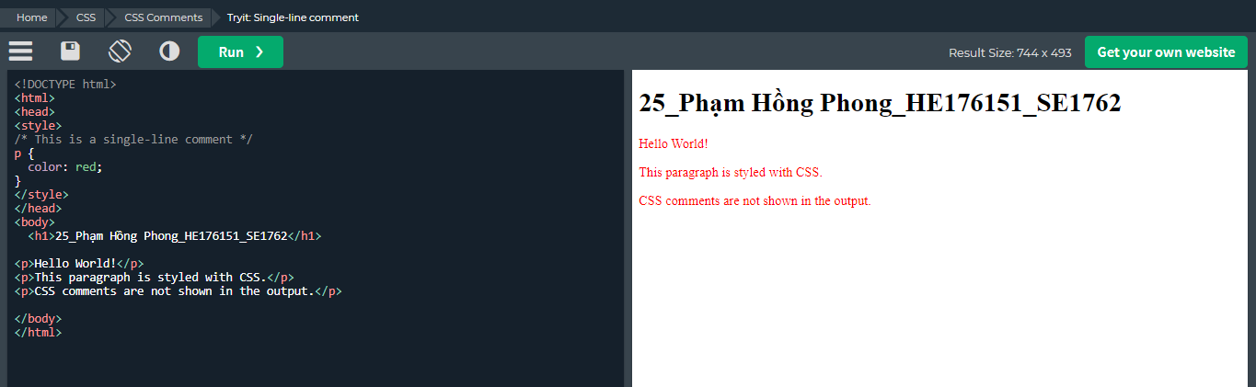

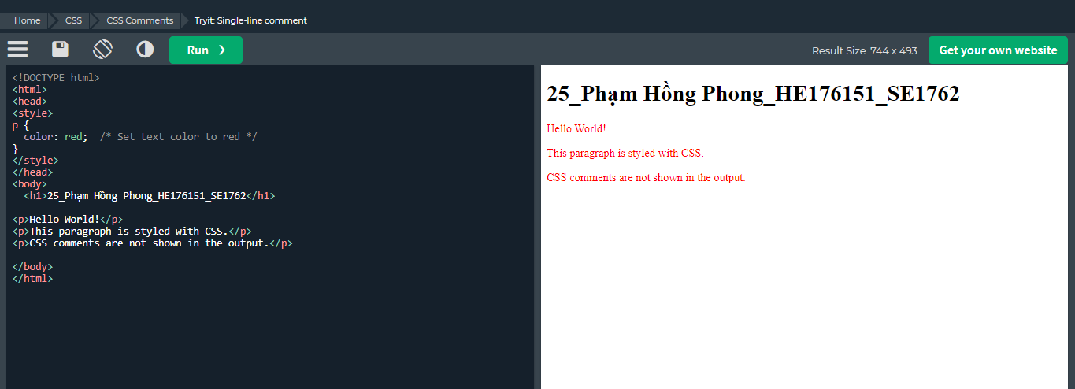

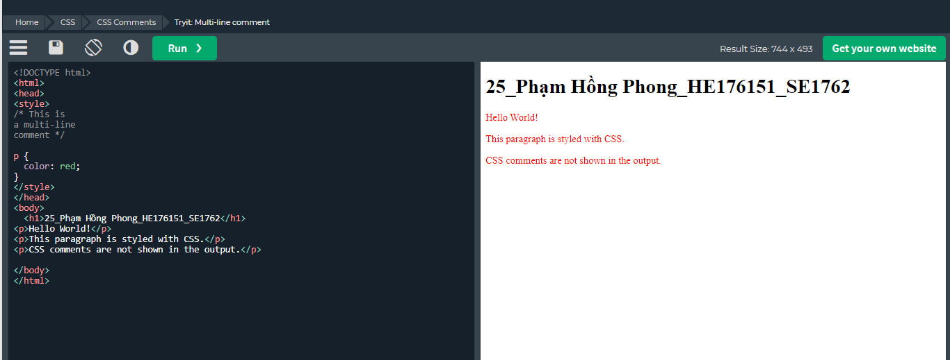

Sử dụng comments kết hợp giữa HTML và CSS

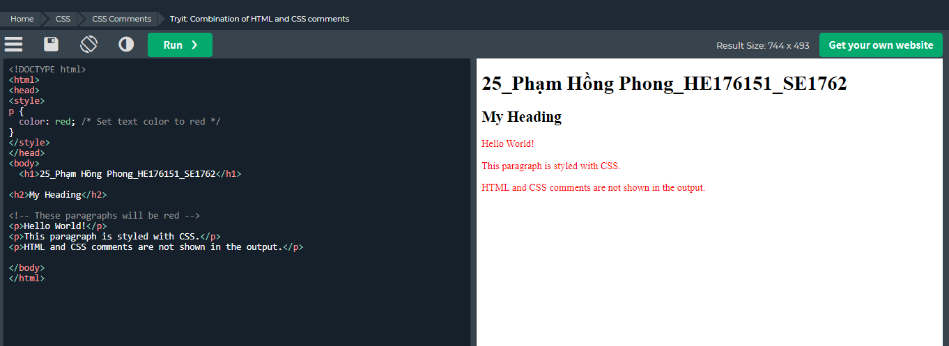

# CSS colours

Cách sử dụng: color: value;

<https://ingiacong.co/bang-code-mau/> : Bảng mã màu cho CSS

# CSS Backgrounds

## Background-colour: value

With CSS, a colour is most often specified by:

* a valid colour name - like "red"
* a HEX value - like "#ff0000"
* an RGB value - like "rgb(255,0,0)"

Opacity / Transparency

Thuộc tính opacity chỉ định độ mờ/độ trong suốt của một phần tử. Nó có thể nhận giá trị từ 0,0 - 1,0. Giá trị càng thấp thì càng minh bạch:

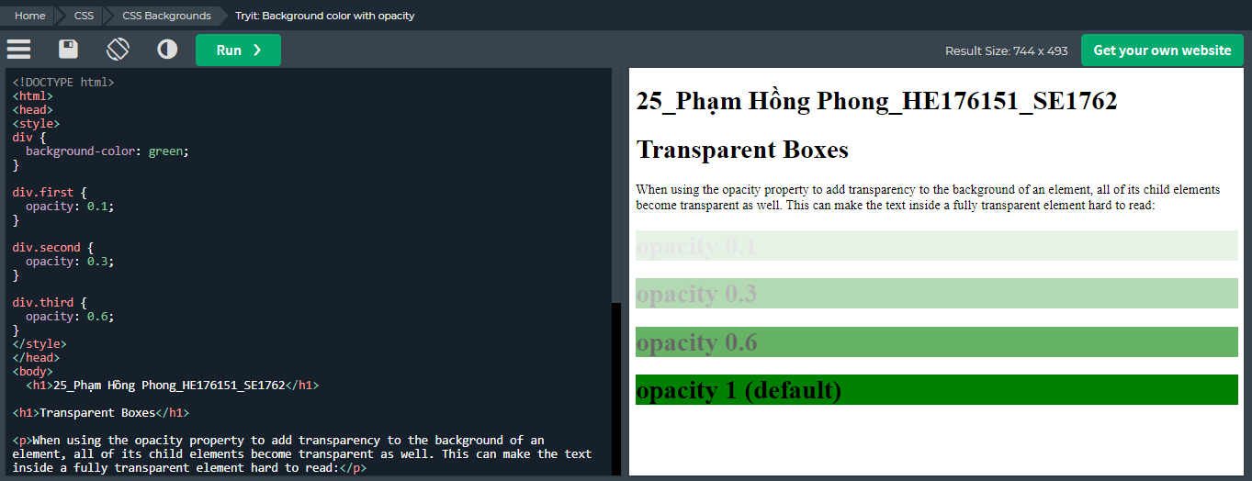

Transparency using RGBA

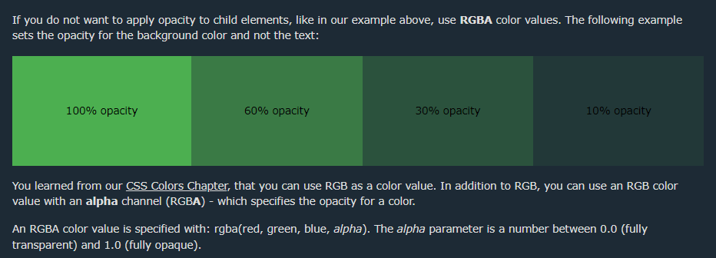

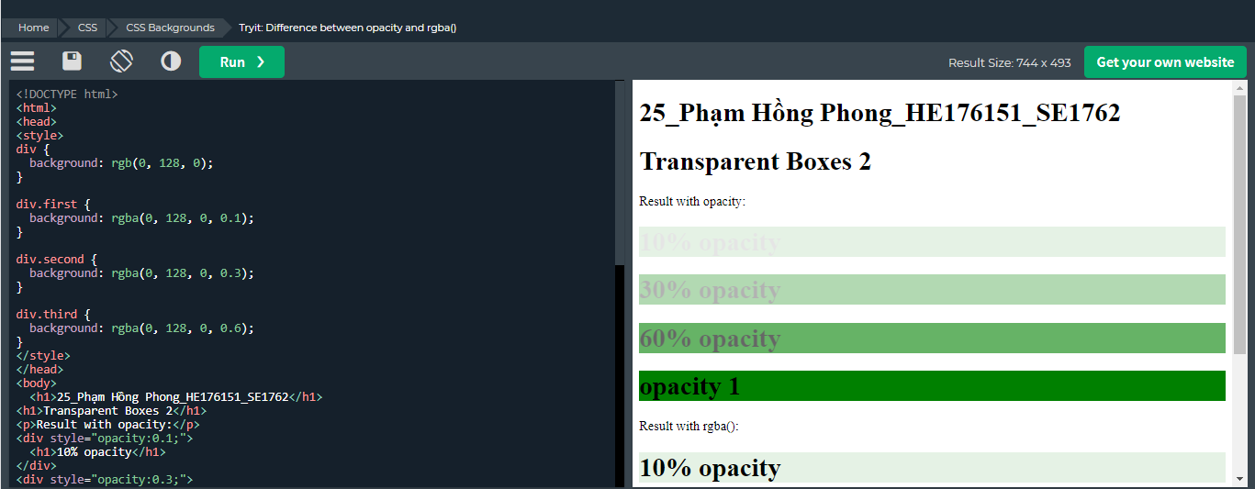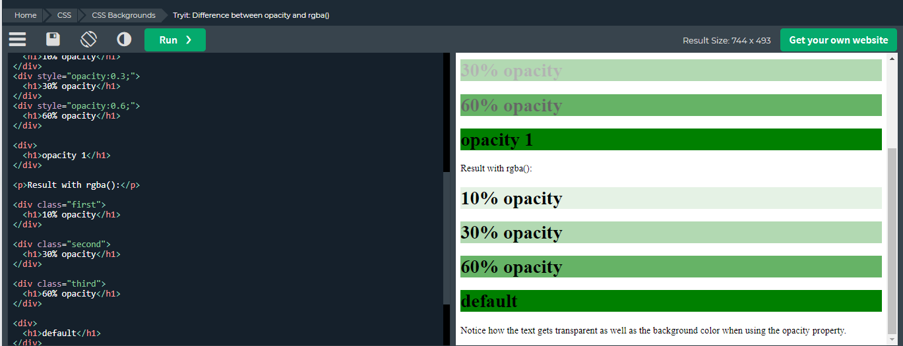

## Background-image

Thuộc tính hình nền chỉ định một hình ảnh được sử dụng làm nền của một phần tử.

Theo mặc định, hình ảnh được lặp lại để bao phủ toàn bộ phần tử.

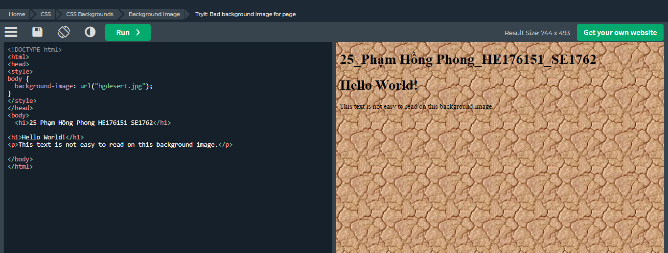

Ví dụ này cho thấy sự kết hợp không tốt giữa văn bản và hình nền

Note: When using a background image, use an image that does not disturb the text.

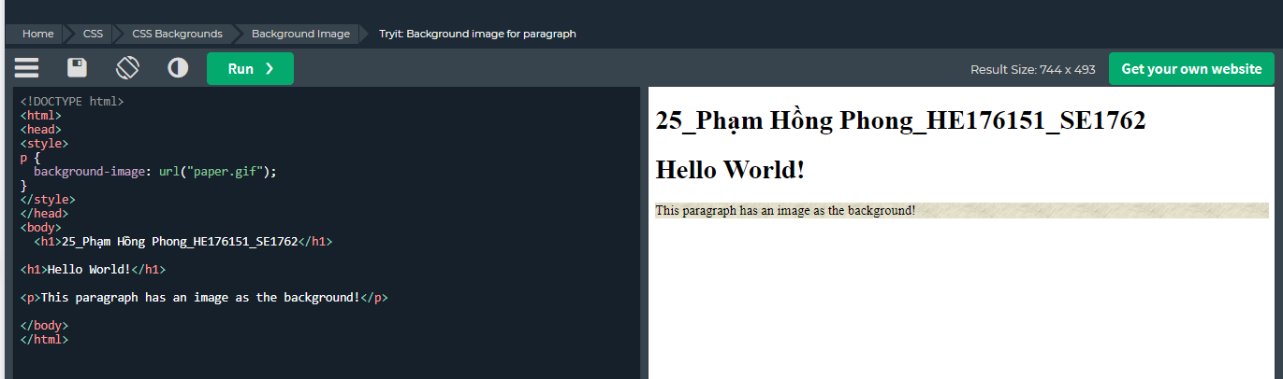

## Background-repeat

By default, the background-image property repeats an image both horizontally and vertically.

Some images should be repeated only horizontally or vertically, or they will look strange, like this:

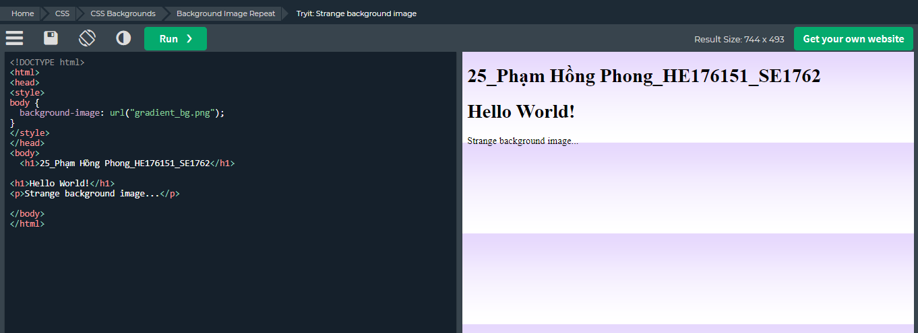

If the image above is repeated only horizontally (background-repeat: repeat-x;), the background will look better:

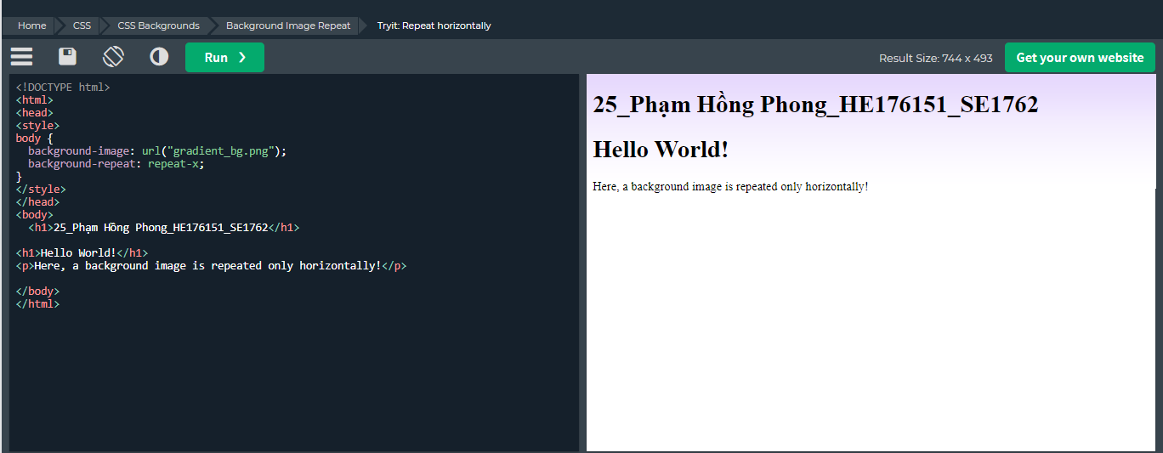

Tip: To repeat an image vertically, set background-repeat: repeat-y;

Showing the background image only once is also specified by the background-repeat property:

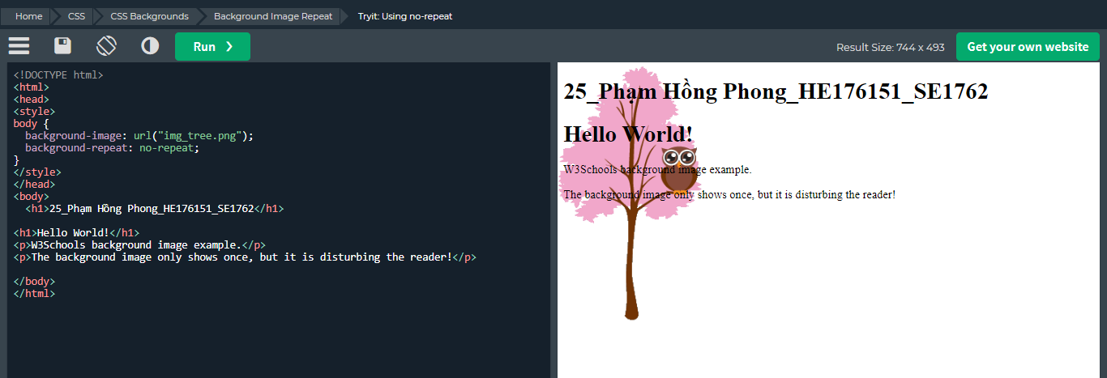

Trong ví dụ trên, hình nền được đặt ở cùng vị trí với văn bản. Chúng tôi muốn thay đổi vị trí của hình ảnh để nó không làm xáo trộn văn bản quá nhiều.

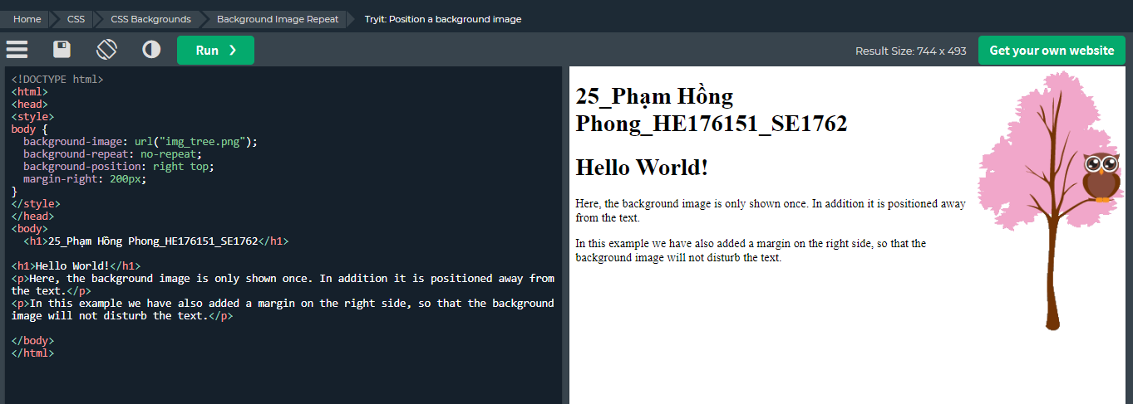

Position the background image in the top-right corner

## Background Attachment

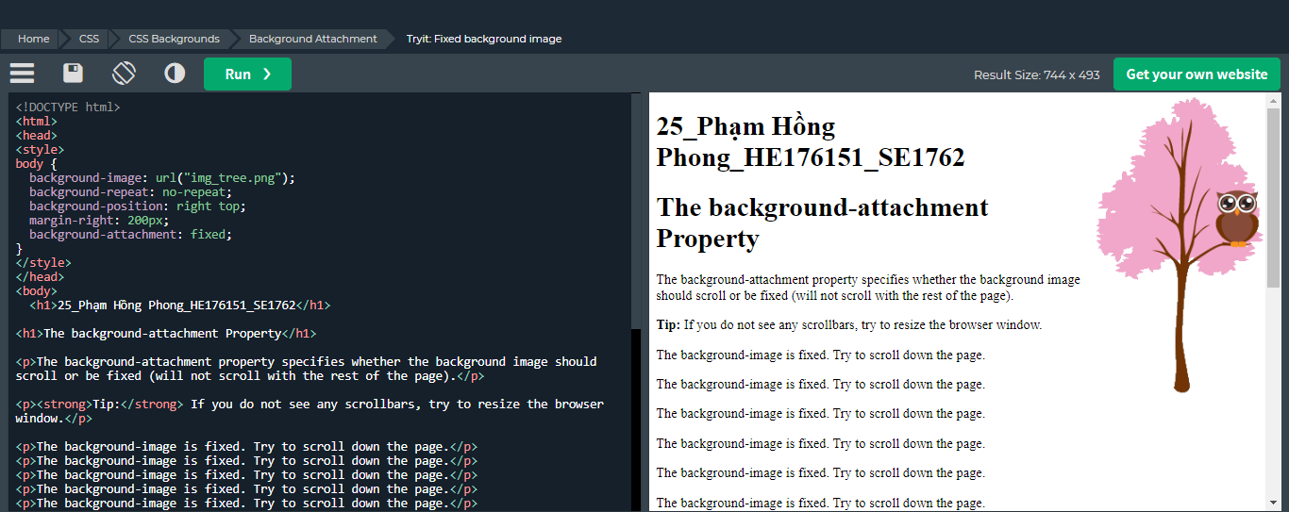

Khi scroll thì hình ảnh vẫn được giữ nguyên

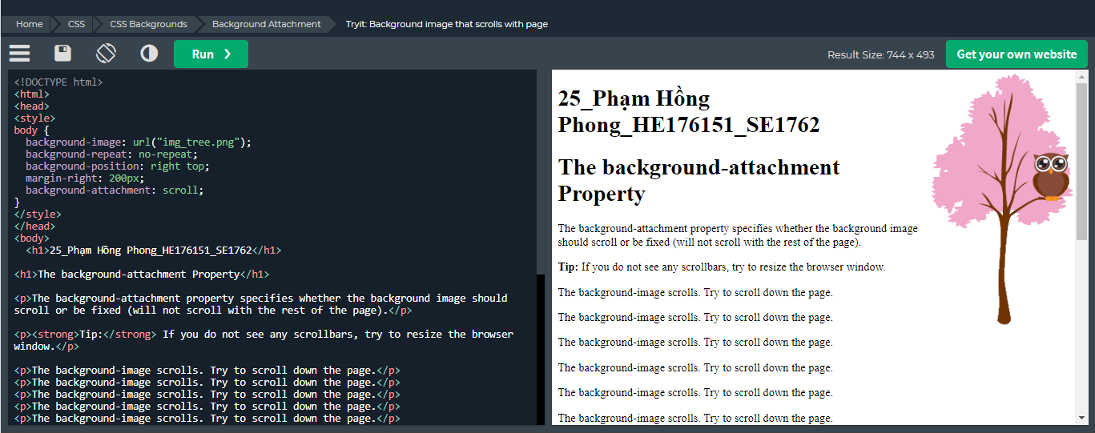

Khi scroll thì hình ảnh chuyển động theo

## Background Shorthand

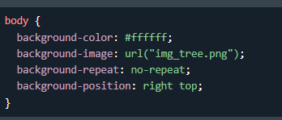

-> dùng shorthand

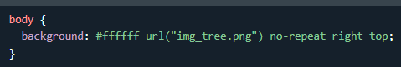

# CSS Borders

## Borders

Thuộc tính đường viền CSS cho phép bạn chỉ định kiểu, chiều rộng và màu sắc của đường viền của một phần tử.

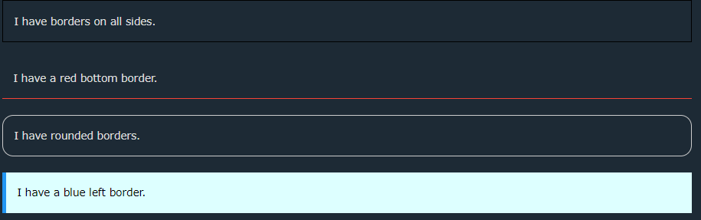

The border-style property specifies what kind of border to display.

The following values are allowed:

+dotted - Defines a dotted border

+dashed - Defines a dashed border

+solid - Defines a solid border

+double - Defines a double border

+groove - Defines a 3D grooved border. The effect depends on the border-colour value

+ridge - Defines a 3D ridged border. The effect depends on the border-colour value

+inset - Defines a 3D inset border. The effect depends on the border-colour value

+outset - Defines a 3D outset border. The effect depends on the border-colour value

+none - Defines no border

+hidden - Defines a hidden border

The border-style property can have from one to four values (for the top border, right border, bottom border, and the left border)

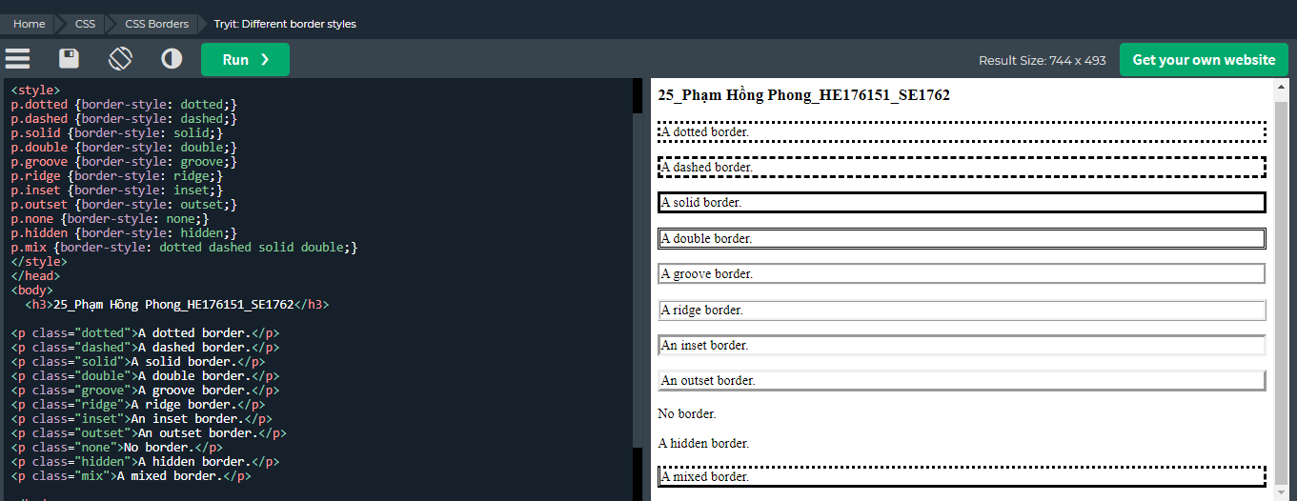

Note: None of the OTHER CSS border properties (which you will learn more about in the next chapters) will have ANY effect unless the border-style property is set!

## Border Width

The border-width property specifies the width of the four borders.

The width can be set as a specific size (in px, pt, cm, em, etc) or by using one of the three predefined values: thin, medium, or thick:

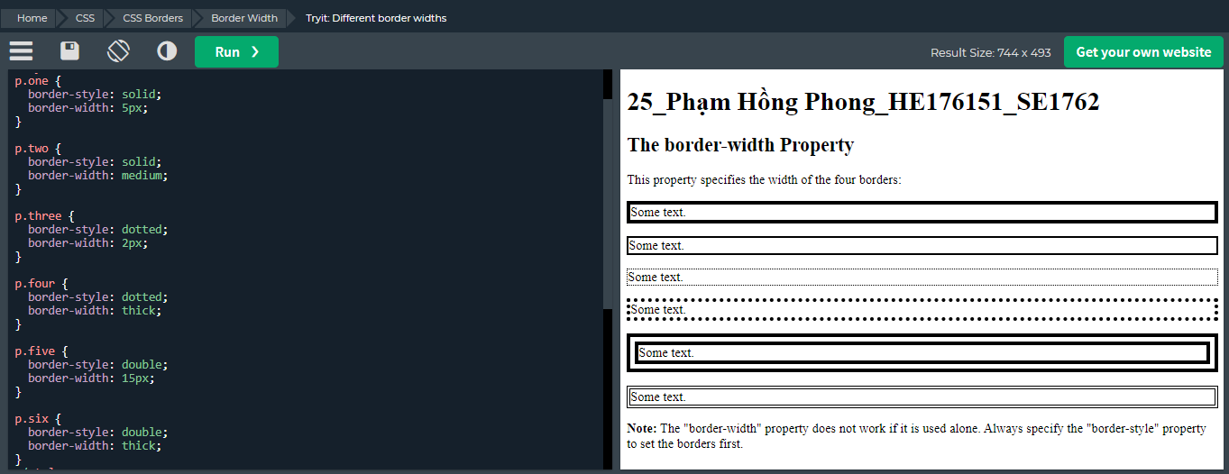

Specific Side Widths

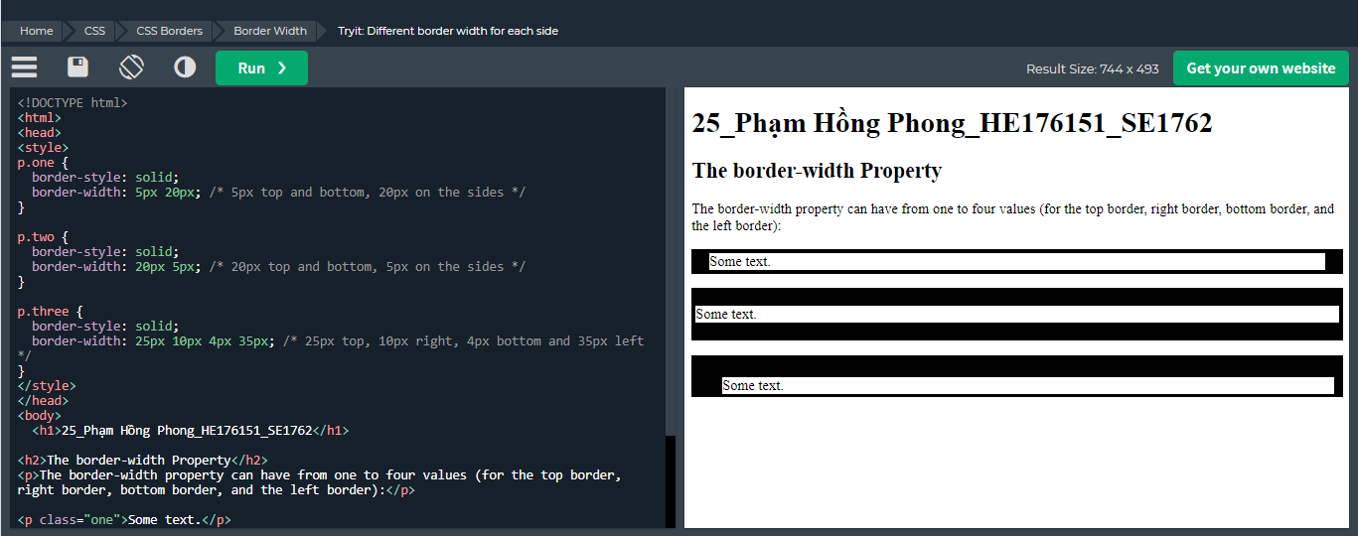

## Border colours

Border color: value;

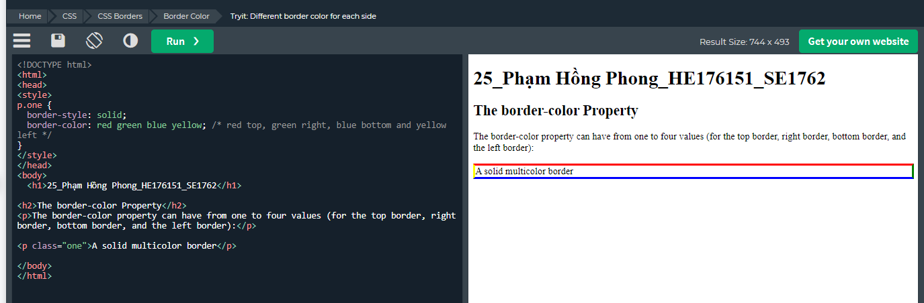

Thuộc tính border-color có thể có từ một đến bốn giá trị (cho viền trên, viền phải, viền dưới và viền trái).

## CSS Border Sides

CSS Border - Individual Sides

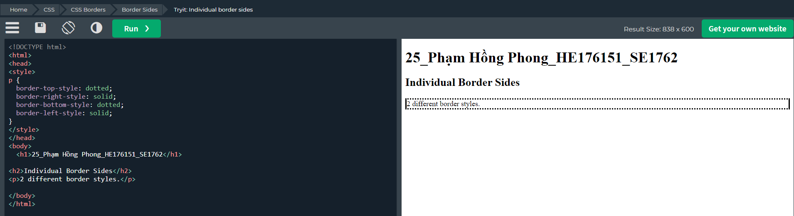

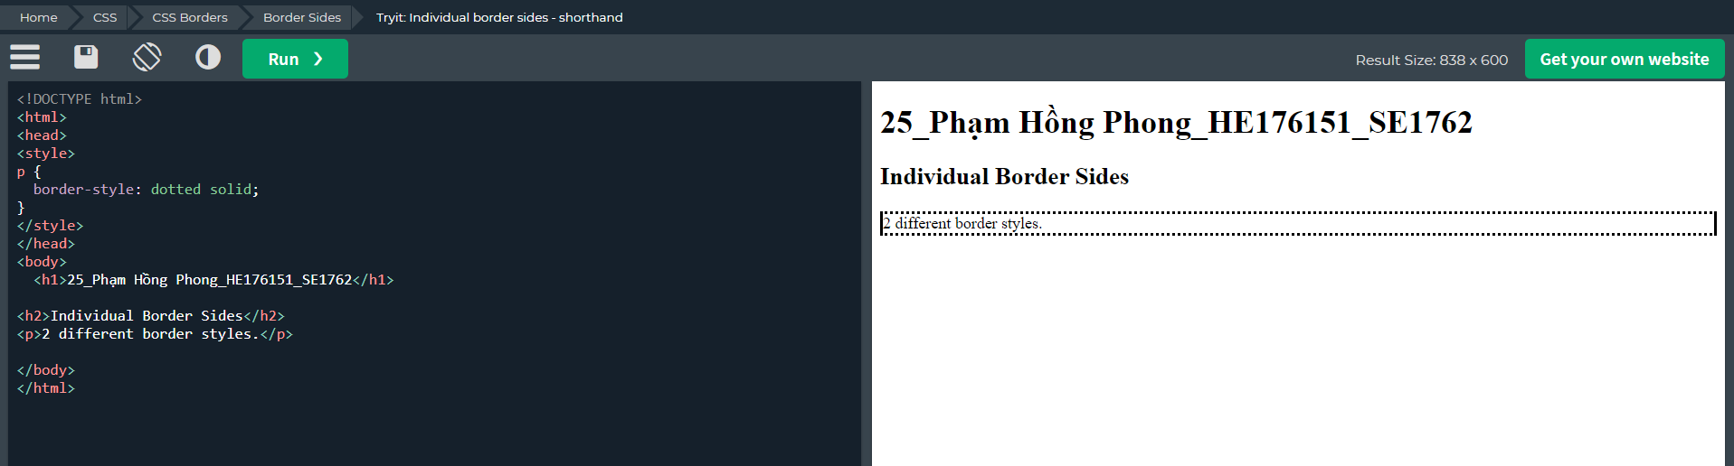

So, here is how it works:

If the border-style property has four values:

border-style: dotted solid double dashed;

* top border is dotted
* right border is solid
* bottom border is double
* left border is dashed

If the border-style property has three values:

border-style: dotted solid double;

* top border is dotted
* right and left borders are solid
* bottom border is double

If the border-style property has two values:

border-style: dotted solid;

* top and bottom borders are dotted
* right and left borders are solid

If the border-style property has one value:

* border-style: dotted;
* all four borders are dotted

The border-style property is used in the example above. However, it also works with border-width and border-color.

-Like you saw in the previous page, there are many properties to consider when dealing with borders.

-To shorten the code, it is also possible to specify all the individual border properties in one property.

-The border property is a shorthand property for the following individual border properties:

* border-width
* border-style (required)
* border-color

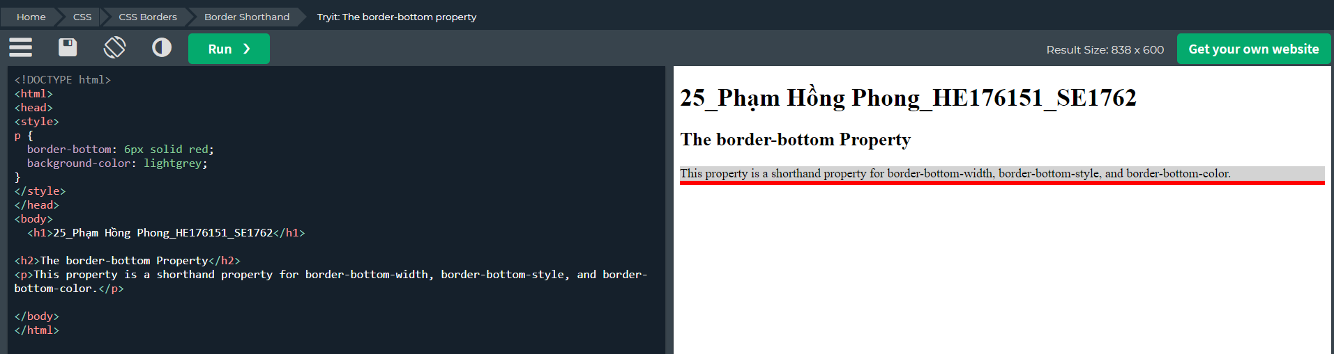

## Border-radius

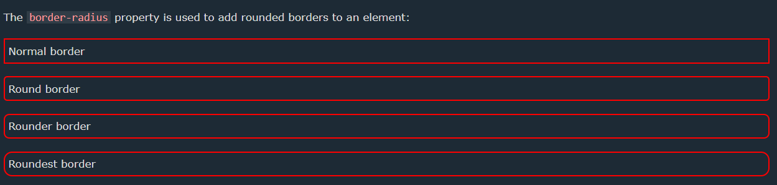

# CSS margins

## Margins

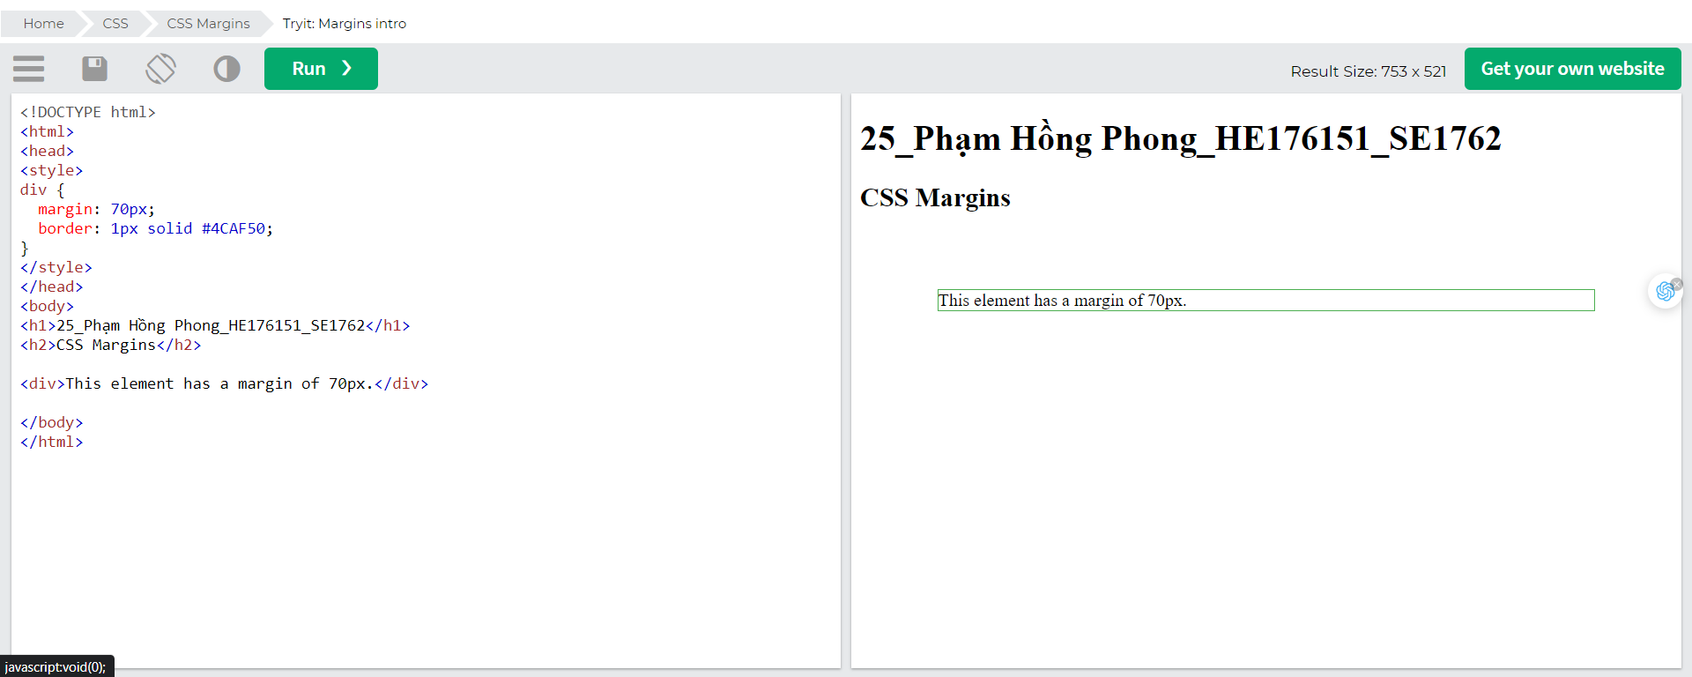

### Margin - Individual Sides

CSS has properties for specifying the margin for each side of an element:

* margin-top
* margin-right
* margin-bottom
* margin-left

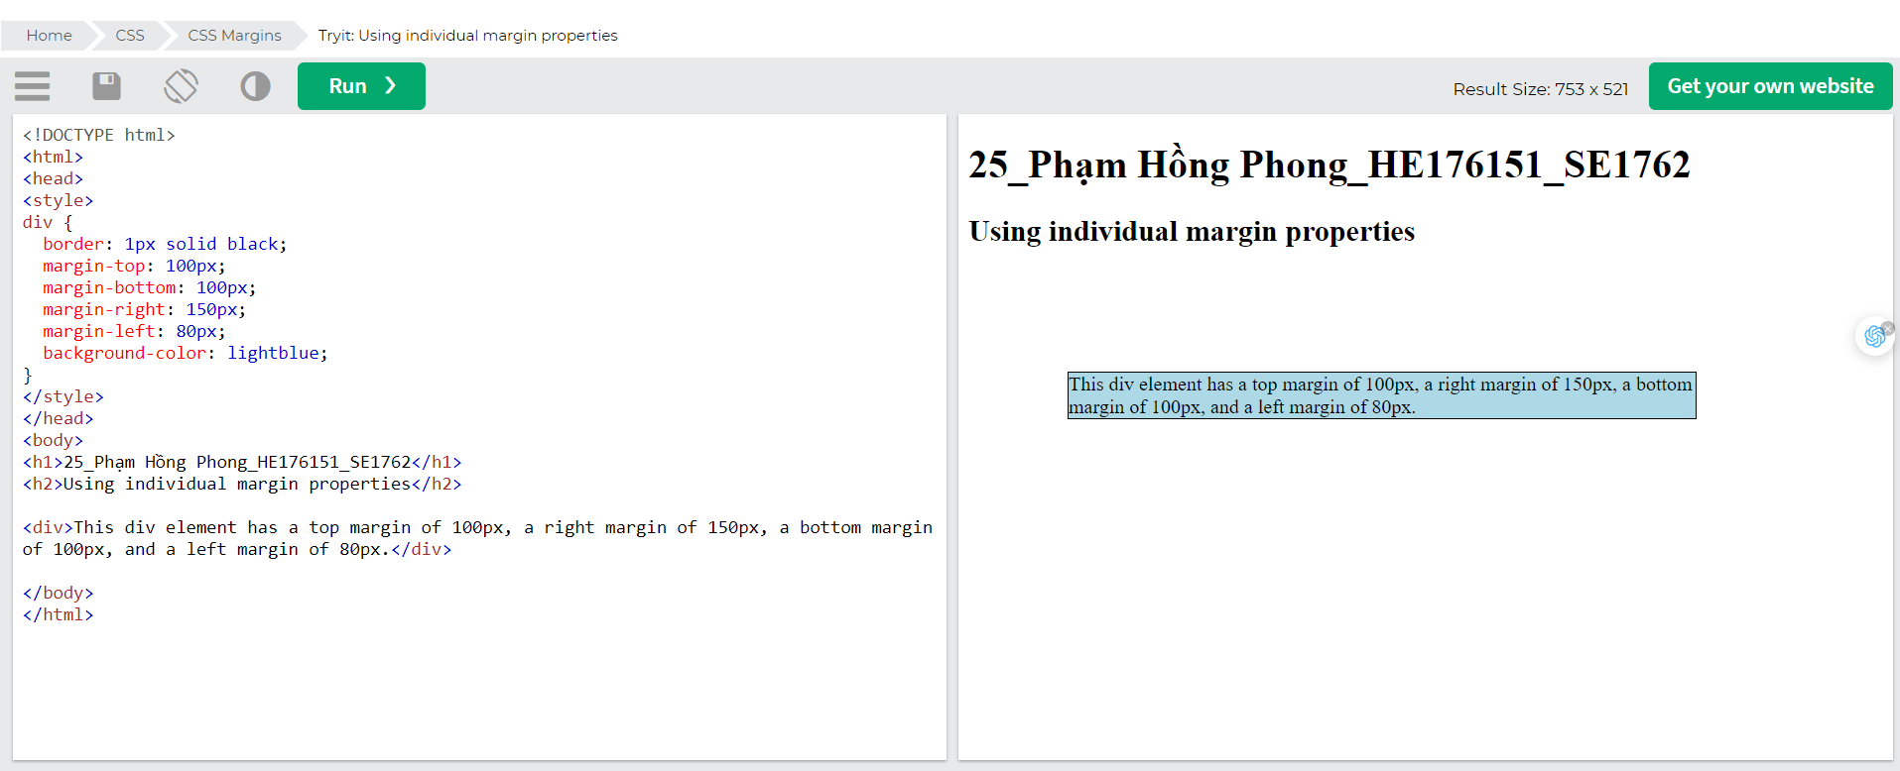

### Margin - Shorthand Property

To shorten the code, it is possible to specify all the margin properties in one property.

The margin property is a shorthand property for the following individual margin properties:

* margin-top
* margin-right
* margin-bottom
* margin-left

So, here is how it works:

If the margin property has four values:

* margin: 25px 50px 75px 100px;
  + top margin is 25px
  + right margin is 50px
  + bottom margin is 75px
  + left margin is 100px

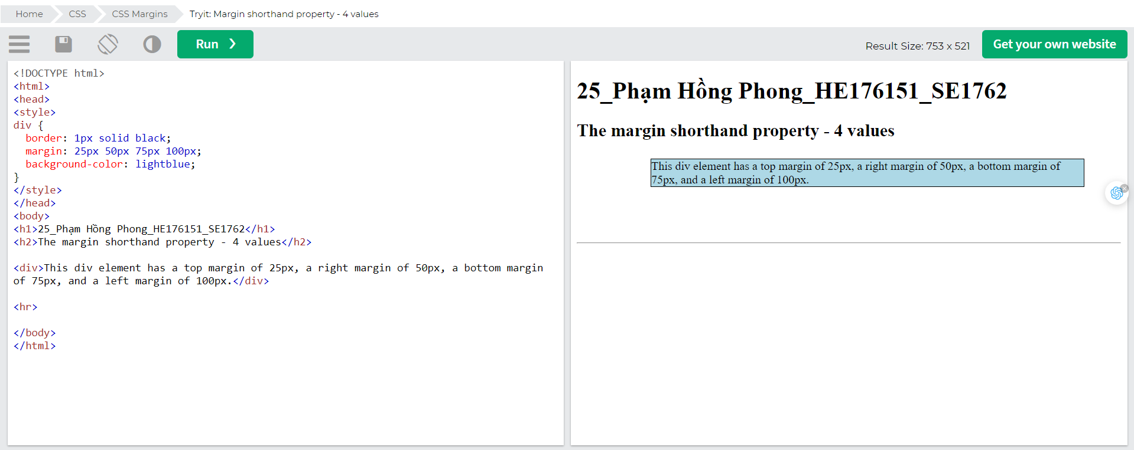

If the margin property has three values:

* margin: 25px 50px 75px;
  + top margin is 25px
  + right and left margins are 50px
  + bottom margin is 75px

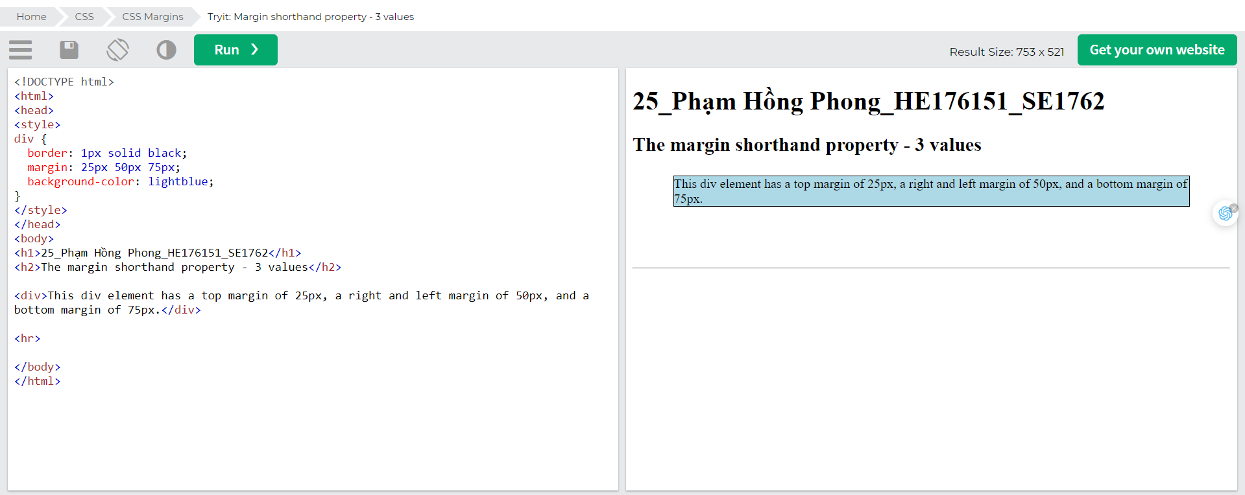

If the margin property has two values:

* margin: 25px 50px;
  + top and bottom margins are 25px
  + right and left margins are 50px

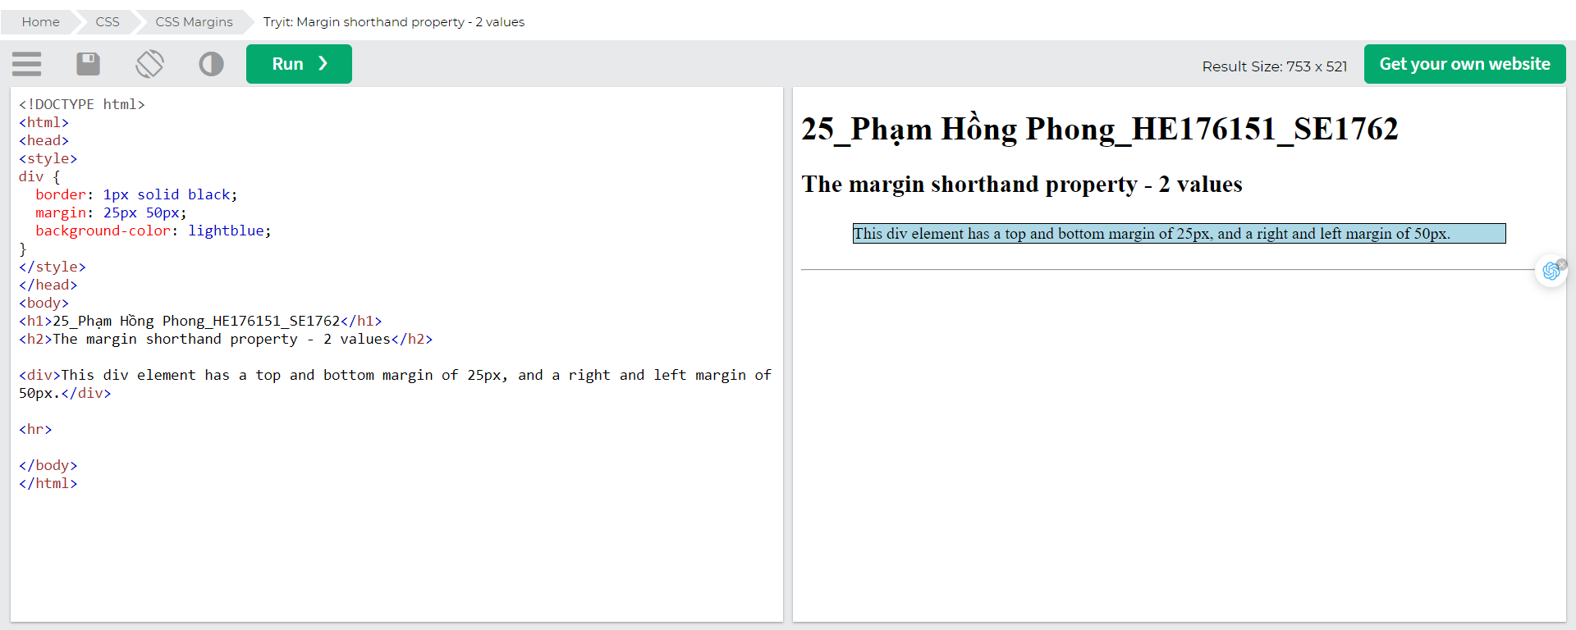

If the margin property has one value:

* margin: 25px;
  + all four margins are 25px

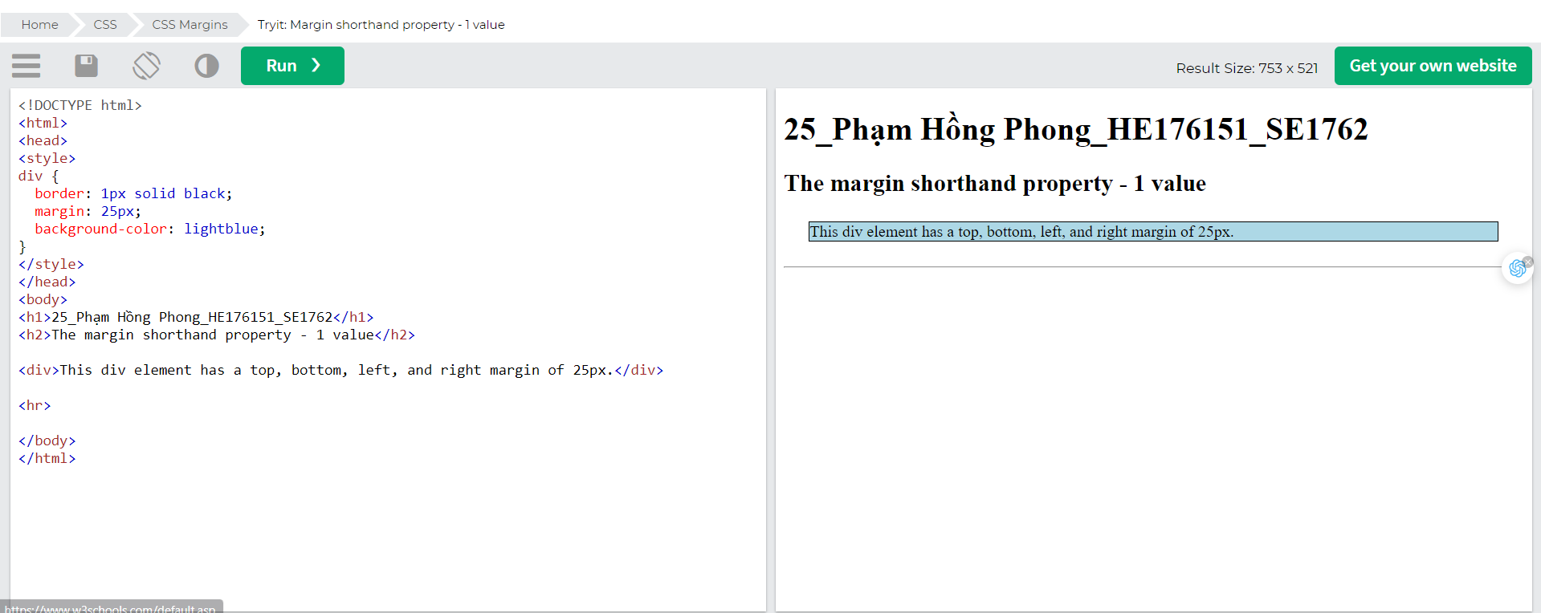

### The auto Value

You can set the margin property to auto to horizontally center the element within its container.

The element will then take up the specified width, and the remaining space will be split equally between the left and right margins.

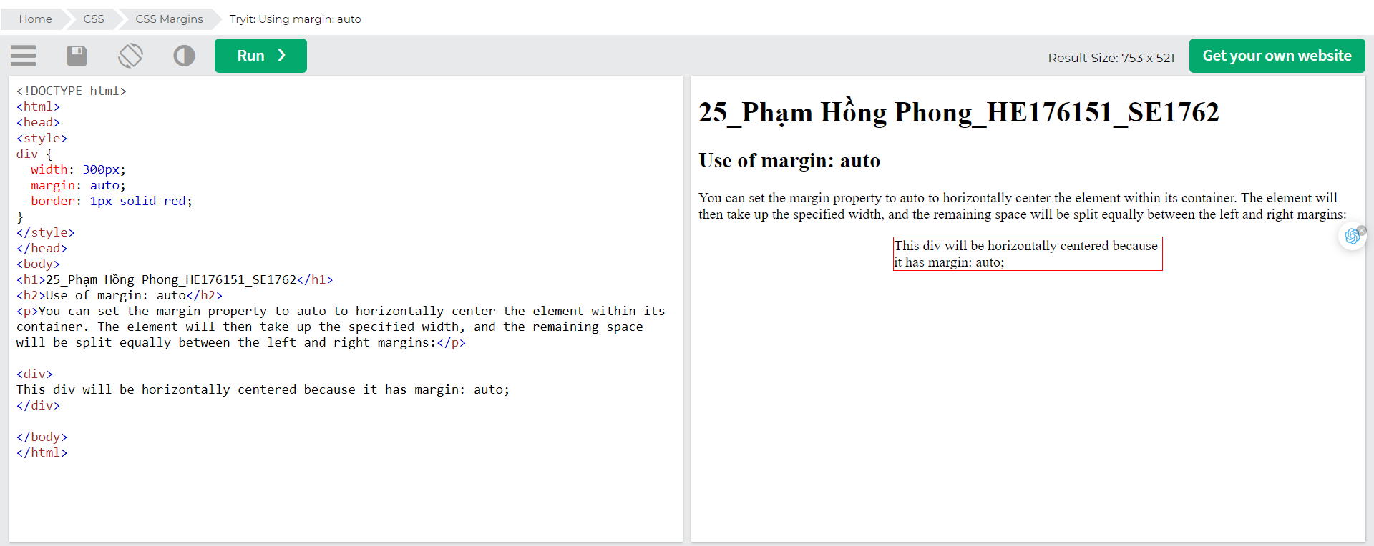

### The inherit Value

This example lets the left margin of the <p class="ex1"> element be inherited from the parent element (<div>):

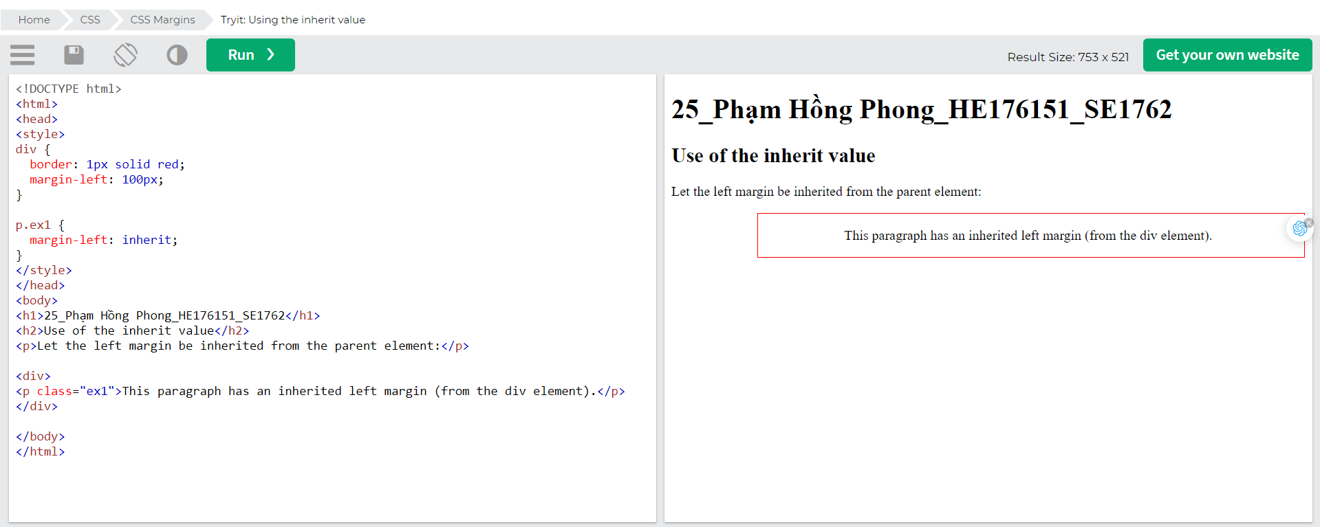

## Margin Collapse

Top and bottom margins of elements are sometimes collapsed into a single margin that is equal to the largest of the two margins.

This does not happen on left and right margins! Only top and bottom margins!

Look at the following example:

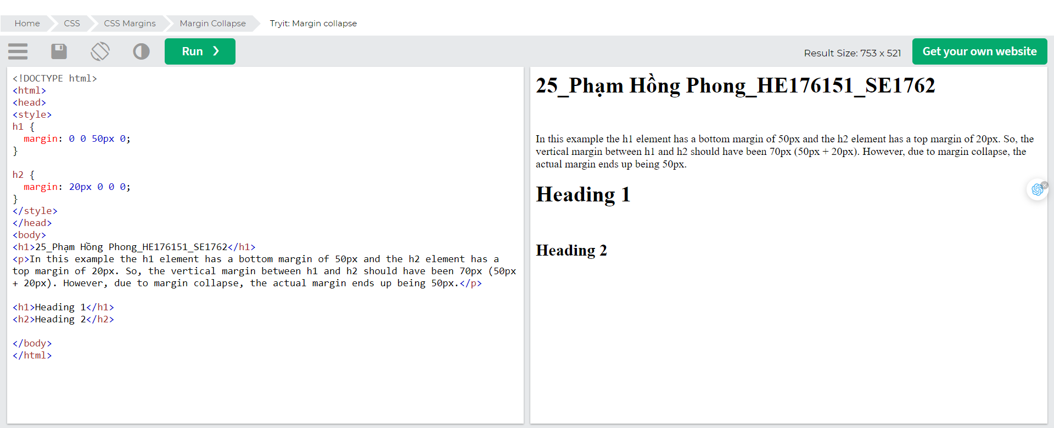

## 

# CSS padding

Padding is used to create space around an element's content, inside of any defined borders.

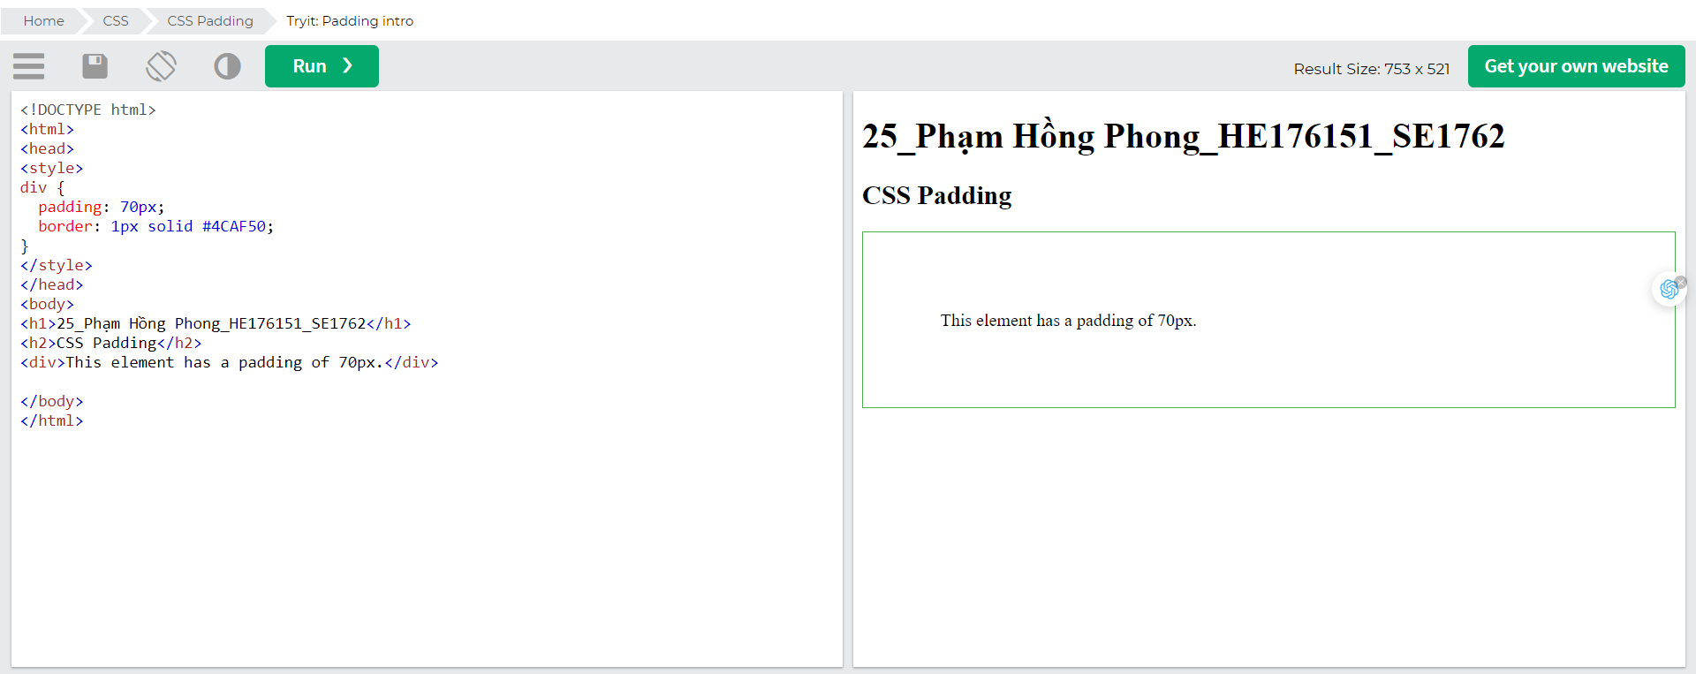

## CSS Padding

The CSS padding properties are used to generate space around an element's content, inside of any defined borders.

With CSS, you have full control over the padding. There are properties for setting the padding for each side of an element (top, right, bottom, and left).

## Padding - Individual Sides

CSS has properties for specifying the padding for each side of an element:

* padding-top
* padding-right
* padding-bottom
* padding-left

All the padding properties can have the following values:

* *length* - specifies a padding in px, pt, cm, etc.
* *%* - specifies a padding in % of the width of the containing element
* inherit - specifies that the padding should be inherited from the parent element

Note: Negative values are not allowed.

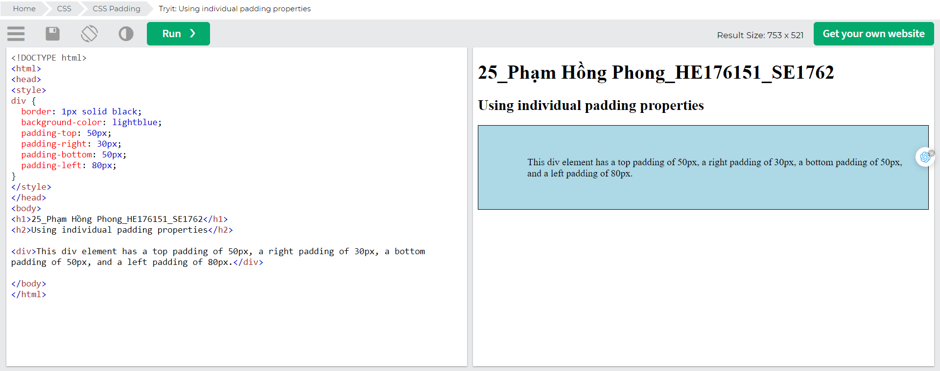

## Padding - Shorthand Property

To shorten the code, it is possible to specify all the padding properties in one property.

The padding property is a shorthand property for the following individual padding properties:

* padding-top
* padding-right
* padding-bottom
* padding-left

So, here is how it works:

If the padding property has four values:

* padding: 25px 50px 75px 100px;
  + top padding is 25px
  + right padding is 50px
  + bottom padding is 75px
  + left padding is 100px

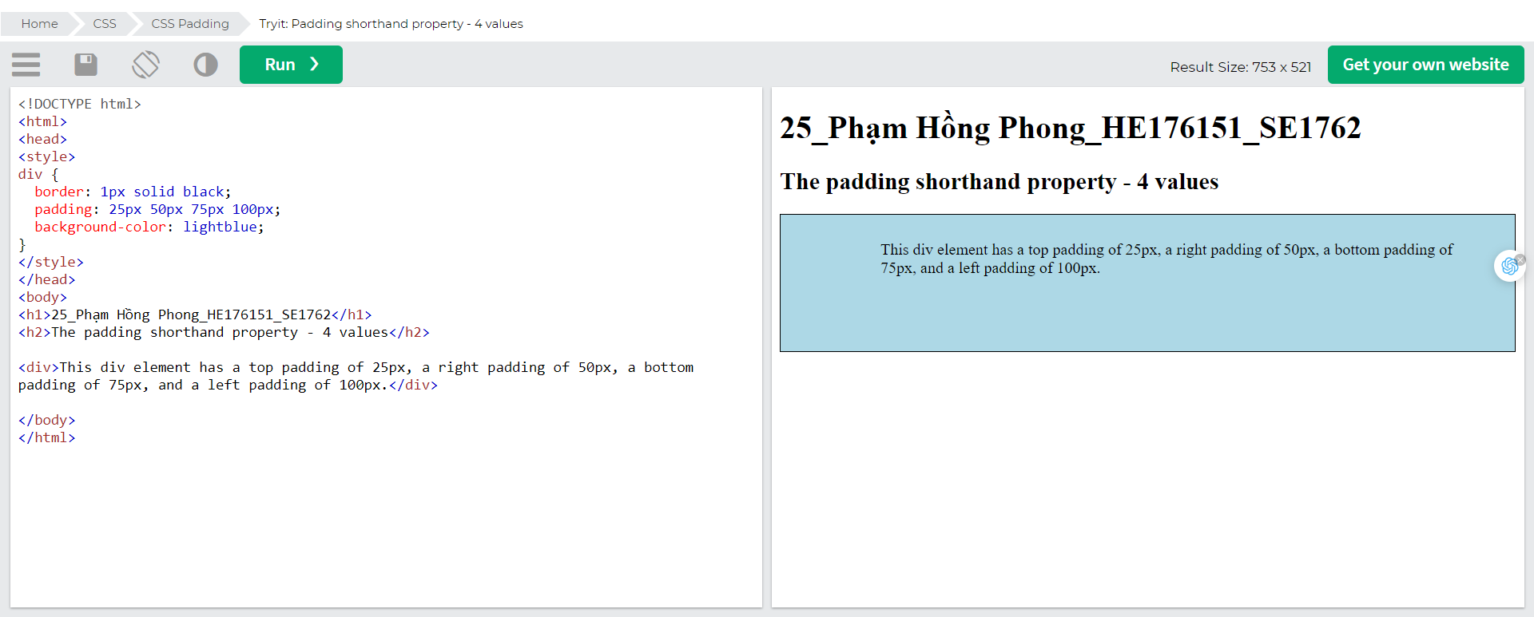

If the padding property has three values:

* padding: 25px 50px 75px;
  + top padding is 25px
  + right and left paddings are 50px
  + bottom padding is 75px

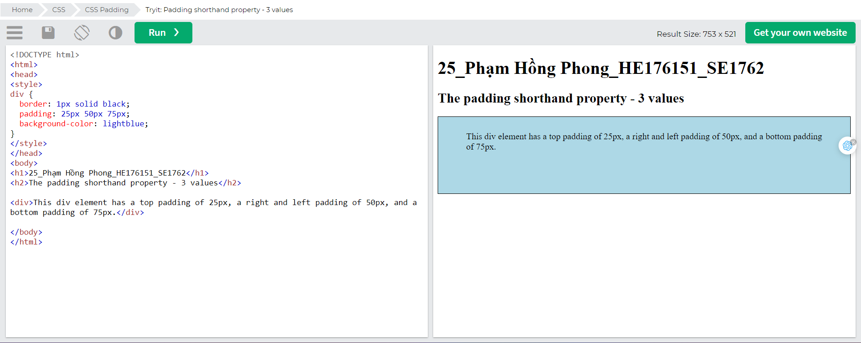

If the padding property has two values:

* padding: 25px 50px;
  + top and bottom paddings are 25px
  + right and left paddings are 50px

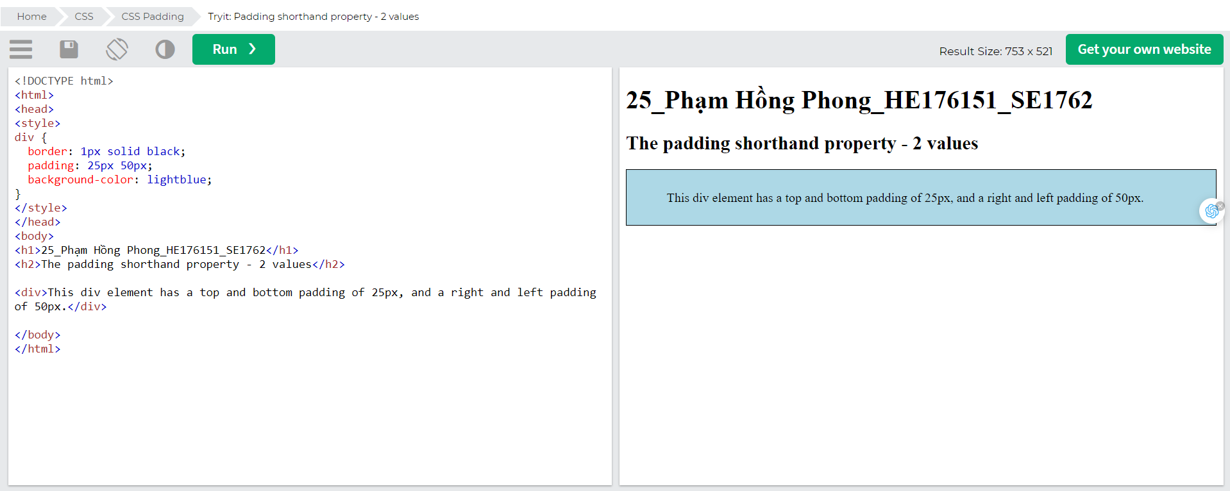

If the padding property has one value:

* padding: 25px;
  + all four paddings are 25px

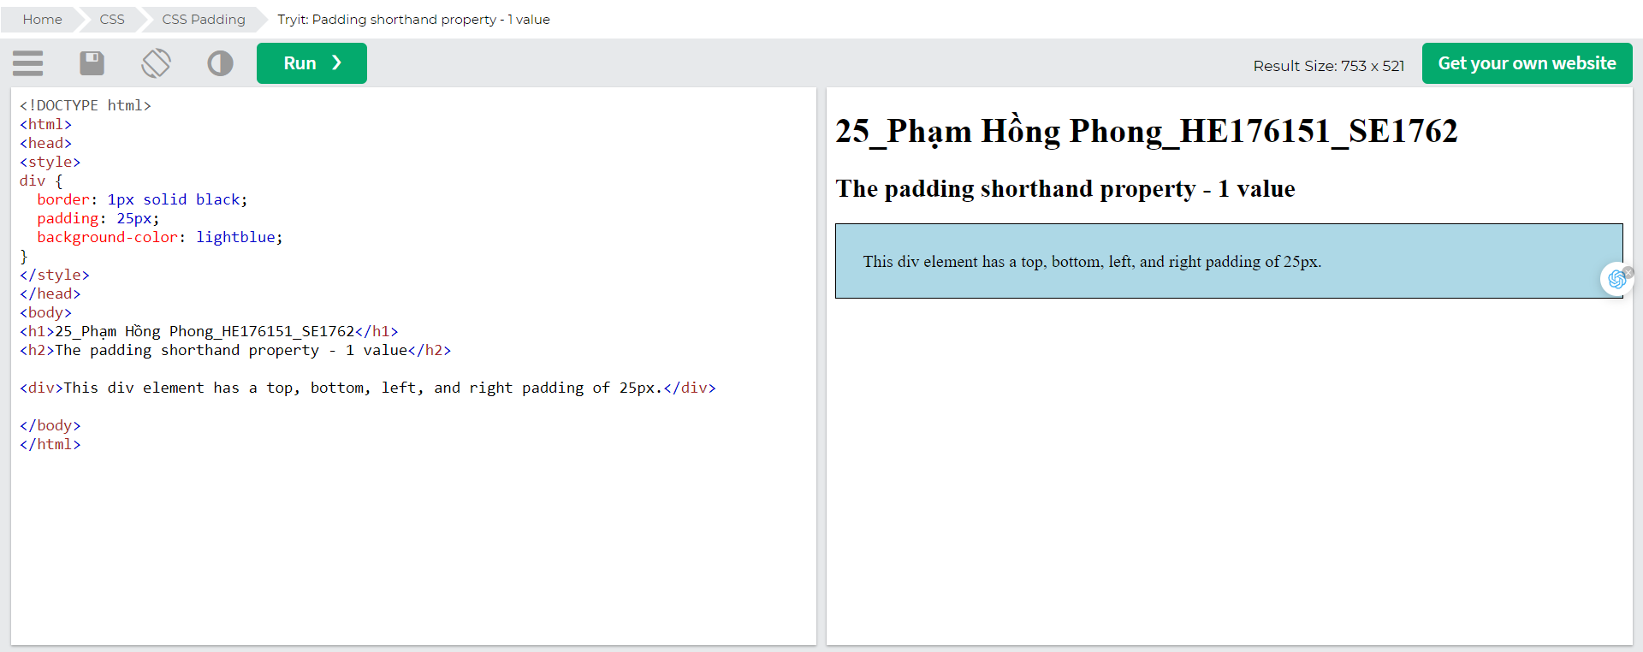

## Padding and Element Width

The CSS width property specifies the width of the element's content area. The content area is the portion inside the padding, border, and margin of an element ([the box model](https://www.w3schools.com/css/css_boxmodel.asp)).

So, if an element has a specified width, the padding added to that element will be added to the total width of the element. This is often an undesirable result.

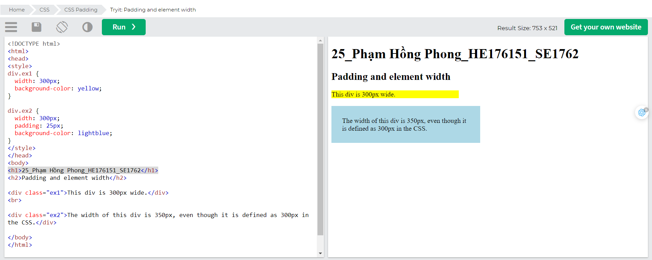

To keep the width at 300px, no matter the amount of padding, you can use the box-sizing property. This causes the element to maintain its actual width; if you increase the padding, the available content space will decrease.

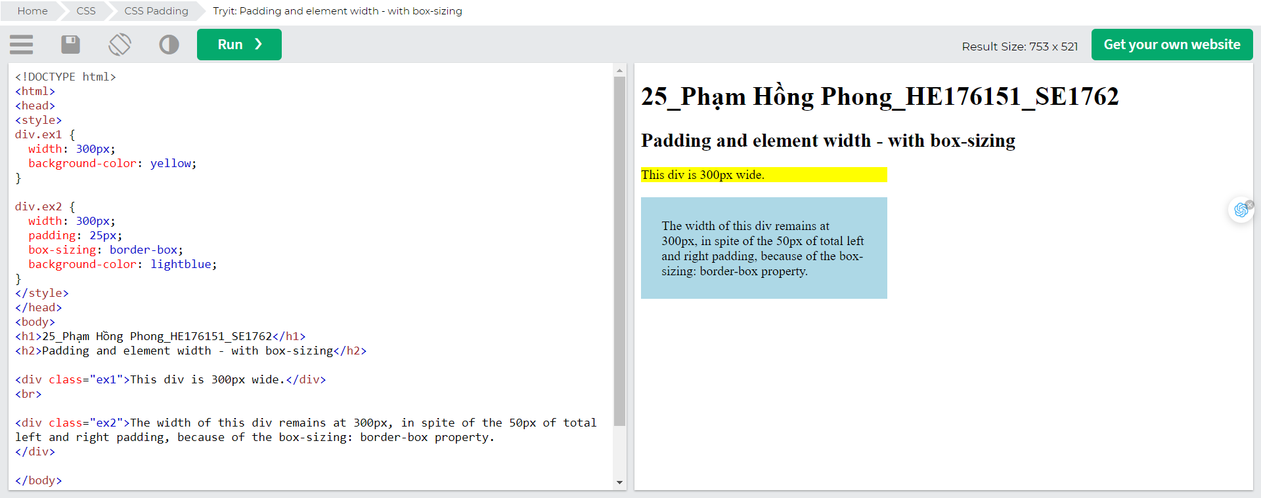

## More Examples

Set the left paddingThis example demonstrates how to set the left padding of a <p> element.

Set the right paddingThis example demonstrates how to set the right padding of a <p> element.

Set the top paddingThis example demonstrates how to set the top padding of a <p> element.

Set the bottom paddingThis example demonstrates how to set the bottom padding of a <p> element.

# CSS height/Width

The CSS height and width properties are used to set the height and width of an element.

The CSS max-width property is used to set the maximum width of an element.

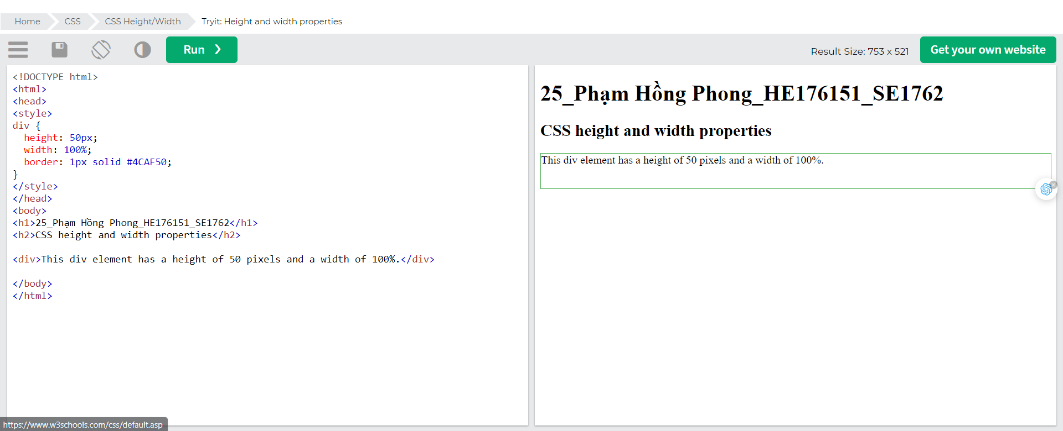

## CSS Setting height and width

The height and width properties are used to set the height and width of an element.

The height and width properties do not include padding, borders, or margins. It sets the height/width of the area inside the padding, border, and margin of the element.

## CSS height and width Values

The height and width properties may have the following values:

* auto - This is default. The browser calculates the height and width
* length - Defines the height/width in px, cm, etc.
* % - Defines the height/width in percent of the containing block
* initial - Sets the height/width to its default value
* inherit - The height/width will be inherited from its parent value

## CSS height and width Examples

This element has a height of 200 pixels and a width of 50%This element has a height of 200 pixels and a width of 50%

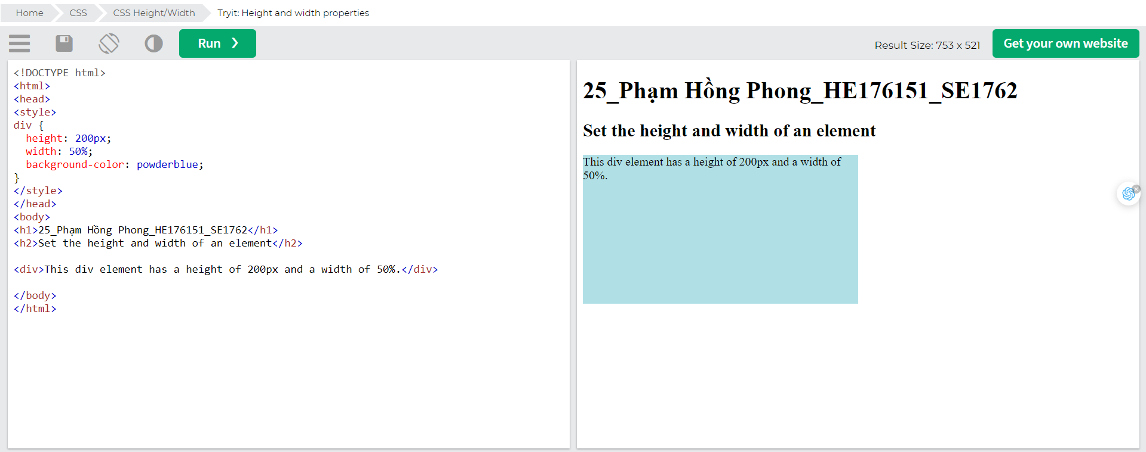

This element has a height of 100 pixels and a width of 500 pixels.

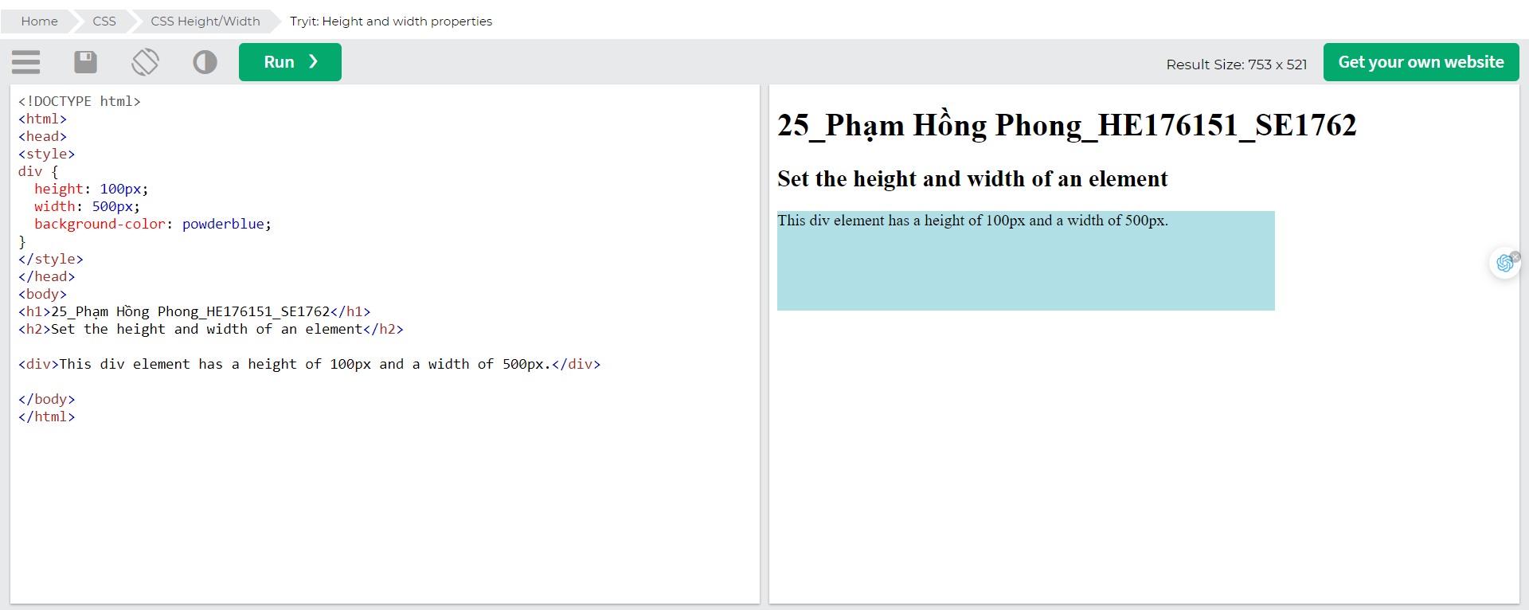

## Setting max-width

The max-width property is used to set the maximum width of an element.

The max-width can be specified in *length values*, like px, cm, etc., or in percent (%) of the containing block, or set to none (this is default. Means that there is no maximum width).

The problem with the <div> above occurs when the browser window is smaller than the width of the element (500px). The browser then adds a horizontal scrollbar to the page.

Using max-width instead, in this situation, will improve the browser's handling of small windows.

Tip: Drag the browser window to smaller than 500px wide, to see the difference between the two divs!

This element has a height of 100 pixels and a max-width of 500 pixels.

Note: If you for some reason use both the width property and the max-width property on the same element, and the value of the width property is larger than the max-width property; the max-width property will be used (and the width property will be ignored).

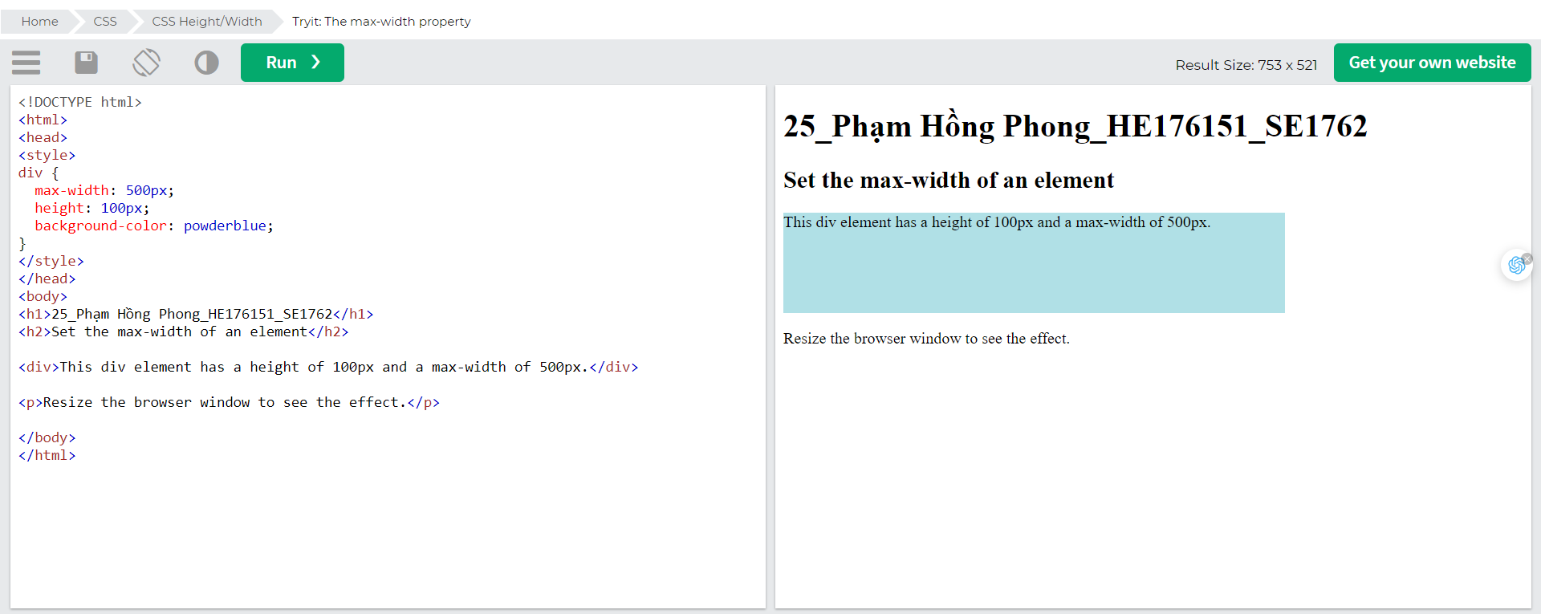

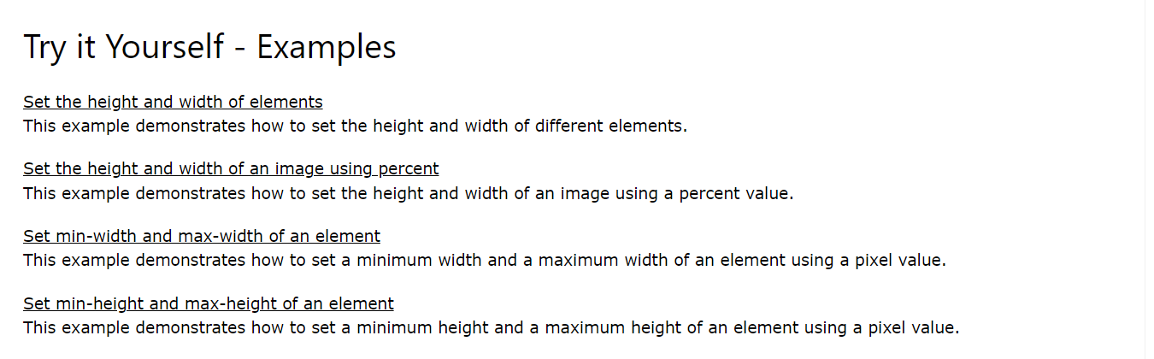

# CSS box model

All HTML elements can be considered as boxes.

## The CSS Box Model

In CSS, the term "box model" is used when talking about design and layout.

The CSS box model is essentially a box that wraps around every HTML element. It consists of: margins, borders, padding, and the actual content. The image below illustrates the box model:

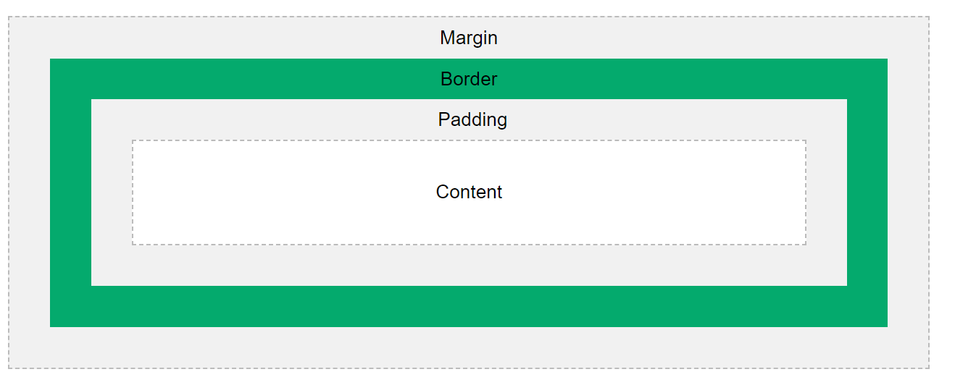

Explanation of the different parts:

* Content - The content of the box, where text and images appear
* Padding - Clears an area around the content. The padding is transparent
* Border - A border that goes around the padding and content
* Margin - Clears an area outside the border. The margin is transparent

The box model allows us to add a border around elements, and to define space between elements.

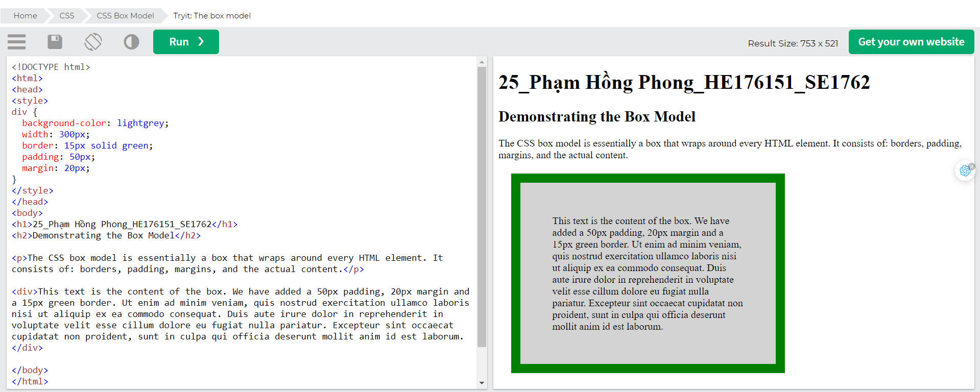

## Width and Height of an Element

In order to set the width and height of an element correctly in all browsers, you need to know how the box model works.

**Important**: When you set the width and height properties of an element with CSS, you just set the width and height of the content area. To calculate the full size of an element, you must also add padding, borders and margins.

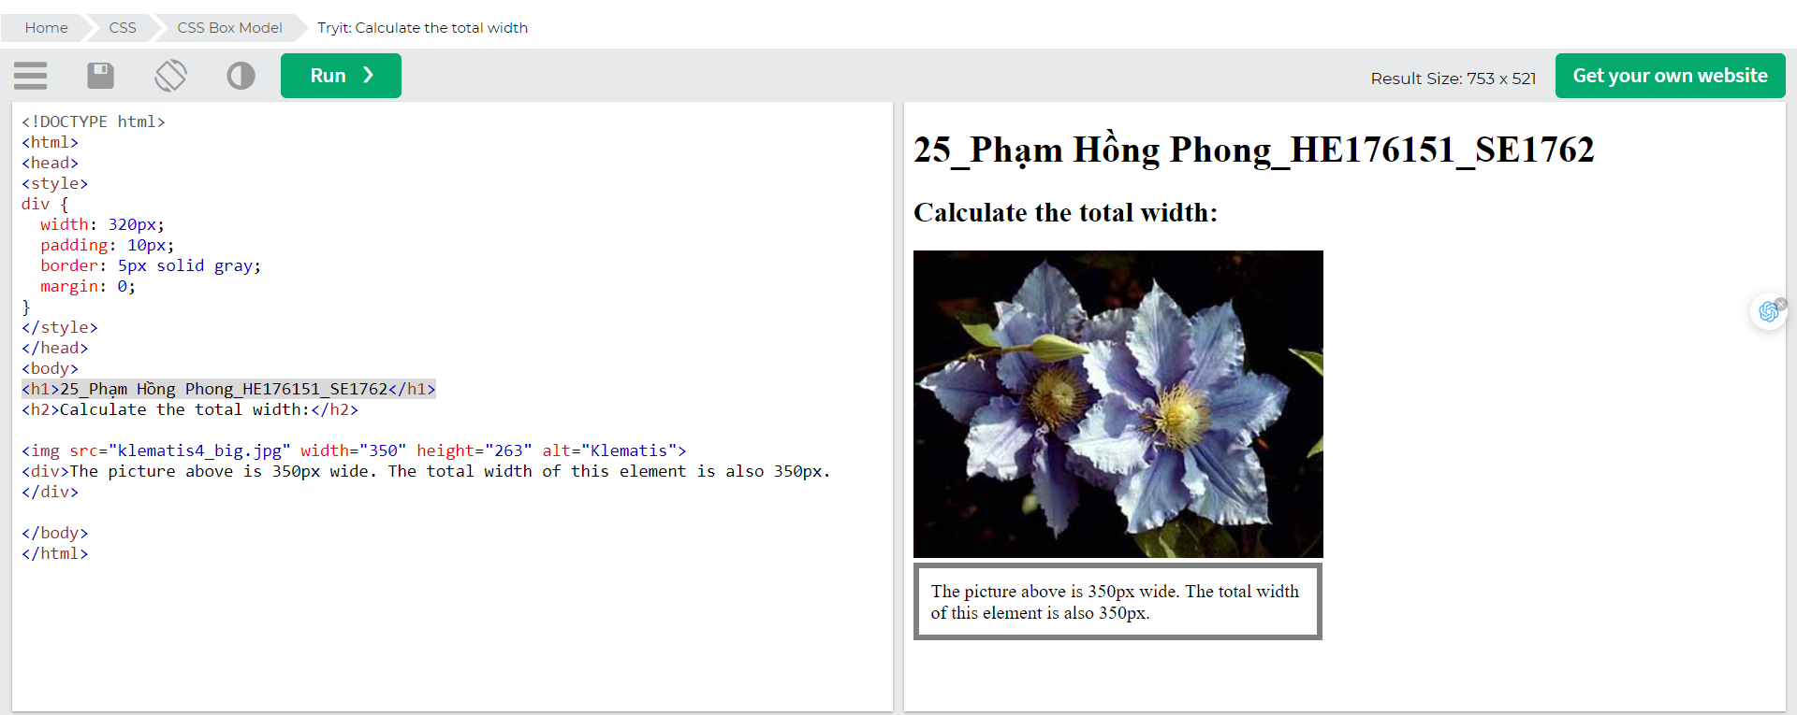

Here is the calculation:

320px (width)

+ 20px (left + right padding)

+ 10px (left + right border)

+ 0px (left + right margin)

= 350px

The total width of an element should be calculated like this:

Total element width = width + left padding + right padding + left border + right border + left margin + right margin

The total height of an element should be calculated like this:

Total element height = height + top padding + bottom padding + top border + bottom border + top margin + bottom margin

# CSS Outline

An outline is a line drawn outside the element's border.

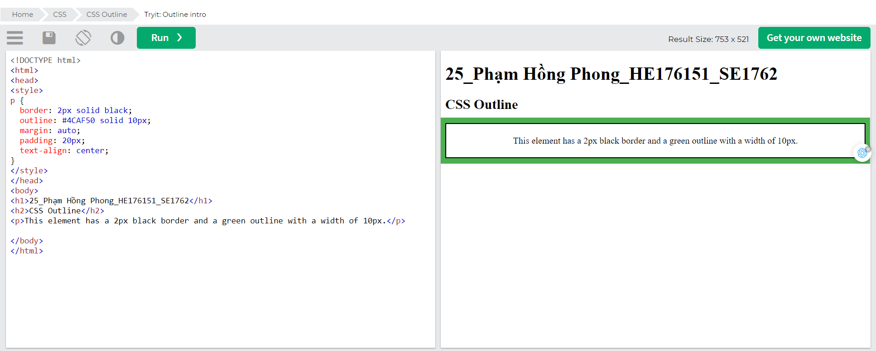

## CSS Outline

An outline is a line that is drawn around elements, OUTSIDE the borders, to make the element "stand out".

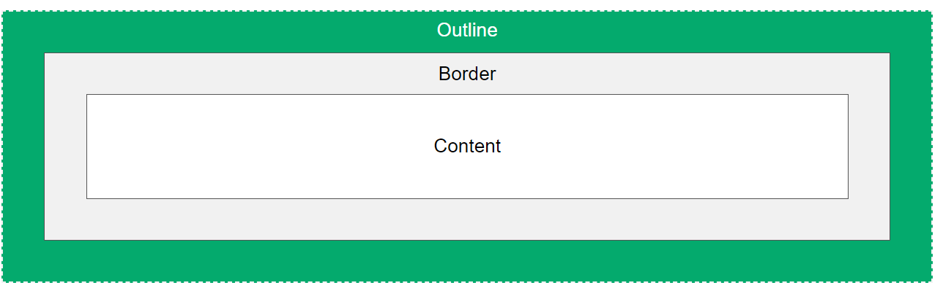

CSS has the following outline properties:

* outline-style
* outline-color
* outline-width
* outline-offset
* outline

Note: Outline differs from [borders](https://www.w3schools.com/css/css_border.asp)! Unlike border, the outline is drawn outside the element's border, and may overlap other content. Also, the outline is NOT a part of the element's dimensions; the element's total width and height is not affected by the width of the outline.

### CSS Outline Style

The outline-style property specifies the style of the outline, and can have one of the following values:

* dotted - Defines a dotted outline
* dashed - Defines a dashed outline
* solid - Defines a solid outline
* double - Defines a double outline
* groove - Defines a 3D grooved outline
* ridge - Defines a 3D ridged outline
* inset - Defines a 3D inset outline
* outset - Defines a 3D outset outline
* none - Defines no outline
* hidden - Defines a hidden outline

The following example shows the different outline-style values:

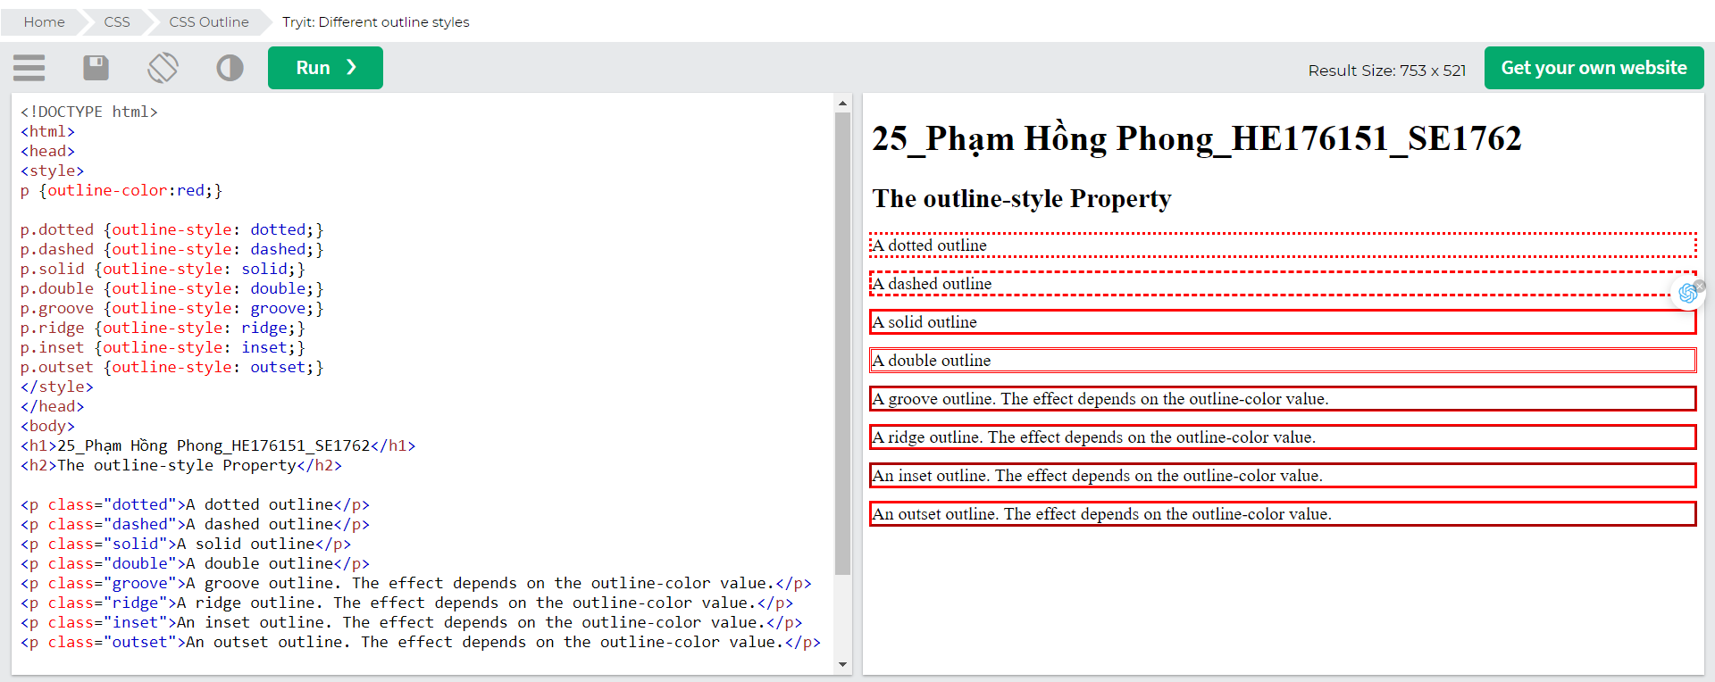

## CSS Outline Width

The outline-width property specifies the width of the outline, and can have one of the following values:

* thin (typically 1px)
* medium (typically 3px)
* thick (typically 5px)
* A specific size (in px, pt, cm, em, etc)

The following example shows some outlines with different widths:

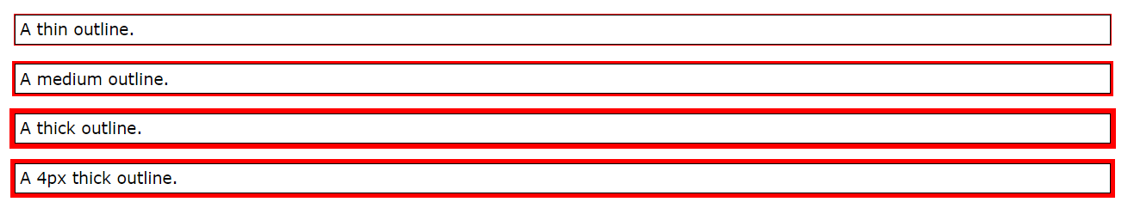

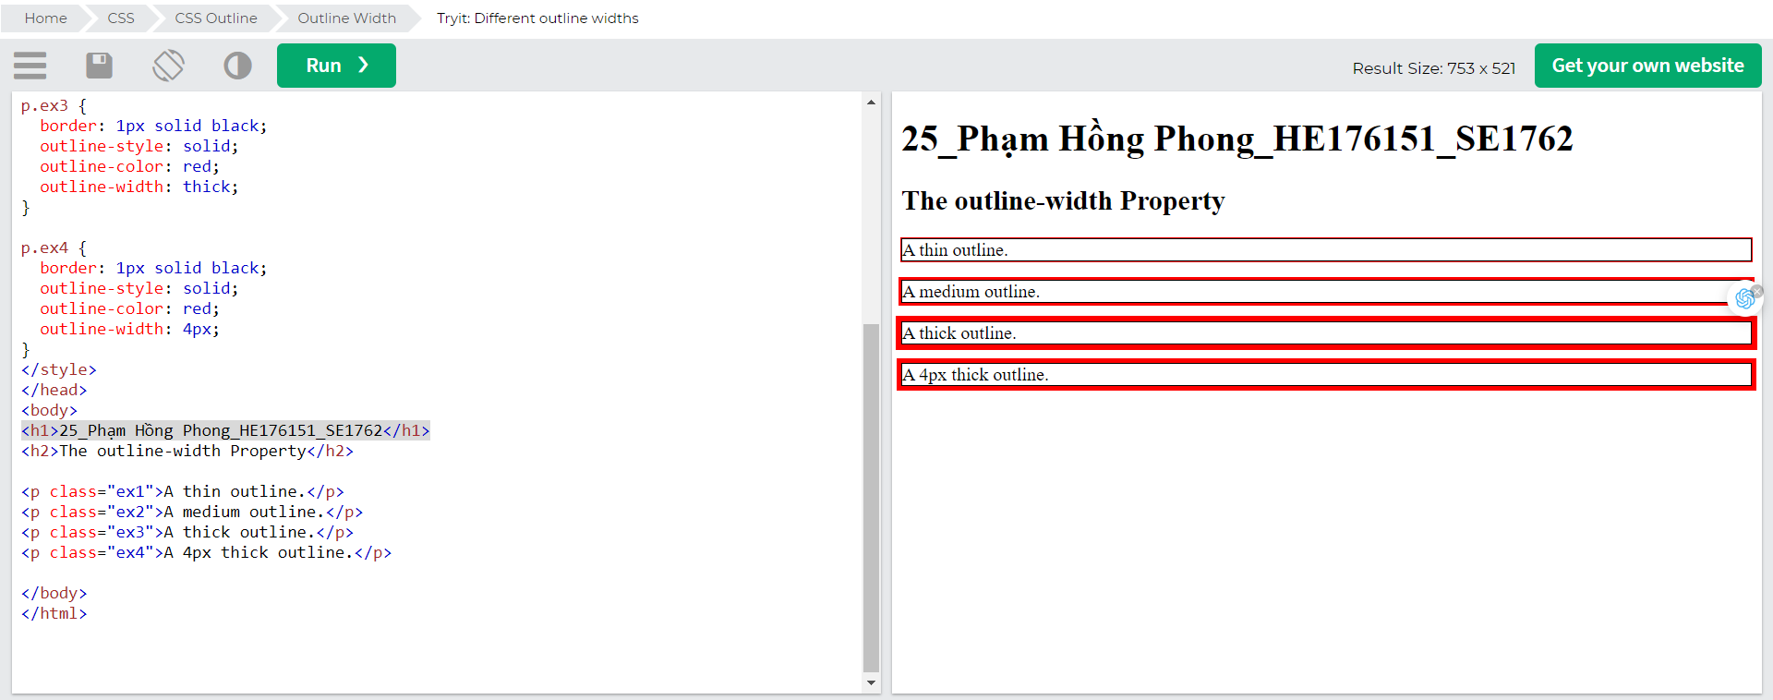

## CSS Outline Color

The outline-color property is used to set the color of the outline.

The color can be set by:

* name - specify a color name, like "red"
* HEX - specify a hex value, like "#ff0000"
* RGB - specify a RGB value, like "rgb(255,0,0)"
* HSL - specify a HSL value, like "hsl(0, 100%, 50%)"
* invert - performs a color inversion (which ensures that the outline is visible, regardless of color background)

The following example shows some different outlines with different colors. Also notice that these elements also have a thin black border inside the outline:

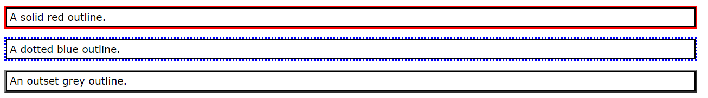

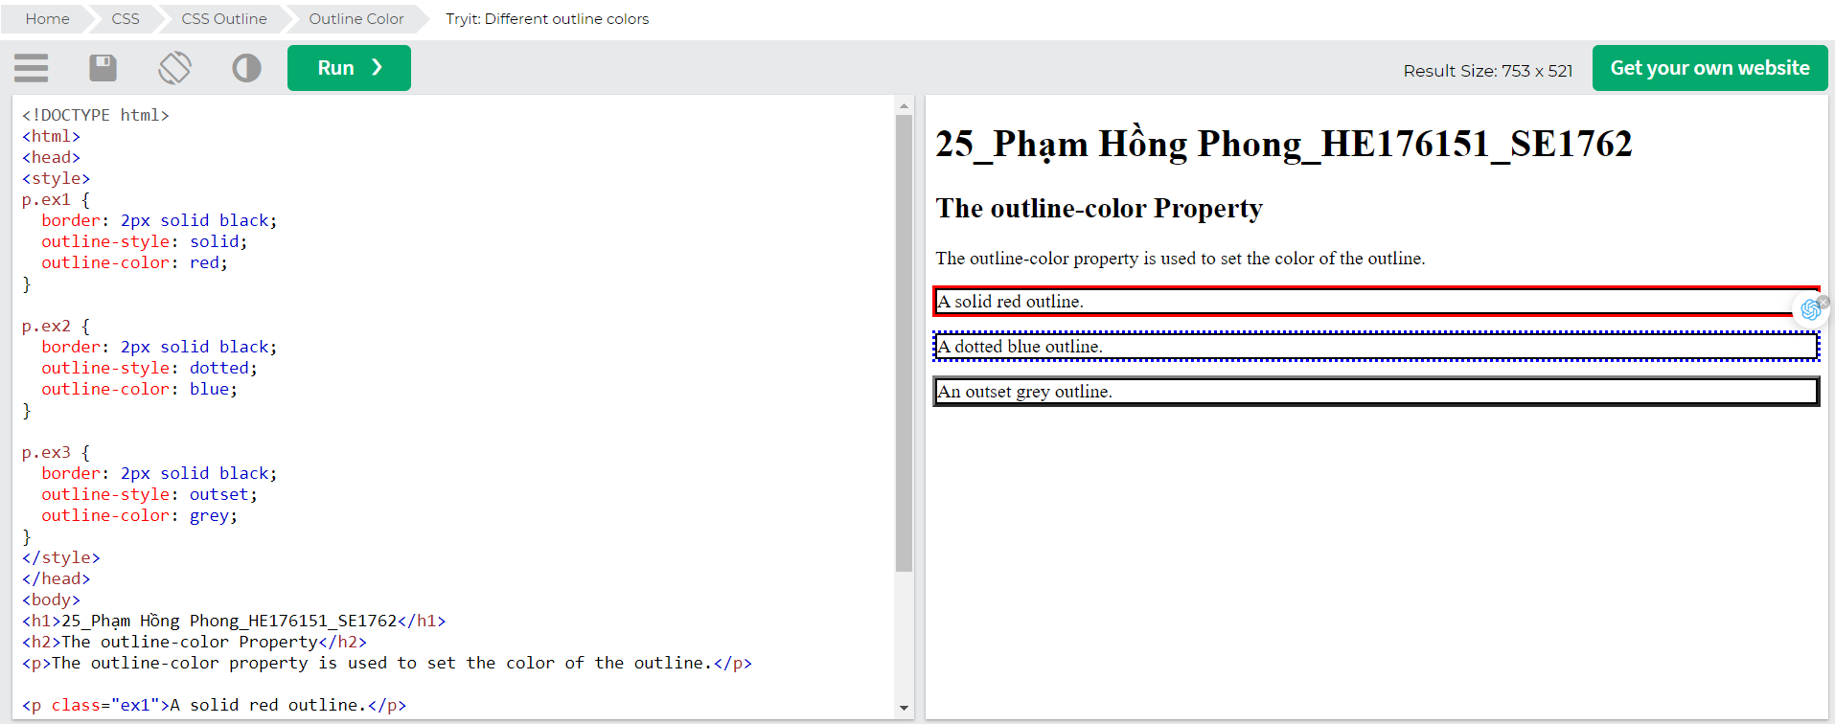

### HEX Values

The outline color can also be specified using a hexadecimal value (HEX):

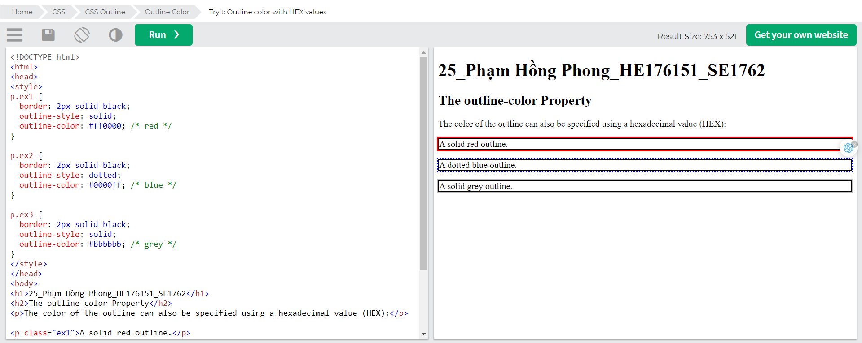

### RGB Values

Or by using RGB values:

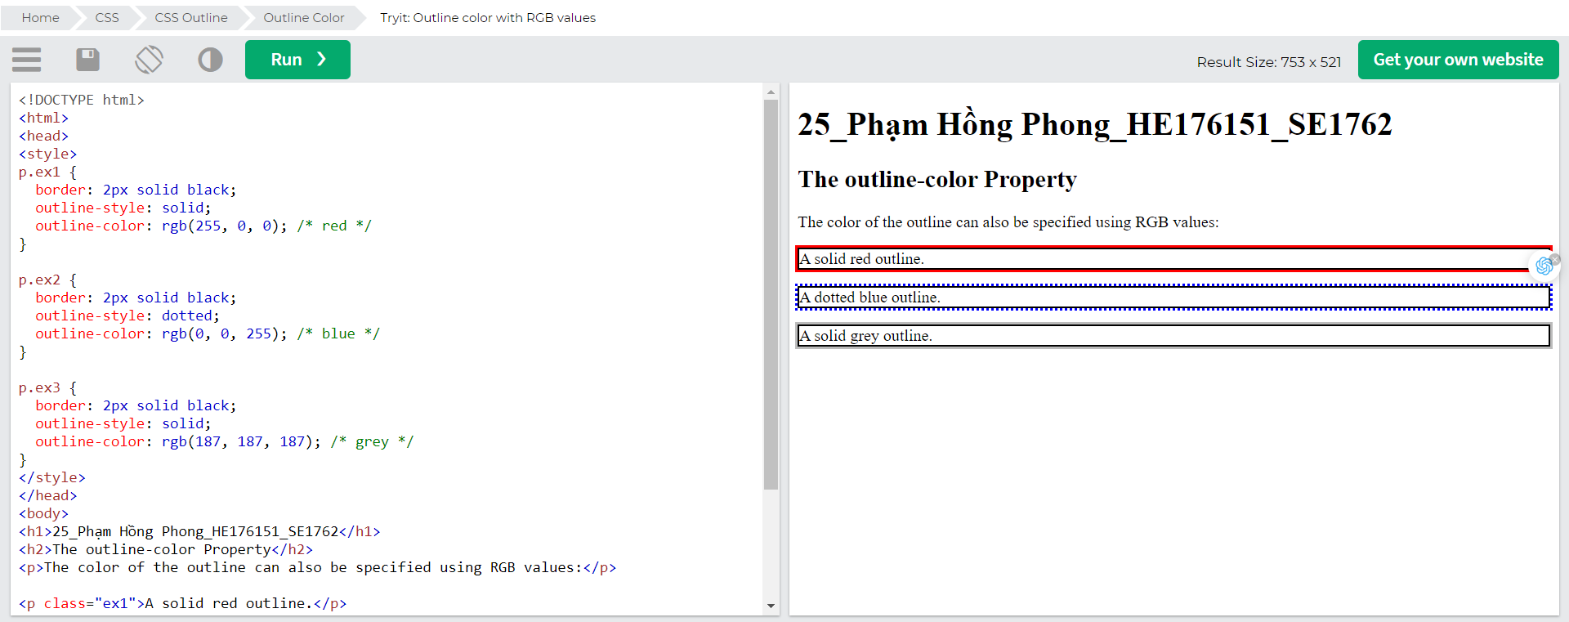

### HSL Values

You can also use HSL values:

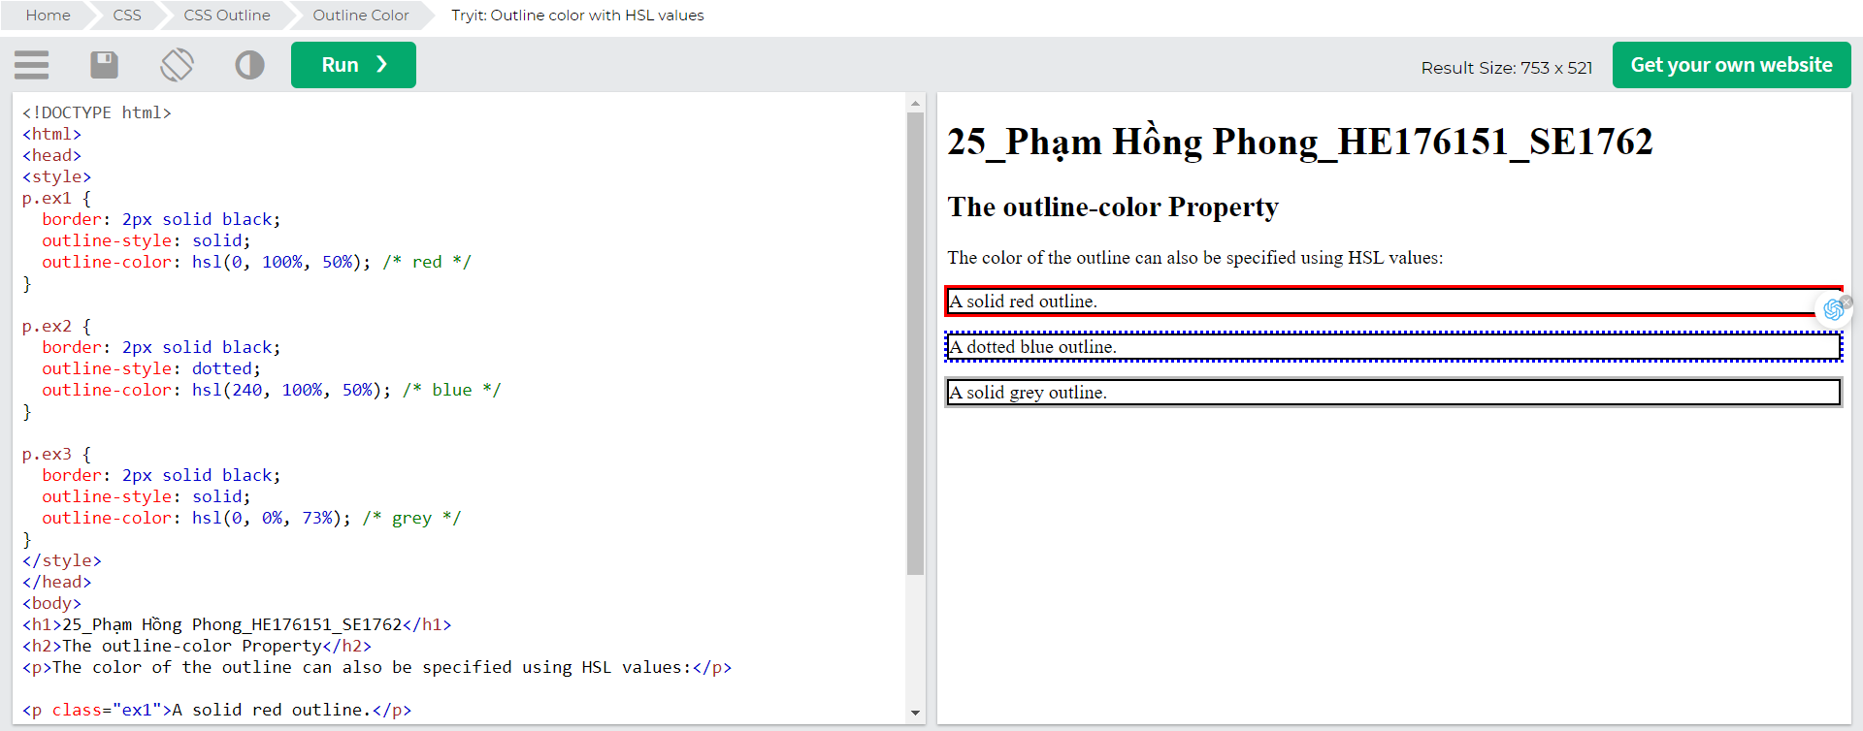

## CSS Outline - Shorthand property

The outline property is a shorthand property for setting the following individual outline properties:

* outline-width
* outline-style (required)
* outline-color

The outline property is specified as one, two, or three values from the list above. The order of the values does not matter.

The following example shows some outlines specified with the shorthand outline property:

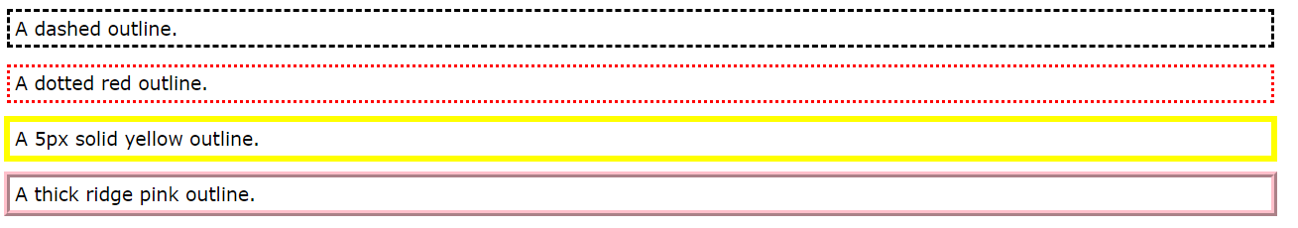

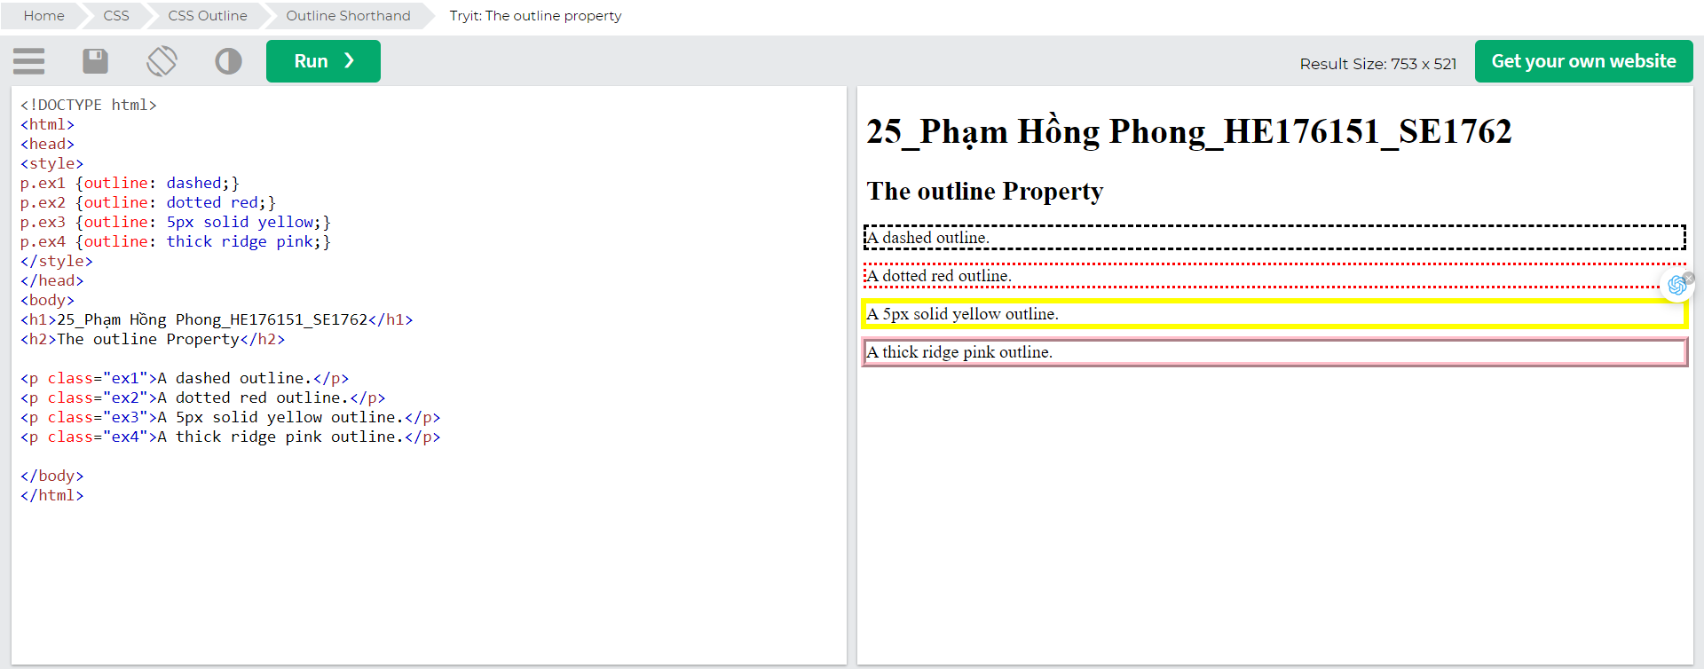

## CSS Outline Offset

The outline-offset property adds space between an outline and the edge/border of an element. The space between an element and its outline is transparent.

The following example specifies an outline 15px outside the border edge:

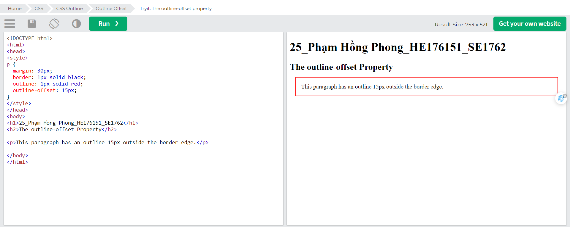The following example shows that the space between an element and its outline is transparent: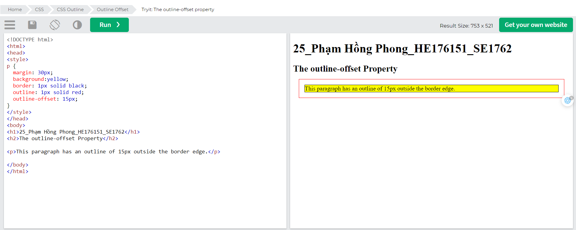

# CSS Text

CSS has a lot of properties for formatting text.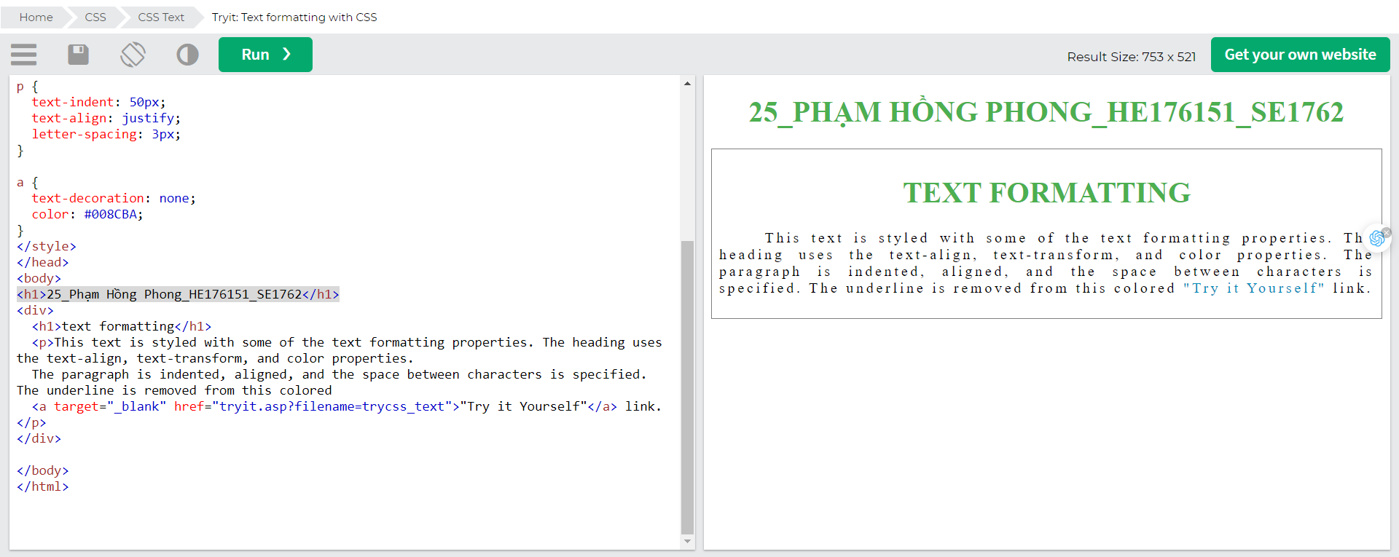

## Text Color

The color property is used to set the color of the text. The color is specified by:

* a color name - like "red"
* a HEX value - like "#ff0000"
* an RGB value - like "rgb(255,0,0)"

Look at [CSS Color Values](https://www.w3schools.com/cssref/css_colors_legal.asp) for a complete list of possible color values.

The default text color for a page is defined in the body selector.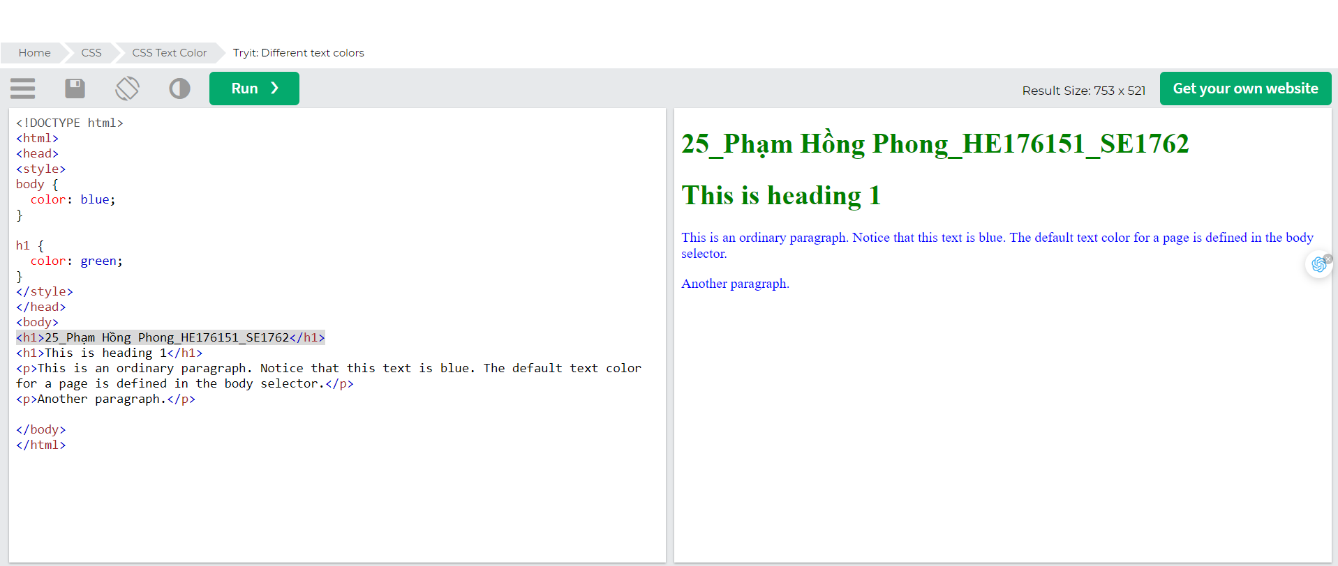

### Text Color and Background Color

In this example, we define both the background-color property and the color property:

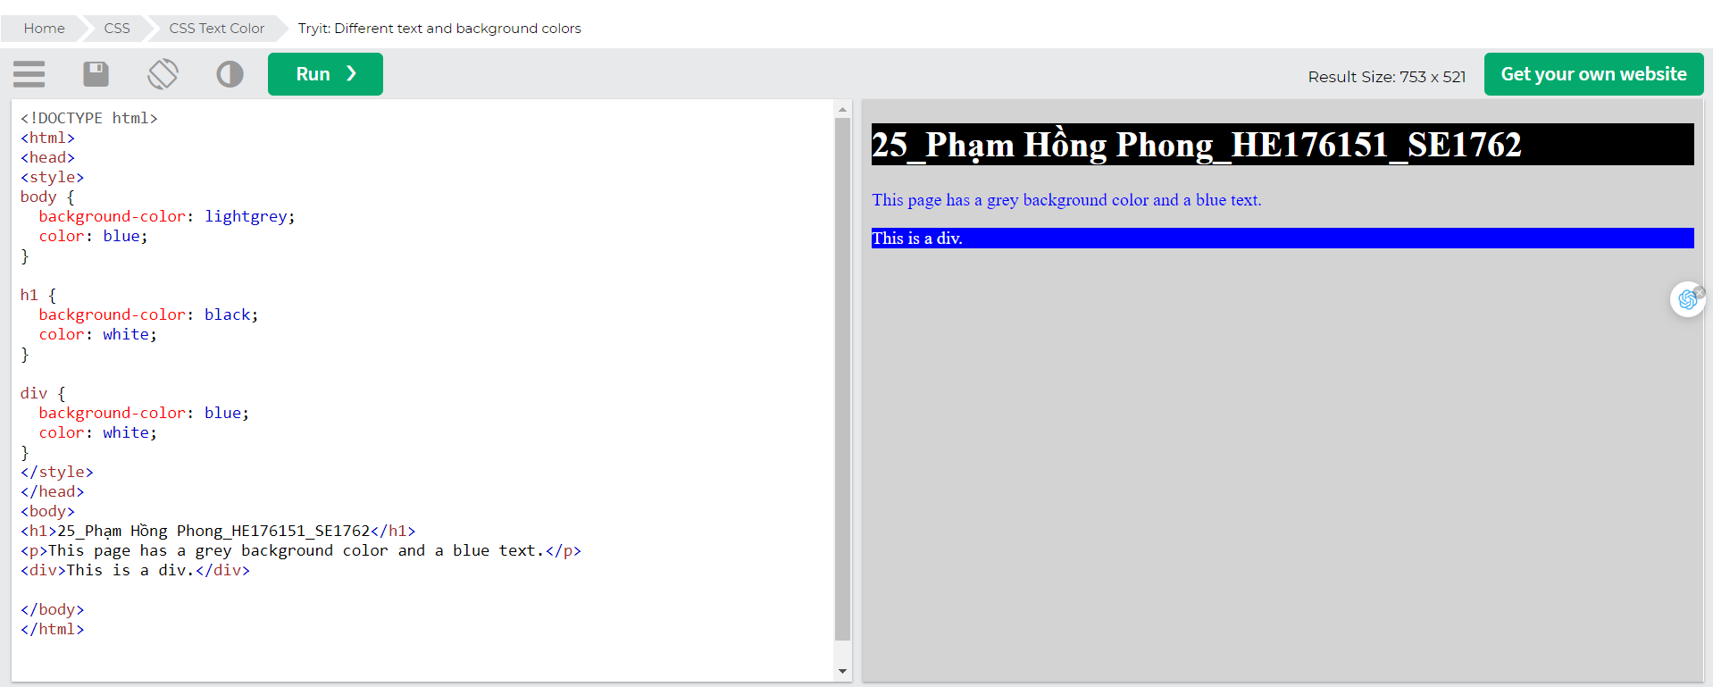

Important: High contrast is very important for people with vision problems. So, always ensure that the contrast between the text color and the background color (or background image) is good!

## Text Alignment and Text Direction

In this chapter you will learn about the following properties:

* text-align
* text-align-last
* direction
* unicode-bidi
* vertical-align

### Text Alignment

The text-align property is used to set the horizontal alignment of a text.

A text can be left or right aligned, centered, or justified.

The following example shows center aligned, and left and right aligned text (left alignment is default if text direction is left-to-right, and right alignment is default if text direction is right-to-left):

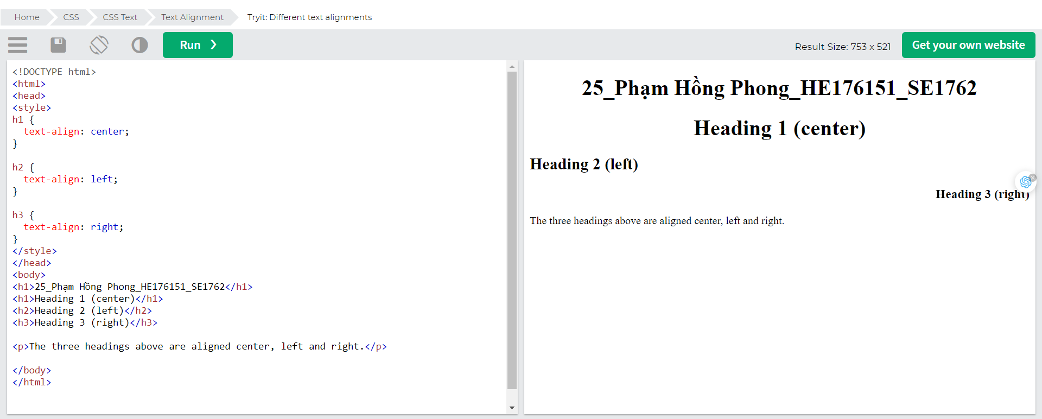When the text-align property is set to "justify", each line is stretched so that every line has equal width, and the left and right margins are straight (like in magazines and newspapers):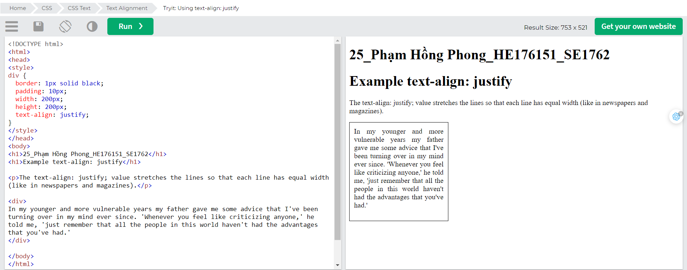

### Text Align Last

The text-align-last property specifies how to align the last line of a text.

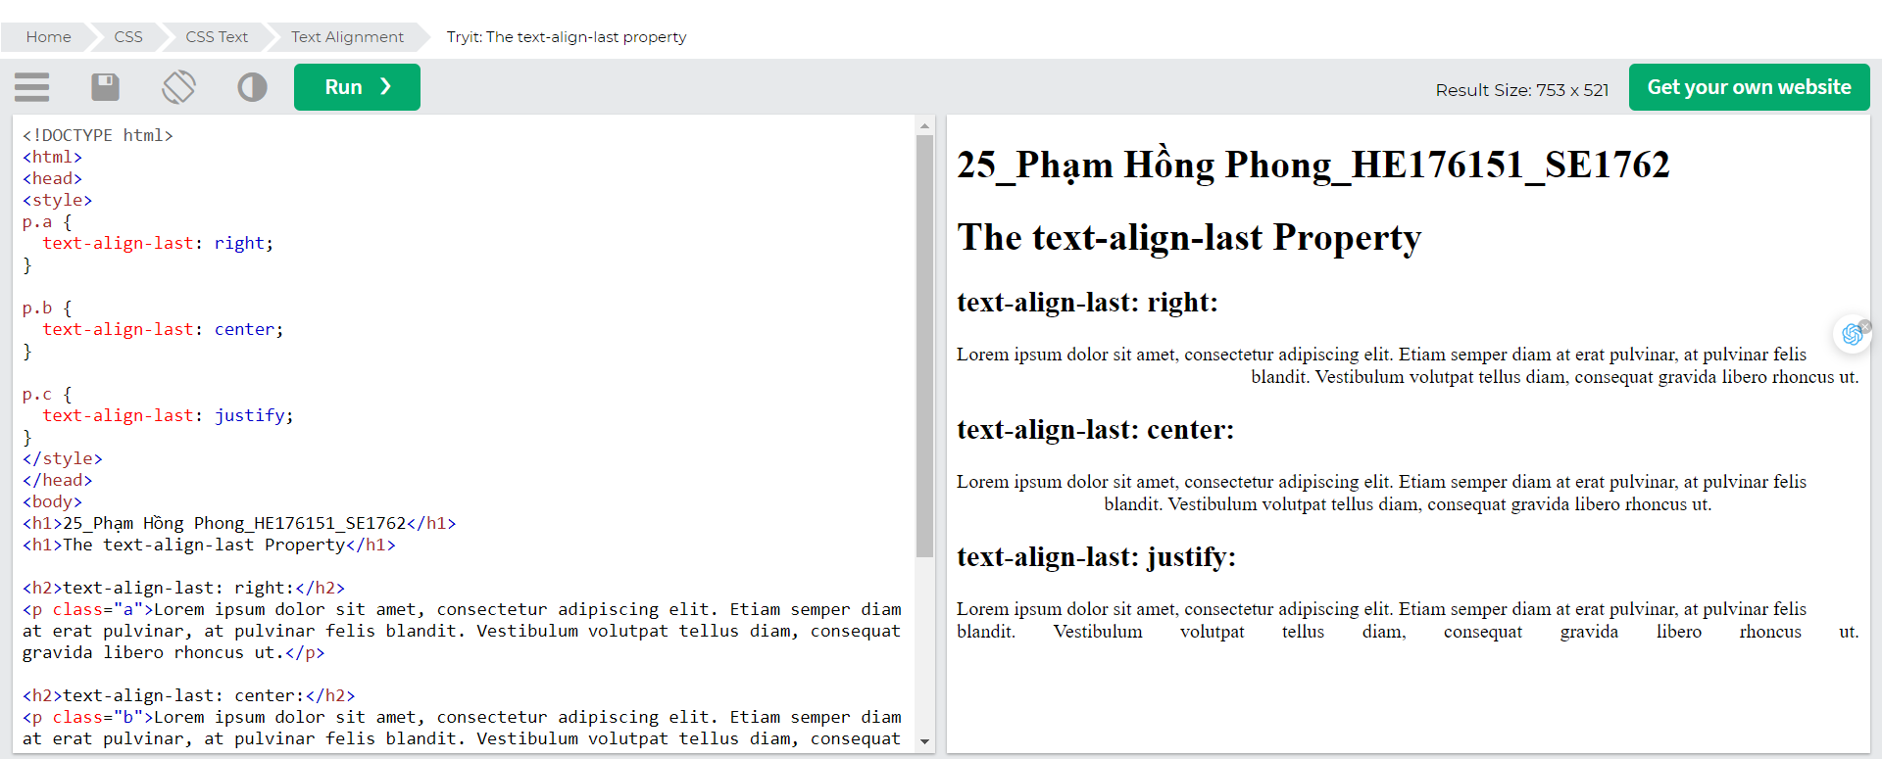

### Text Direction

The direction and unicode-bidi properties can be used to change the text direction of an element:

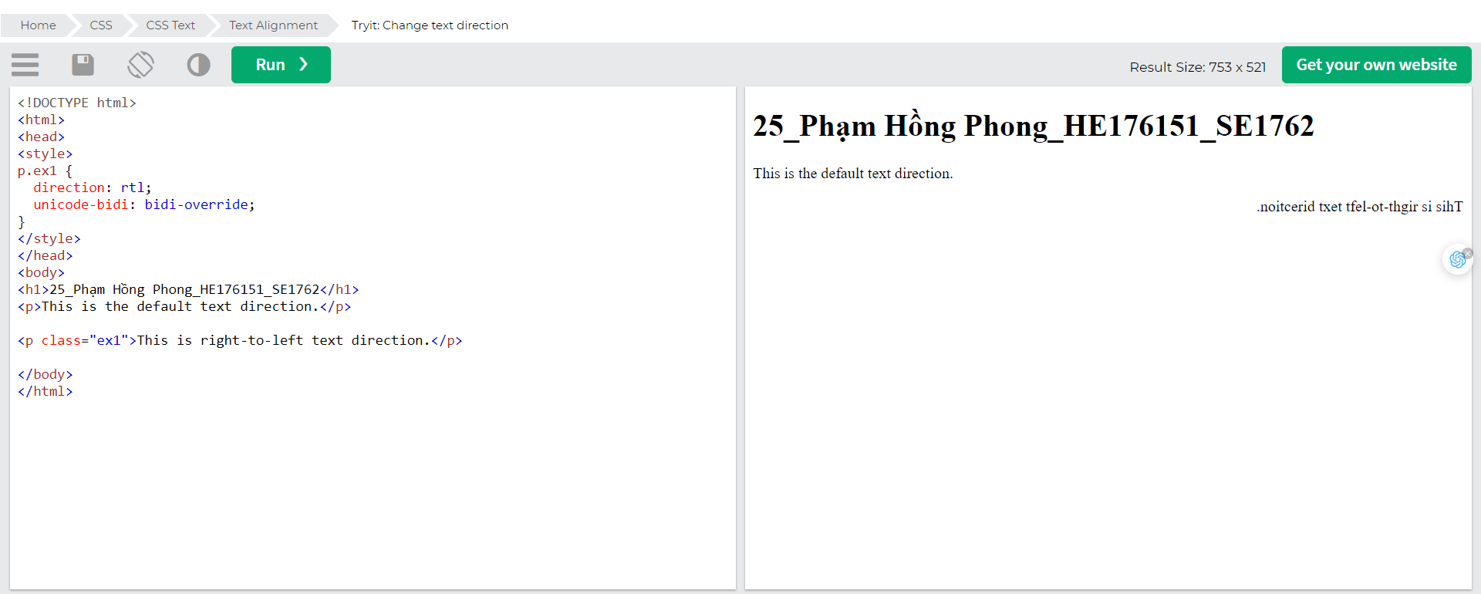

### Vertical Alignment

The vertical-align property sets the vertical alignment of an element.

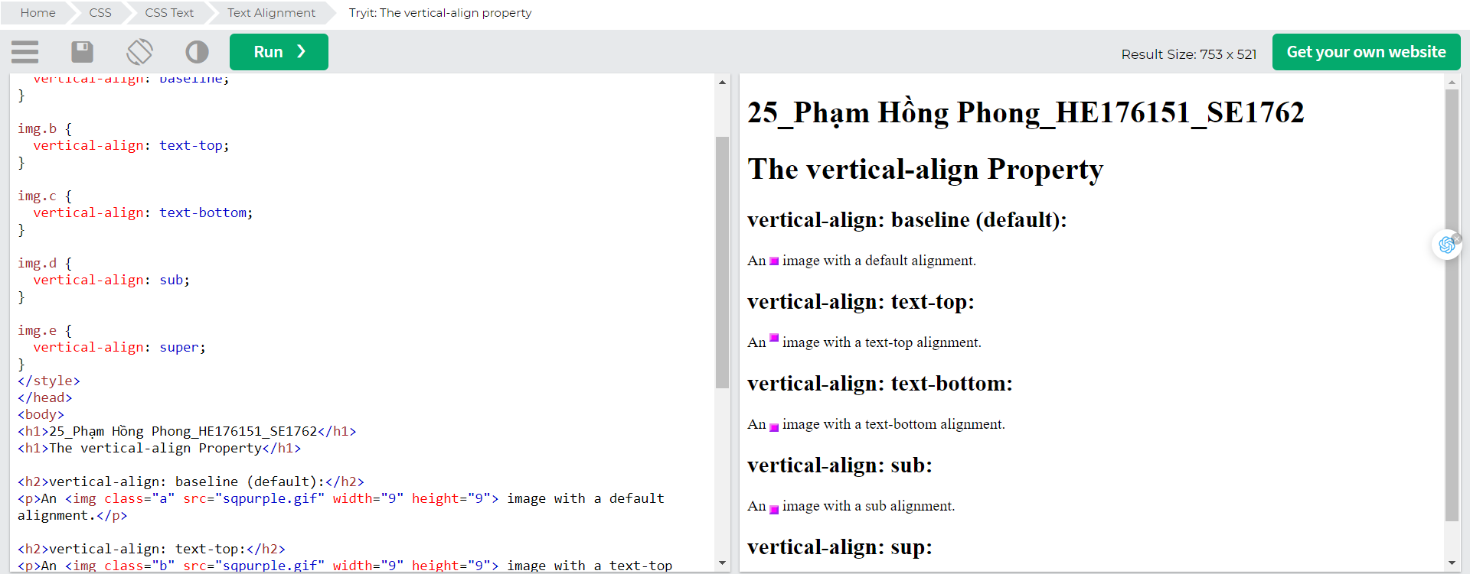

## Text Decoration

In this chapter you will learn about the following properties:

* text-decoration-line
* text-decoration-color
* text-decoration-style
* text-decoration-thickness
* text-decoration

### Add a Decoration Line to Text

The text-decoration-line property is used to add a decoration line to text.

Tip: You can combine more than one value, like overline and underline to display lines both over and under a text.

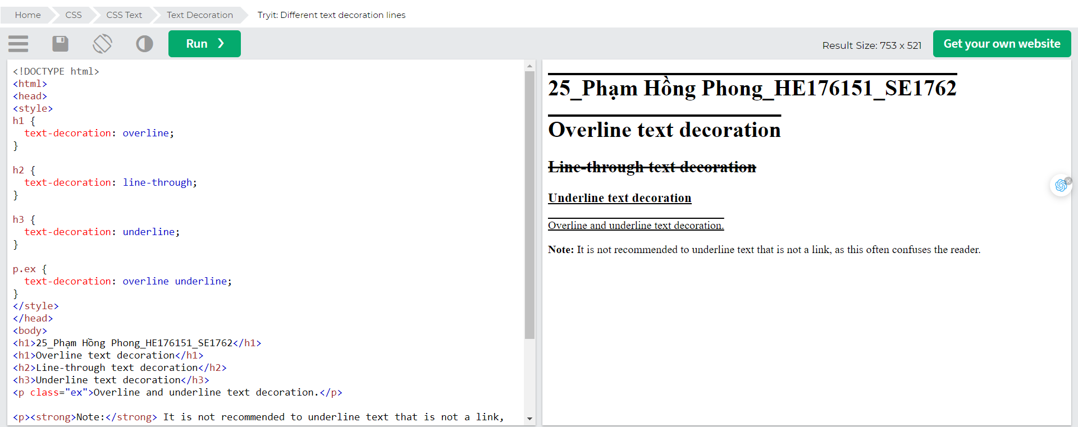

Note: It is not recommended to underline text that is not a link, as this often confuses the reader.

### Specify a Color for the Decoration Line

The text-decoration-color property is used to set the color of the decoration line.

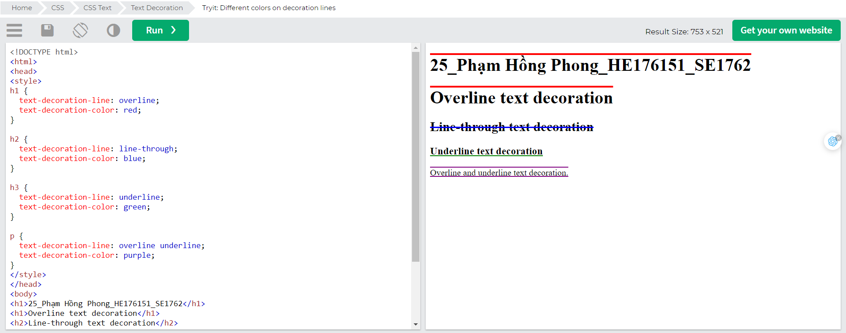

### Specify a Style for the Decoration Line

The text-decoration-style property is used to set the style of the decoration line.

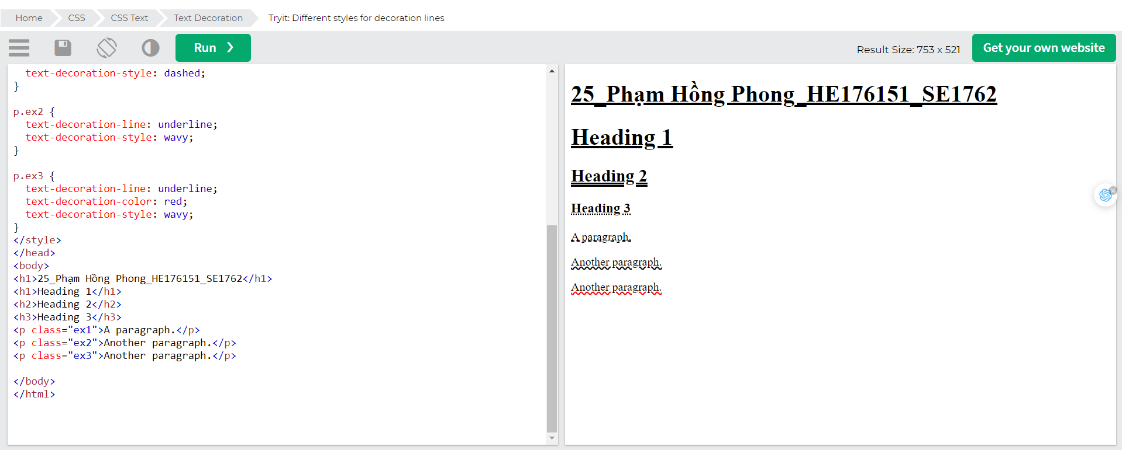

### Specify the Thickness for the Decoration Line

The text-decoration-thickness property is used to set the thickness of the decoration line.

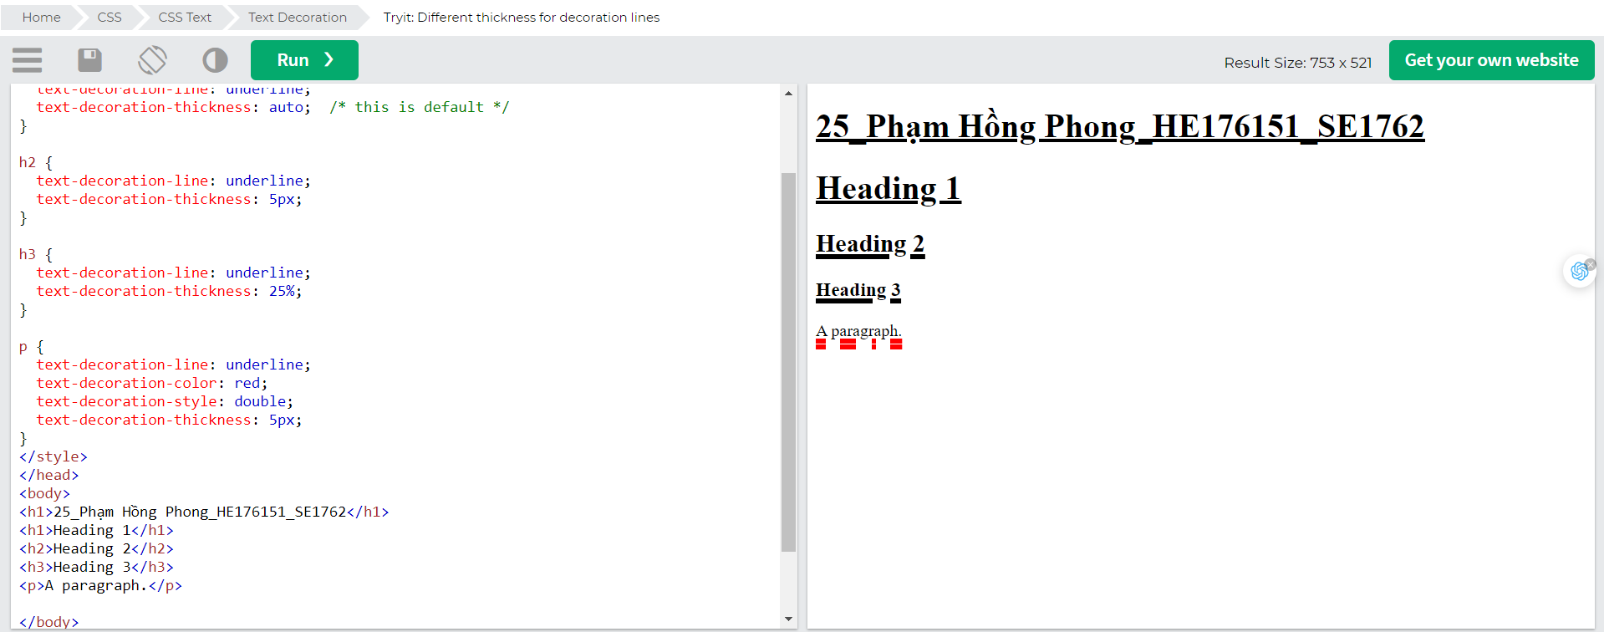

### The Shorthand Property

The text-decoration property is a shorthand property for:

* text-decoration-line (required)
* text-decoration-color (optional)
* text-decoration-style (optional)
* text-decoration-thickness (optional)

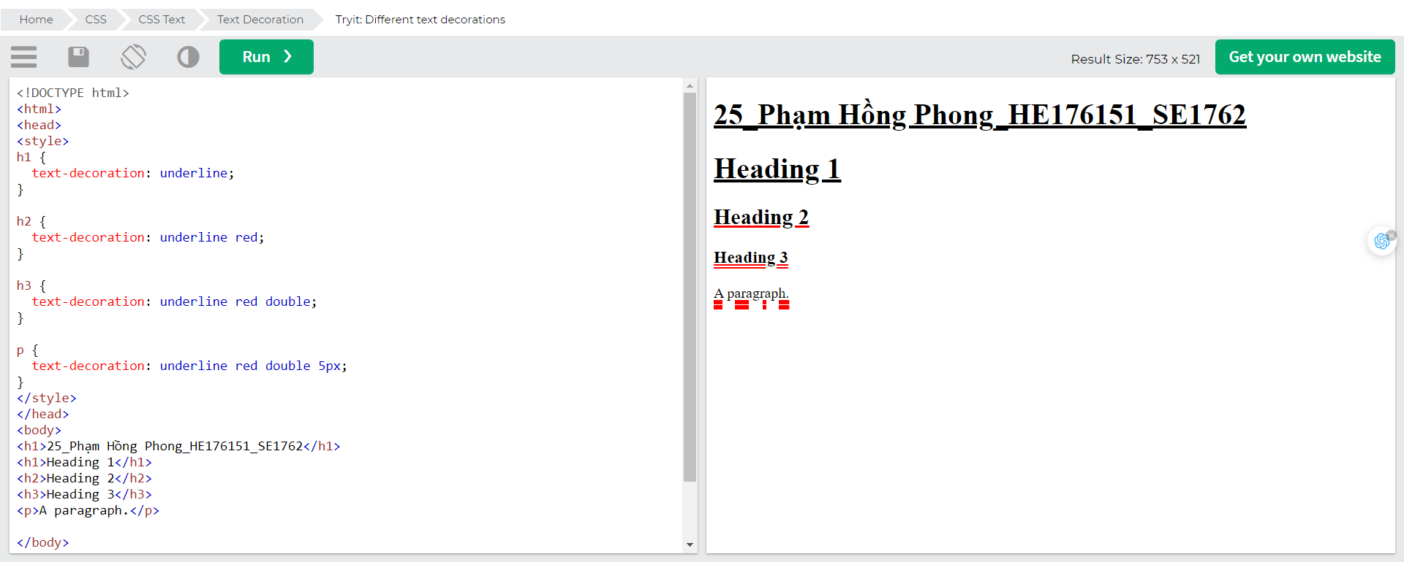

### A Small Tip

All links in HTML are underlined by default. Sometimes you see that links are styled with no underline. The text-decoration: none; is used to remove the underline from links, like this:

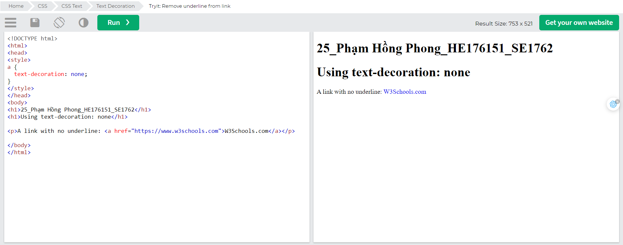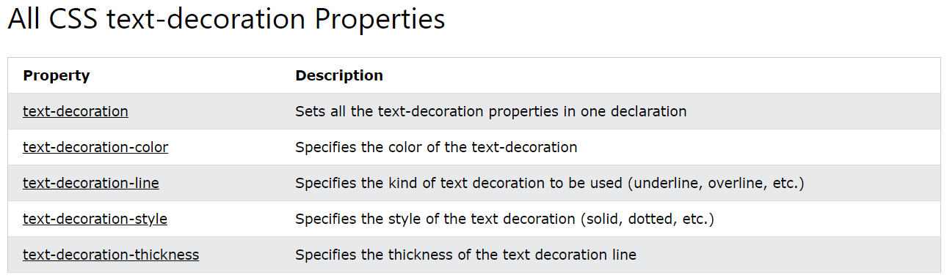

## Text Transformation

The text-transform property is used to specify uppercase and lowercase letters in a text.

It can be used to turn everything into uppercase or lowercase letters, or capitalize the first letter of each word:

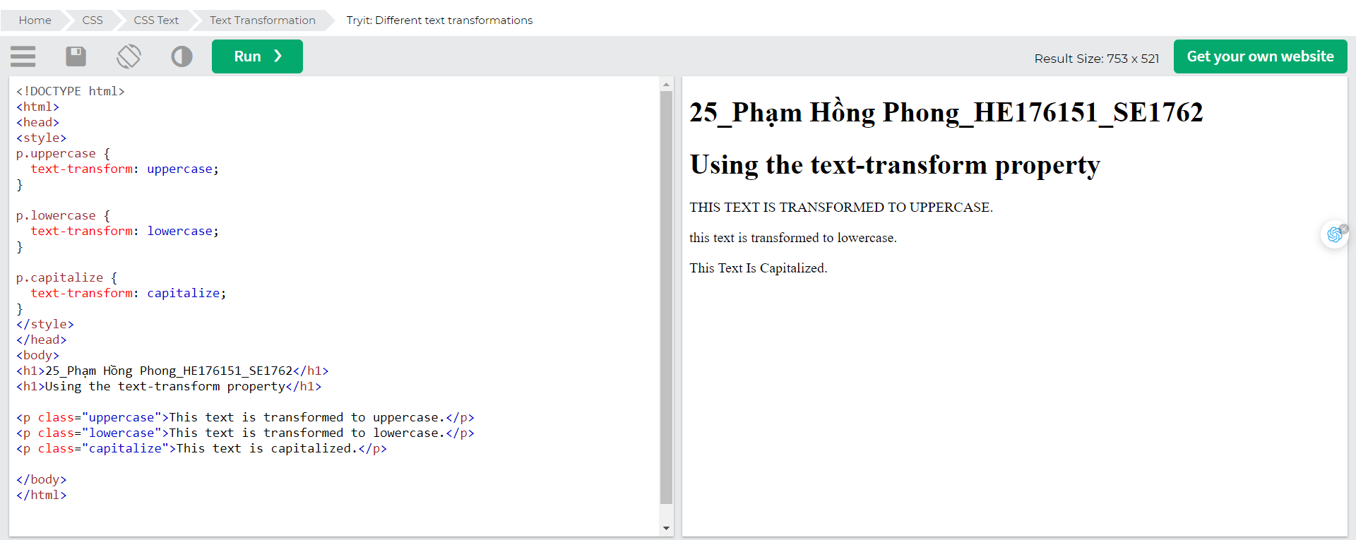

## Text Spacing

In this chapter you will learn about the following properties:

* text-indent
* letter-spacing
* line-height
* word-spacing
* White-space

### Text Indentation

The text-indent property is used to specify the indentation of the first line of a text:

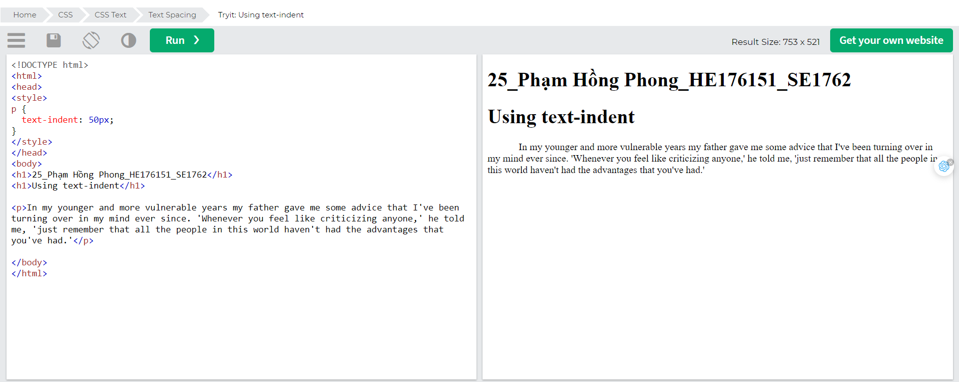

### Letter Spacing

The letter-spacing property is used to specify the space between the characters in a text.

The following example demonstrates how to increase or decrease the space between characters:

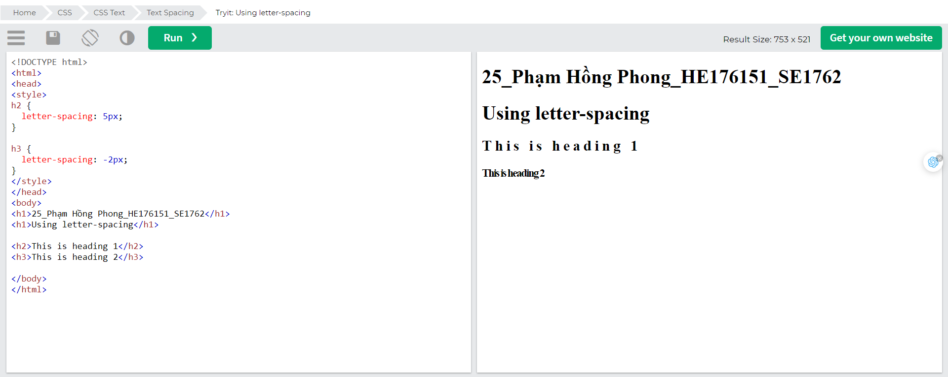

### Line Height

The line-height property is used to specify the space between lines:

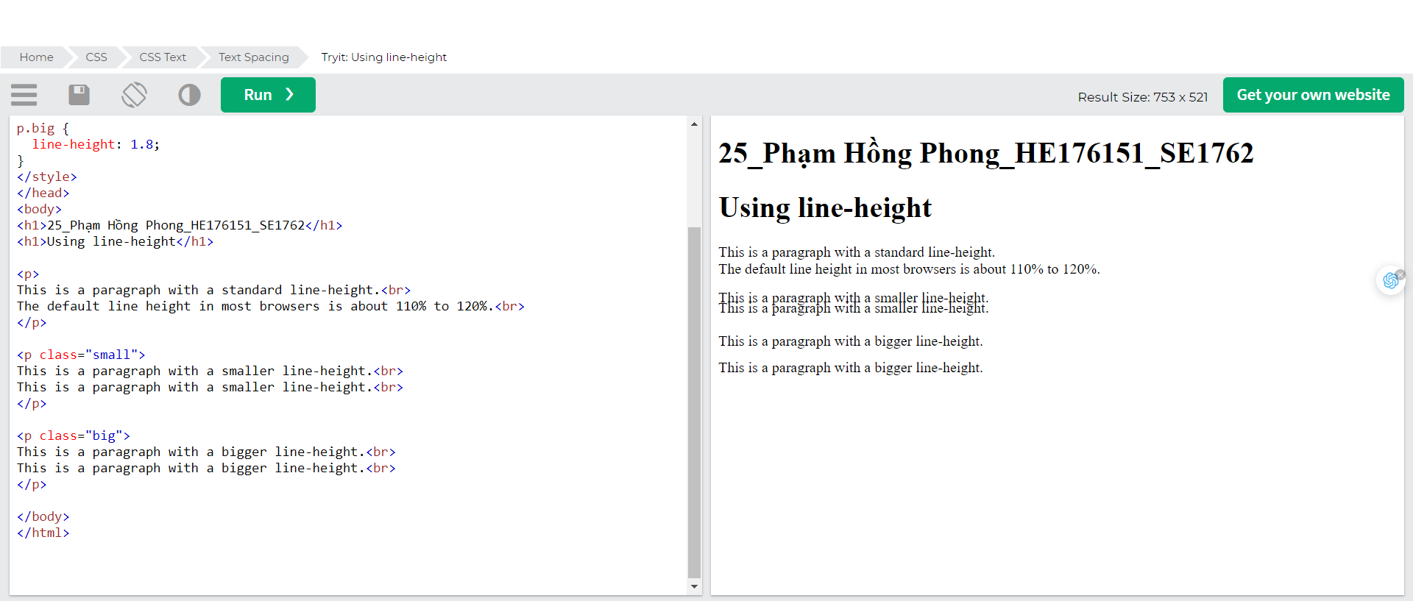

### Word Spacing

The word-spacing property is used to specify the space between the words in a text.

The following example demonstrates how to increase or decrease the space between words:

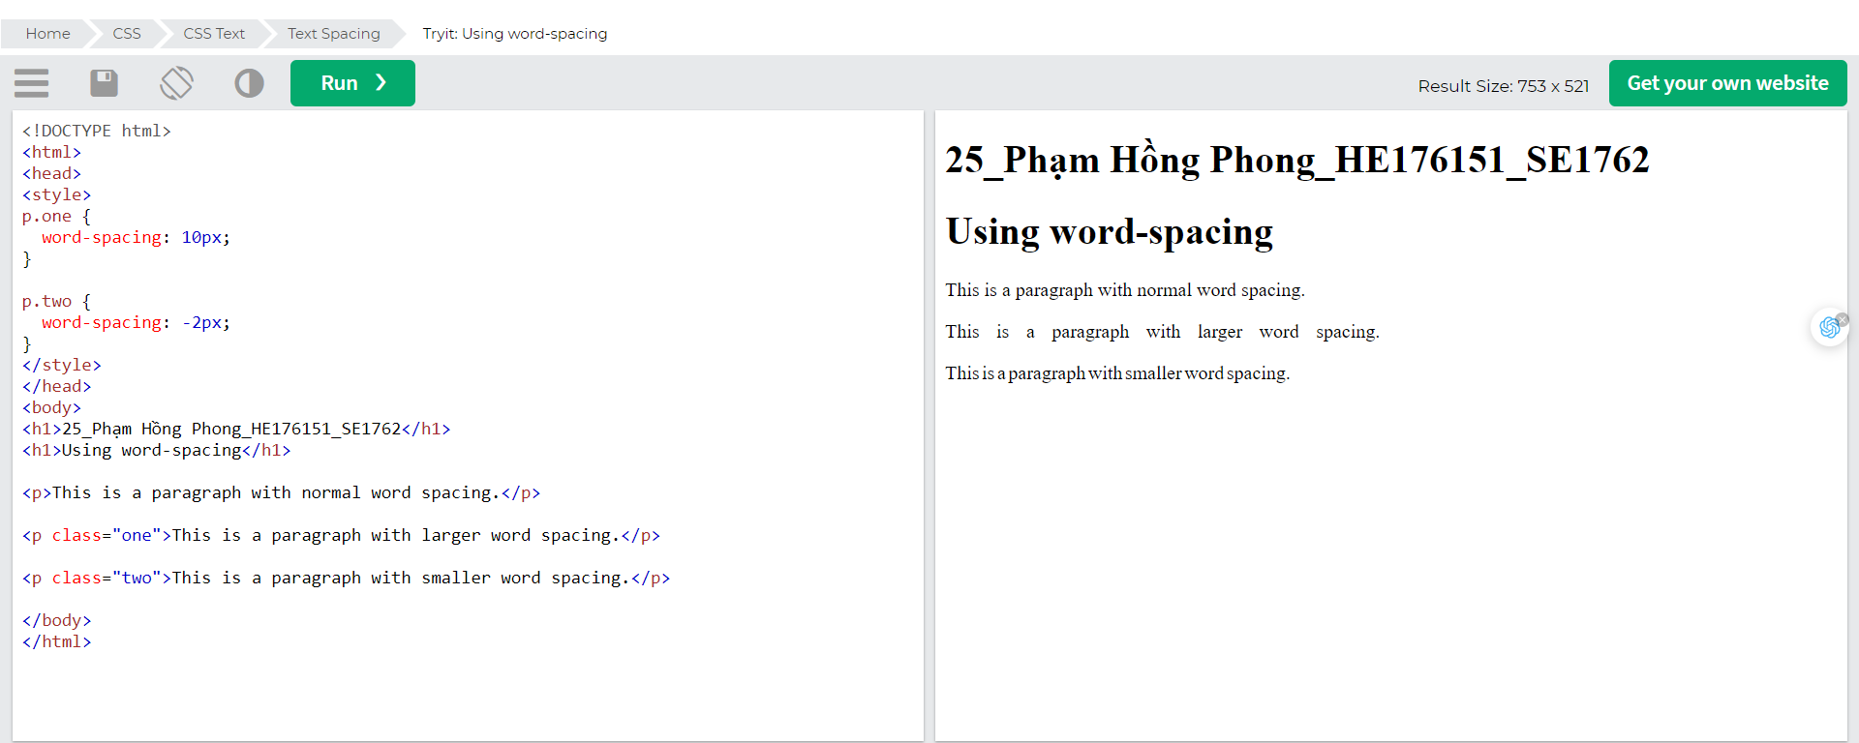

### White Space

The white-space property specifies how white-space inside an element is handled.

This example demonstrates how to disable text wrapping inside an element:

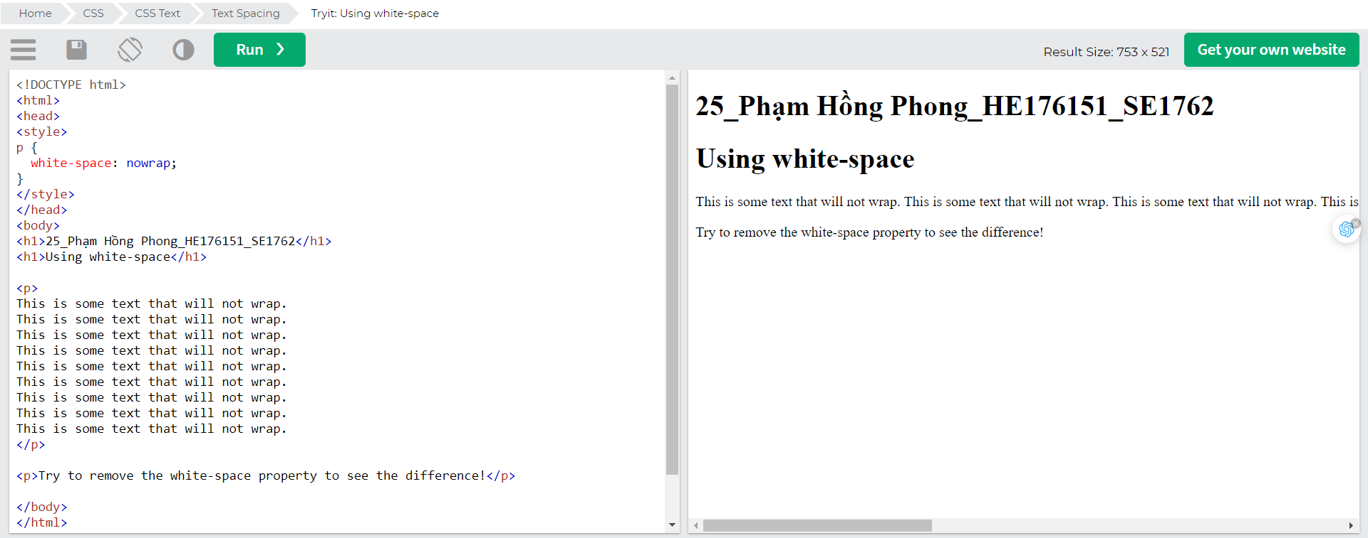

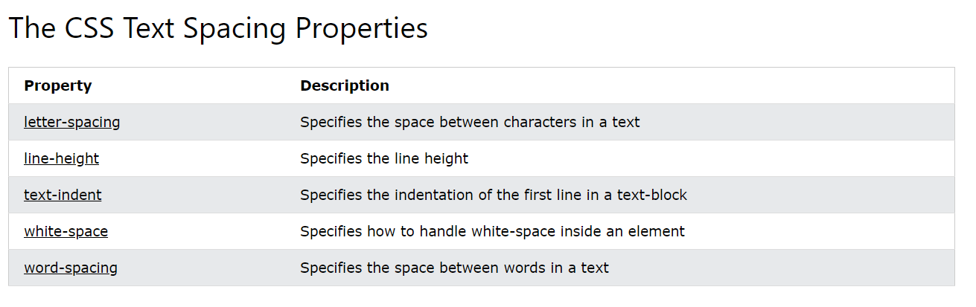

## Text Shadow

The text-shadow property adds shadow to text.

In its simplest use, you only specify the horizontal shadow (2px) and the vertical shadow (2px):

### Text shadow effect!

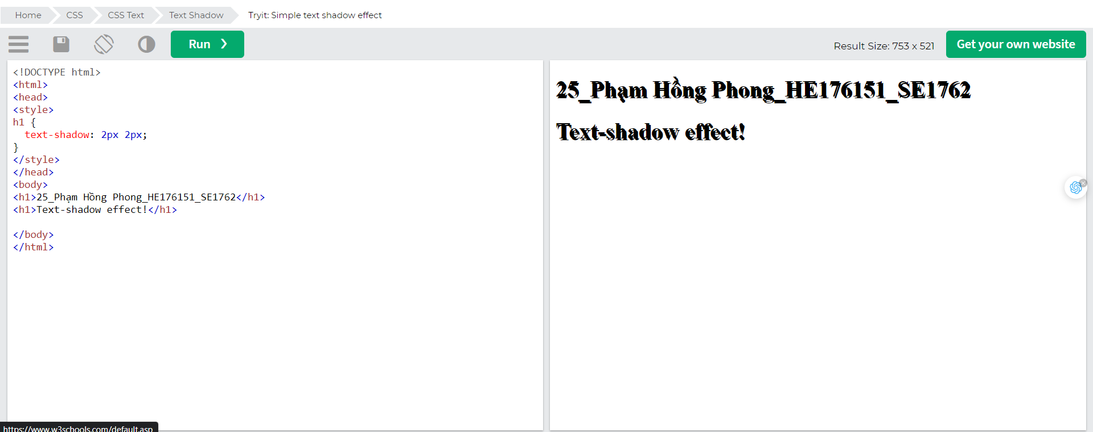

Next, add a color (red) to the shadow:

### Text shadow effect!

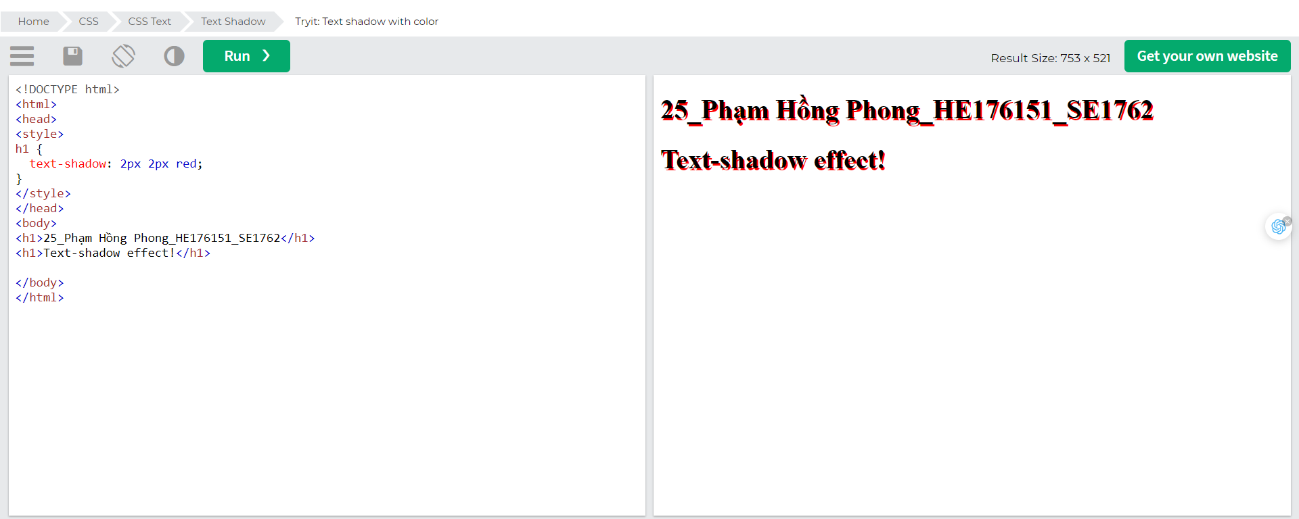

Then, add a blur effect (5px) to the shadow:

### Text shadow effect!

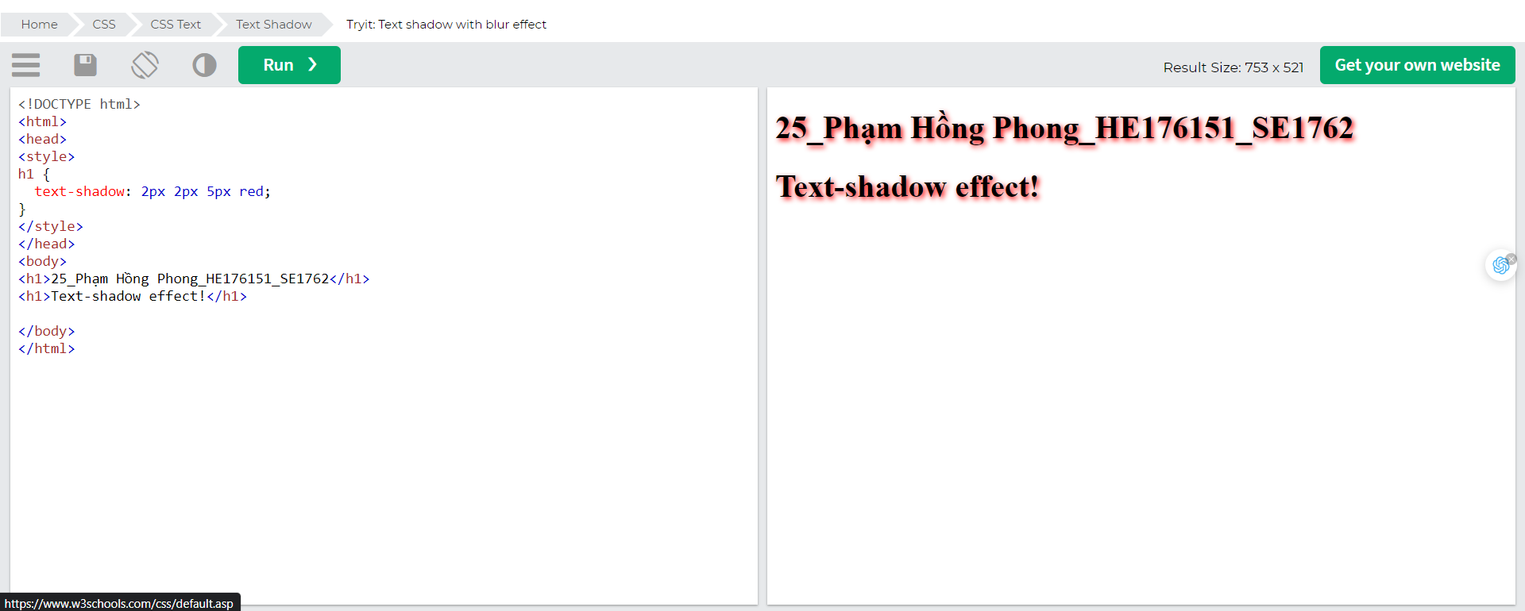

### More Text Shadow Examples

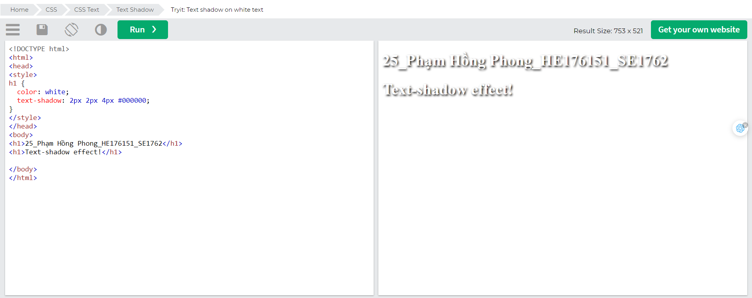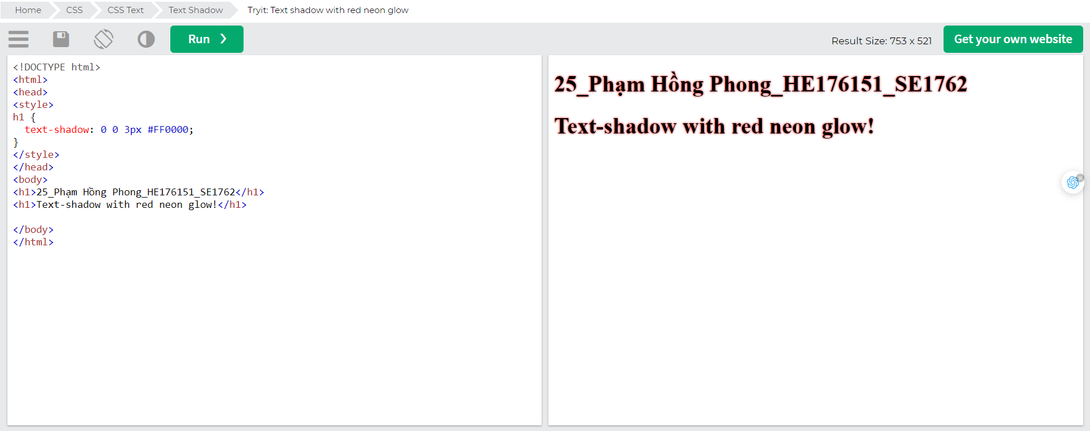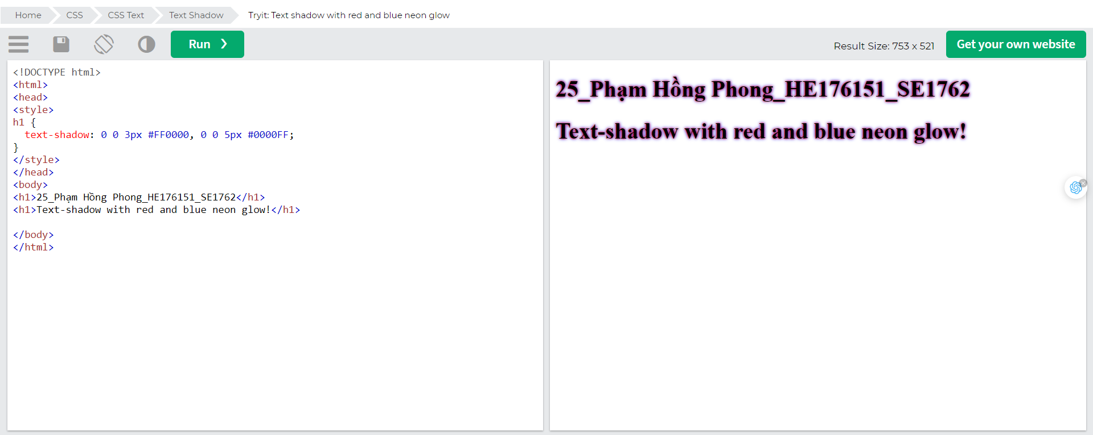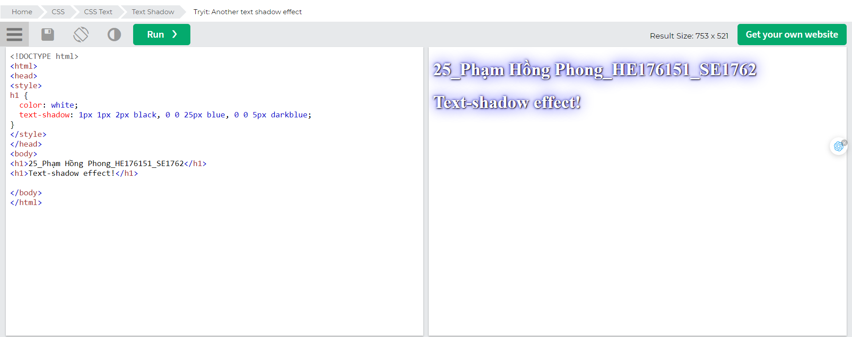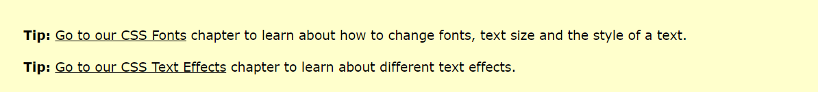

# CSS Fonts

Choosing the right font for your website is important!

Font Selection is Important

Choosing the right font has a huge impact on how the readers experience a website.

The right font can create a strong identity for your brand.

Using a font that is easy to read is important. The font adds value to your text. It is also important to choose the correct color and text size for the font.

## Generic Font Families

In CSS there are five generic font families:

1. Serif fonts have a small stroke at the edges of each letter. They create a sense of formality and elegance.
2. Sans-serif fonts have clean lines (no small strokes attached). They create a modern and minimalistic look.
3. Monospace fonts - here all the letters have the same fixed width. They create a mechanical look.
4. Cursive fonts imitate human handwriting.
5. Fantasy fonts are decorative/playful fonts.

All the different font names belong to one of the generic font families.

### Difference Between Serif and Sans-serif Fonts

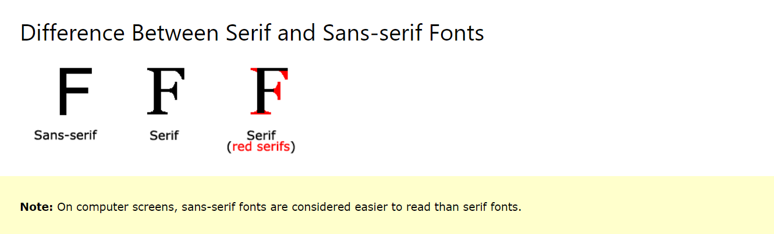

### Some Font Examples

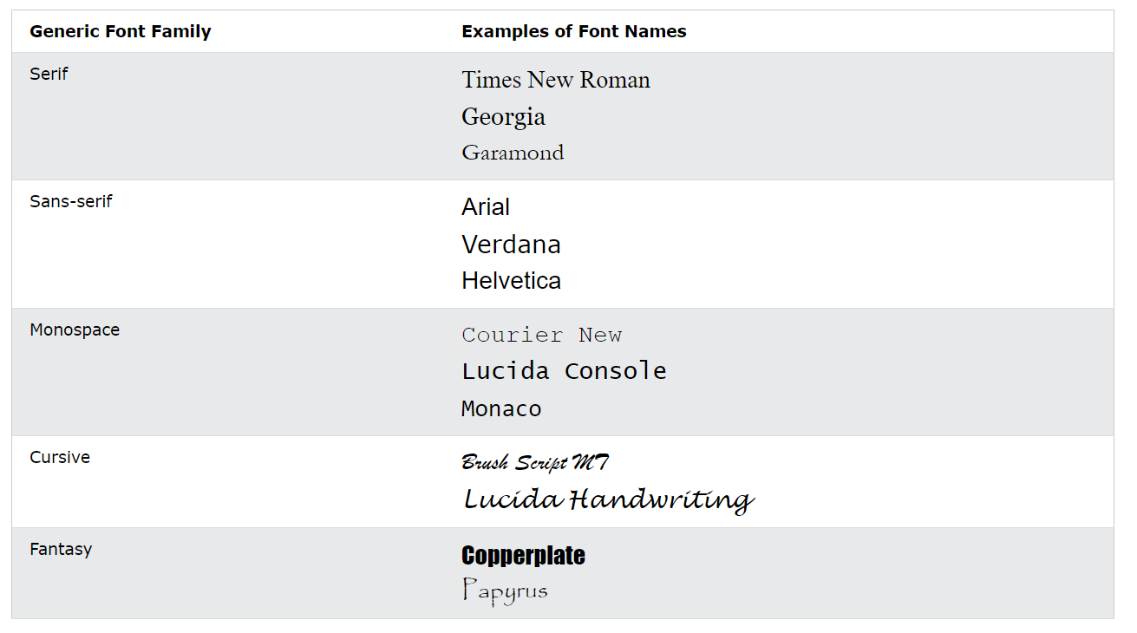

### The CSS font-family Property

In CSS, we use the font-family property to specify the font of a text.

Note: If the font name is more than one word, it must be in quotation marks, like: "Times New Roman".

Tip: The font-family property should hold several font names as a "fallback" system, to ensure maximum compatibility between browsers/operating systems. Start with the font you want, and end with a generic family (to let the browser pick a similar font in the generic family, if no other fonts are available). The font names should be separated with comma. Read more about fallback fonts in the [next chapter](https://www.w3schools.com/css/css_font_websafe.asp).

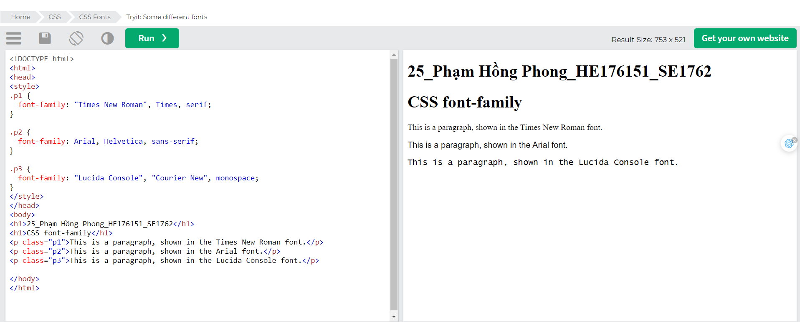

## Web Safe Fonts

### What are Web Safe Fonts?

Web safe fonts are fonts that are universally installed across all browsers and devices.

### Fallback Fonts

However, there are no 100% completely web safe fonts. There is always a chance that a font is not found or is not installed properly.

Therefore, it is very important to always use fallback fonts.

This means that you should add a list of similar "backup fonts" in the font-family property. If the first font does not work, the browser will try the next one, and the next one, and so on. Always end the list with a generic font family name.

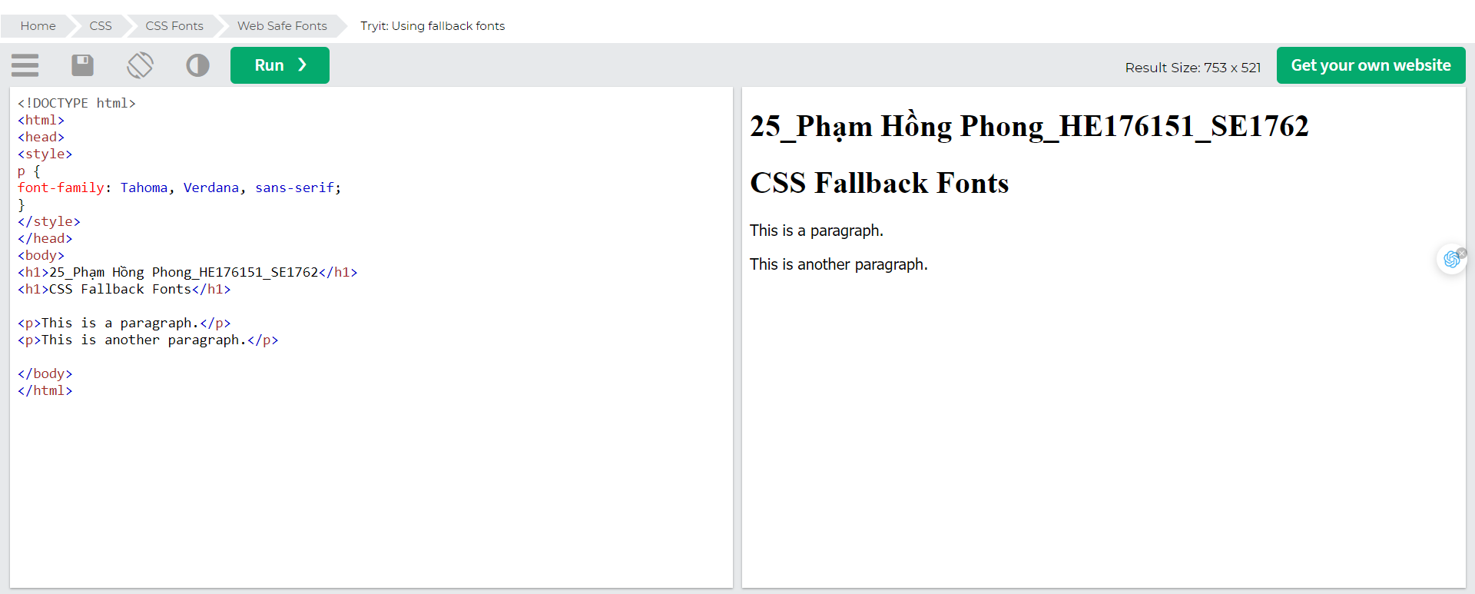

### Best Web Safe Fonts for HTML and CSS

The following list are the best web safe fonts for HTML and CSS:

* Arial (sans-serif)
* Verdana (sans-serif)
* Tahoma (sans-serif)
* Trebuchet MS (sans-serif)
* Times New Roman (serif)
* Georgia (serif)
* Garamond (serif)
* Courier New (monospace)
* Brush Script MT (cursive)

Note: Before you publish your website, always check how your fonts appear on different browsers and devices, and always use [fallback fonts](https://www.w3schools.com/css/css_font_fallbacks.asp)!

### Arial (sans-serif)

Arial is the most widely used font for both online and printed media. Arial is also the default font in Google Docs.

Arial is one of the safest web fonts, and it is available on all major operating systems.

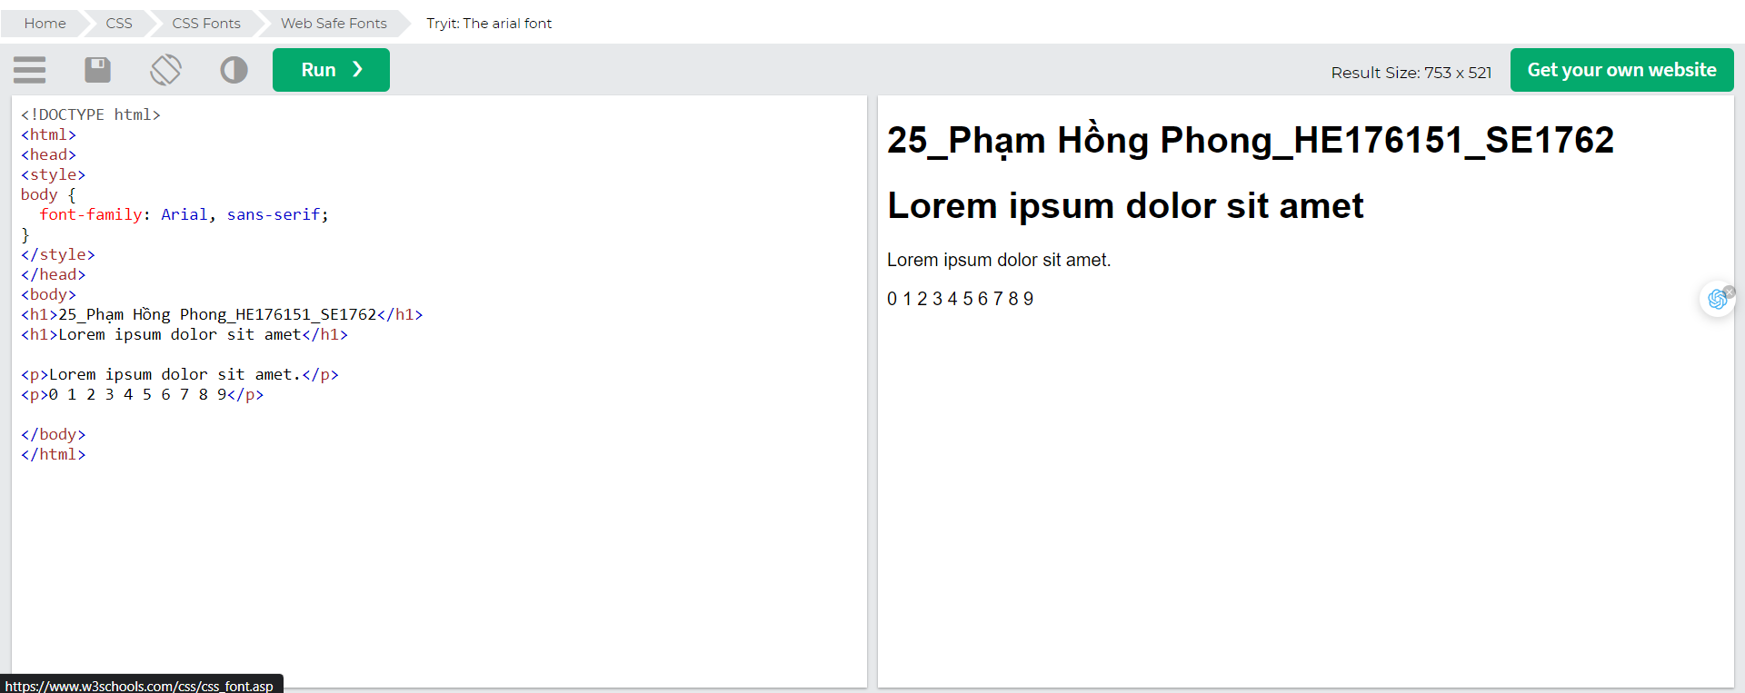

### Verdana (sans-serif)

Verdana is a very popular font. Verdana is easily readable even for small font sizes.

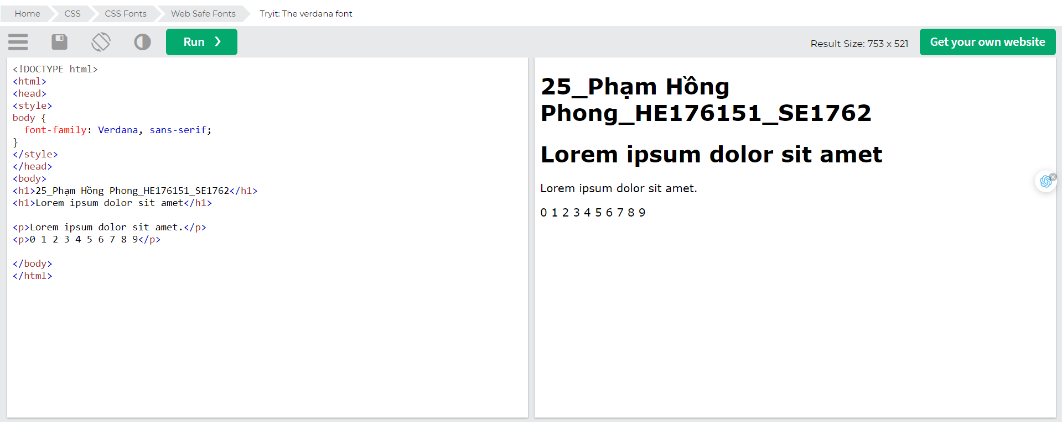

### Tahoma (sans-serif)

The Tahoma font has less space between the characters.

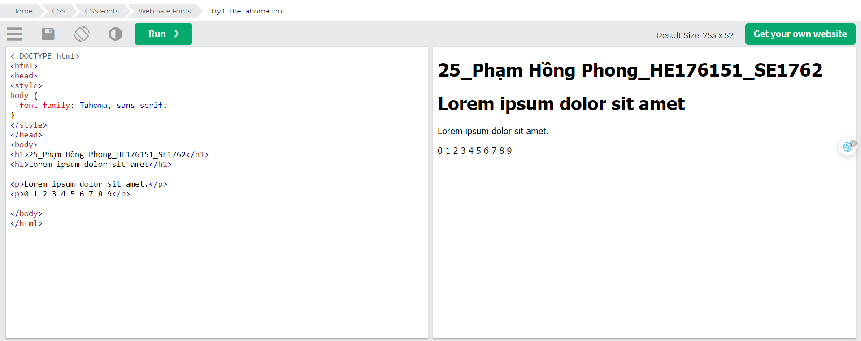

### Trebuchet MS (sans-serif)

Trebuchet MS was designed by Microsoft in 1996. Use this font carefully. Not supported by all mobile operating systems.

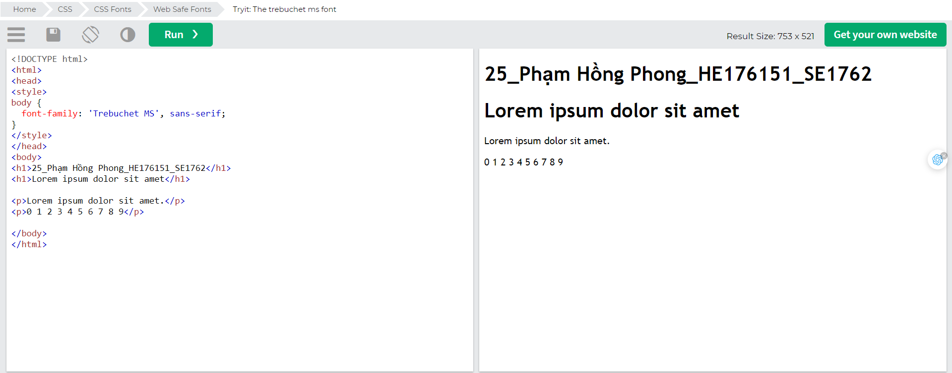

### Times New Roman (serif)

Times New Roman is one of the most recognizable fonts in the world. It looks professional and is used in many newspapers and "news" websites. It is also the primary font for Windows devices and applications.

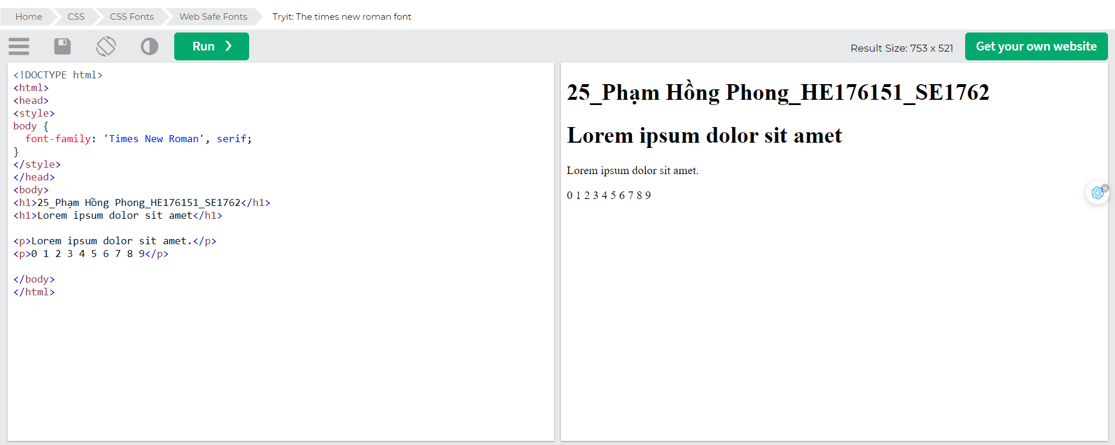

### Georgia (serif)

Georgia is an elegant serif font. It is very readable at different font sizes, so it is a good candidate for mobile-responsive design.

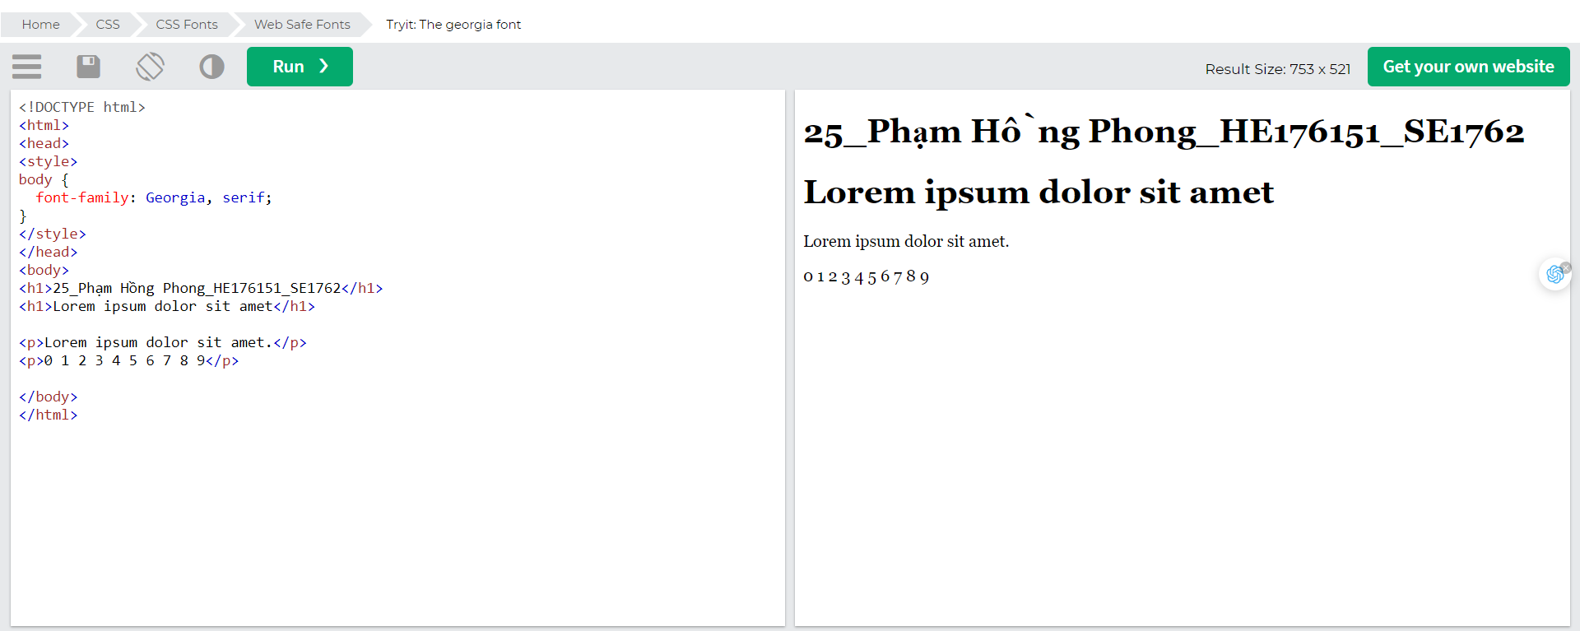

### Garamond (serif)

Garamond is a classical font used for many printed books. It has a timeless look and good readability.

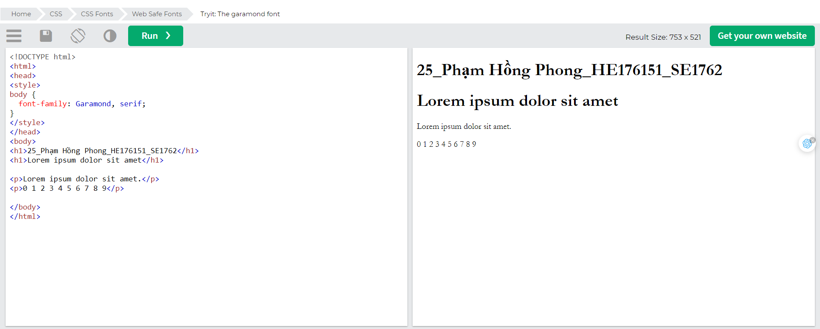

### Courier New (monospace)

Courier New is the most widely used monospace serif font. Courier New is often used with coding displays, and many email providers use it as their default font. Courier New is also the standard font for movie screenplays.

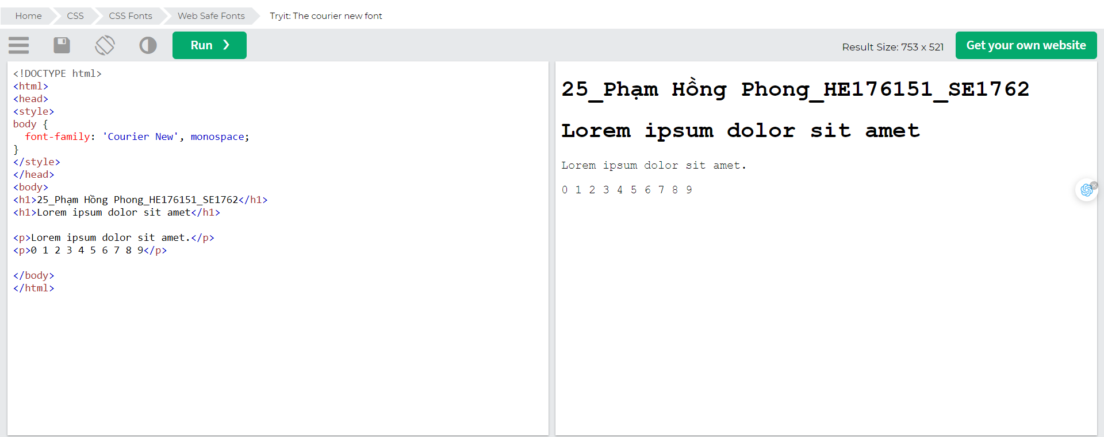

### Brush Script MT (cursive)

The Brush Script MT font was designed to mimic handwriting. It is elegant and sophisticated, but can be hard to read. Use it carefully.

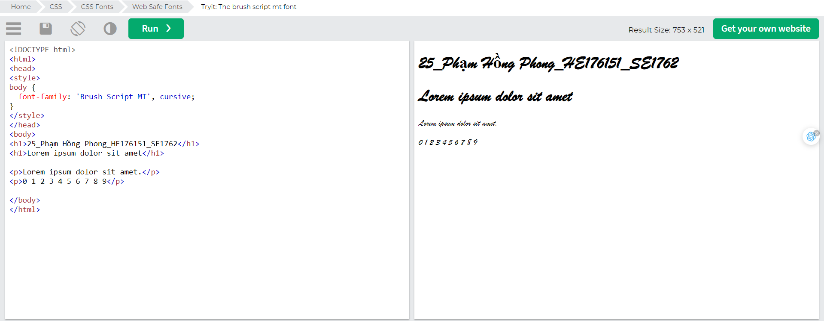

## Font Fallbacks

### Commonly Used Font Fallbacks

Below are some commonly used font fallbacks, organized by the 5 generic font families:

* Serif
* Sans-serif
* Monospace
* Cursive
* Fantasy

### Serif Fonts

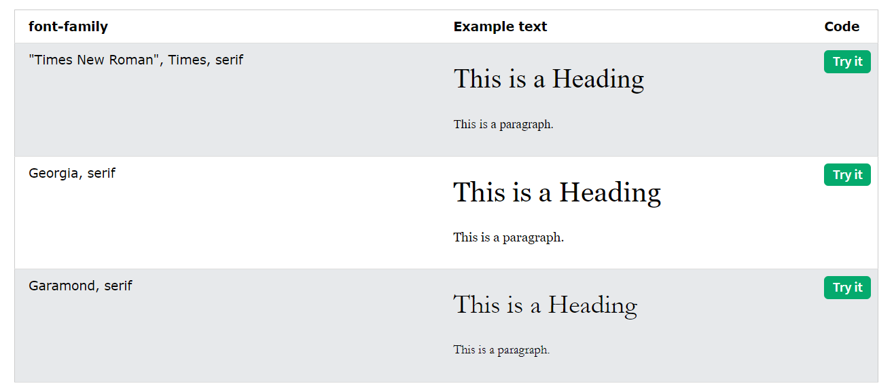

### Sans-Serif Fonts

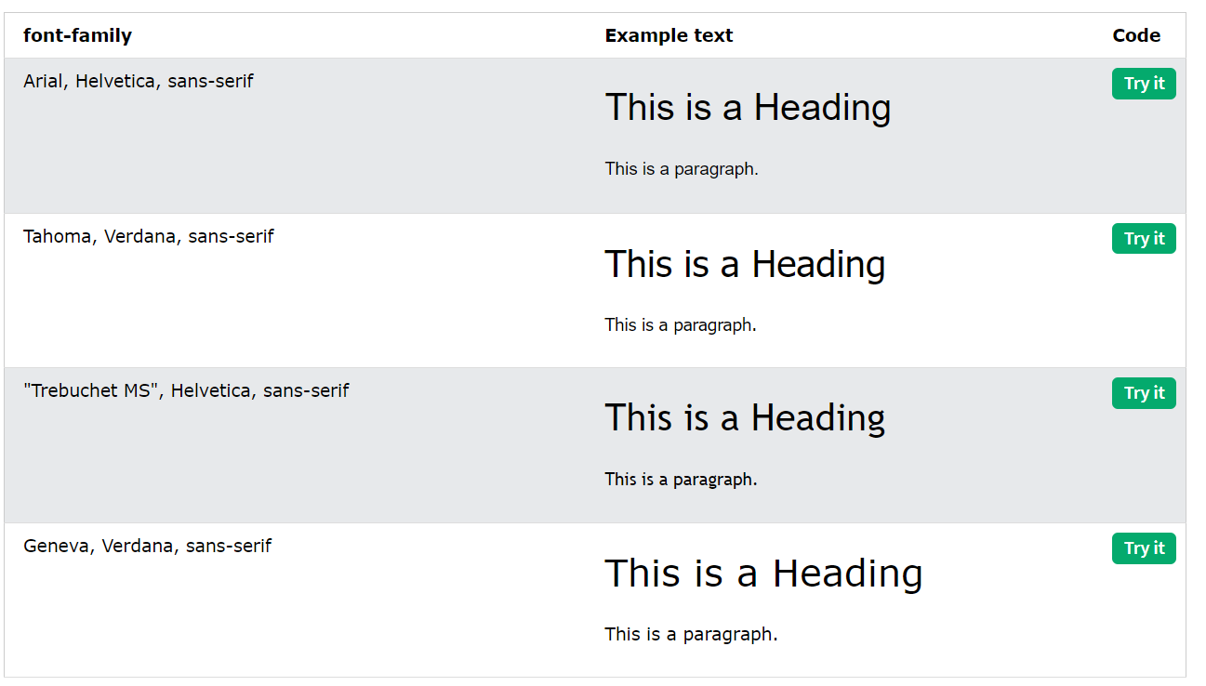

### Monospace Fonts

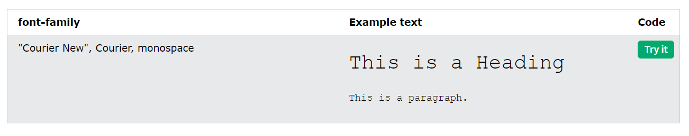

### Cursive Fonts

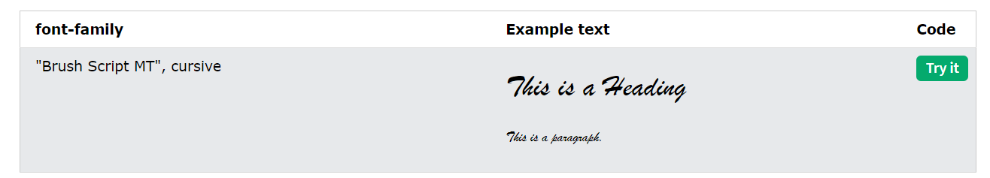

### Fantasy Fonts

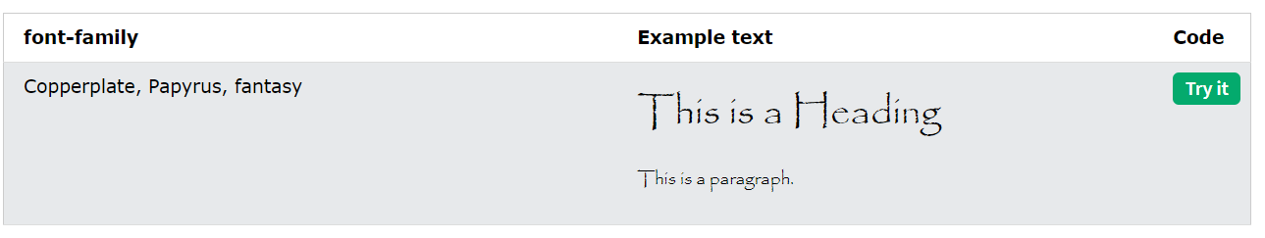

## Font Style

The font-style property is mostly used to specify italic text.

This property has three values:

* normal - The text is shown normally
* italic - The text is shown in italics
* oblique - The text is "leaning" (oblique is very similar to italic, but less supported)

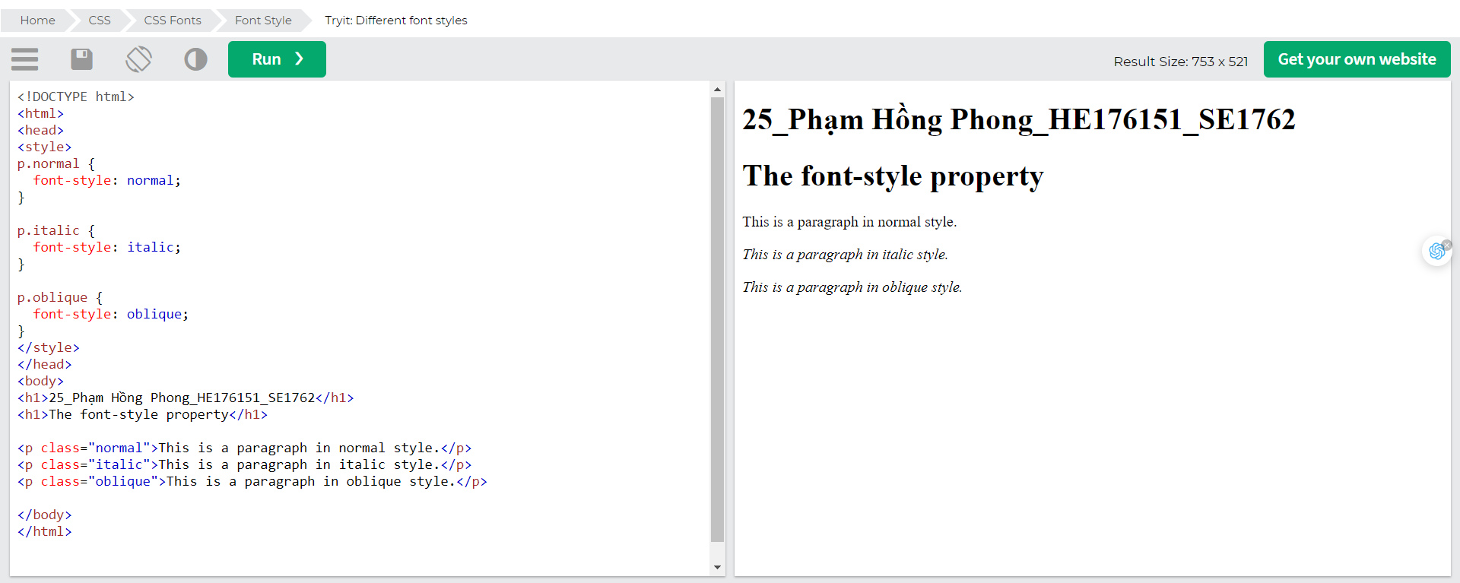

### Font Weight

The font-weight property specifies the weight of a font:

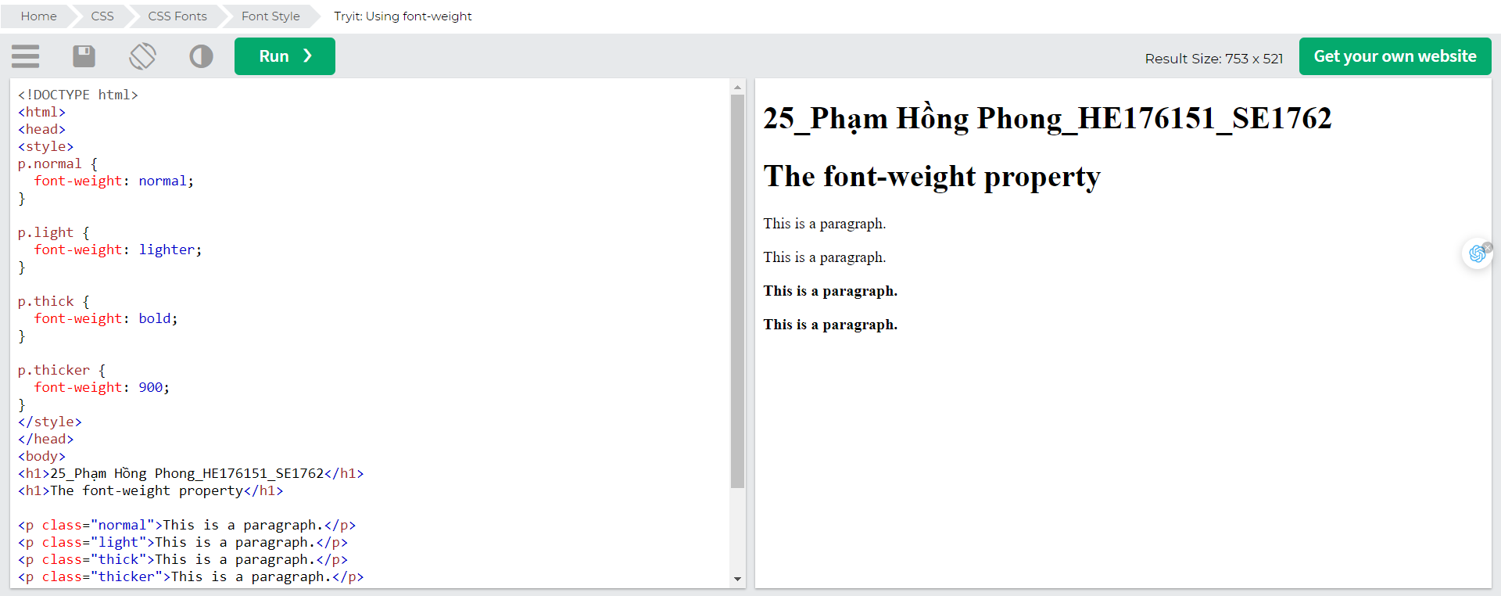

### Font Variant

The font-variant property specifies whether or not a text should be displayed in a small-caps font.

In a small-caps font, all lowercase letters are converted to uppercase letters. However, the converted uppercase letters appear in a smaller font size than the original uppercase letters in the text.

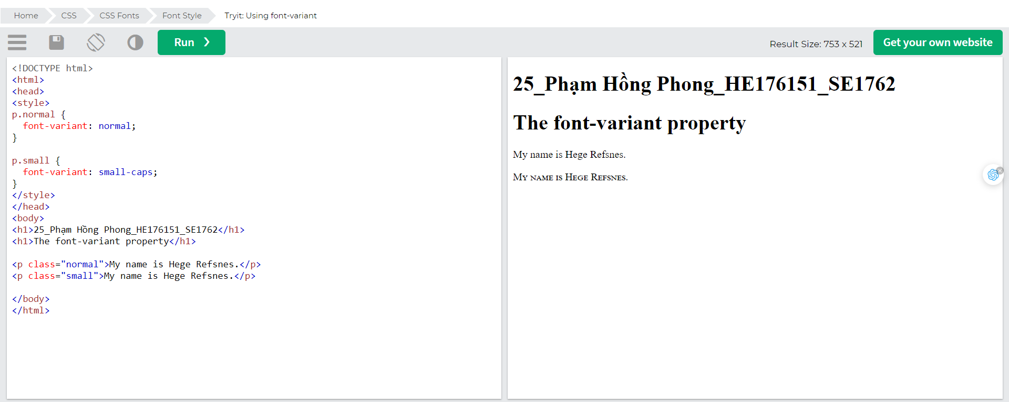

## Font Size

The font-size property sets the size of the text.

Being able to manage the text size is important in web design. However, you should not use font size adjustments to make paragraphs look like headings, or headings look like paragraphs.

Always use the proper HTML tags, like <h1> - <h6> for headings and <p> for paragraphs.

The font-size value can be an absolute, or relative size.

Absolute size:

* Sets the text to a specified size
* Does not allow a user to change the text size in all browsers (bad for accessibility reasons)
* Absolute size is useful when the physical size of the output is known

Relative size:

* Sets the size relative to surrounding elements
* Allows a user to change the text size in browsers

Note: If you do not specify a font size, the default size for normal text, like paragraphs, is 16px (16px=1em).

### Set Font Size With Pixels

Setting the text size with pixels gives you full control over the text size:

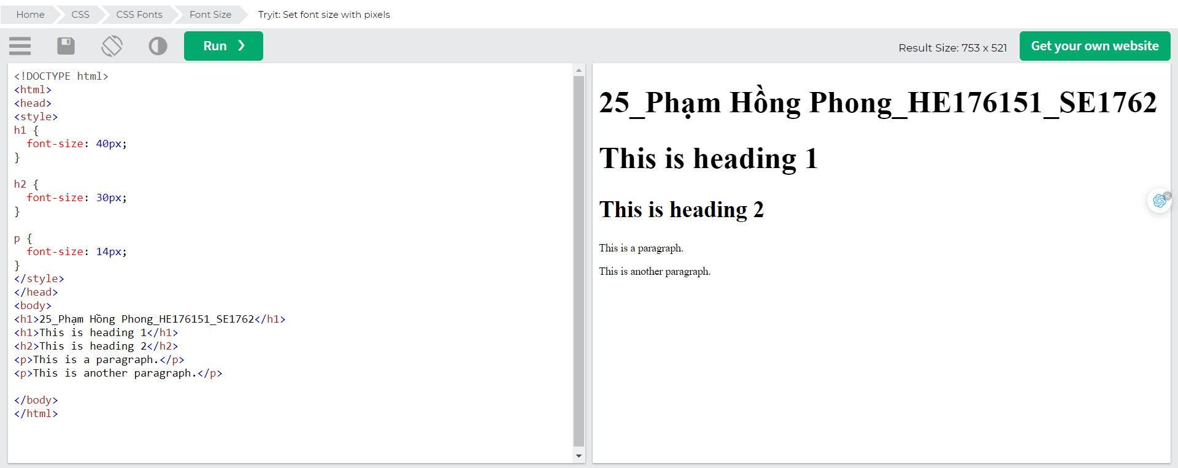

Tip: If you use pixels, you can still use the zoom tool to resize the entire page.

### Set Font Size With Em

To allow users to resize the text (in the browser menu), many developers use em instead of pixels.

1em is equal to the current font size. The default text size in browsers is 16px. So, the default size of 1em is 16px.

The size can be calculated from pixels to em using this formula: *pixels*/16=*em*

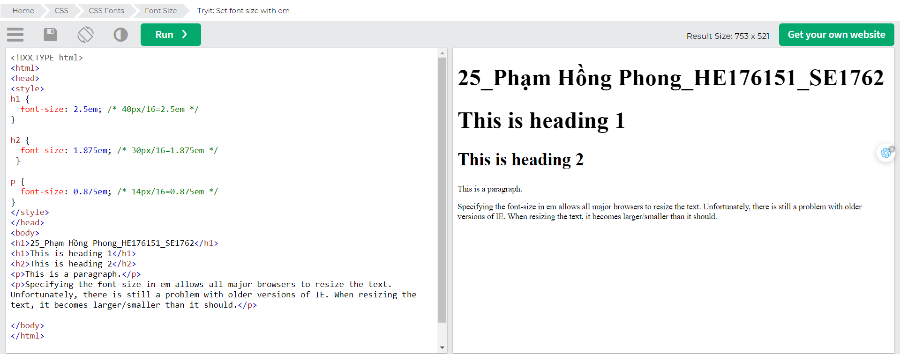

In the example above, the text size in em is the same as the previous example in pixels. However, with the em size, it is possible to adjust the text size in all browsers.

Unfortunately, there is still a problem with older versions of Internet Explorer. The text becomes larger than it should when made larger, and smaller than it should when made smaller.

### Use a Combination of Percent and Em

The solution that works in all browsers, is to set a default font-size in percent for the <body> element:

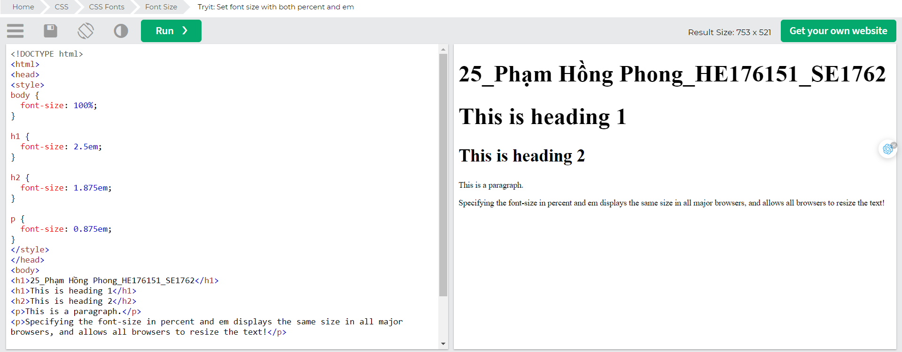

Our code now works great! It shows the same text size in all browsers, and allows all browsers to zoom or resize the text!

### Responsive Font Size

The text size can be set with a vw unit, which means the "viewport width".

That way the text size will follow the size of the browser window:

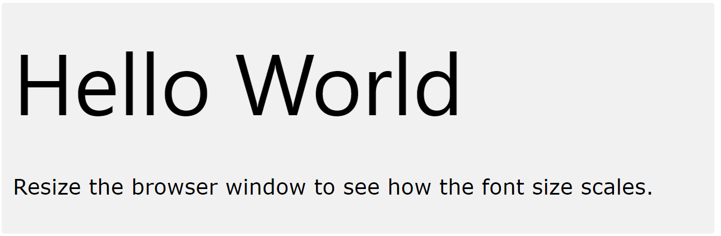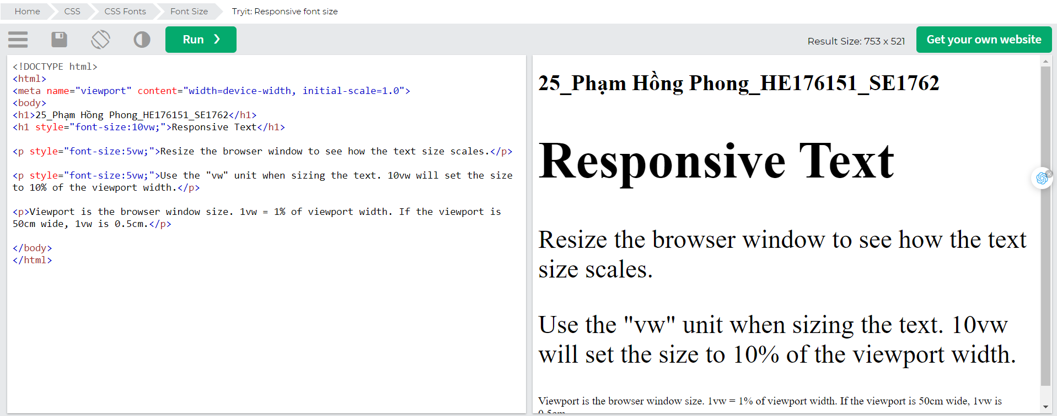

## Google Fonts

If you do not want to use any of the standard fonts in HTML, you can use Google Fonts.

Google Fonts are free to use, and have more than 1000 fonts to choose from.

### How To Use Google Fonts

Just add a special style sheet link in the <head> section and then refer to the font in the CSS.

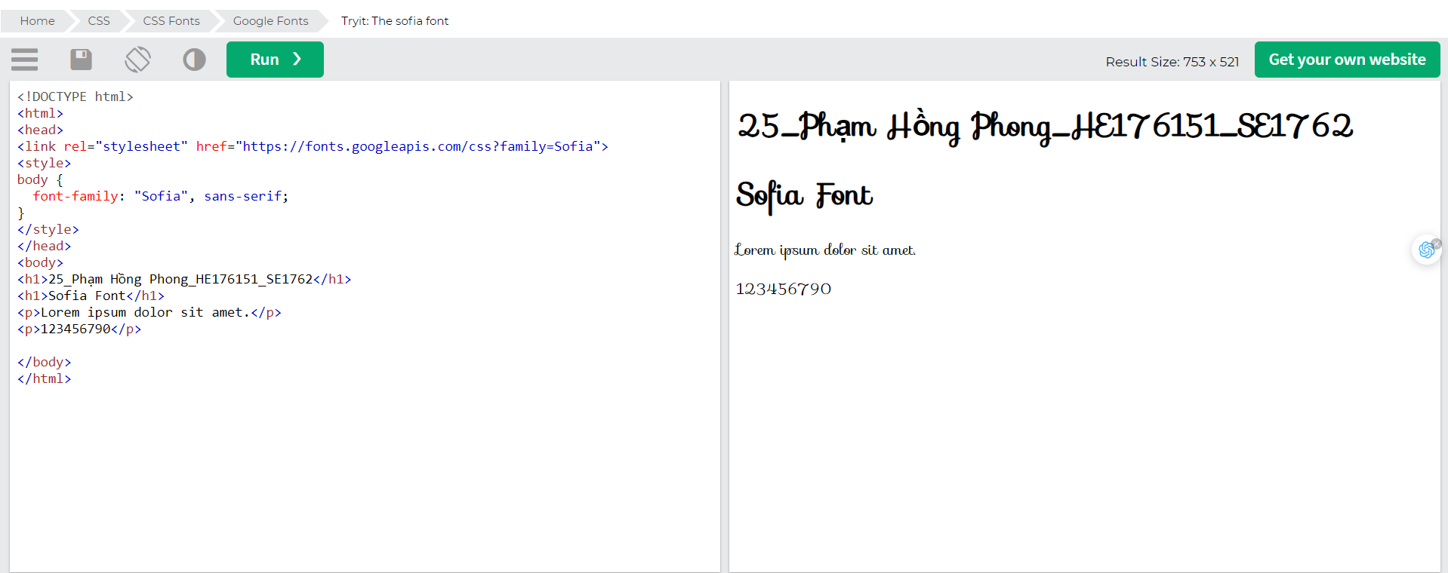

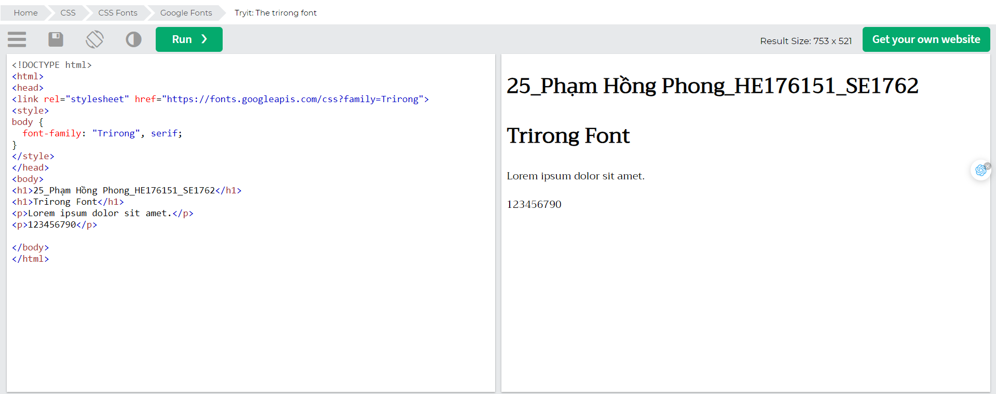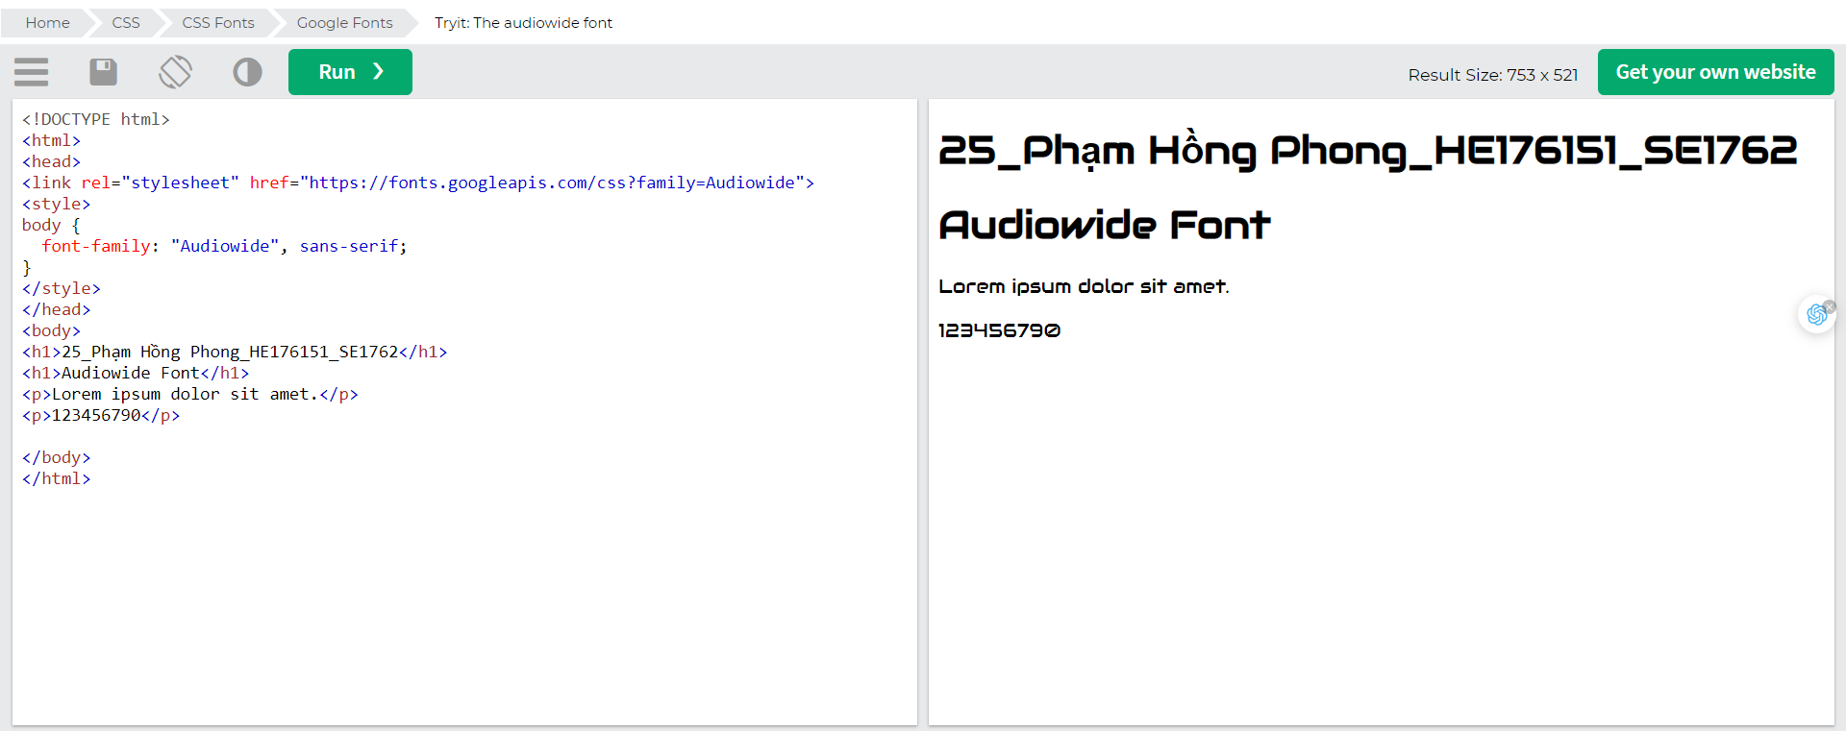Note: When specifying a font in CSS, always list at minimum one fallback font (to avoid unexpected behaviors). So, also here you should add a generic font family (like serif or sans-serif) to the end of the list.

For a list of all available Google Fonts, visit our [How To - Google Fonts Tutorial](https://www.w3schools.com/howto/howto_google_fonts.asp).

### Use Multiple Google Fonts

To use multiple Google fonts, just separate the font names with a pipe character (|), like this:

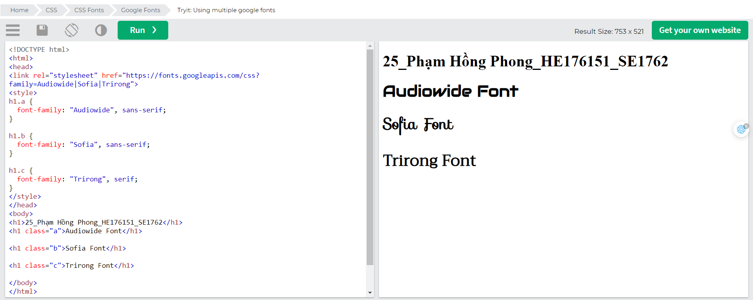Note: Requesting multiple fonts may slow down your web pages! So be careful about that.

### Styling Google Fonts

Of course you can style Google Fonts as you like, with CSS!

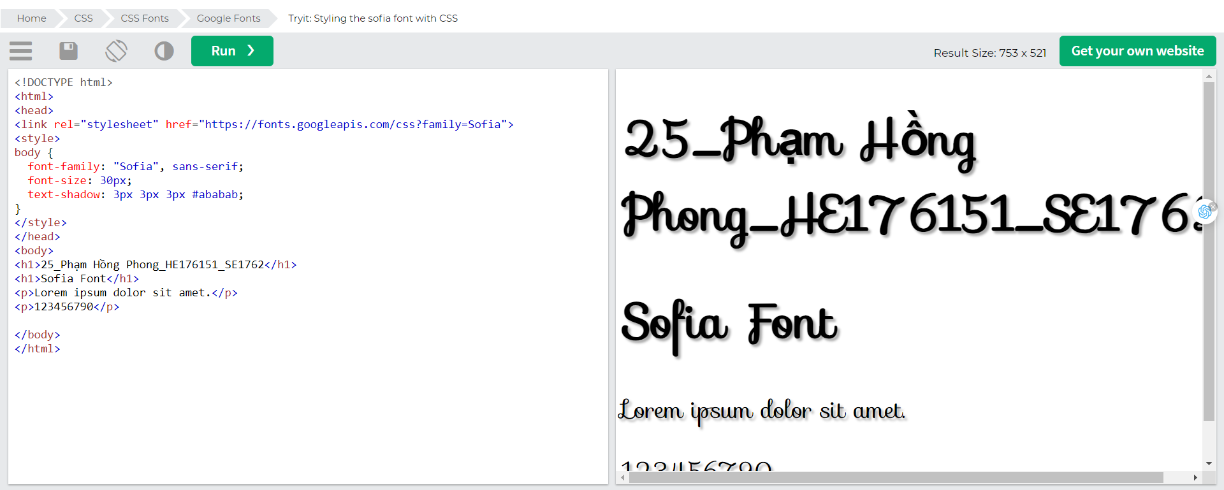

### Enabling Font Effects

Google has also enabled different font effects that you can use.

First add effect=*effectname* to the Google API, then add a special class name to the element that is going to use the special effect. The class name always starts with font-effect- and ends with the *effectname*.

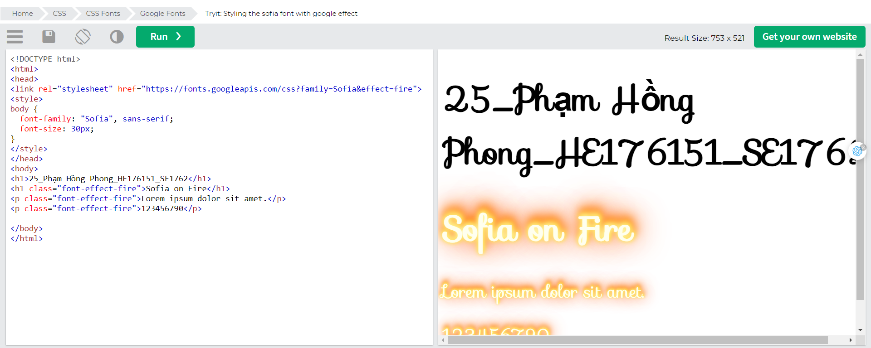To request multiple font effects, just separate the effect names with a pipe character (|), like this:

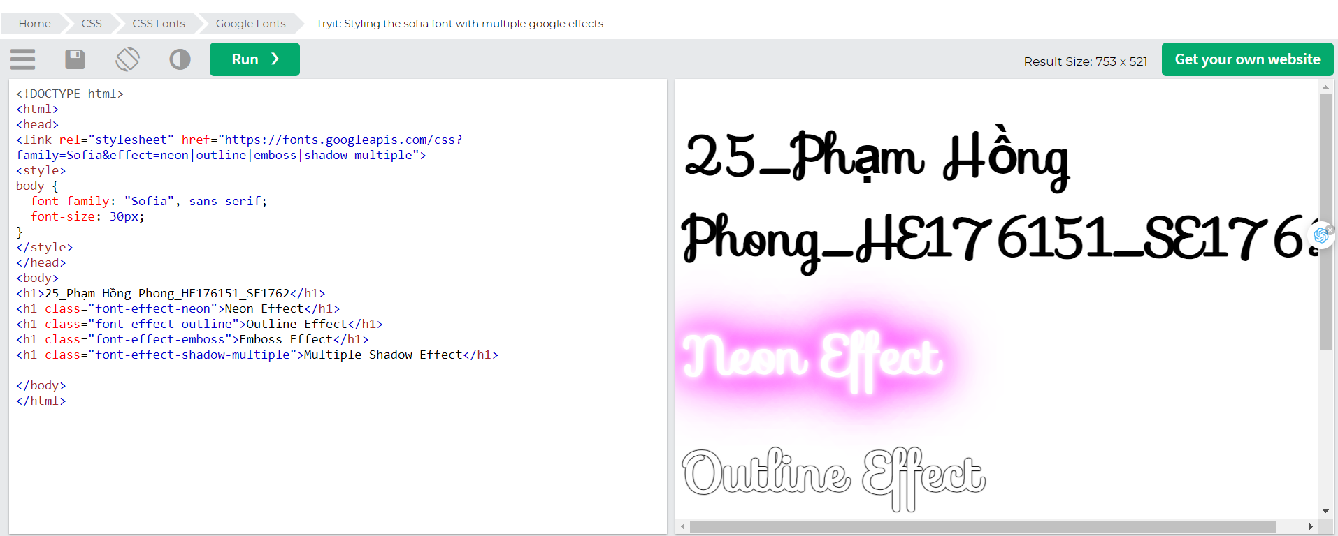

## Font Pairings

## Font Pairing Rules

Here are some basic rules to create great font pairings:

### 1. Complement

It is always safe to find font pairings that complement one another.

A great font combination should harmonize, without being too similar or too different.

### 2. Use Font Superfamilies

A font superfamily is a set of fonts designed to work well together. So, using different fonts within the same superfamily is safe.

For example, the Lucida superfamily contains the following fonts: Lucida Sans, Lucida Serif, Lucida Typewriter Sans, Lucida Typewriter Serif and Lucida Math.

### 3. Contrast is King

Two fonts that are too similar will often conflict. However, contrasts, done the right way, brings out the best in each font.

Example: Combining serif with sans serif is a well known combination.

A strong superfamily includes both serif and sans serif variations of the same font (e.g. Lucida and Lucida Sans).

### 4. Choose Only One Boss

One font should be the boss. This establishes a hierarchy for the fonts on your page. This can be achieved by varying the size, weight and color.

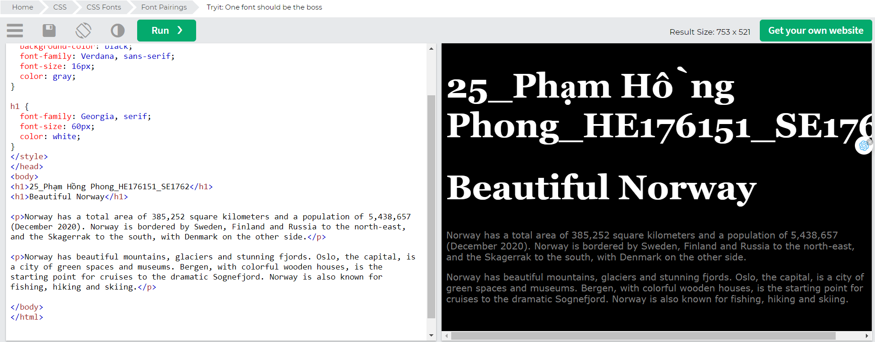

Below, we have shown some popular font pairings that will suit many brands and contexts.

### Georgia and Verdana

Georgia and Verdana is a classic combination. It also sticks to the web safe font standards:

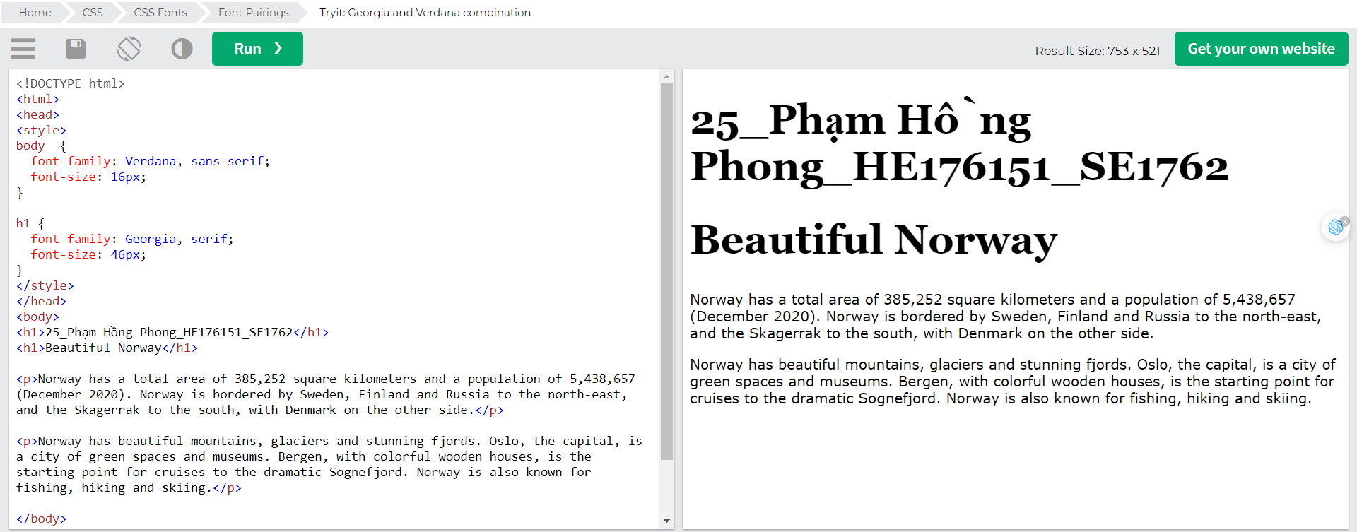

### Helvetica and Garamond

Helvetica and Garamond is another classic combination that uses web safe fonts:

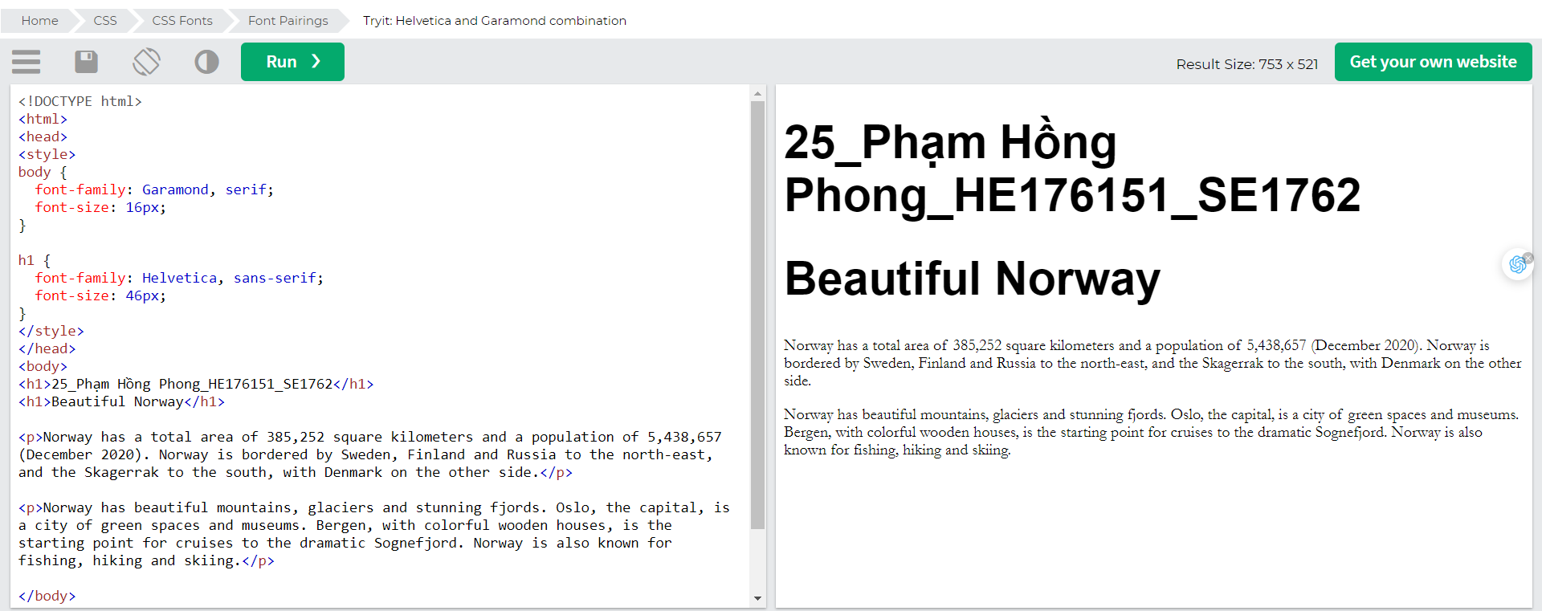

### Popular Google Font Pairings

If you do not want to use standard fonts in HTML, you can use Google Fonts.

Google Fonts are free to use, and have more than 1000 fonts to choose from.

Below are some popular Google Web Font Pairings.

### Merriweather and Open Sans

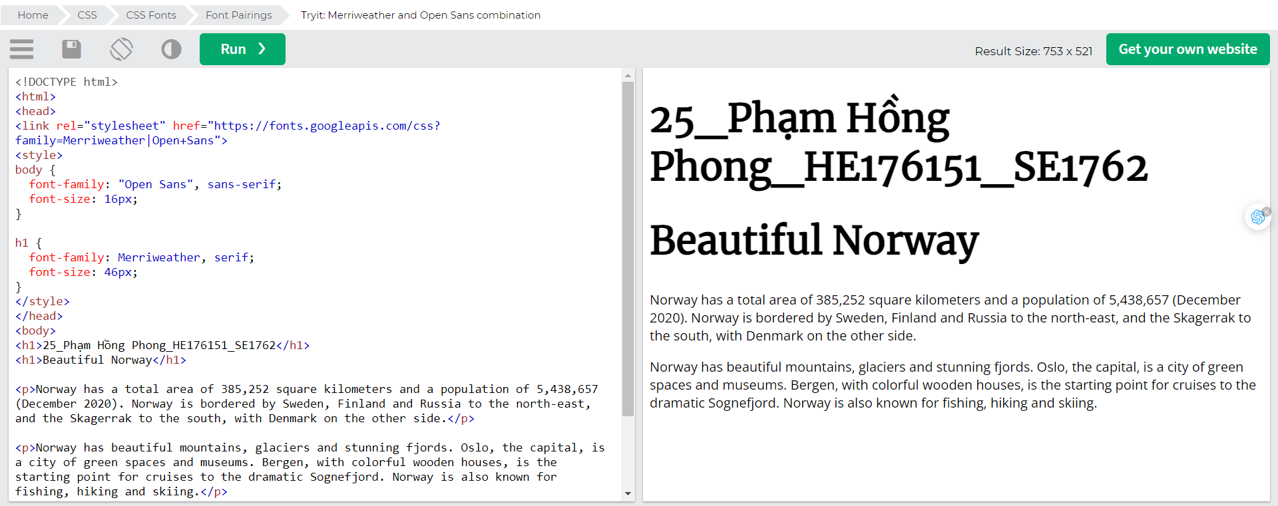

### Ubuntu and Lora

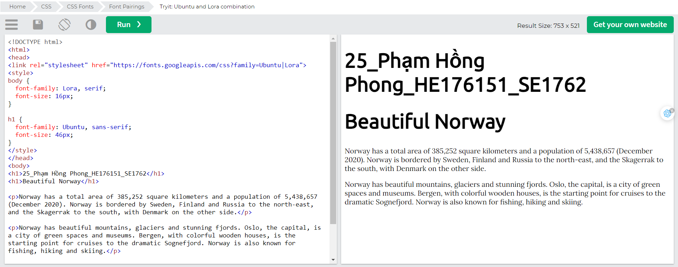

### Abril Fatface and Poppins

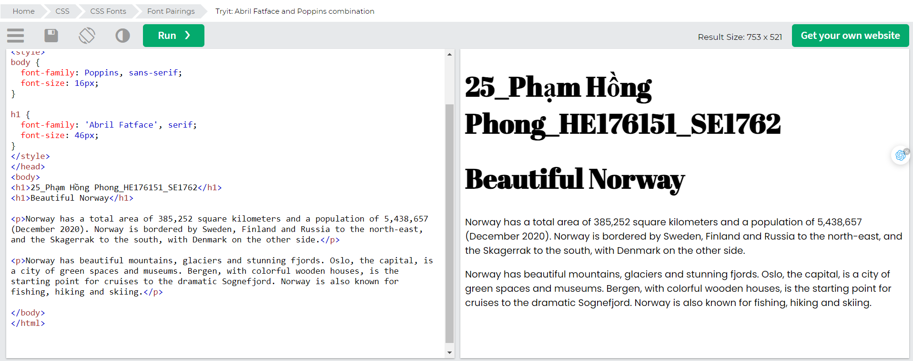

### Cinzel and Fauna One

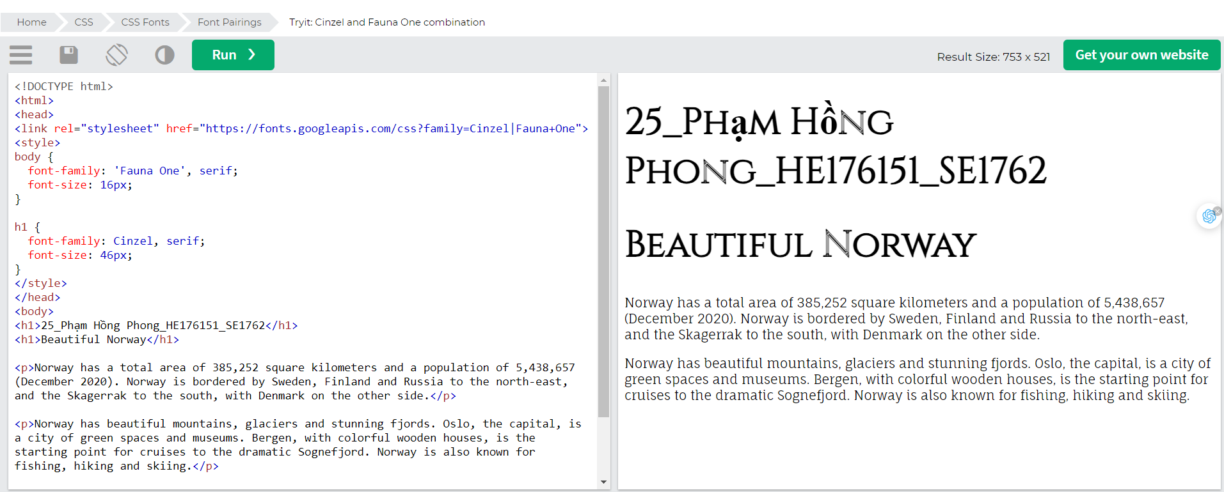

### Fjalla One and Libre Baskerville

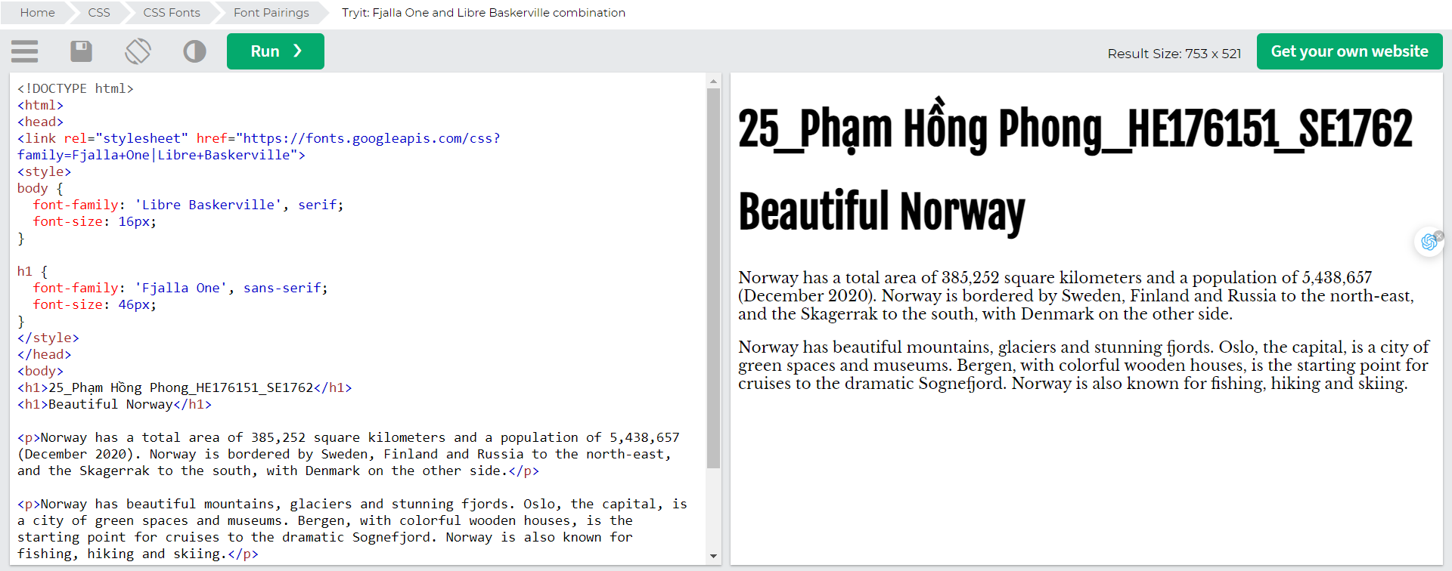

### Space Mono and Muli

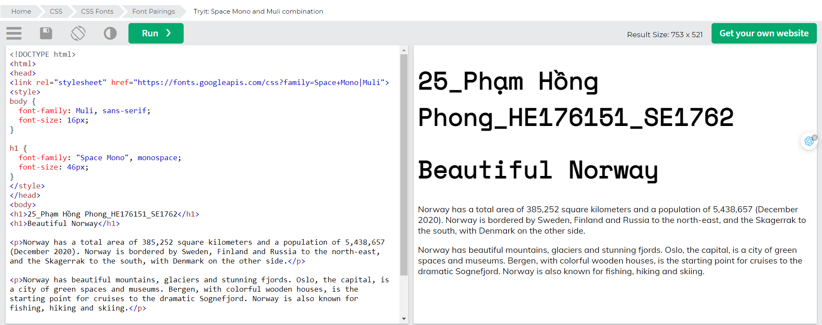

### Spectral and Rubik

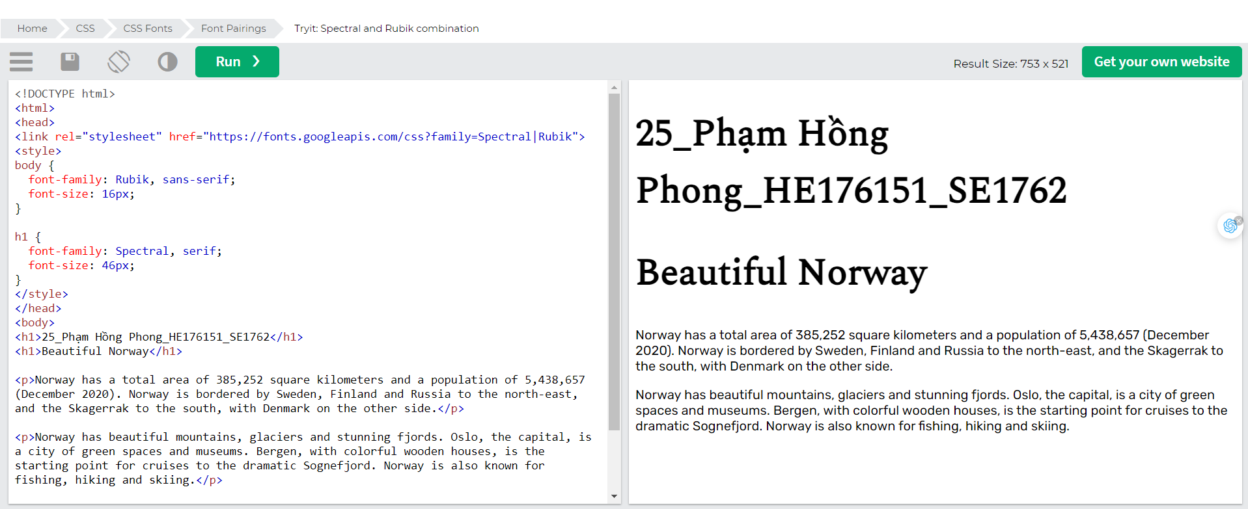

### Oswald and Noto Sans

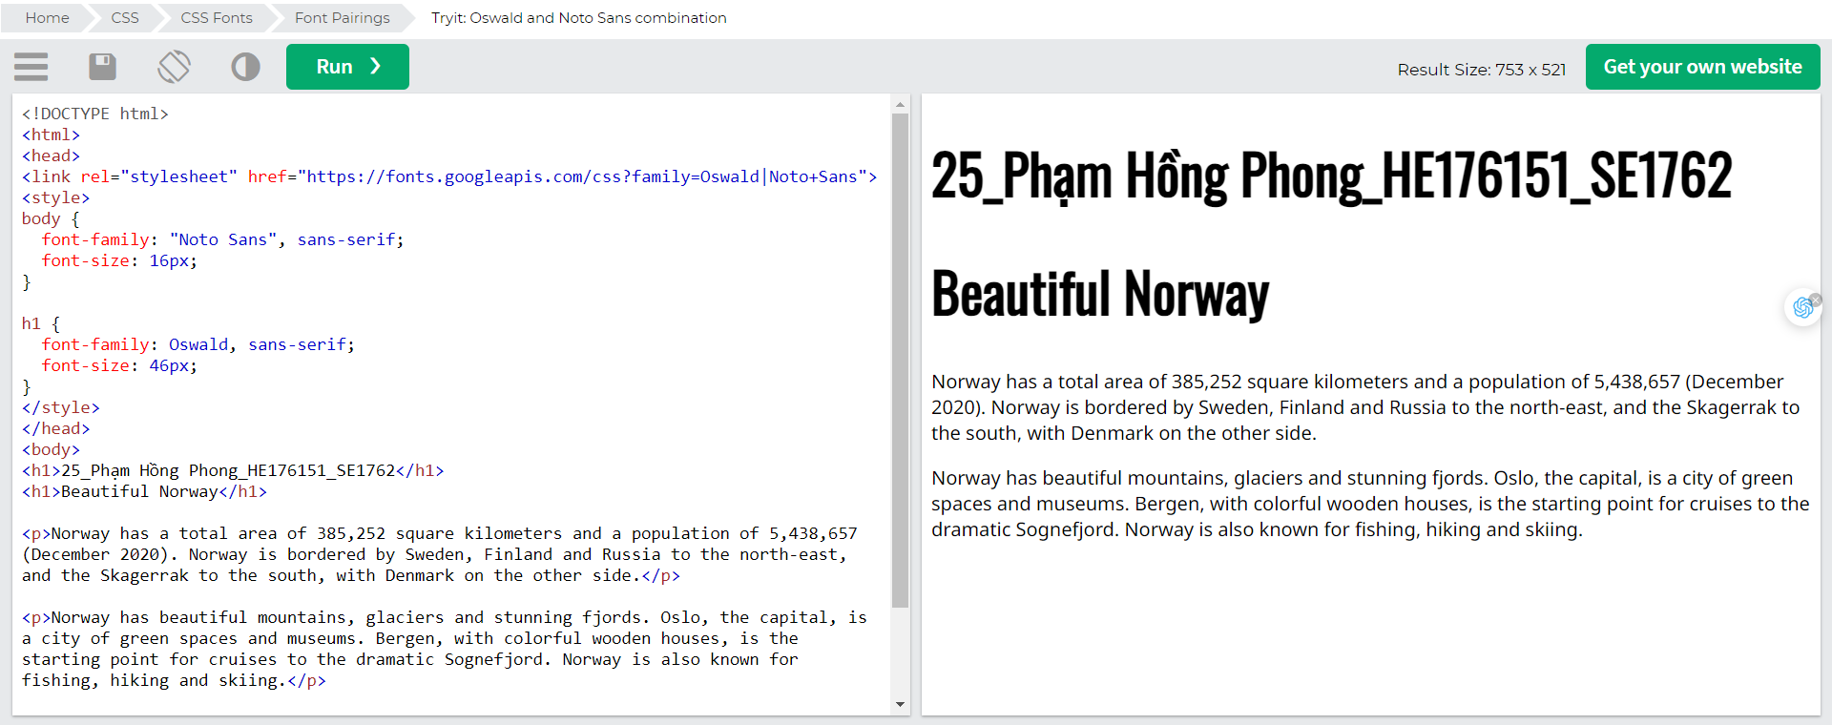

## Font Property

To shorten the code, it is also possible to specify all the individual font properties in one property.

The font property is a shorthand property for:

* font-style
* font-variant
* font-weight
* font-size/line-height
* font-family

Note: The font-size and font-family values are required. If one of the other values is missing, their default value are used.

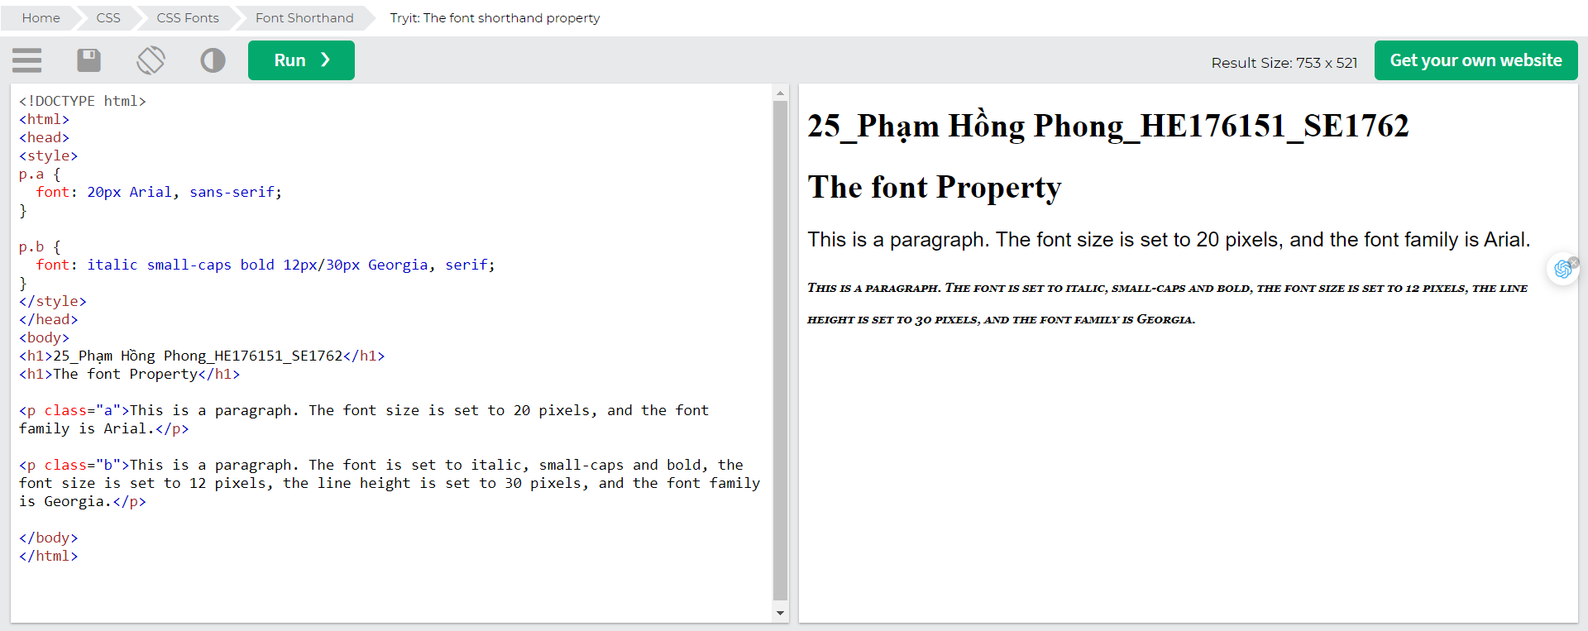

# CSS Icons

Icons can easily be added to your HTML page, by using an icon library.

## How To Add Icons

The simplest way to add an icon to your HTML page, is with an icon library, such as Font Awesome.

Add the name of the specified icon class to any inline HTML element (like <i> or <span>).

All the icons in the icon libraries below, are scalable vectors that can be customized with CSS (size, color, shadow, etc.)

## Font Awesome Icons

To use the Font Awesome icons, go to [fontawesome.com](https://fontawesome.com/), sign in, and get a code to add in the <head> section of your HTML page:

<script src="https://kit.fontawesome.com/*yourcode*.js" crossorigin="anonymous"></script>

Read more about how to get started with Font Awesome in our [Font Awesome 5 tutorial](https://www.w3schools.com/icons/fontawesome5_intro.asp).

Note: No downloading or installation is required!

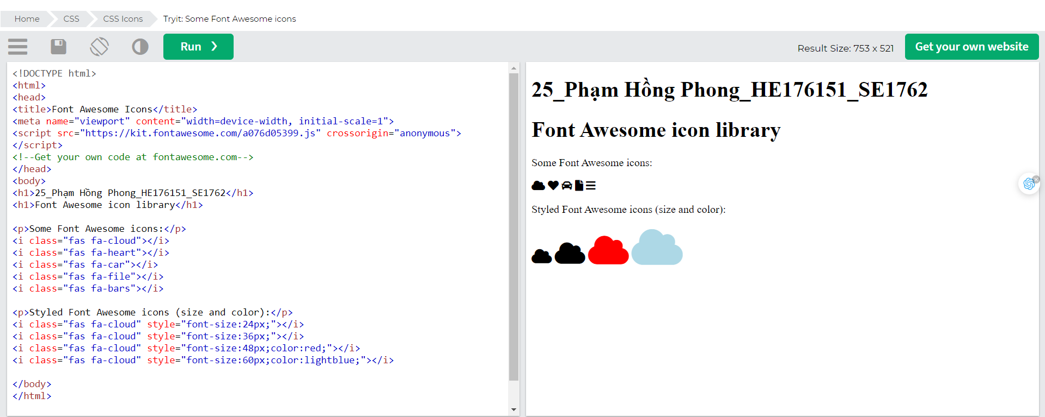

## Bootstrap Icons

To use the Bootstrap glyphicons, add the following line inside the <head> section of your HTML page:

<link rel="stylesheet" href="https://maxcdn.bootstrapcdn.com/bootstrap/3.3.7/css/bootstrap.min.css">

Note: No downloading or installation is required!

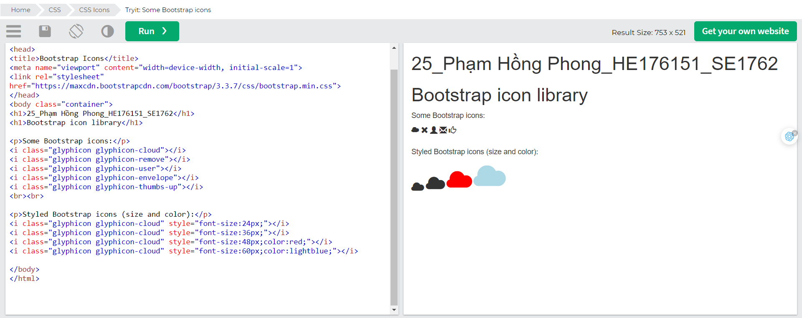

## Google Icons

To use the Google icons, add the following line inside the <head> section of your HTML page:

<link rel="stylesheet" href="https://fonts.googleapis.com/icon?family=Material+Icons">

Note: No downloading or installation is required!

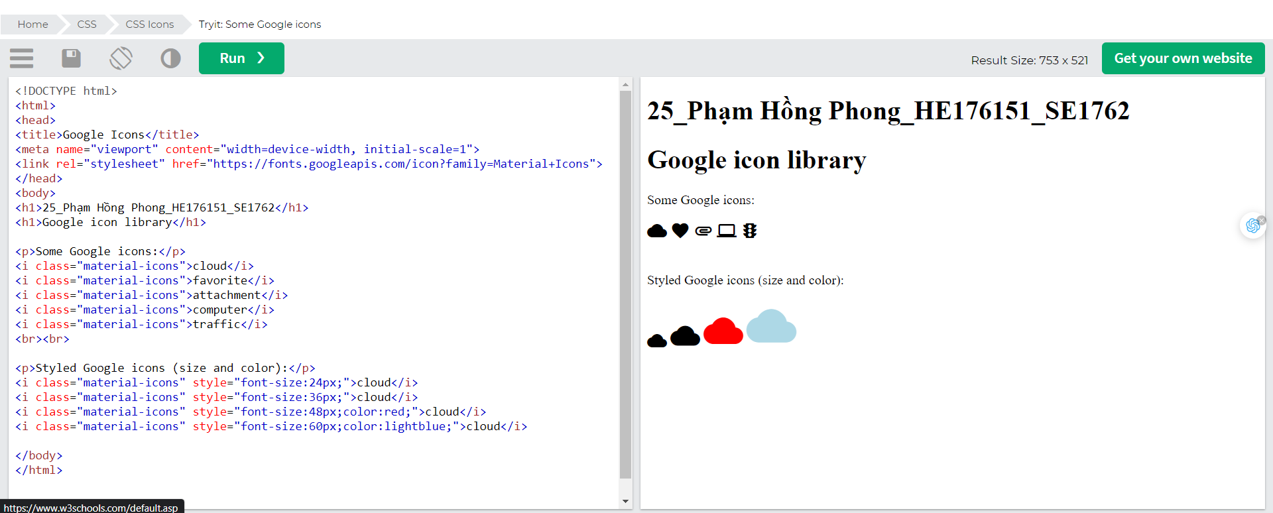

# CSS Links

With CSS, links can be styled in many different ways.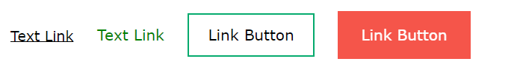

## Styling Links

Links can be styled with any CSS property (e.g. colour, font-family, background, etc.).

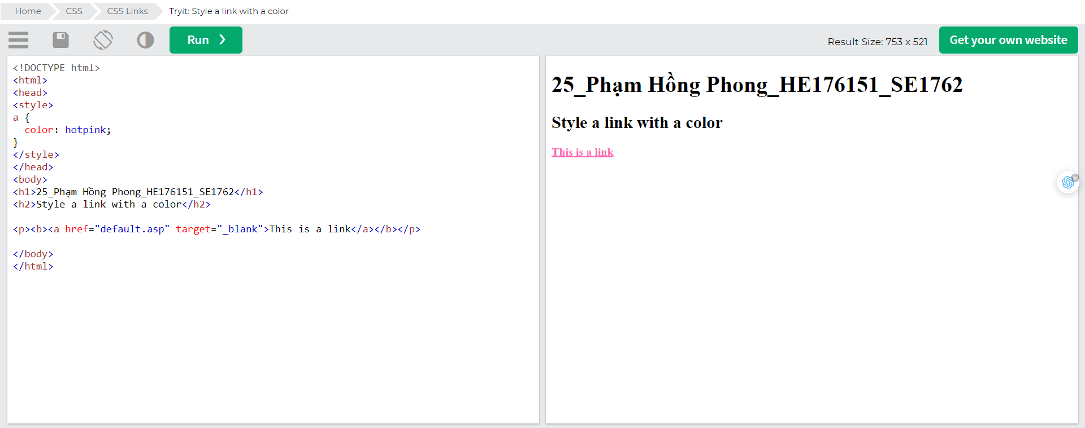In addition, links can be styled differently depending on what state they are in.

The four links states are:

* a:link - a normal, unvisited link
* a:visited - a link the user has visited
* a:hover - a link when the user mouses over it
* a:active - a link the moment it is clicked

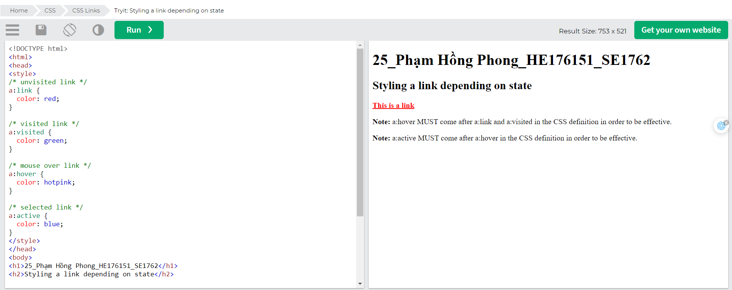When setting the style for several link states, there are some order rules:

* a:hover MUST come after a:link and a:visited
* a:active MUST come after a:hover

## Text Decoration

The text-decoration property is mostly used to remove underlines from links:

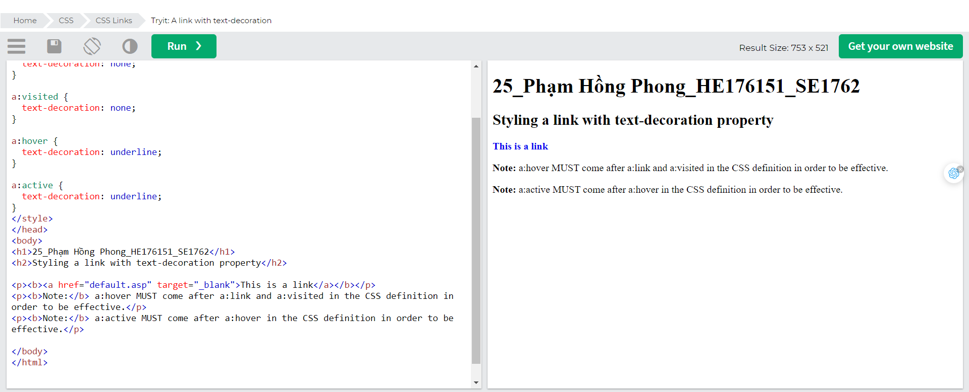

## Background Colour

The background-colour property can be used to specify a background colour for links:

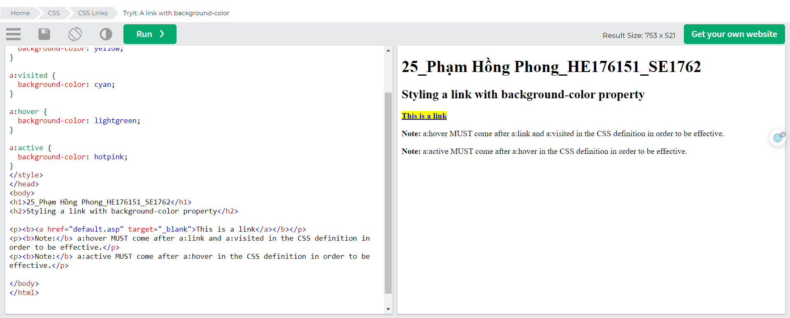

## Link Buttons

This example demonstrates a more advanced example where we combine several CSS properties to display links as boxes/buttons:

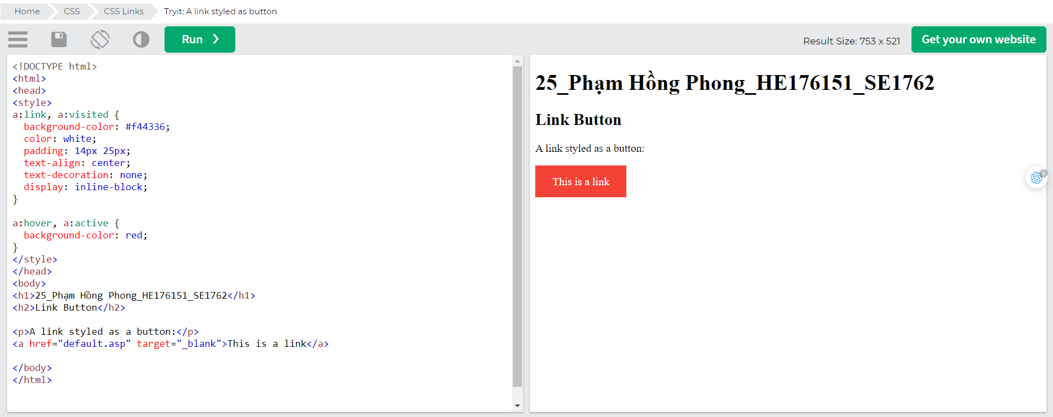

## More Examples

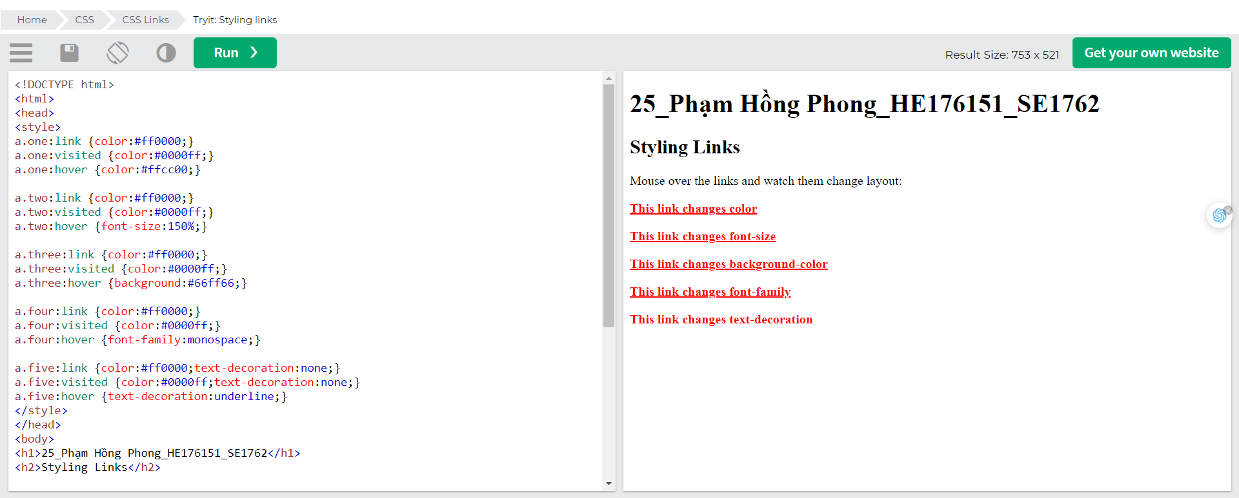

# CSS Lists

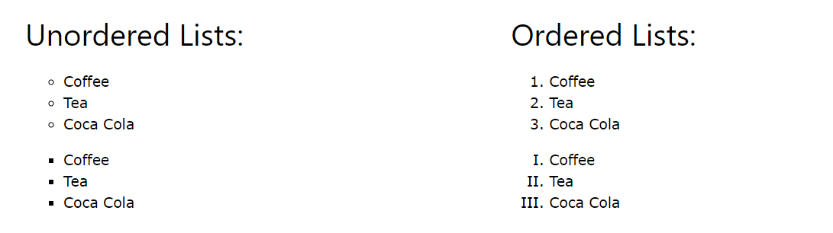

## HTML Lists and CSS List Properties

In HTML, there are two main types of lists:

* unordered lists (<ul>) - the list items are marked with bullets
* ordered lists (<ol>) - the list items are marked with numbers or letters

The CSS list properties allow you to:

* Set different list item markers for ordered lists
* Set different list item markers for unordered lists
* Set an image as the list item marker
* Add background colours to lists and list items

## Different List Item Markers

The list-style-type property specifies the type of list item marker.

The following example shows some of the available list item markers:

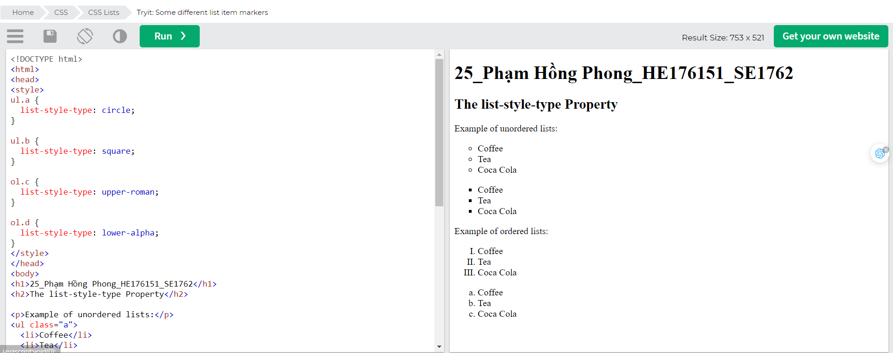

Note: Some of the values are for unordered lists, and some for ordered lists.

## An Image as The List Item Marker

The list-style-image property specifies an image as the list item marker:

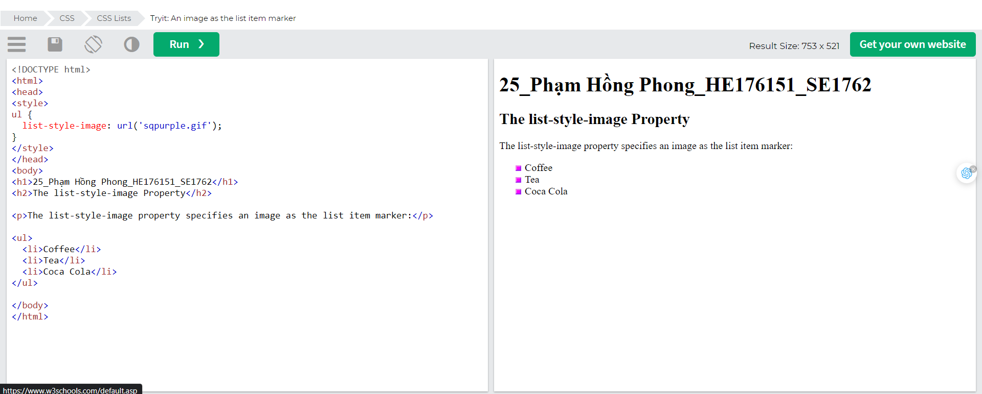

## Position The List Item Markers

The list-style-position property specifies the position of the list-item markers (bullet points).

"list-style-position: outside;" means that the bullet points will be outside the list item.

The start of each line of a list item will be aligned vertically. This is default:

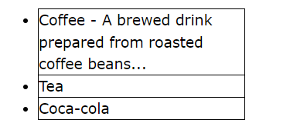

"list-style-position: inside;" means that the bullet points will be inside the list item.

As it is part of the list item, it will be part of the text and push the text at the start:

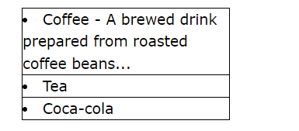

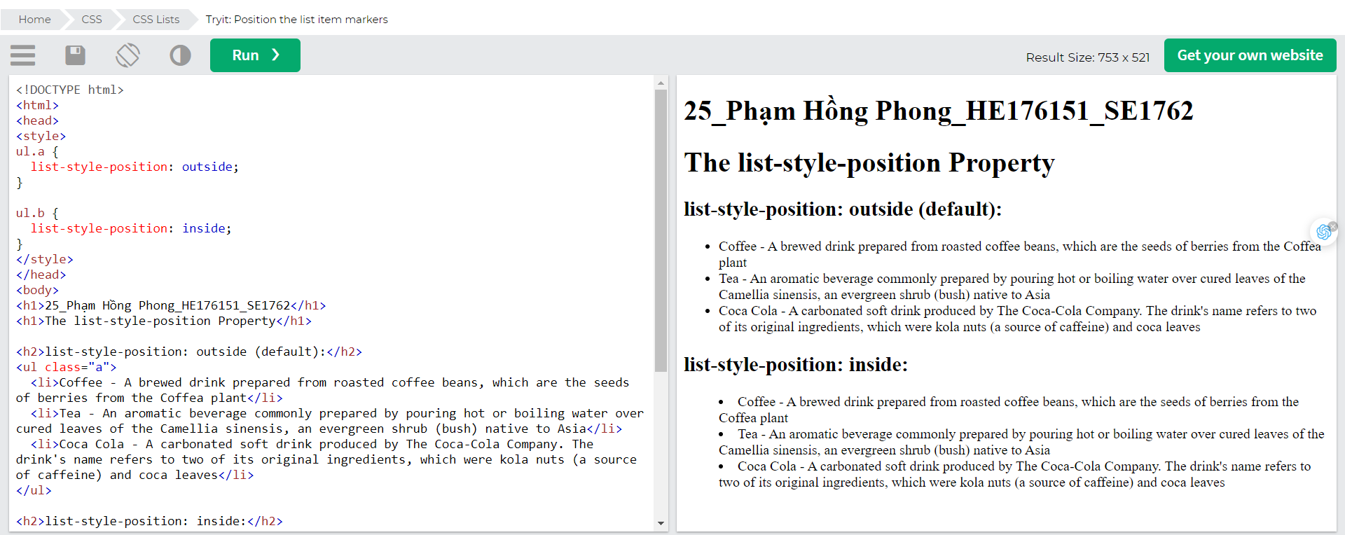

## Remove Default Settings

The list-style-type:none property can also be used to remove the markers/bullets. Note that the list also has default margin and padding.

To remove this, add margin:0 && padding:0 to <ul> or <ol>:

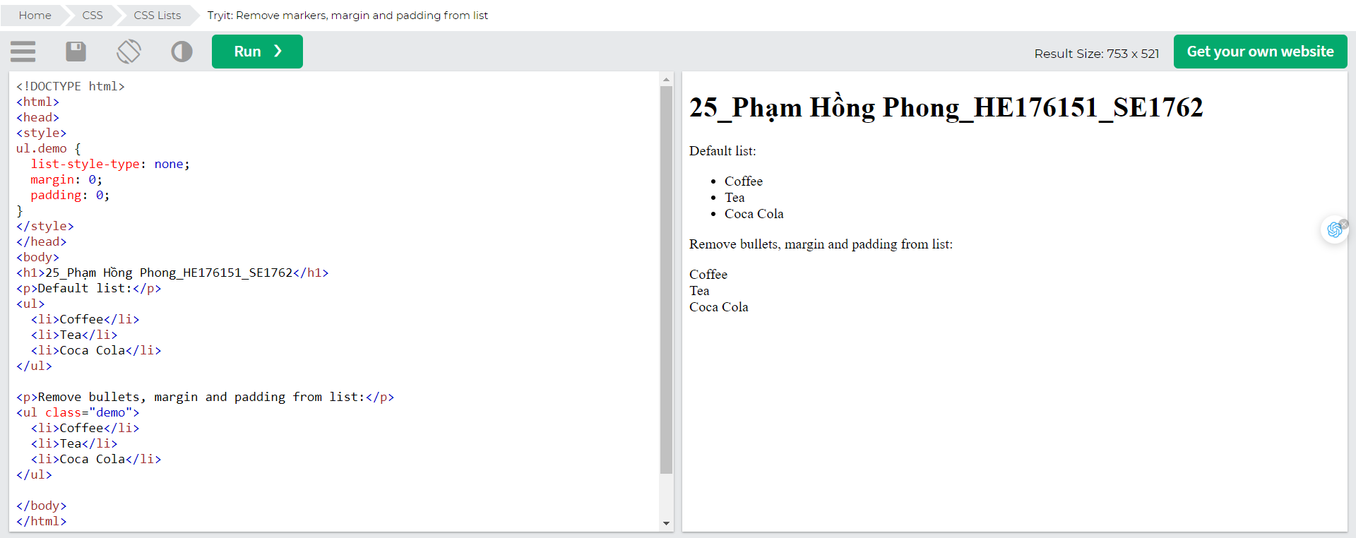

## List - Shorthand property

The list-style property is a shorthand property. It is used to set all the list properties in one declaration:

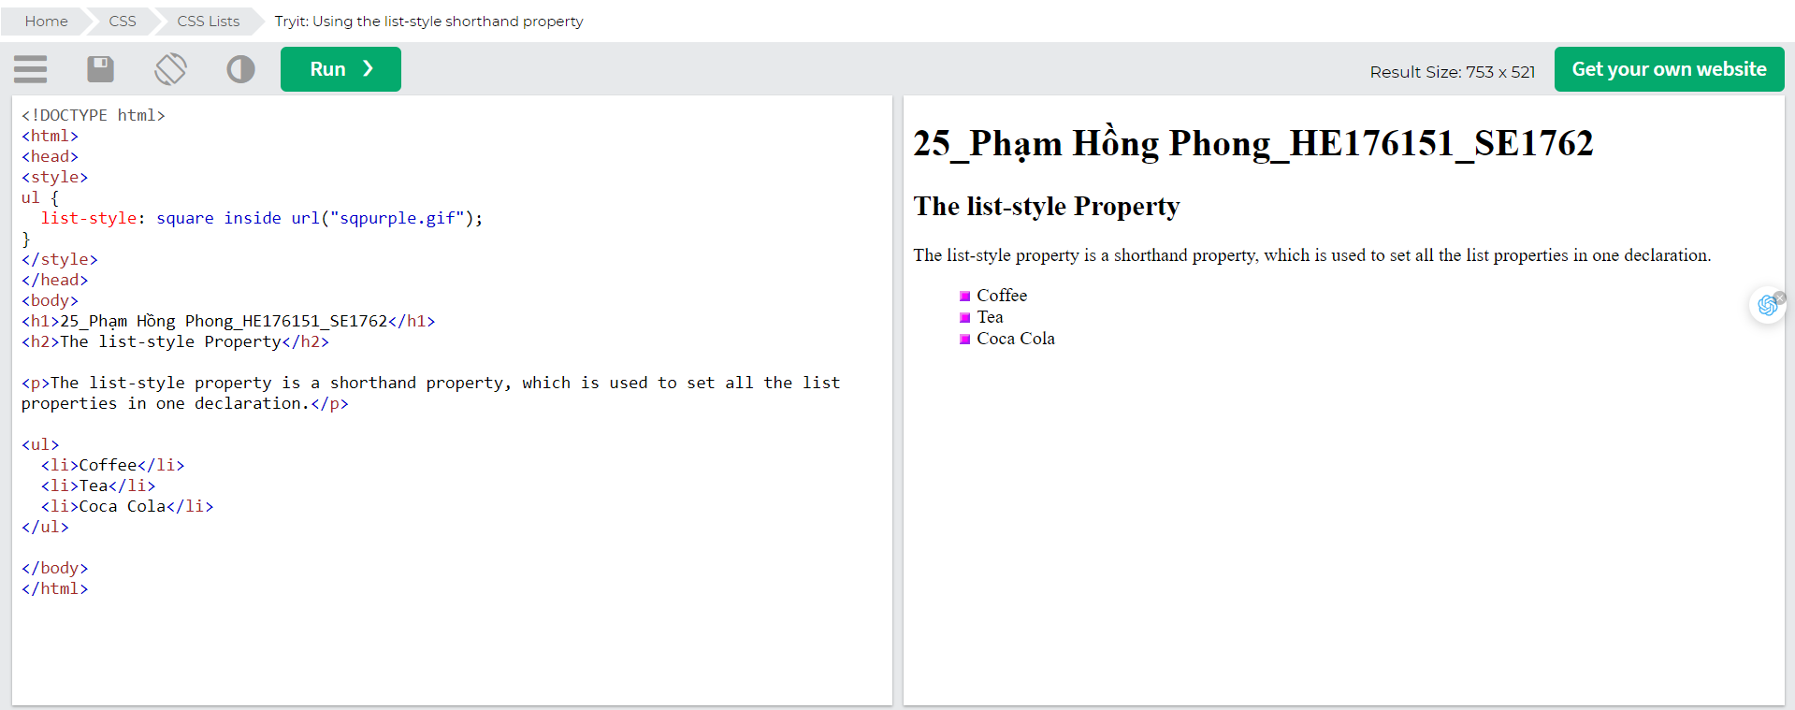When using the shorthand property, the order of the property values are:

* list-style-type (if a list-style-image is specified, the value of this property will be displayed if the image for some reason cannot be displayed)
* list-style-position (specifies whether the list-item markers should appear inside or outside the content flow)
* list-style-image (specifies an image as the list item marker)

If one of the property values above is missing, the default value for the missing property will be inserted, if any.

## Styling List With Colours

We can also style lists with colors, to make them look a little more interesting.

Anything added to the <ol> or <ul> tag, affects the entire list, while properties added to the <li> tag will affect the individual list items:

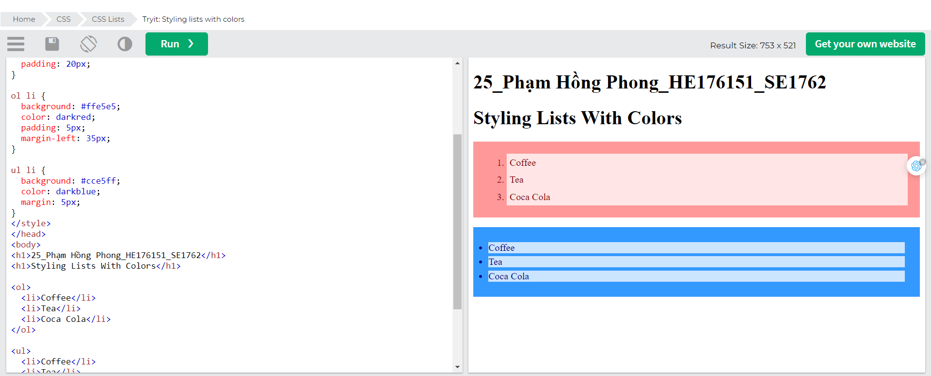

# CSS Tables

The look of an HTML table can be greatly improved with CSS:

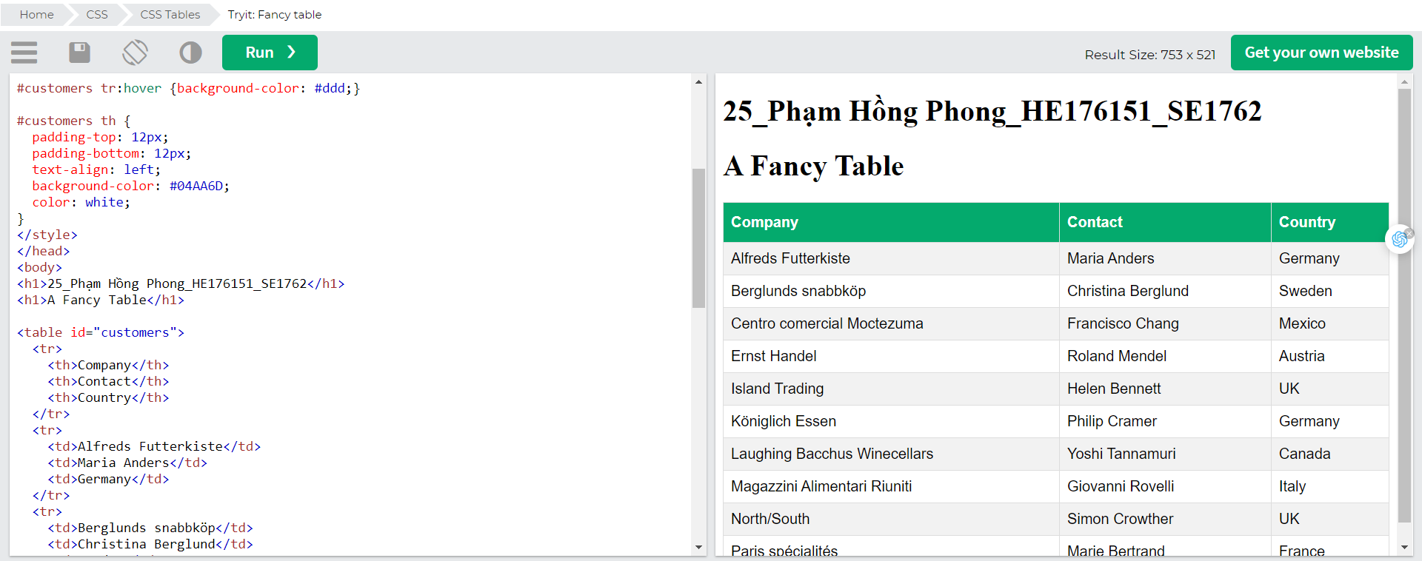

## Table Borders

To specify table borders in CSS, use the border property.

The example below specifies a solid border for <table>, <th>, and <td> elements: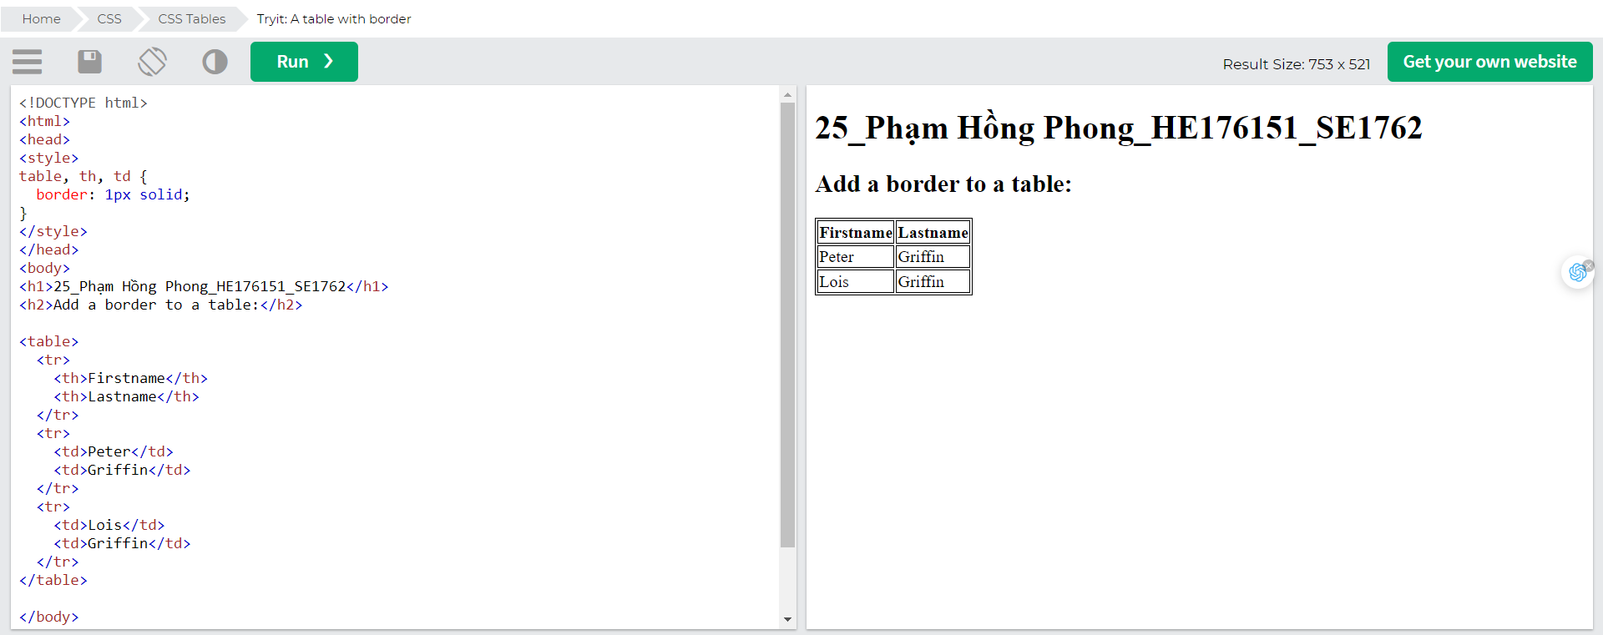

### Full-Width Table

The table above might seem small in some cases. If you need a table that should span the entire screen (full-width), add width: 100% to the <table> element:

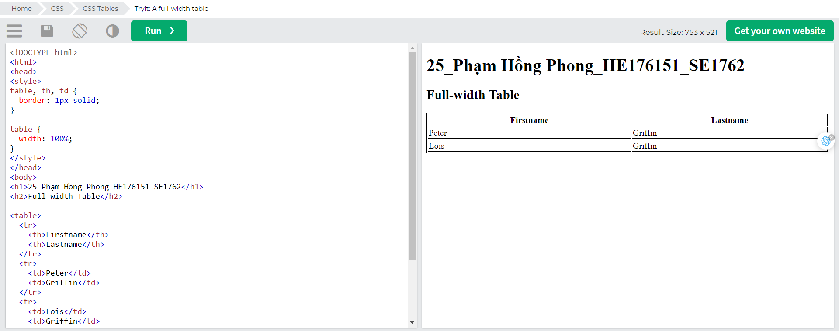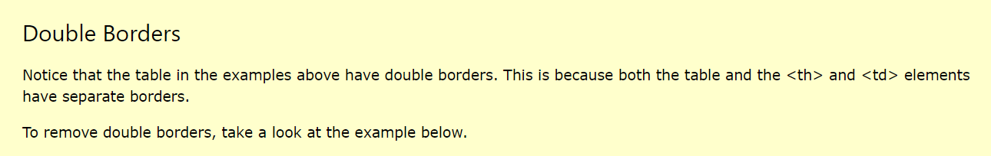

### Collapse Table Borders

The border-collapse property sets whether the table borders should be collapsed into a single border:

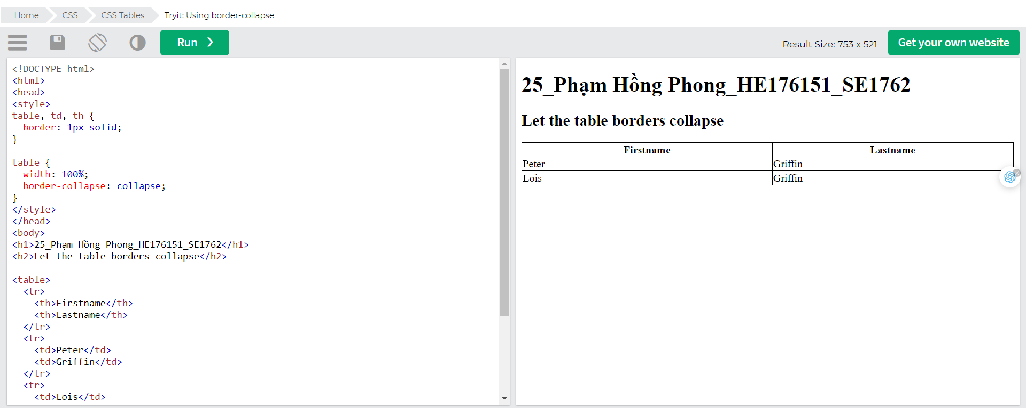

If you only want a border around the table, only specify the border property for <table>: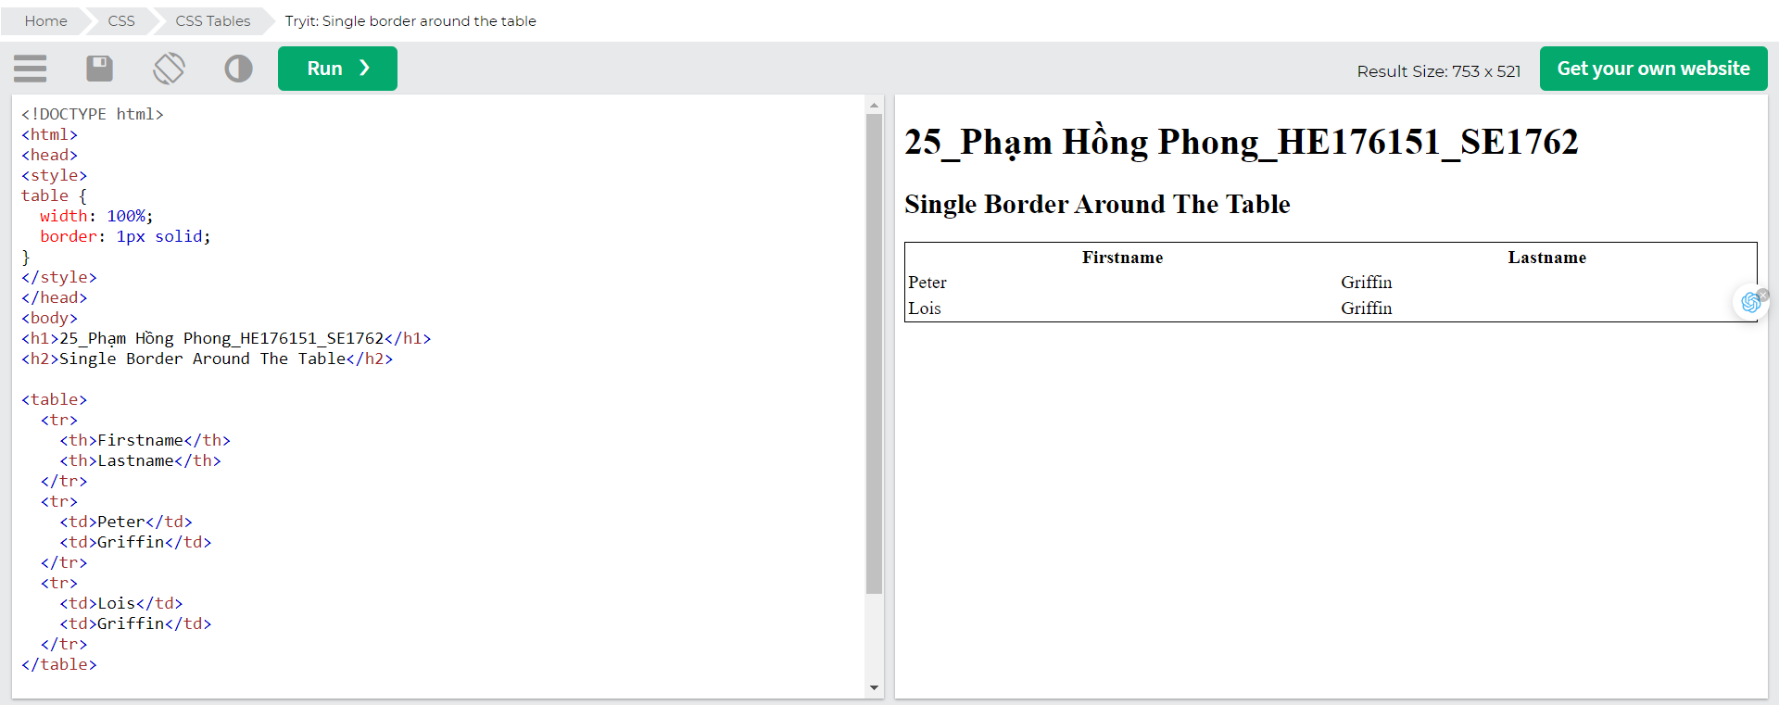

## Table Size

### Table Width and Height

The width and height of a table are defined by the width and height properties.

The example below sets the width of the table to 100%, and the height of the <th> elements to 70px:

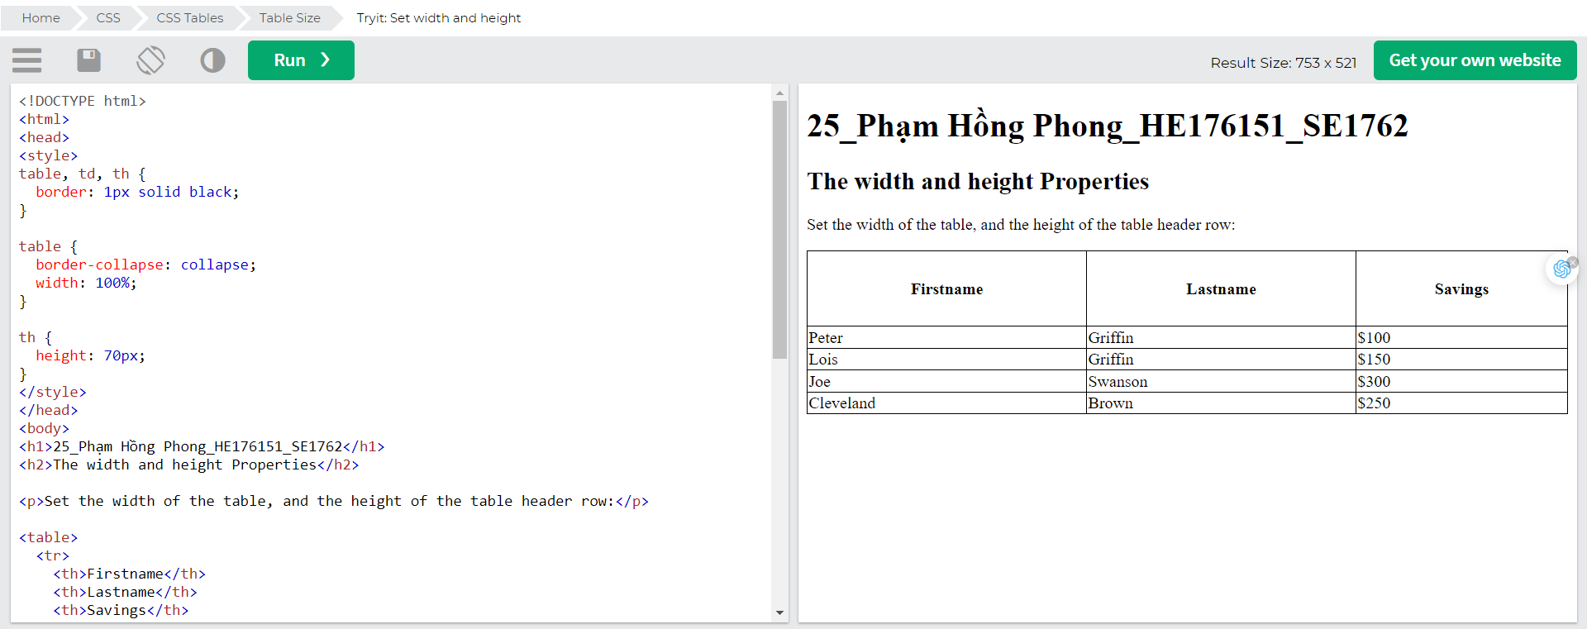

To create a table that should only span half the page, use width: 50%: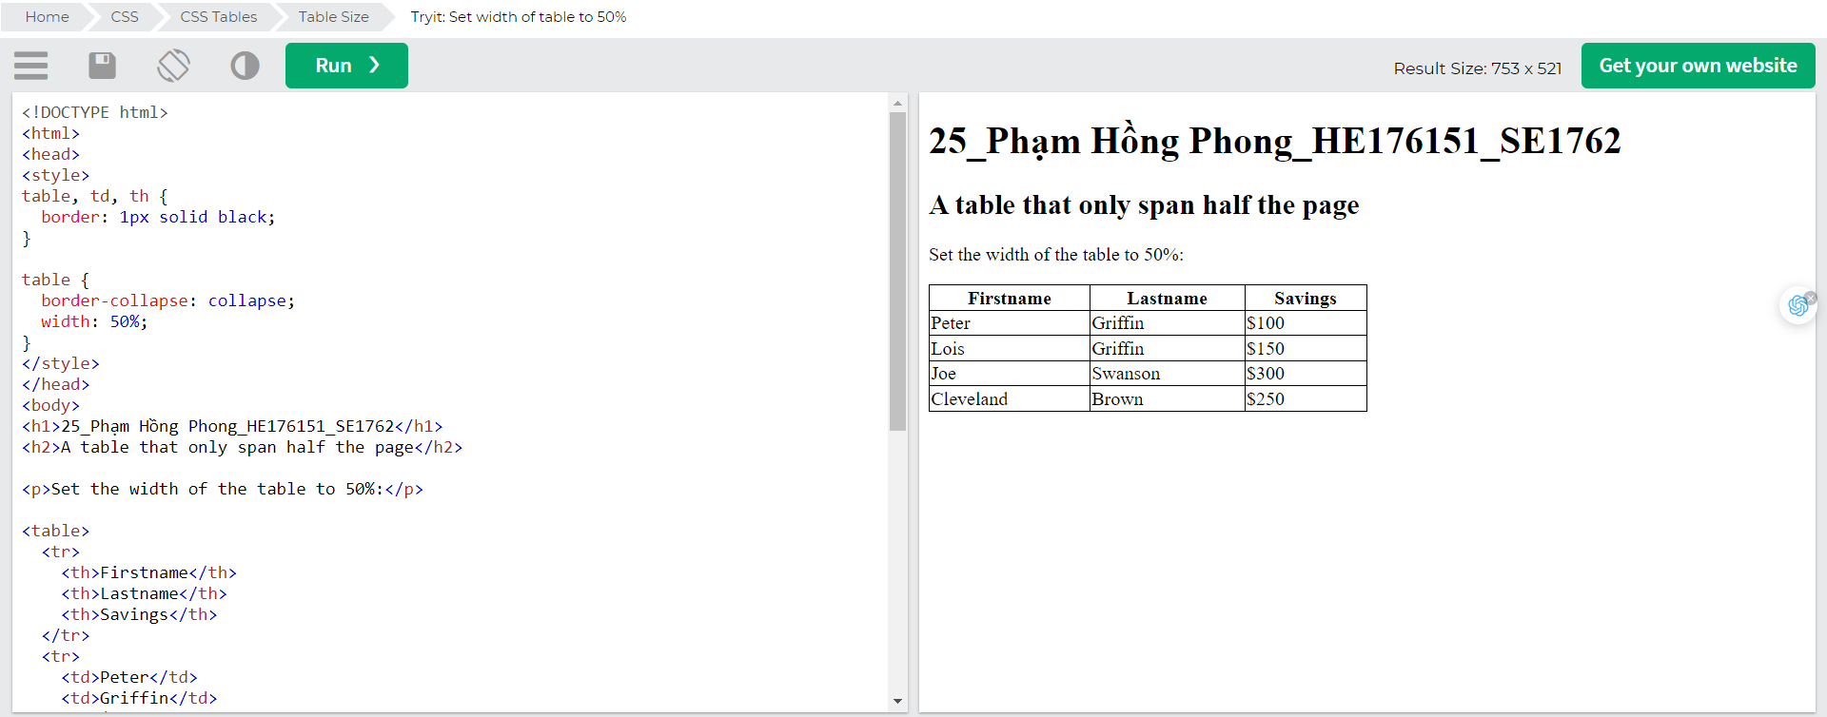

## Table Alignment

### Horizontal Alignment

The text-align property sets the horizontal alignment (like left, right, or center) of the content in <th> or <td>.

By default, the content of <th> elements are center-aligned and the content of <td> elements are left-aligned.

To center-align the content of <td> elements as well, use text-align: center: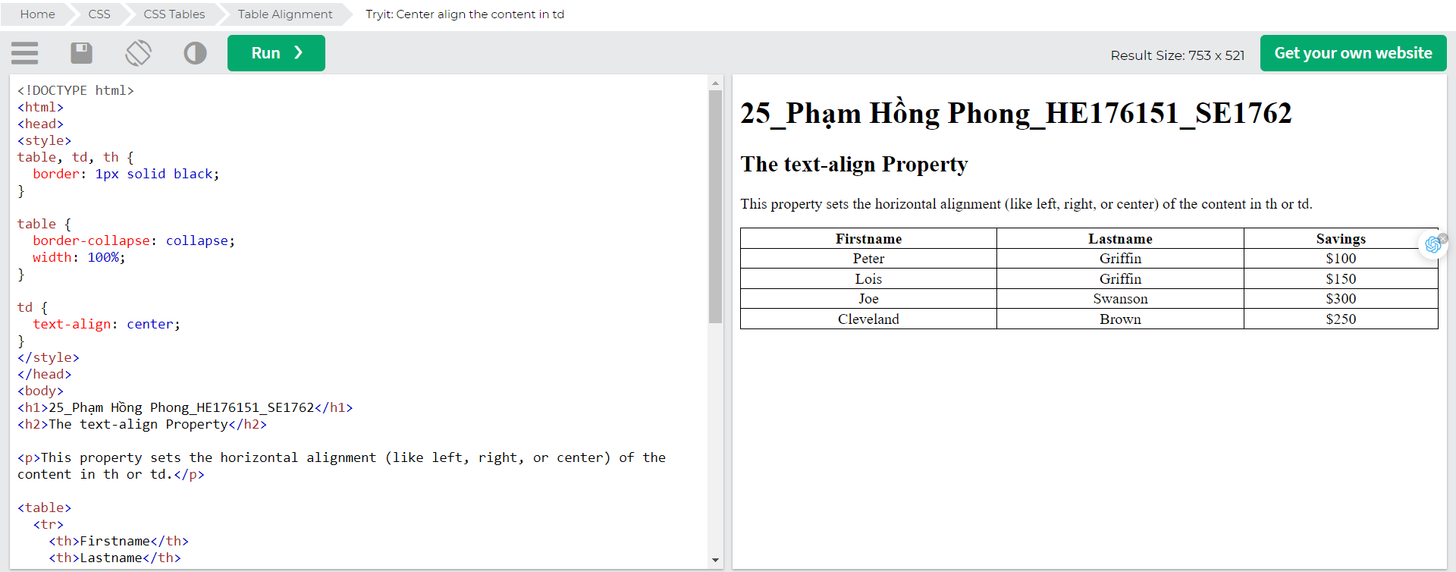

To left-align the content, force the alignment of <th> elements to be left-aligned, with the text-align: left property: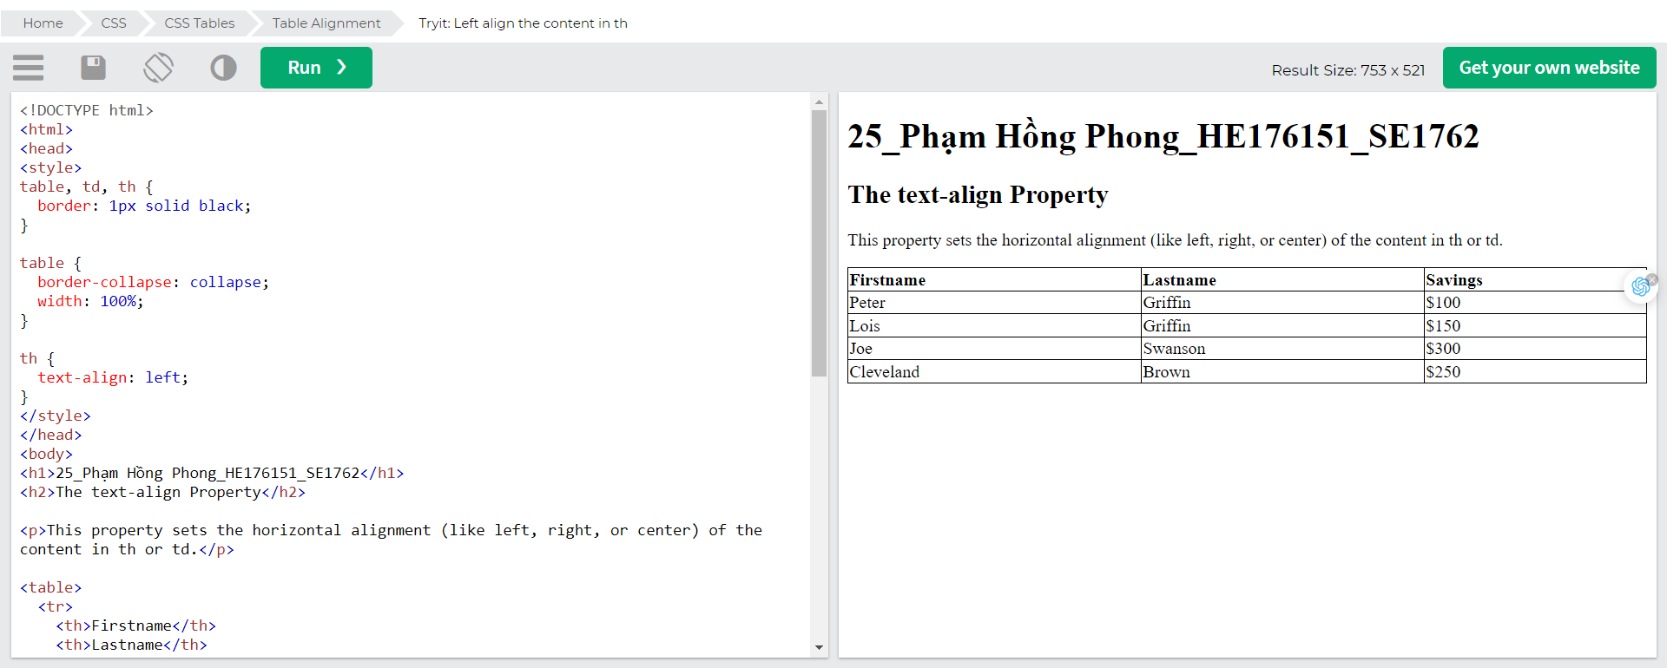

### Vertical Alignment

The vertical-align property sets the vertical alignment (like top, bottom, or middle) of the content in <th> or <td>.

By default, the vertical alignment of the content in a table is middle (for both <th> and <td> elements).

The following example sets the vertical text alignment to bottom for <td> elements: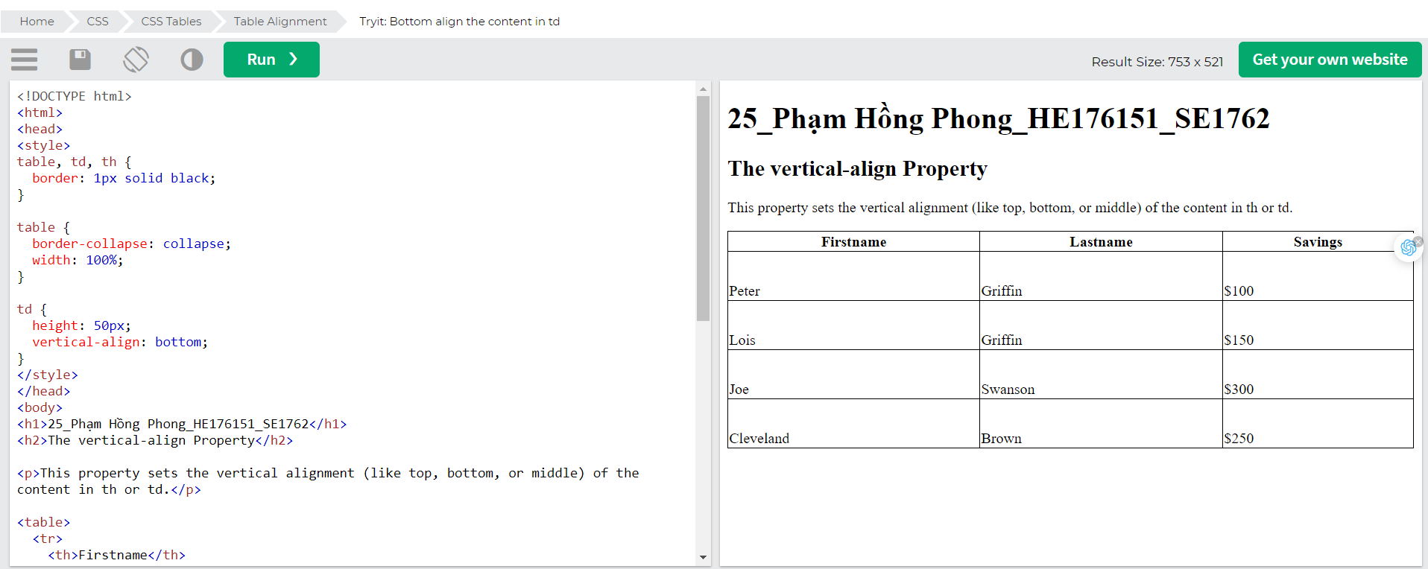

## Table Style

### Table Padding

To control the space between the border and the content in a table, use the padding property on <td> and <th> elements:

| **First Name** | **Last Name** | **Savings** |
| --- | --- | --- |
| Peter | Griffin | $100 |
| Lois | Griffin | $150 |
| Joe | Swanson | $300 |

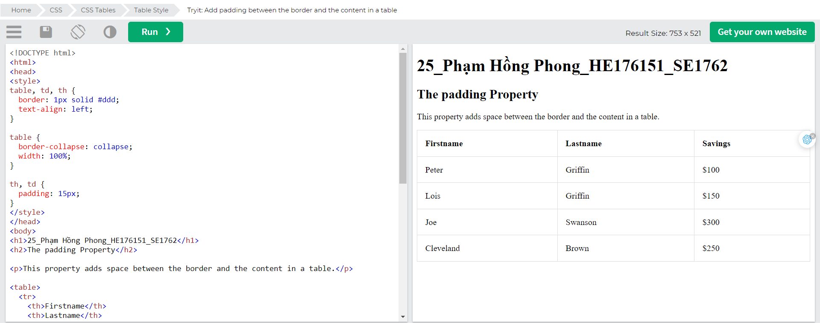

### Horizontal DividersAdd the border-bottom property to <th> and <td> for horizontal dividers:

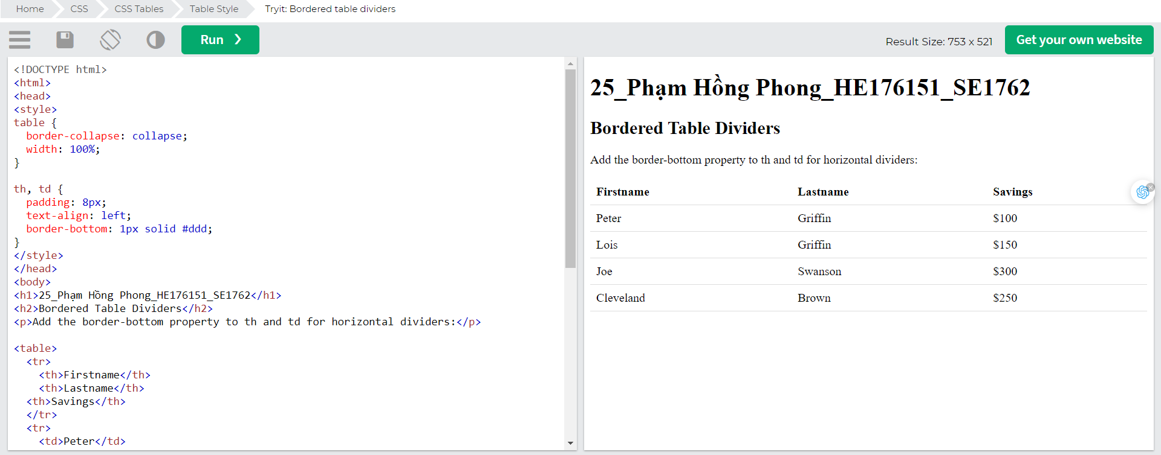

### Hoverable Table

Use the :hover selector on <tr> to highlight table rows on mouse over: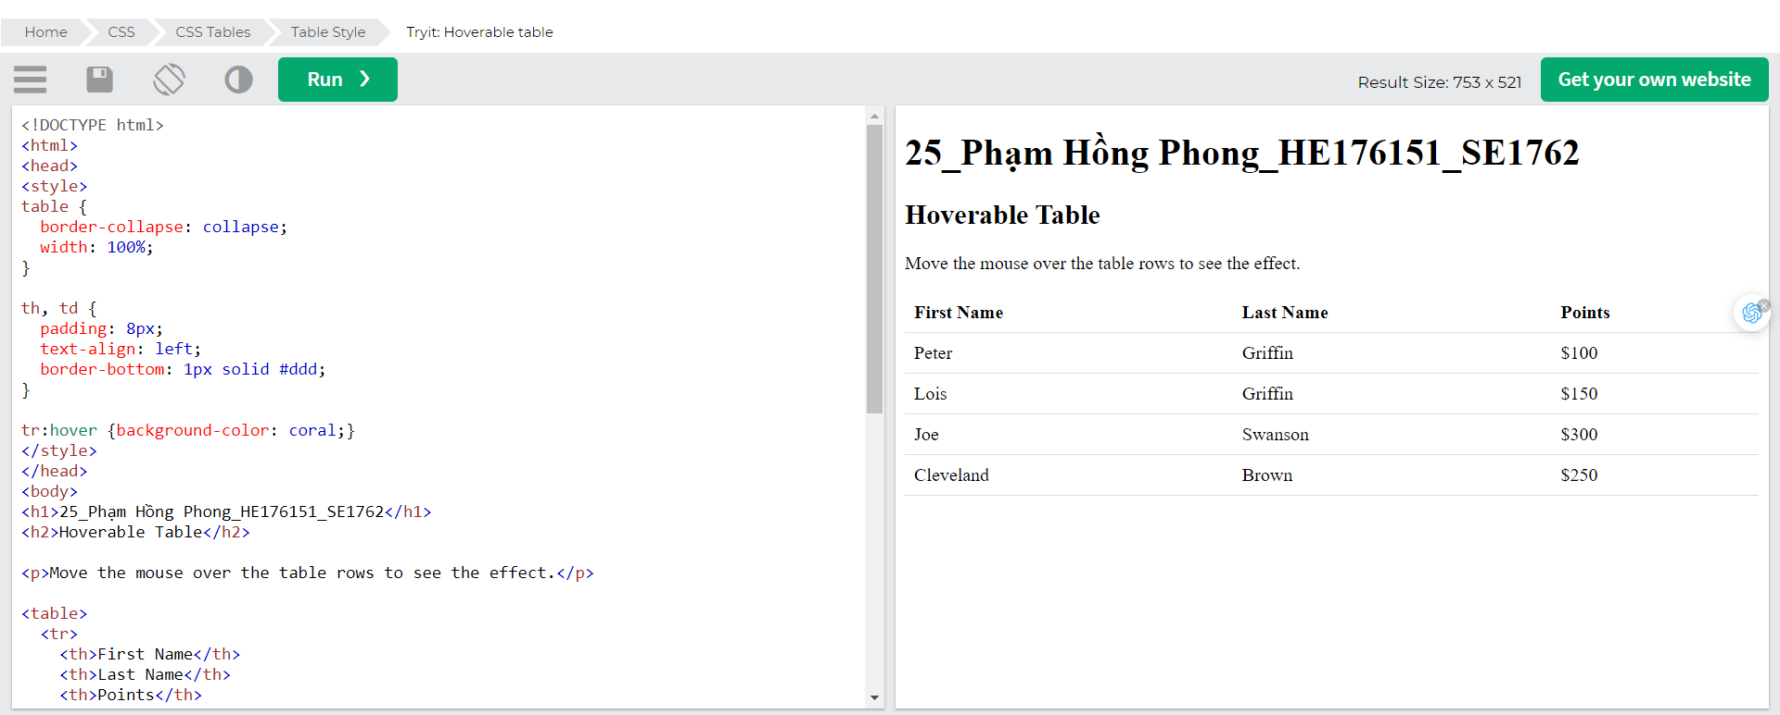

### Striped Tables

### For zebra-striped tables, use the nth-child() selector and add a background-color to all even (or odd) table rows:

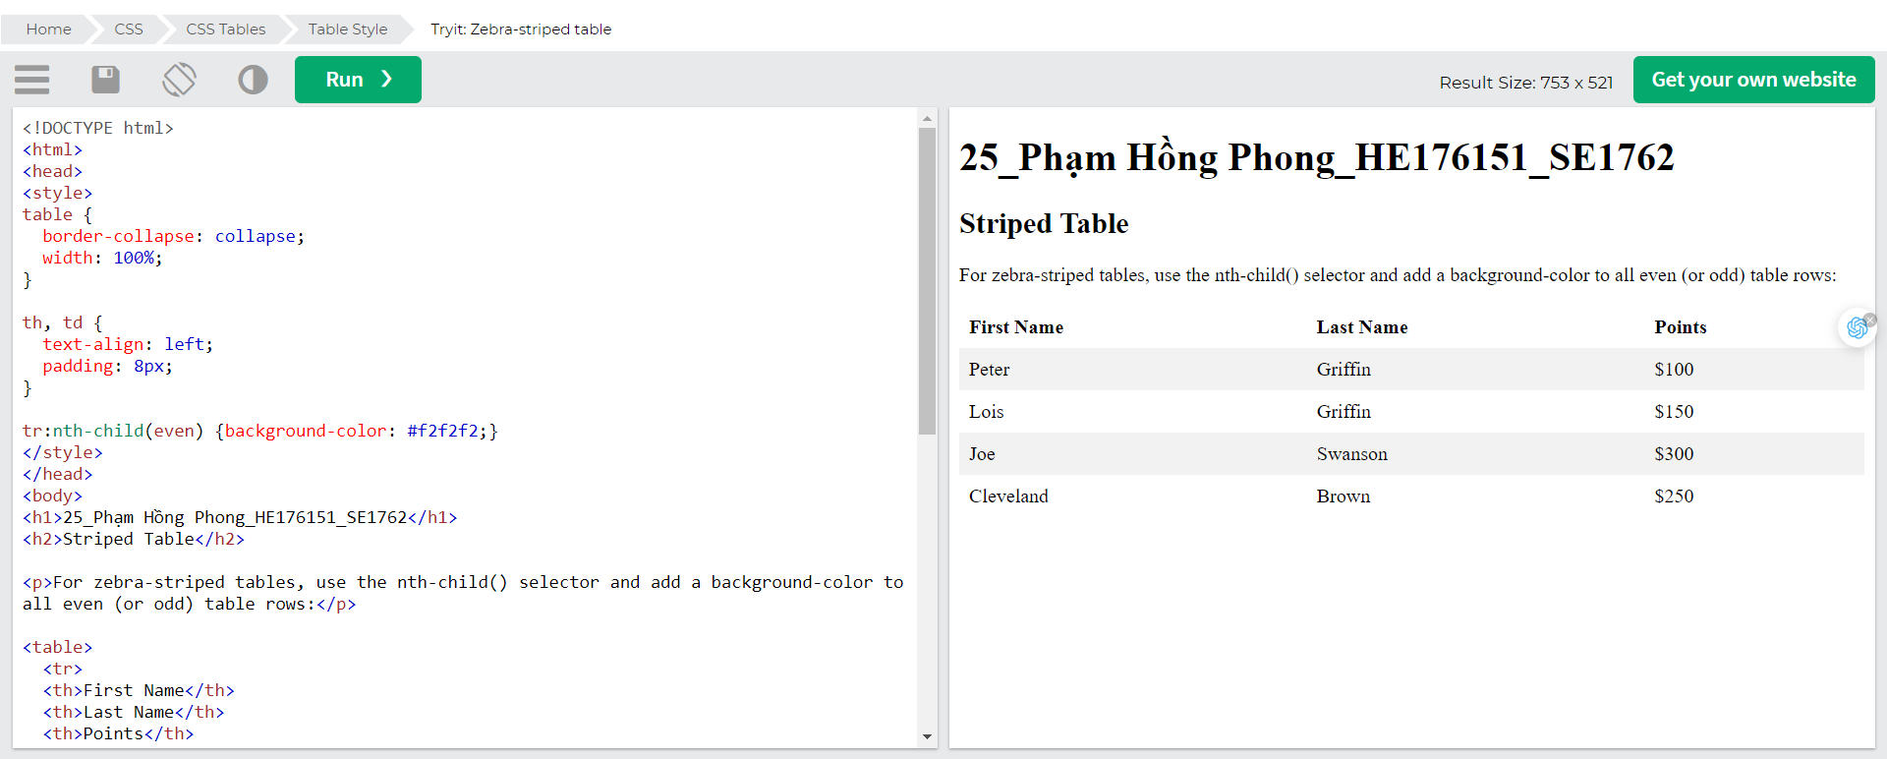

### Table Colour

The example below specifies the background color and text color of <th> elements:

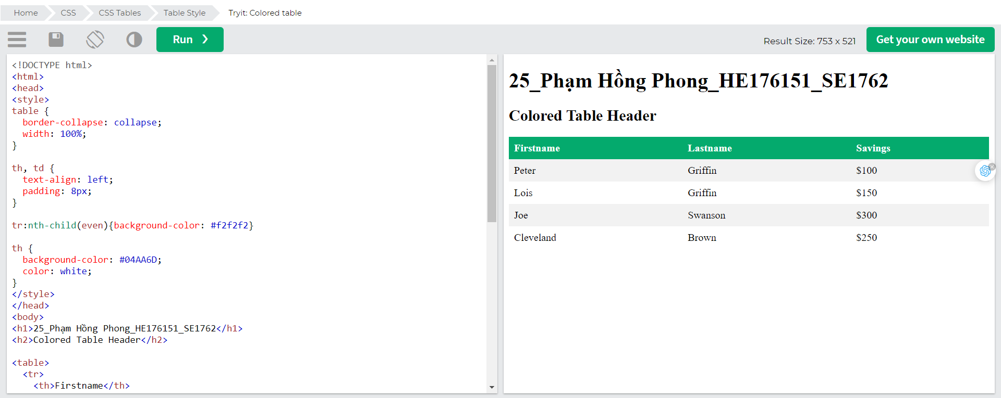

## Responsive Table

A responsive table will display a horizontal scroll bar if the screen is too small to display the full content:

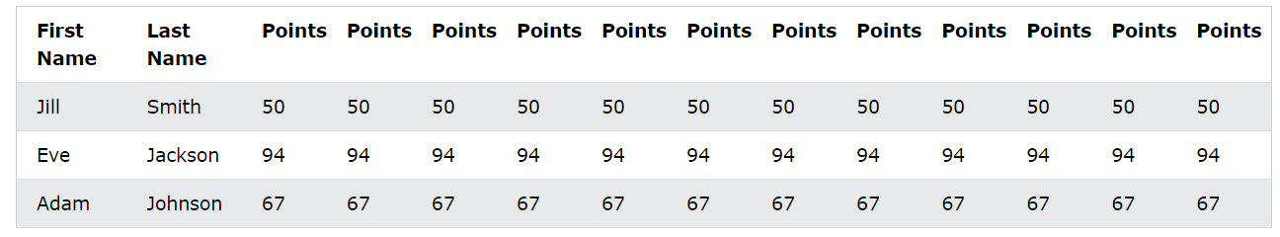

Add a container element (like <div>) with overflow-x:auto around the <table> element to make it responsive:

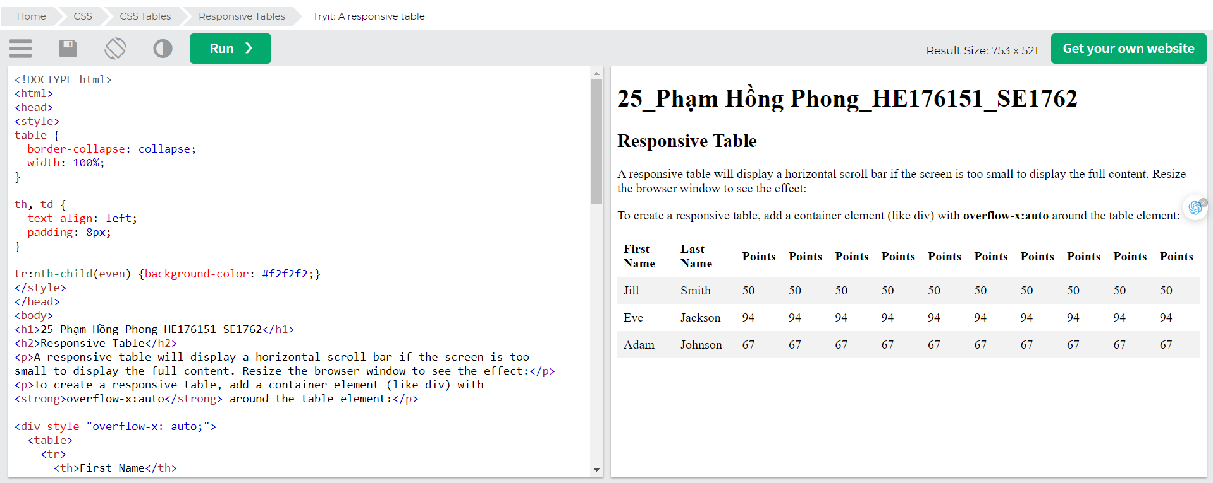

# CSS Display

The display property is the most important CSS property for controlling layout.

## The display Property

The display property specifies if/how an element is displayed.

Every HTML element has a default display value depending on what type of element it is. The default display value for most elements is block or inline.

## Block-level Elements

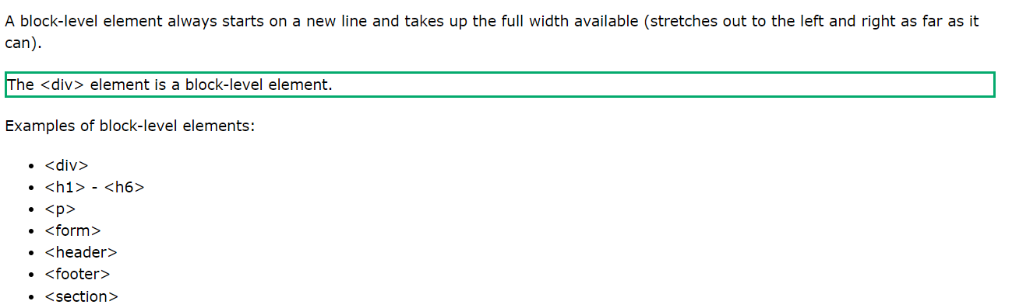

## Inline Elements

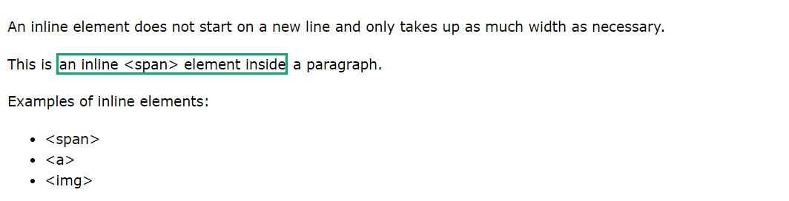

## Display: none;

display: none; is commonly used with JavaScript to hide and show elements without deleting and recreating them. Take a look at our last example on this page if you want to know how this can be achieved.

The <script> element uses display: none; as default.

## Override The Default Display Value

Như đã đề cập, mọi phần tử đều có giá trị hiển thị mặc định. Tuy nhiên, bạn có thể ghi đè lên điều này.

Việc thay đổi phần tử nội tuyến thành phần tử khối hoặc ngược lại có thể hữu ích để làm cho trang có giao diện cụ thể mà vẫn tuân theo các tiêu chuẩn web.

A common example is making inline <li> elements for horizontal menus:

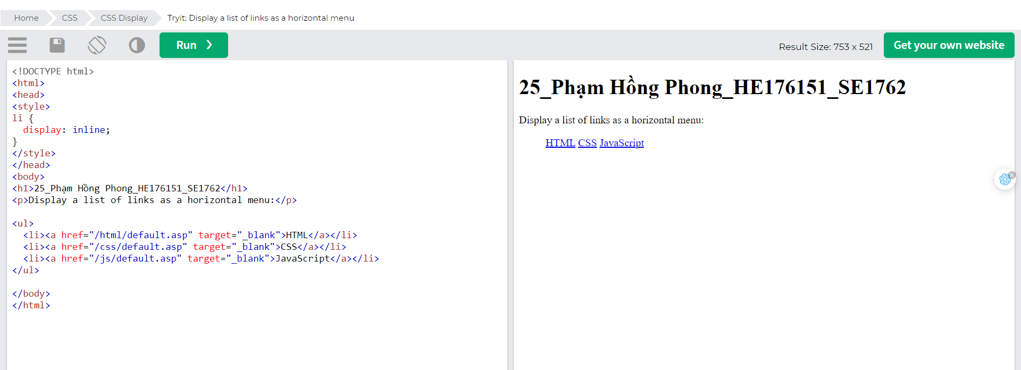

The following example displays <span> elements as block elements:

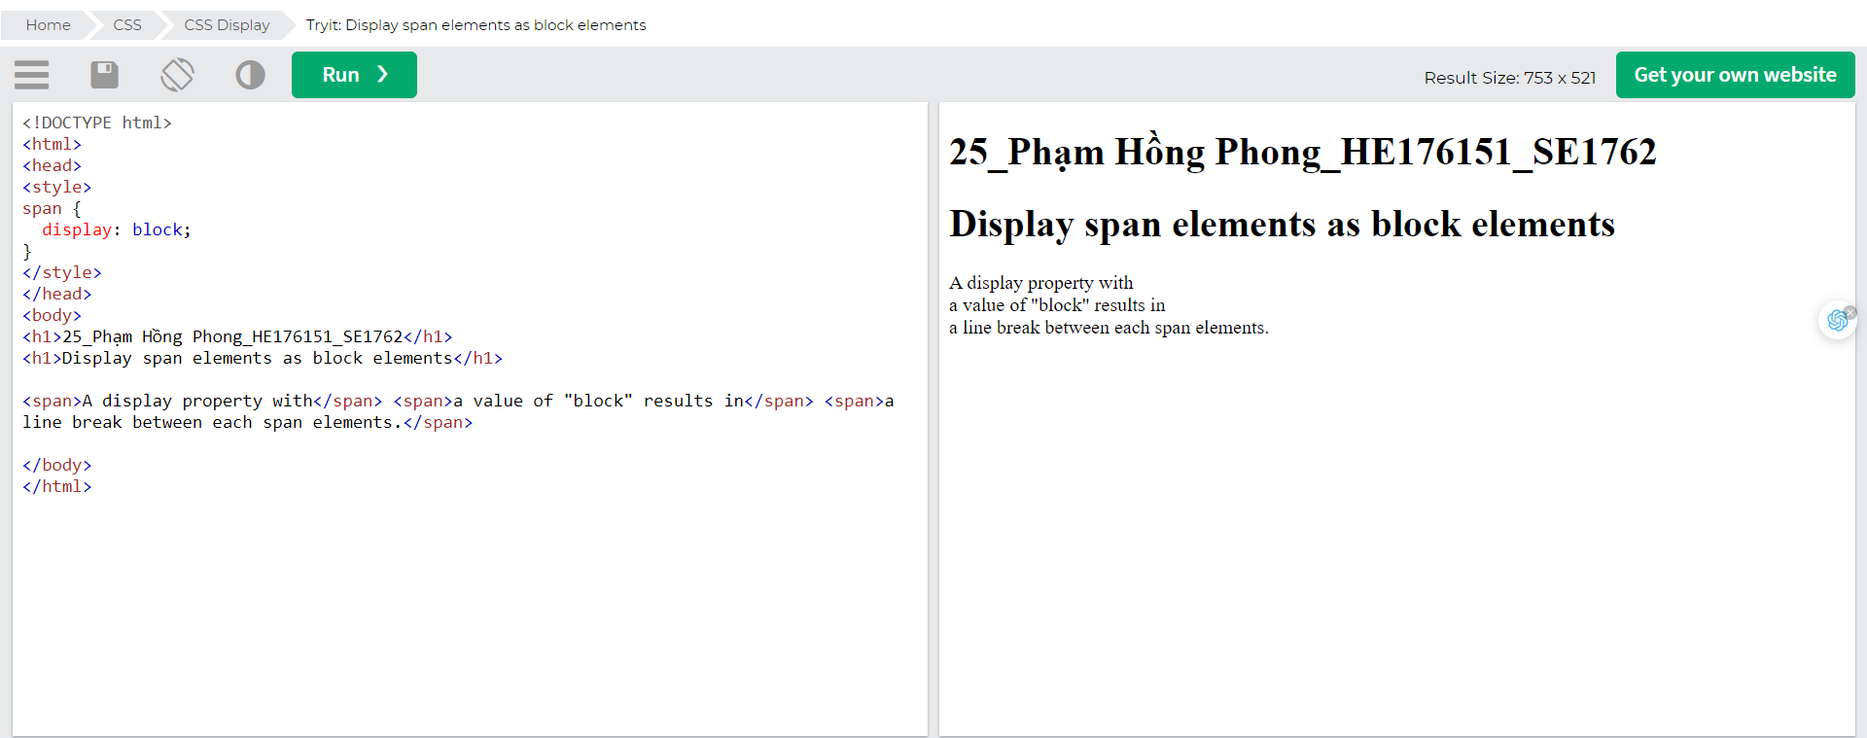

The following example displays <a> elements as block elements: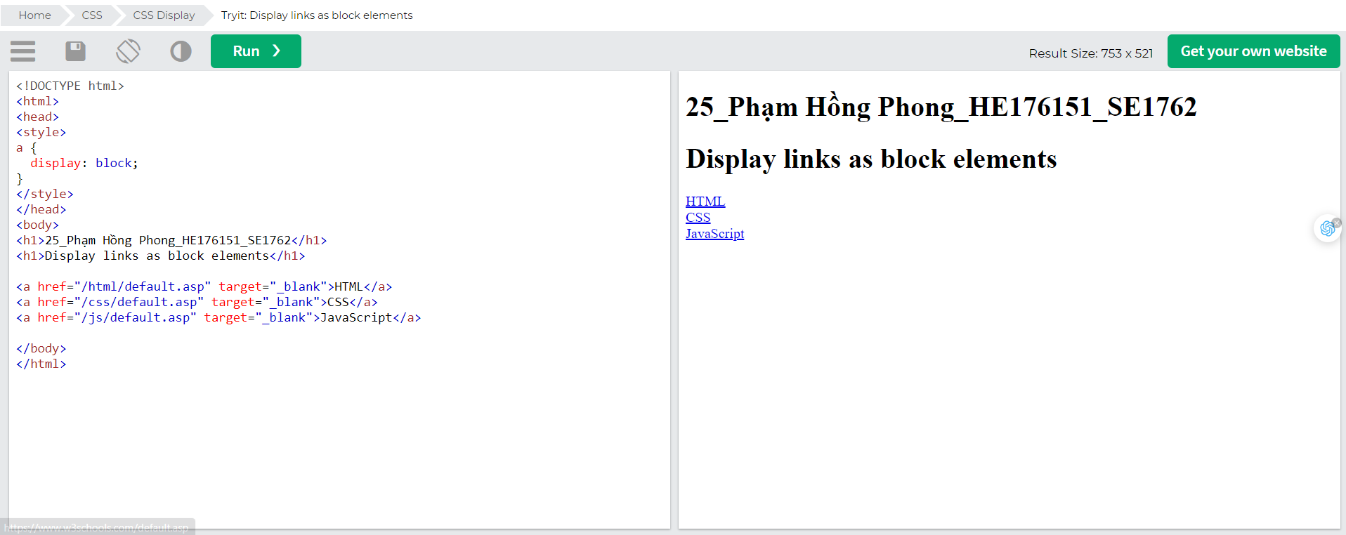

## Hide an Element - display:none or visibility:hidden?

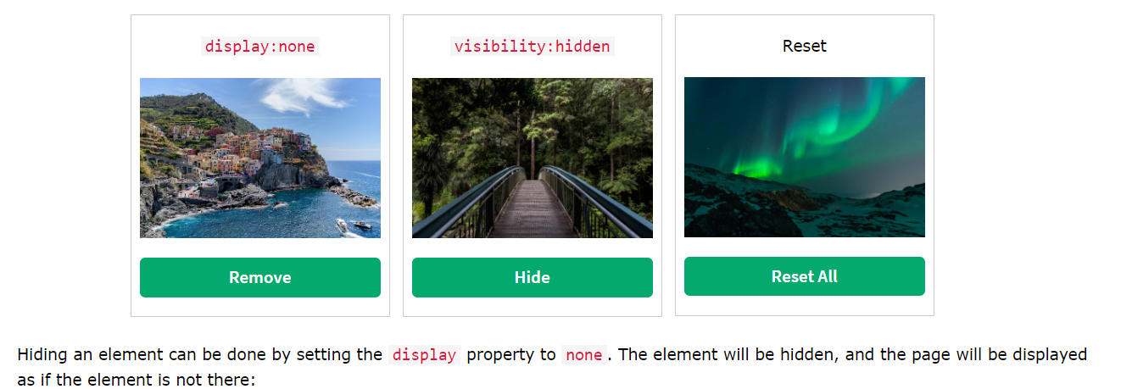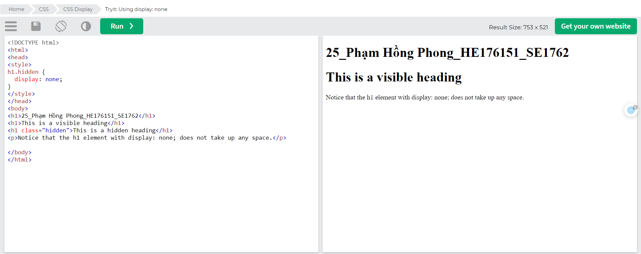visibility:hidden; also hides an element.

However, the element will still take up the same space as before. The element will be hidden, but still affect the layout:

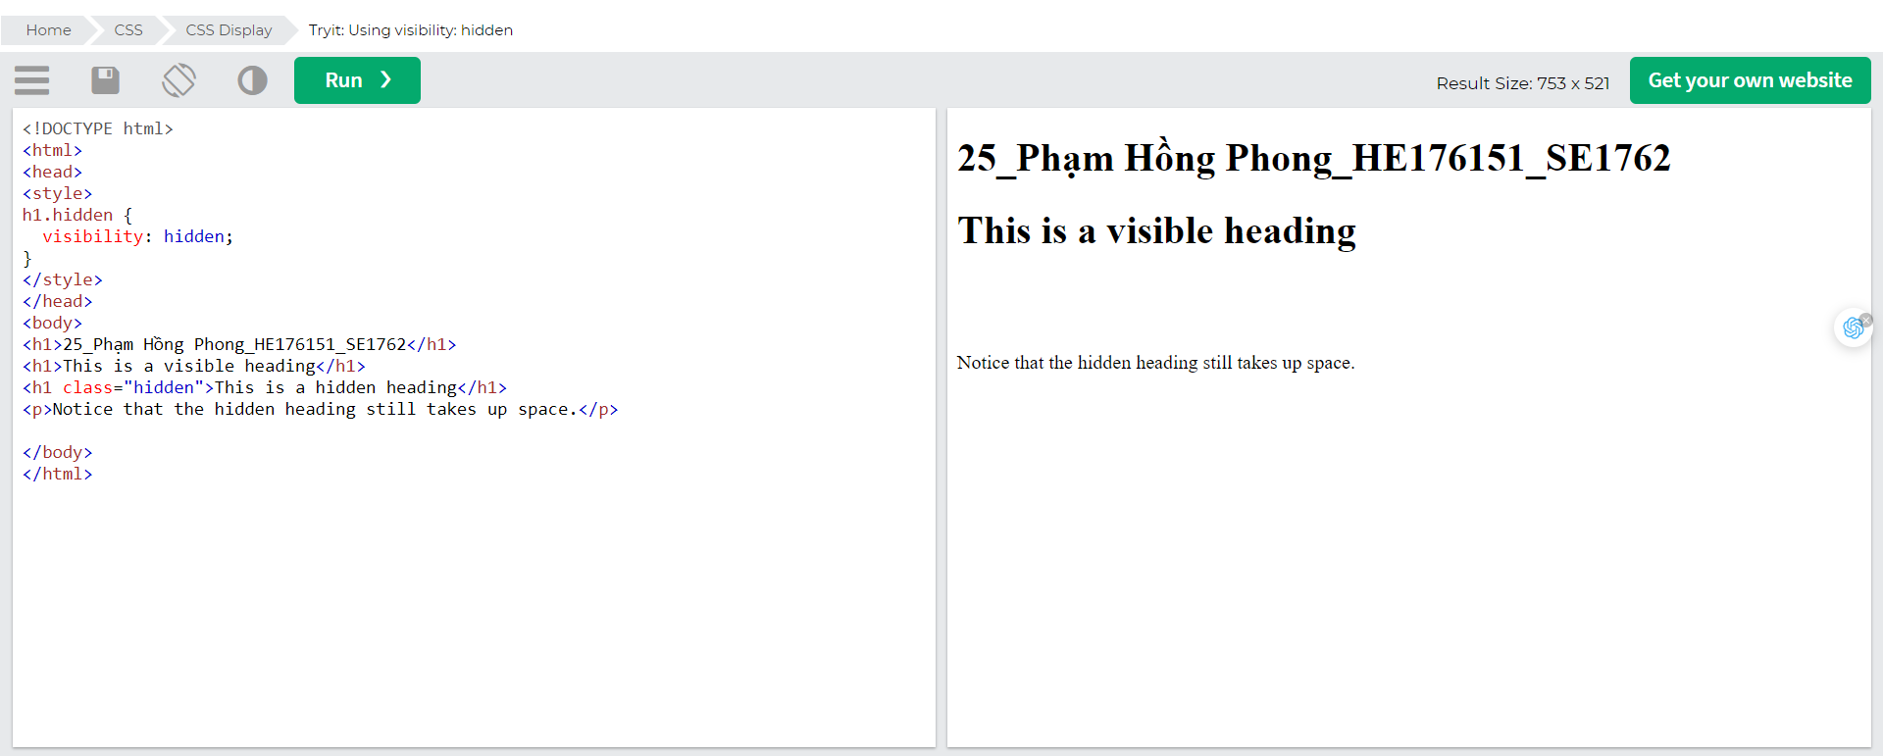

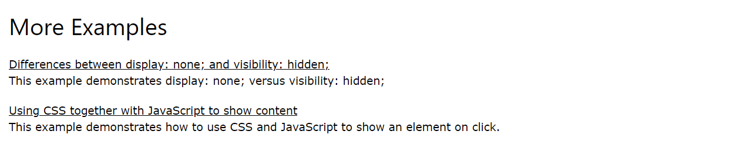

# CSS Max-width

## Using width, max-width and margin: auto;

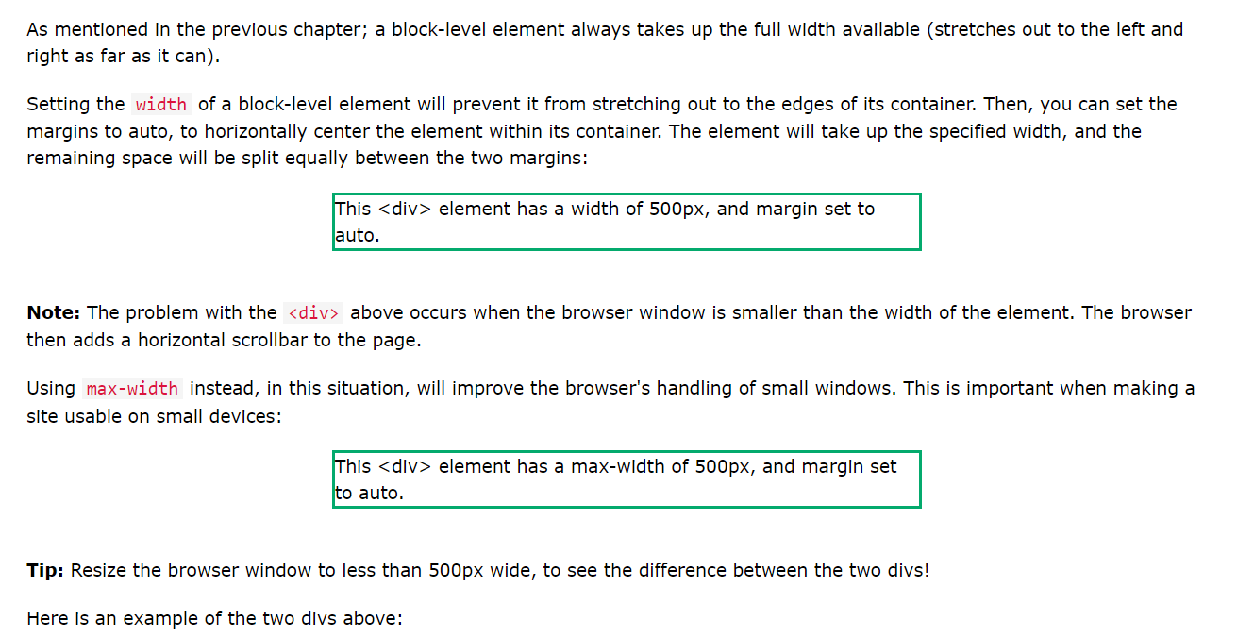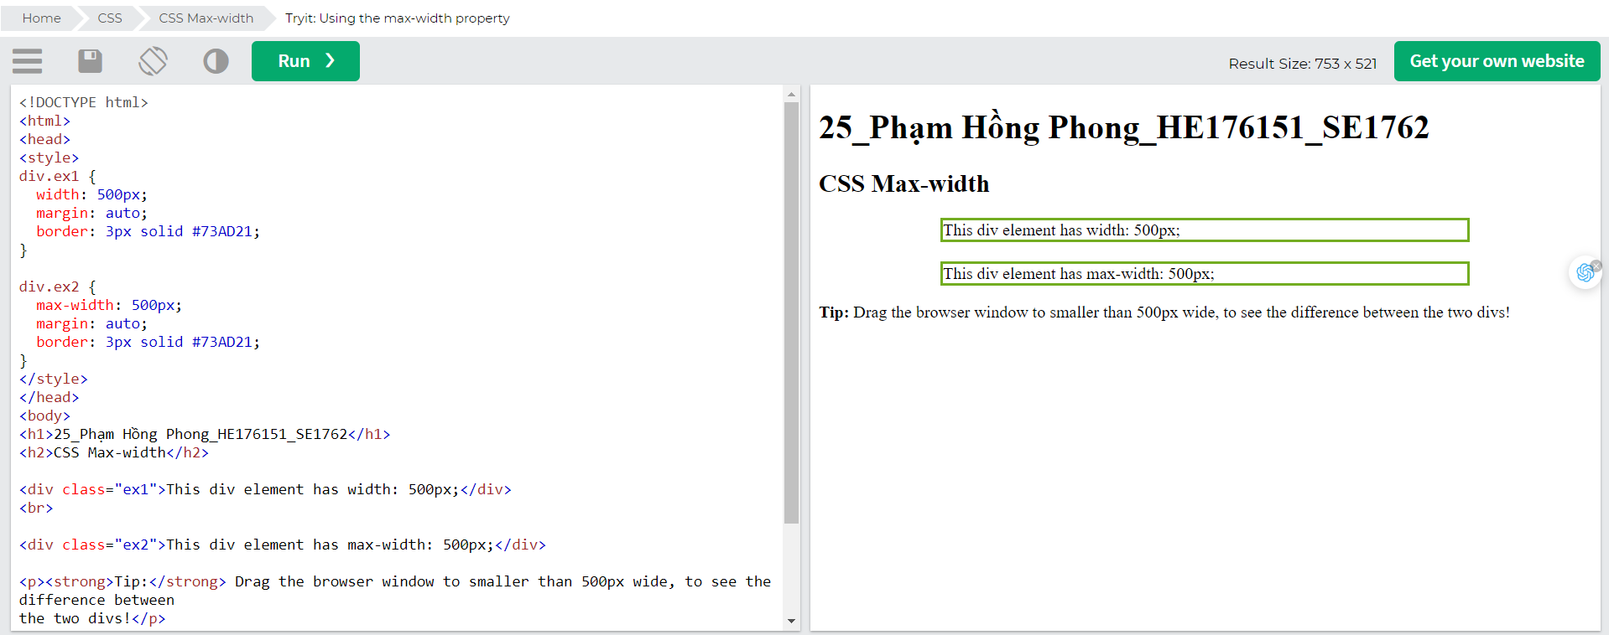

# CSS Position

The position property specifies the type of positioning method used for an element (static, relative, fixed, absolute or sticky).

## The position Property

The position property specifies the type of positioning method used for an element.

There are five different position values:

* static
* relative
* fixed
* absolute
* sticky

Elements are then positioned using the top, bottom, left, and right properties. However, these properties will not work unless the position property is set first. They also work differently depending on the position value.

## position: static;

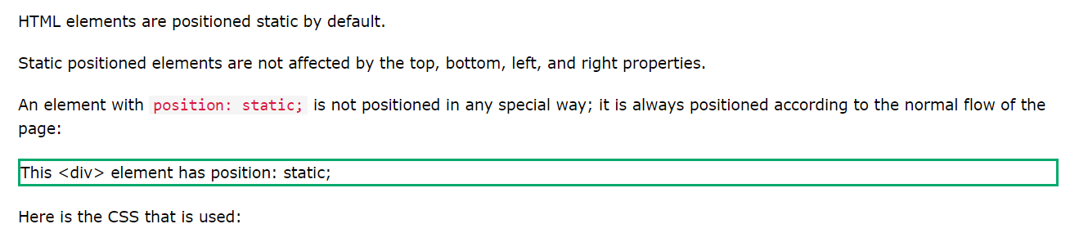

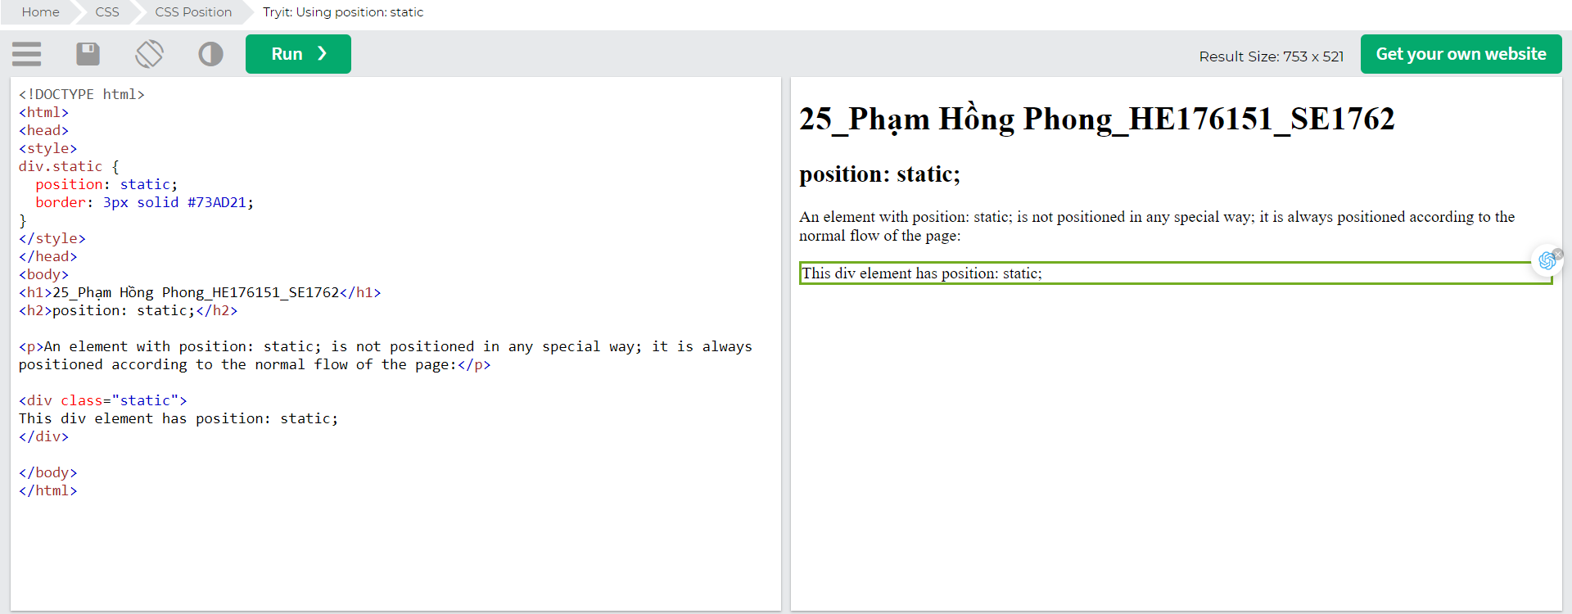

## position: relative;

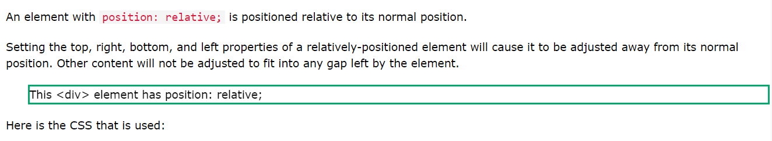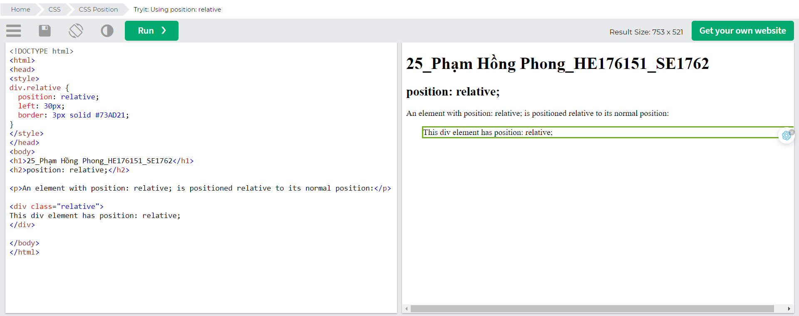

## position: fixed;

An element with position: fixed; is positioned relative to the viewport, which means it always stays in the same place even if the page is scrolled. The top, right, bottom, and left properties are used to position the element.

A fixed element does not leave a gap in the page where it would normally have been located.

Notice the fixed element in the lower-right corner of the page. Here is the CSS that is used:

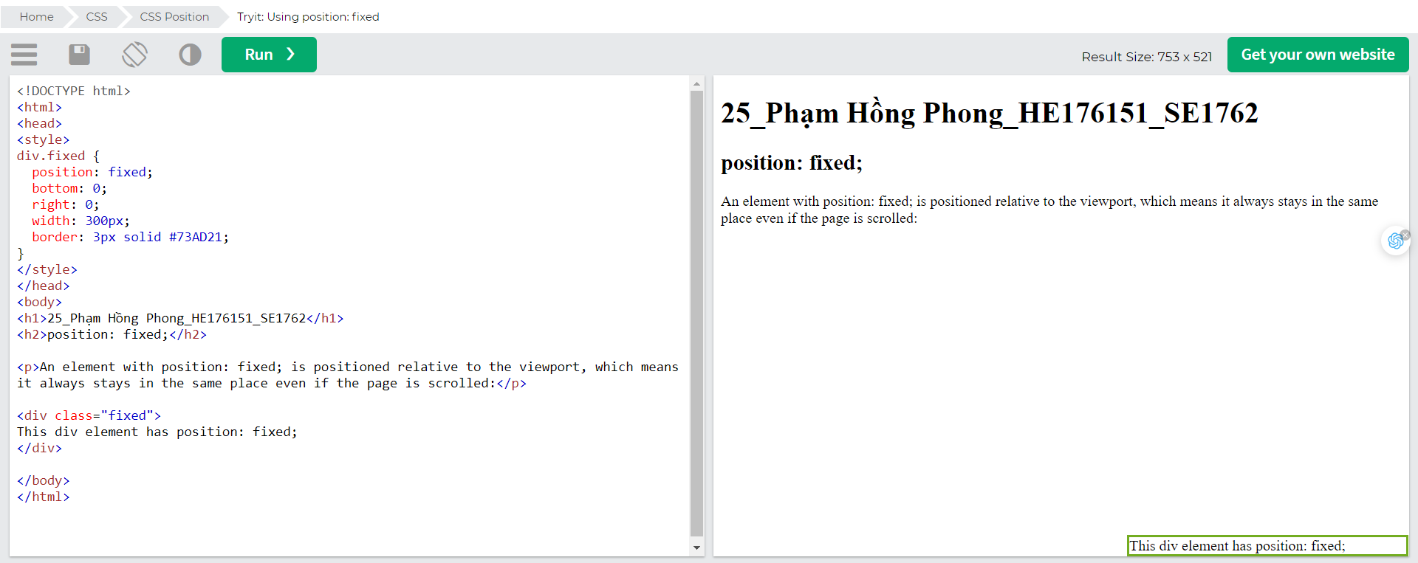

## position: absolute;

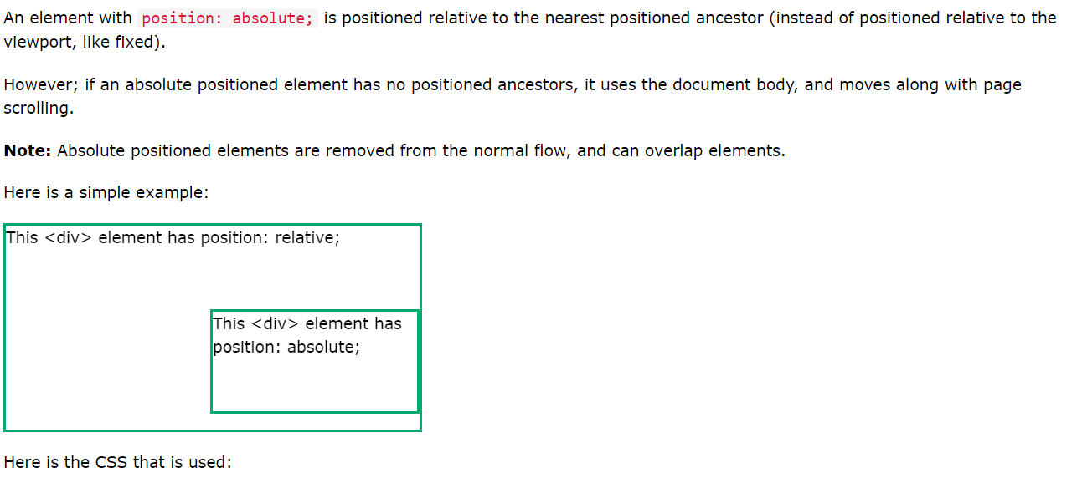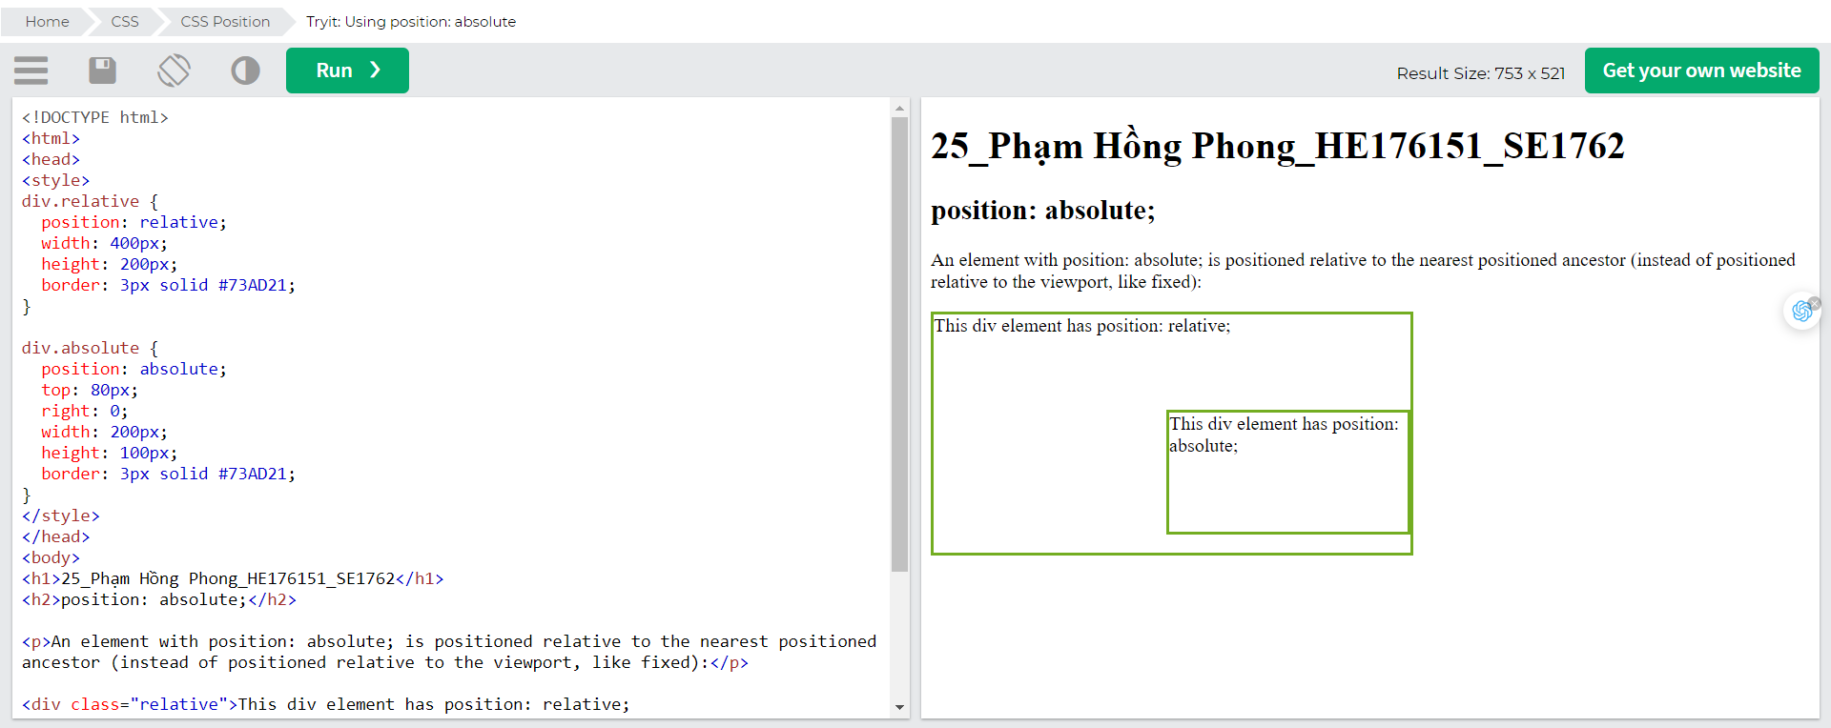

## position: sticky;

An element with position: sticky; is positioned based on the user's scroll position.

A sticky element toggles between relative and fixed, depending on the scroll position. It is positioned relative until a given offset position is met in the viewport - then it "sticks" in place (like position:fixed).

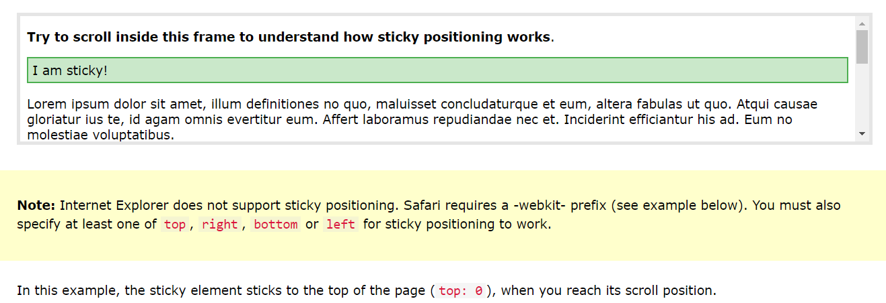

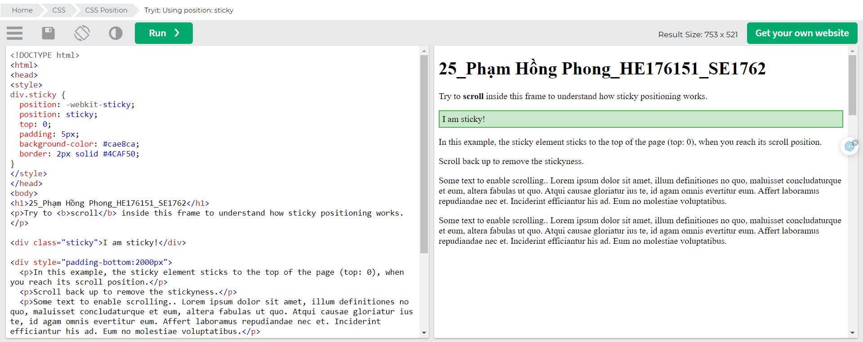

## Positioning Text In an Image

How to position text over an image:

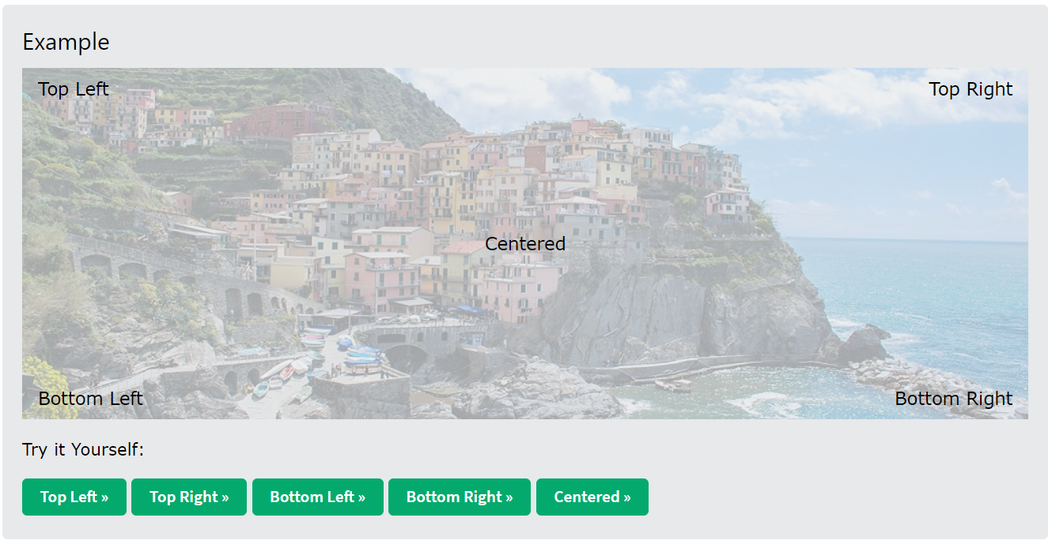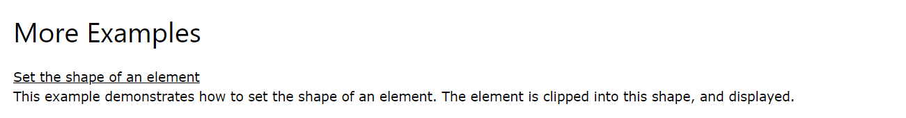

# CSS Z-index

The z-index property specifies the stack order of an element.

## The z-index Property

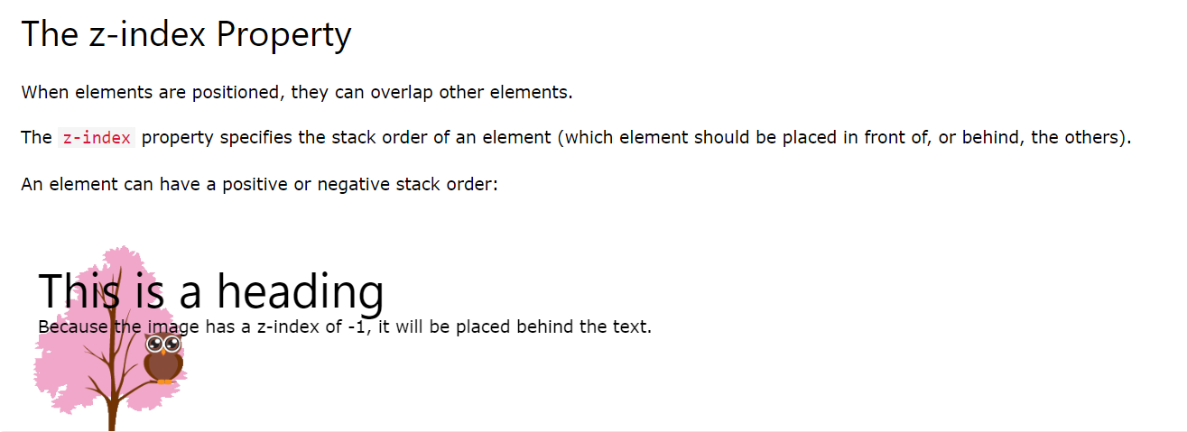

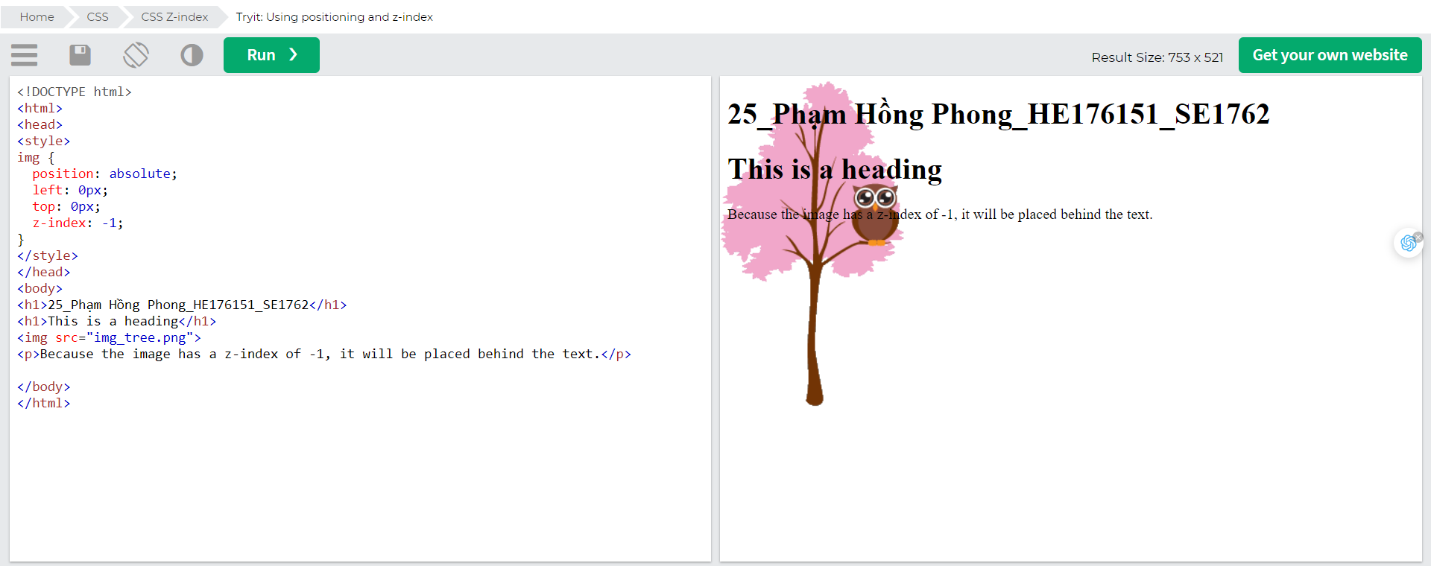

## Another z-index Example

## Without z-index

If two positioned elements overlap each other without a z-index specified, the element defined last in the HTML code will be shown on top.

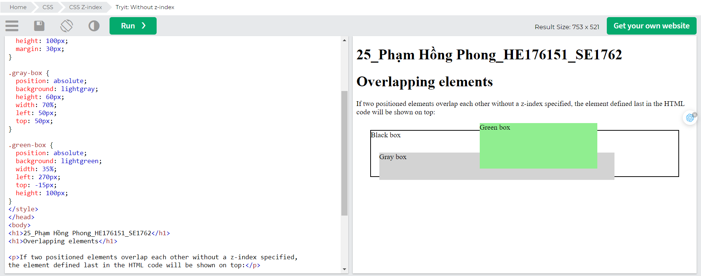

# CSS Overflow

The CSS overflow property controls what happens to content that is too big to fit into an area.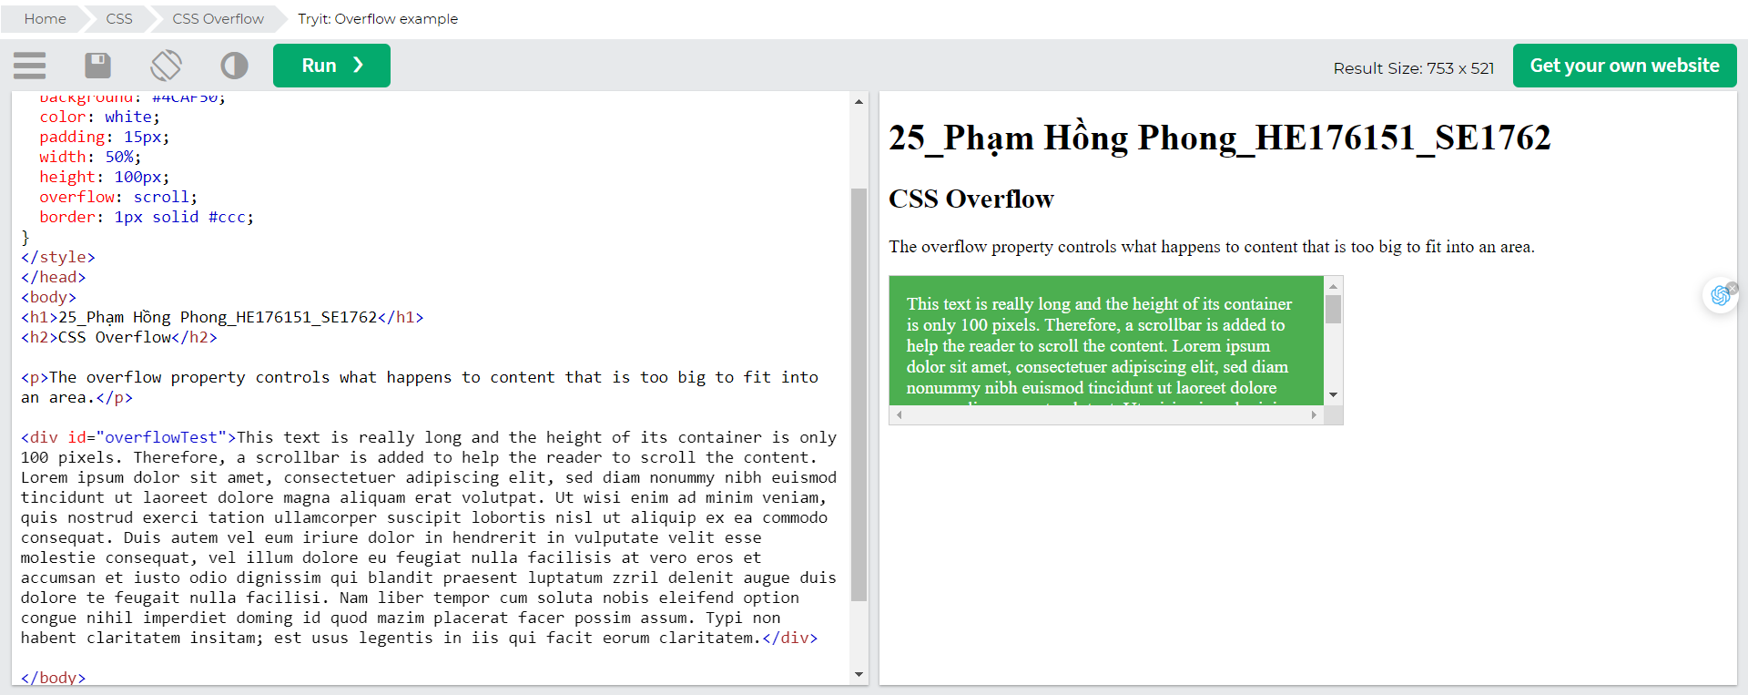

## CSS Overflow

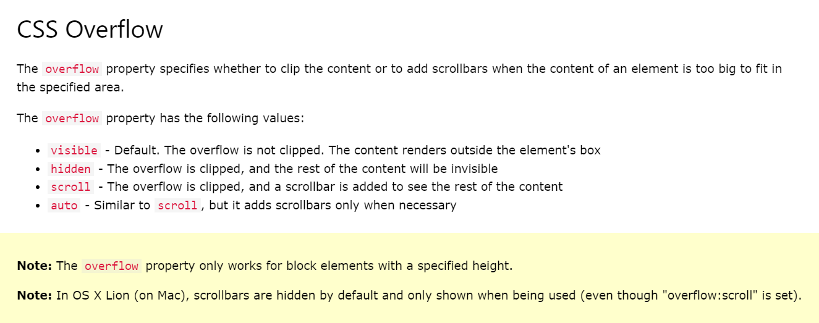

## overflow: visible

By default, the overflow is visible, meaning that it is not clipped and it renders outside the element's box:

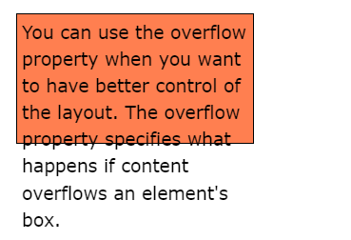

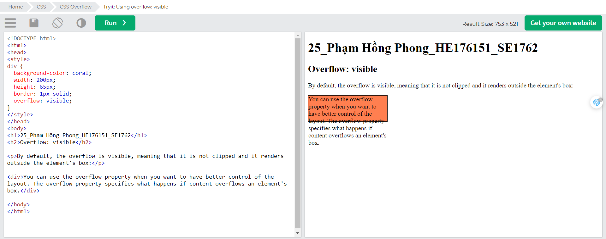

## overflow: hidden

With the hidden value, the overflow is clipped, and the rest of the content is hidden:

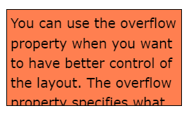

## overflow: scroll

Setting the value to scroll, the overflow is clipped and a scrollbar is added to scroll inside the box. Note that this will add a scrollbar both horizontally and vertically (even if you do not need it):

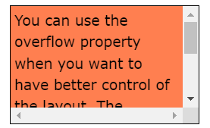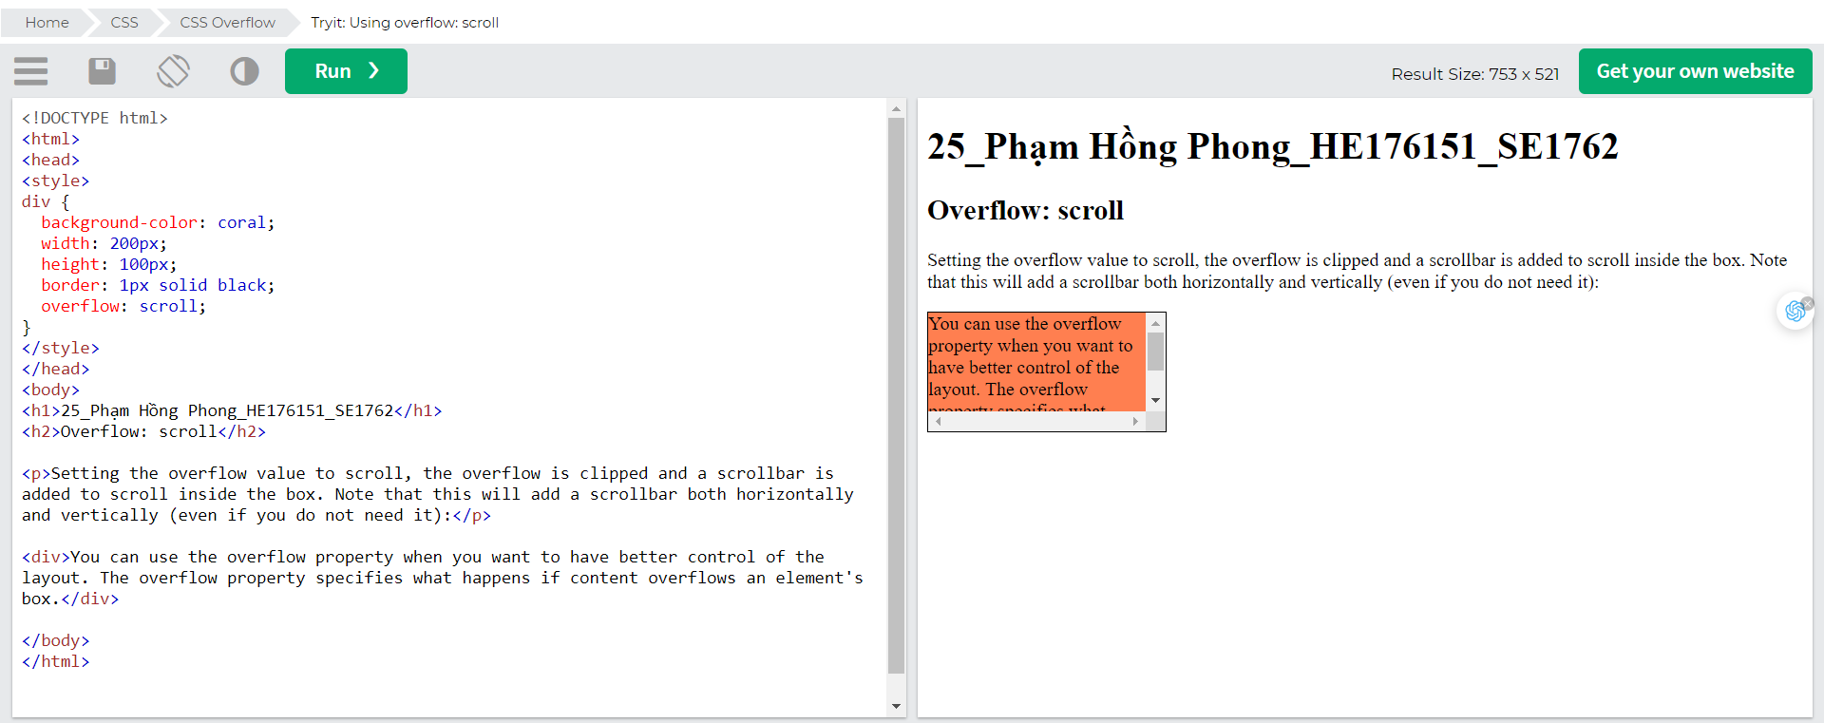

## overflow: auto

The auto value is similar to scroll, but it adds scrollbars only when necessary:

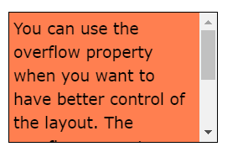

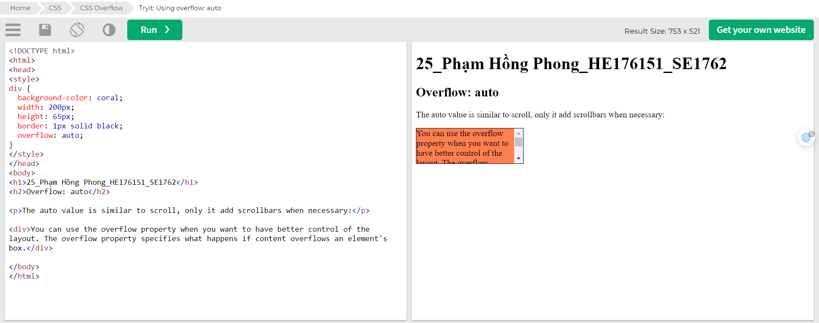

## overflow-x and overflow-y

The overflow-x and overflow-y properties specifies whether to change the overflow of content just horizontally or vertically (or both):

overflow-x specifies what to do with the left/right edges of the content.  
overflow-y specifies what to do with the top/bottom edges of the content.

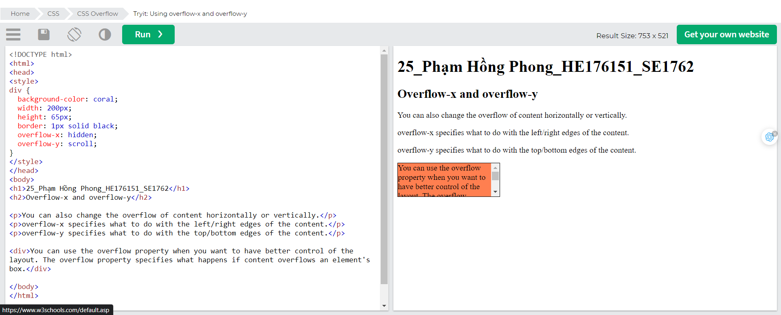

# CSS Float

The CSS float property specifies how an element should float.

The CSS clear property specifies what elements can float beside the cleared element and on which side.



## Float

### The float Property

The float property is used for positioning and formatting content e.g. let an image float left to the text in a container.

The float property can have one of the following values:

* left - The element floats to the left of its container
* right - The element floats to the right of its container
* none - The element does not float (will be displayed just where it occurs in the text). This is default
* inherit - The element inherits the float value of its parent

In its simplest use, the float property can be used to wrap text around images.

### Example - float: right;

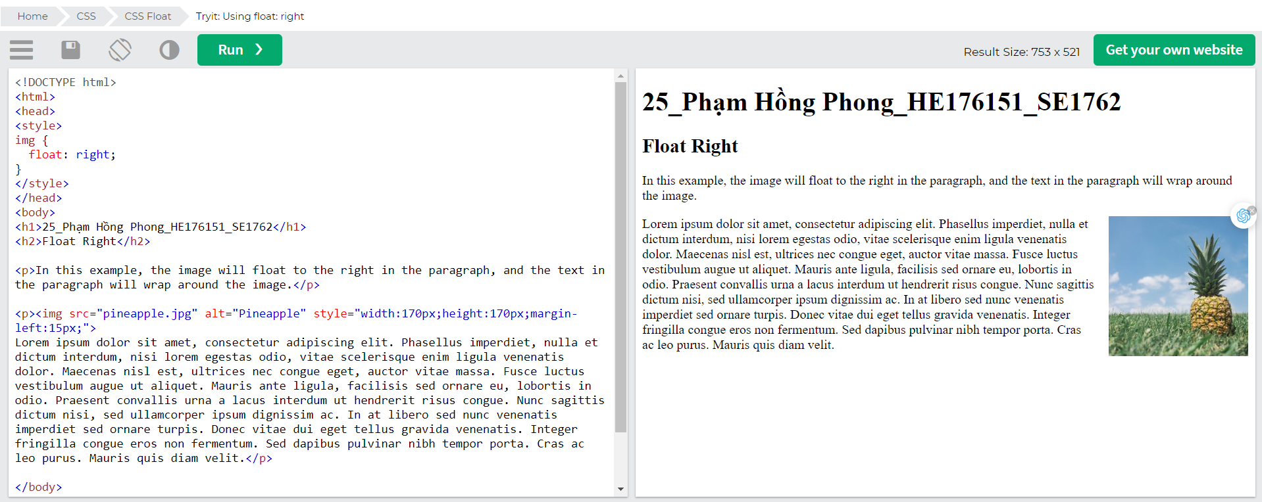

### Example - float: left;

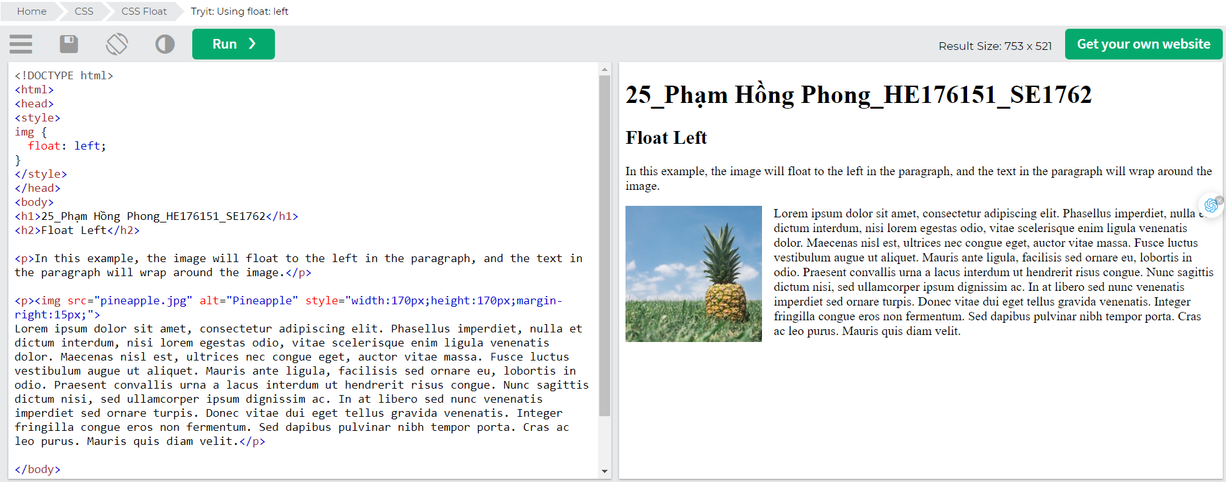

### Example - No float

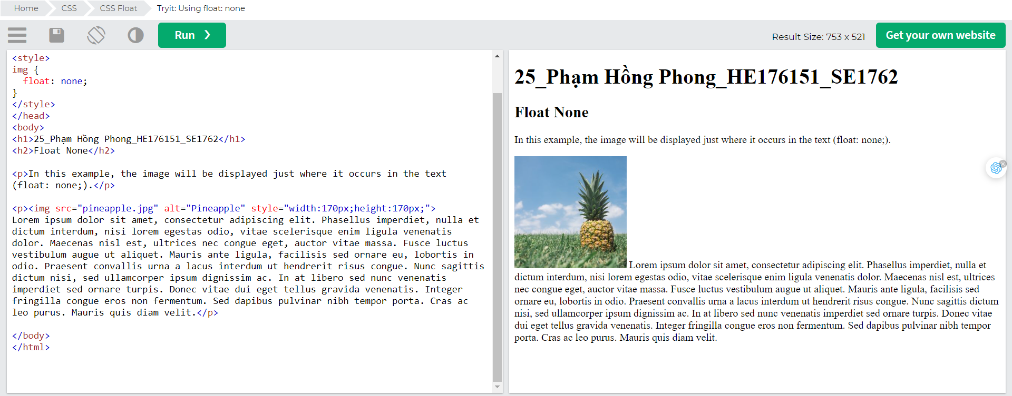

### Example - Float Next To Each Other

Normally div elements will be displayed on top of each other. However, if we use float: left we can let elements float next to each other: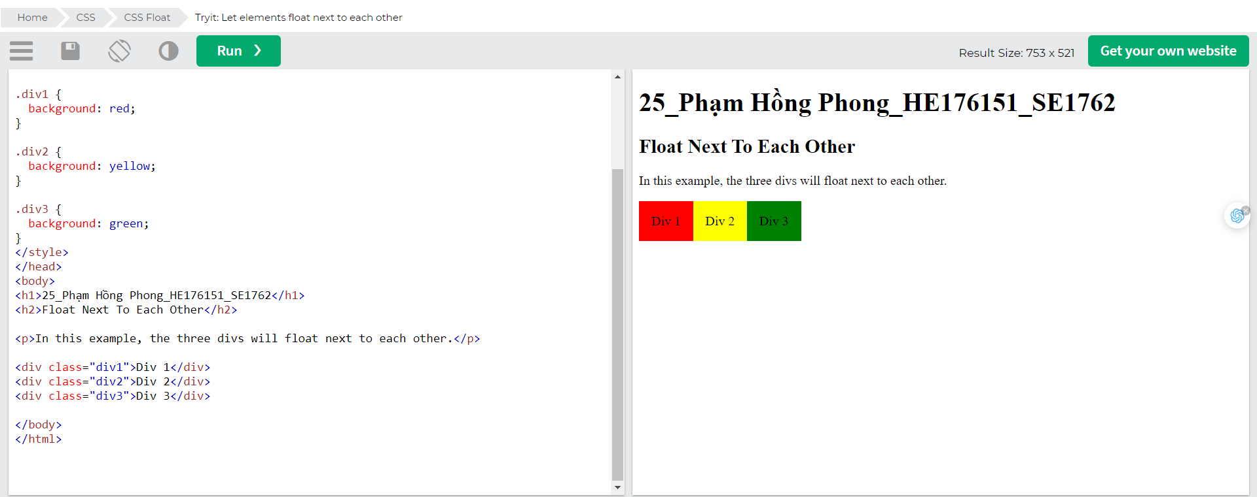

## Clear

### The clear Property

When we use the float property, and we want the next element below (not on right or left), we will have to use the clear property.

The clear property specifies what should happen with the element that is next to a floating element.

The clear property can have one of the following values:

* none - The element is not pushed below left or right floated elements. This is default
* left - The element is pushed below left floated elements
* right - The element is pushed below right floated elements
* both - The element is pushed below both left and right floated elements
* inherit - The element inherits the clear value from its parent

When clearing floats, you should match the clear to the float: If an element is floated to the left, then you should clear to the left. Your floated element will continue to float, but the cleared element will appear below it on the web page.

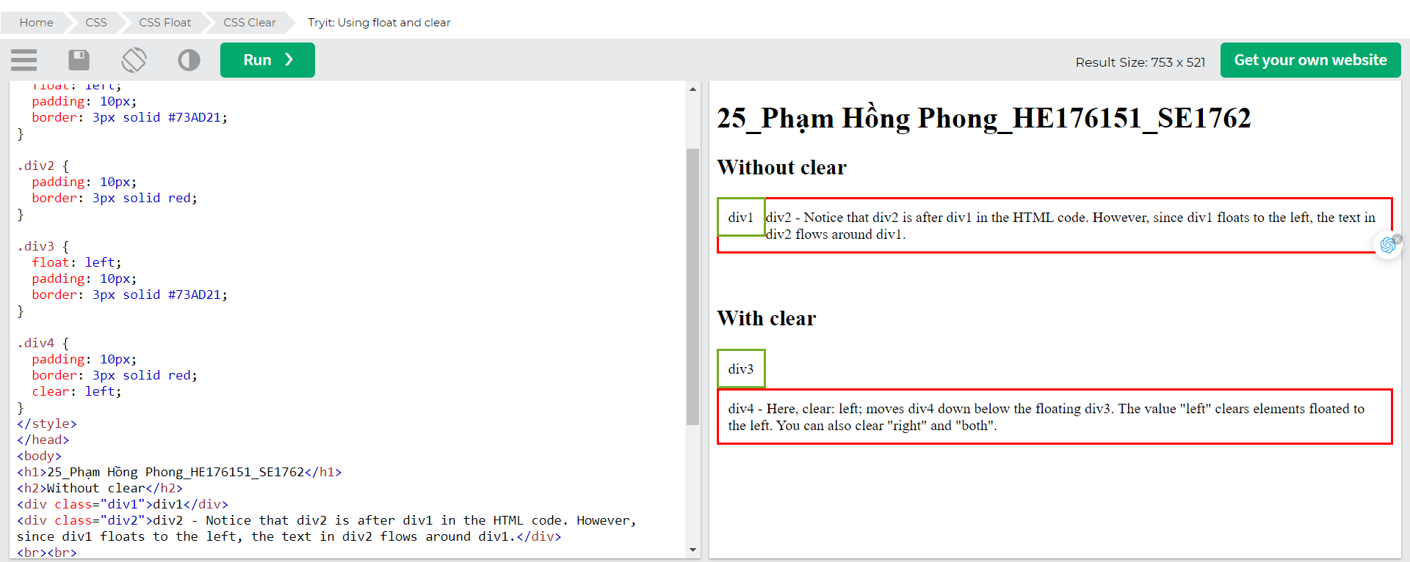

## The clearfix Hack

If a floated element is taller than the containing element, it will "overflow" outside of its container. We can then add a clearfix hack to solve this problem: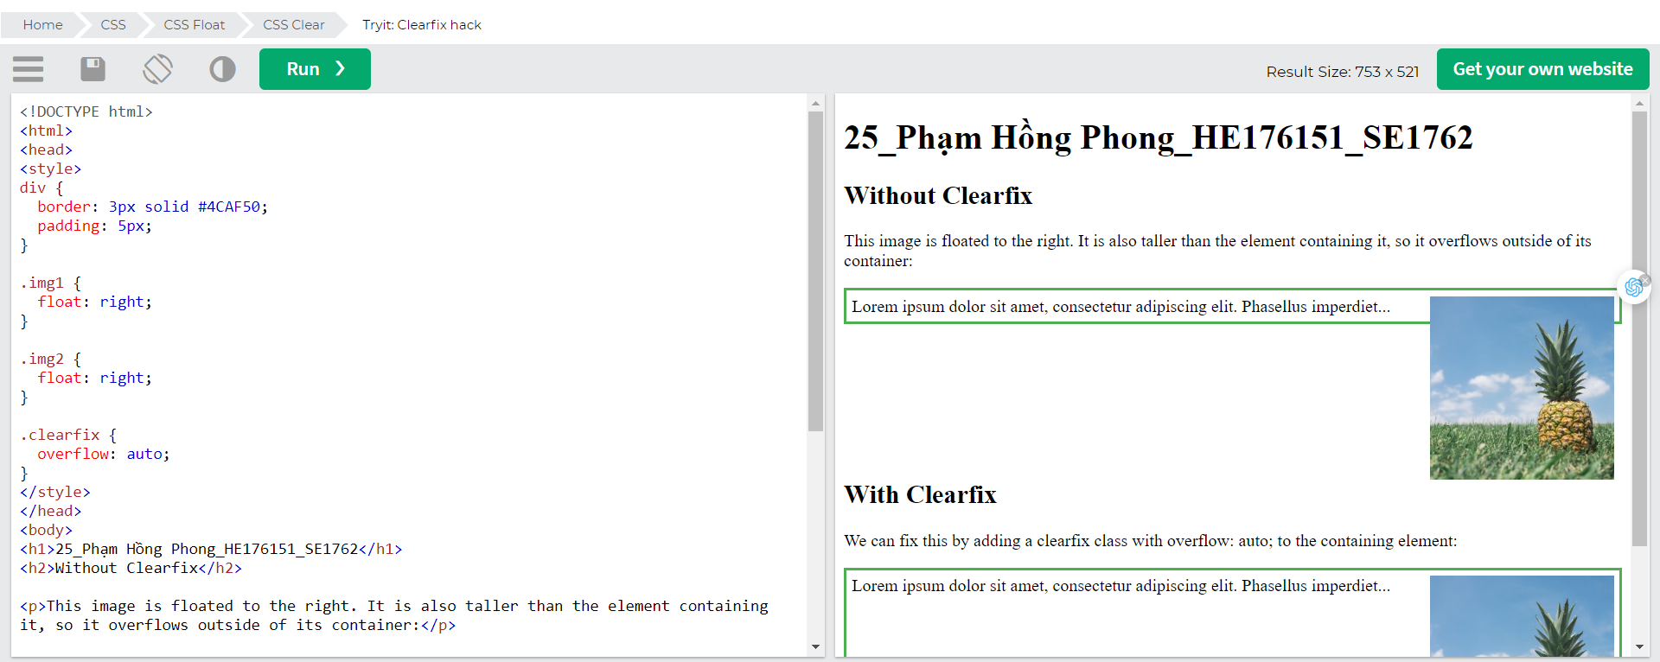The overflow: auto clearfix works well as long as you are able to keep control of your margins and padding (else you might see scrollbars). The new, modern clearfix hack however, is safer to use, and the following code is used for most webpages: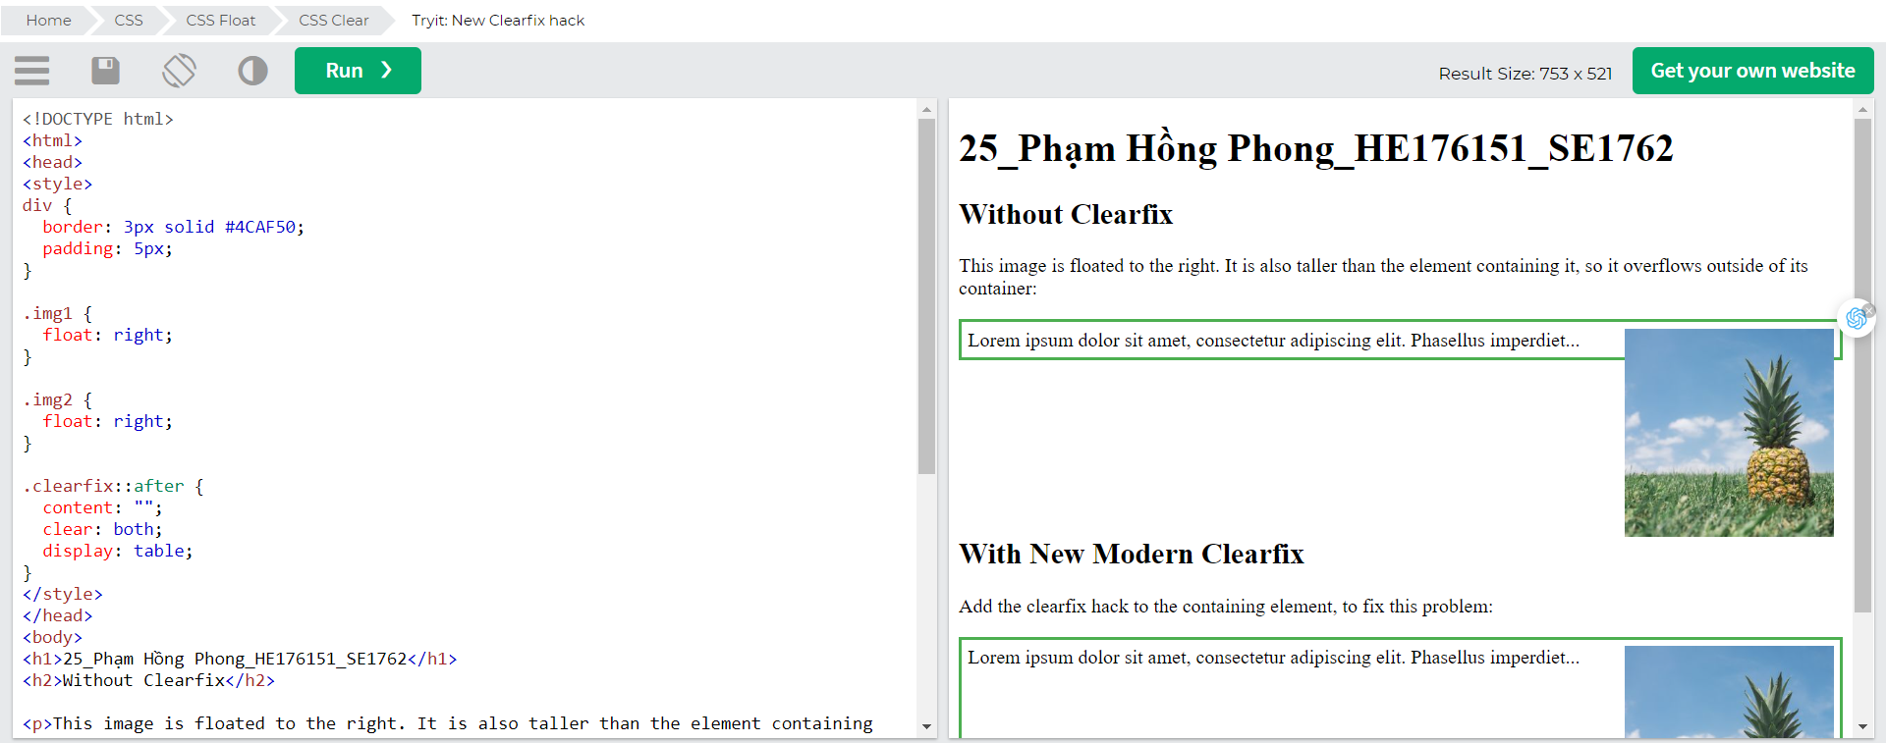

## Float Examples

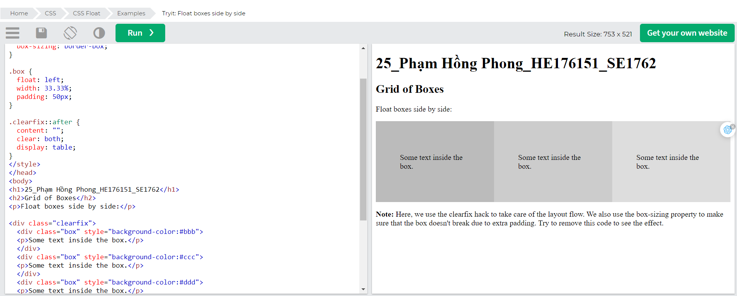

## Images Side By Side

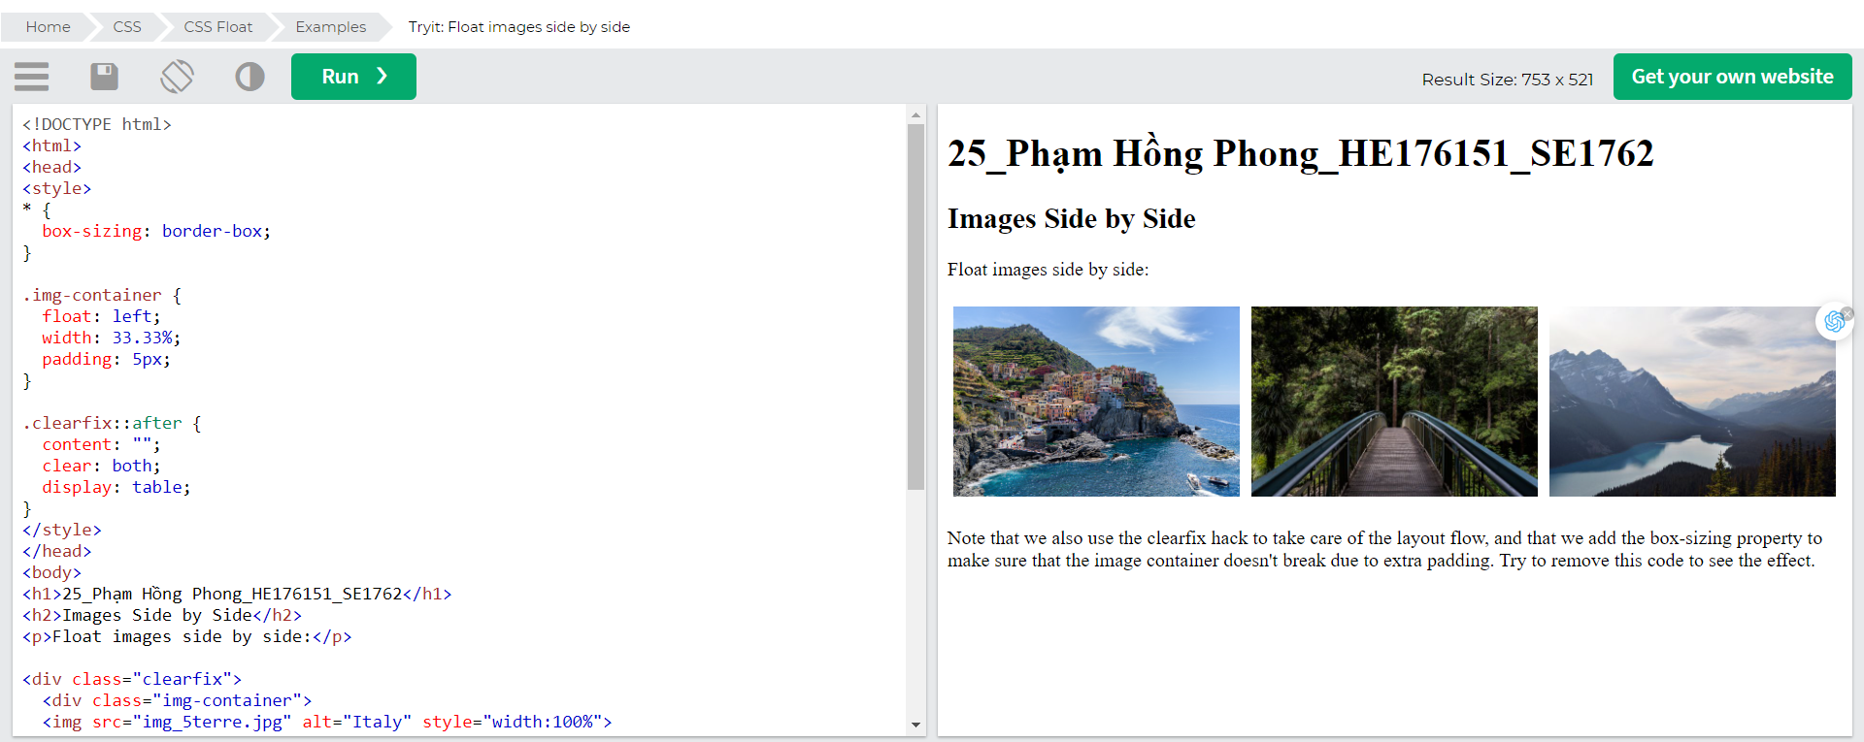

## Equal Height Boxes

In the previous example, you learned how to float boxes side by side with an equal width. However, it is not easy to create floating boxes with equal heights. A quick fix however, is to set a fixed height, like in the example below: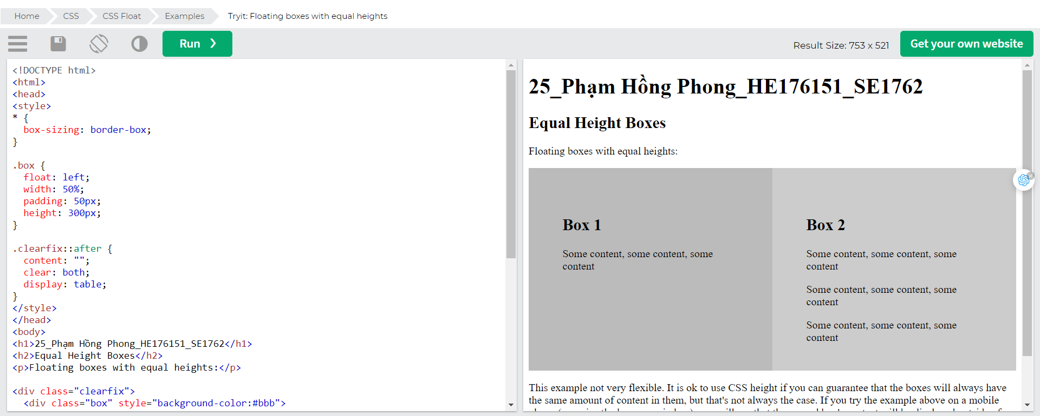However, this is not very flexible. It is ok if you can guarantee that the boxes will always have the same amount of content in them. But many times, the content is not the same. If you try the example above on a mobile phone, you will see that the second box's content will be displayed outside of the box. This is where CSS3 Flexbox comes in handy - as it can automatically stretch boxes to be as long as the longest box: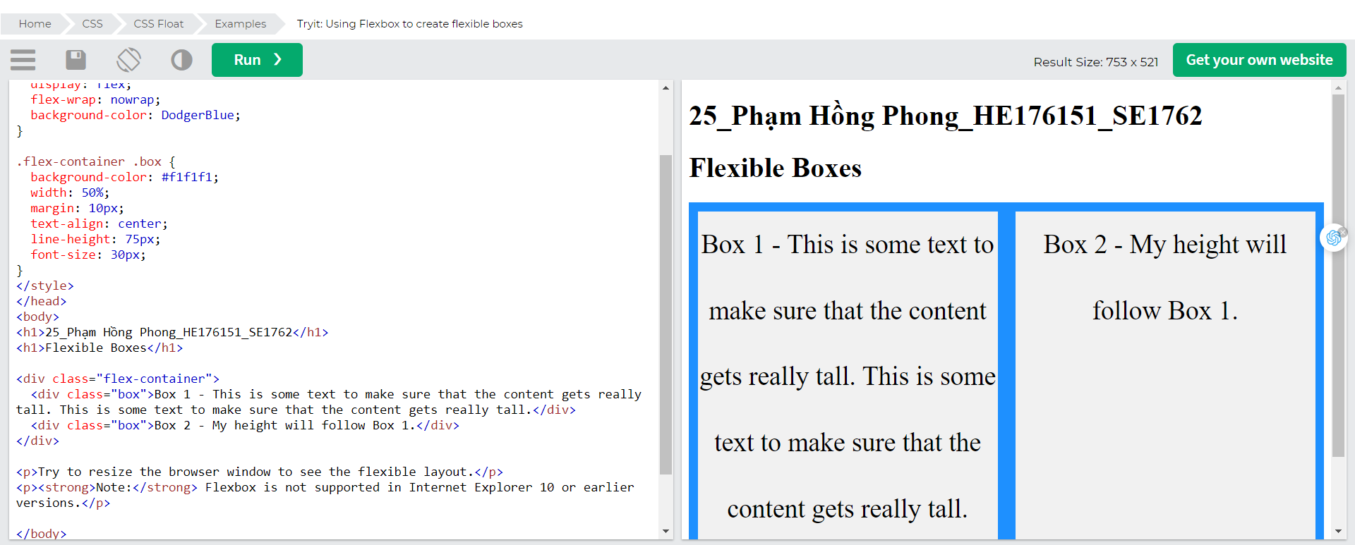

## Navigation Menu

You can also use float with a list of hyperlinks to create a horizontal menu: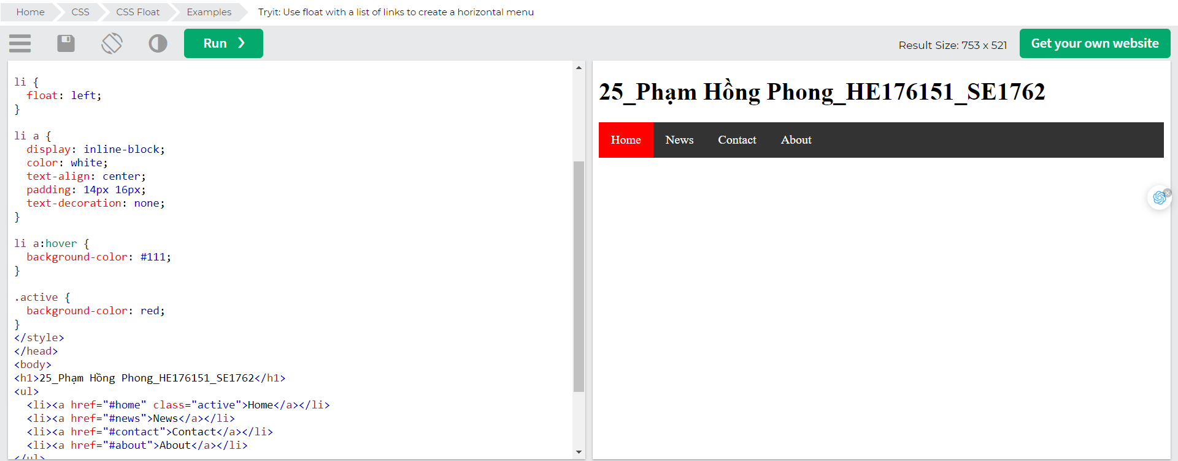

## Web Layout Example

It is also common to do entire web layouts using the float property: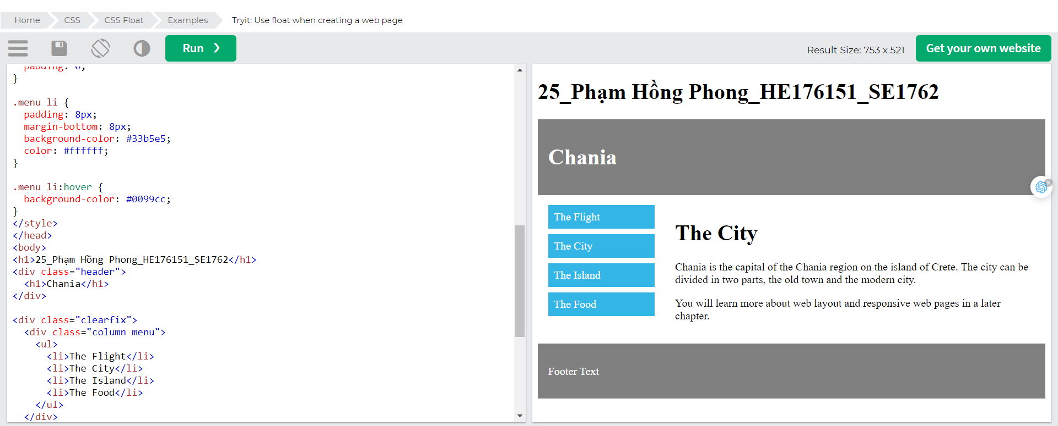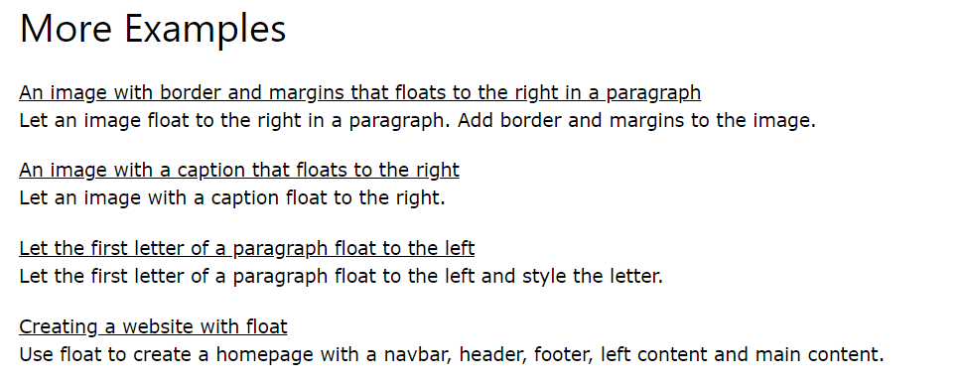

# CSS Inline-block

## The display: inline-block Value

Compared to display: inline, the major difference is that display: inline-block allows to set a width and height on the element.

Also, with display: inline-block, the top and bottom margins/paddings are respected, but with display: inline they are not.

Compared to display: block, the major difference is that display: inline-block does not add a line-break after the element, so the element can sit next to other elements.

The following example shows the different behavior of display: inline, display: inline-block and display: block: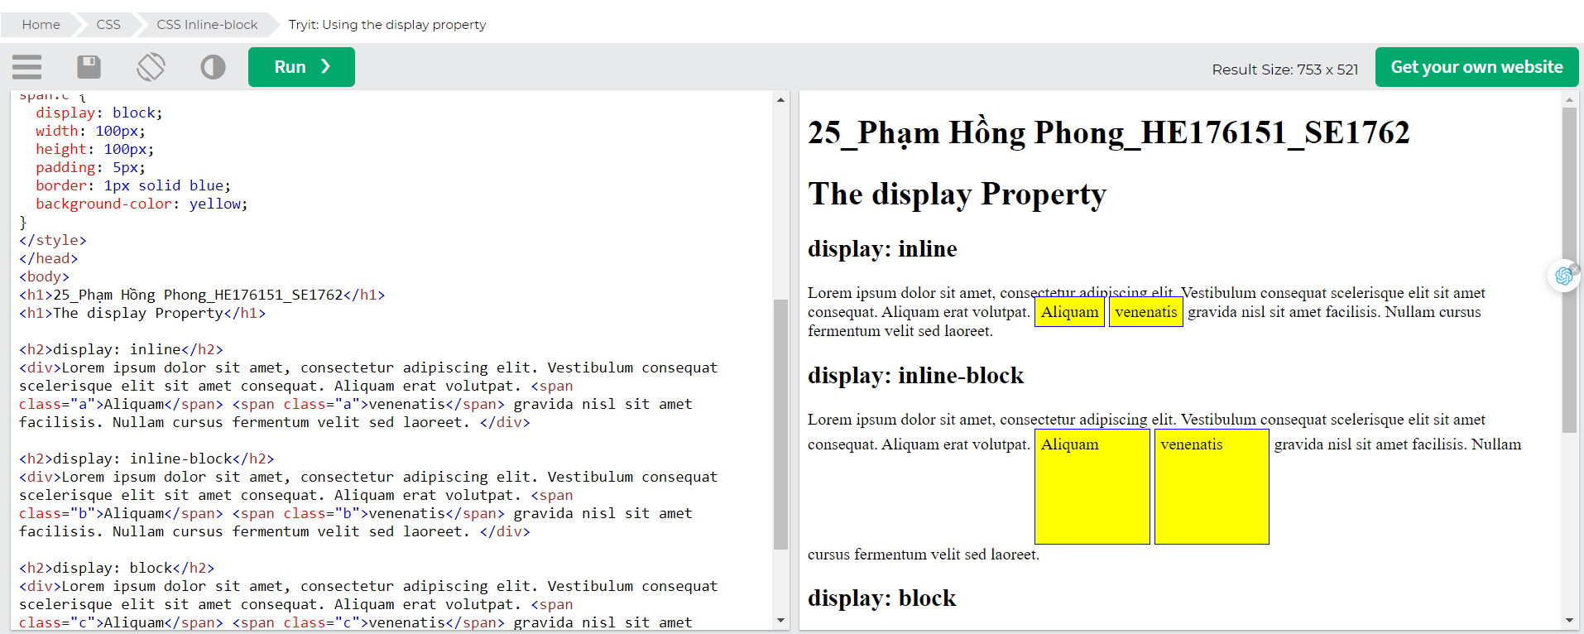

## Using inline-block to Create Navigation Links

One common use for display: inline-block is to display list items horizontally instead of vertically. The following example creates horizontal navigation links: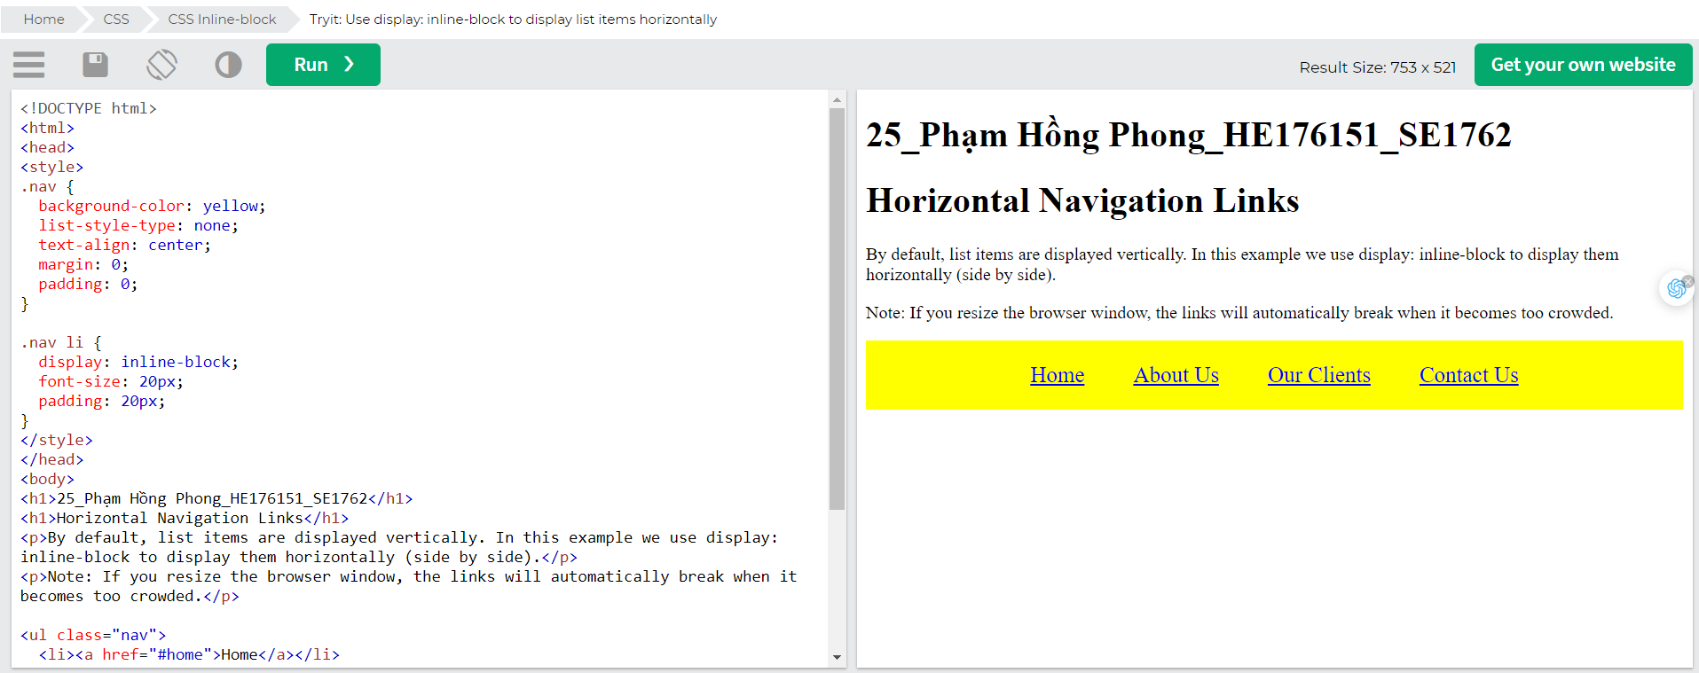

# CSS align

## Center Align Elements

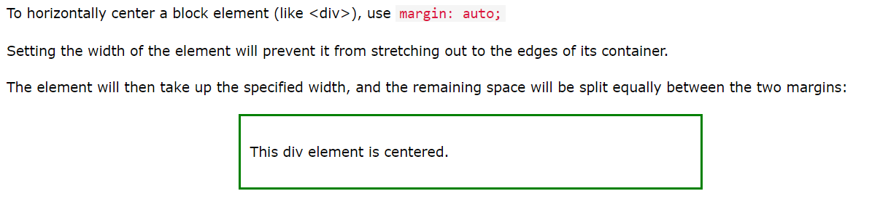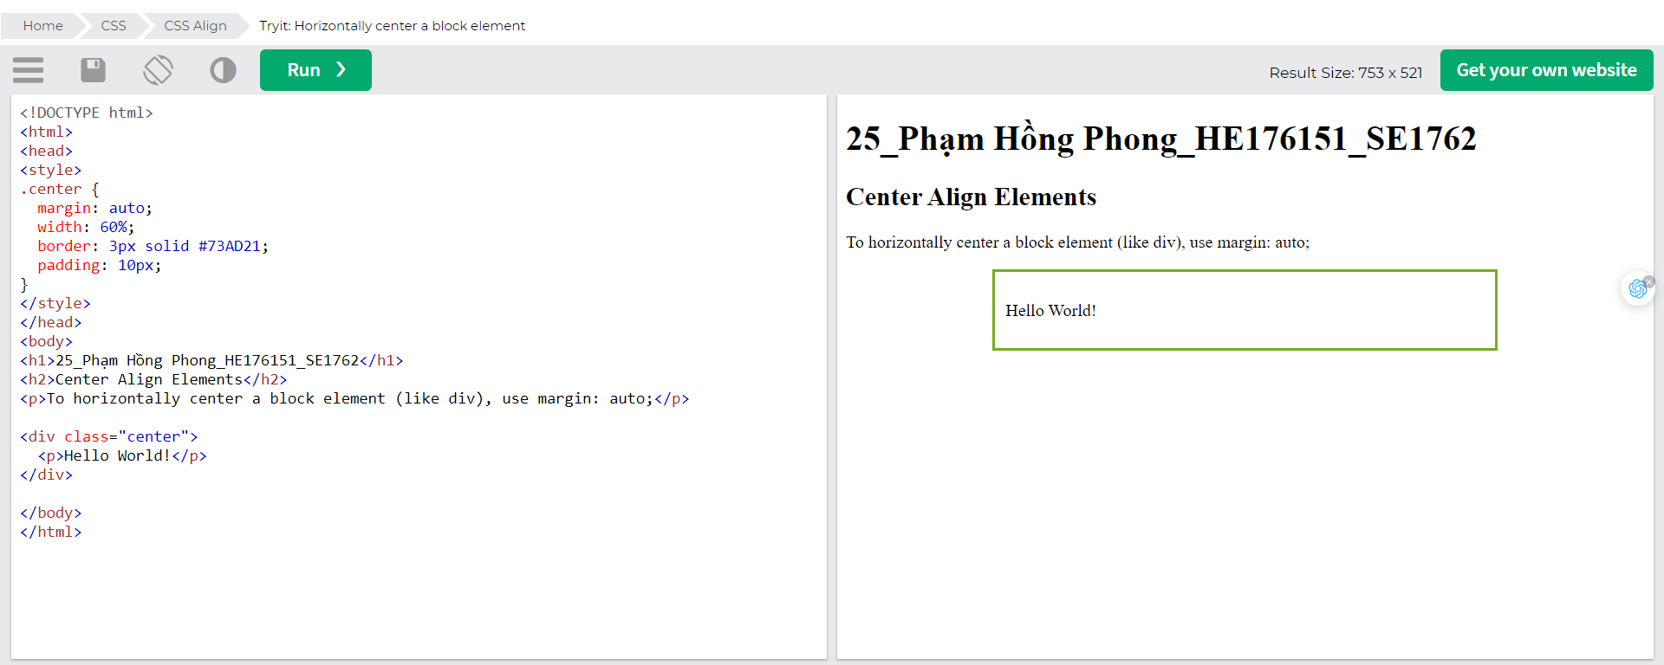

## Center Align Text

To just center the text inside an element, use text-align: center;

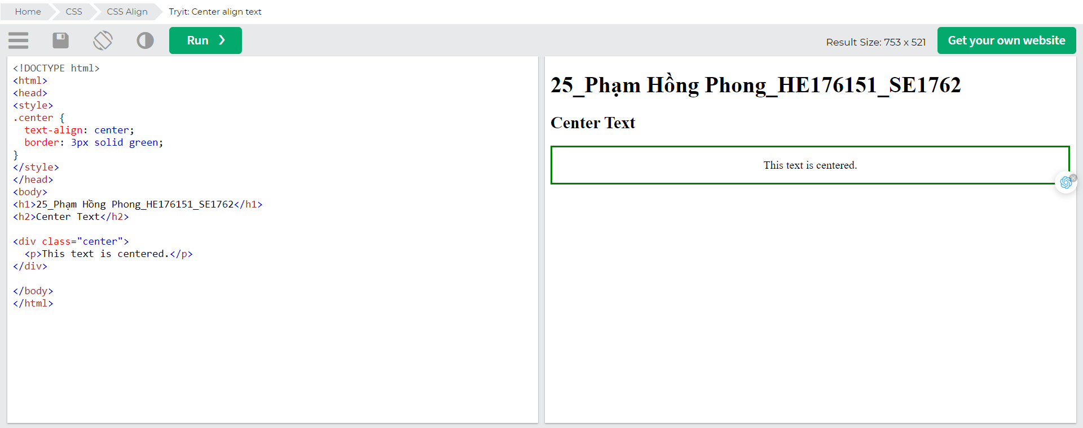

## Center an Image

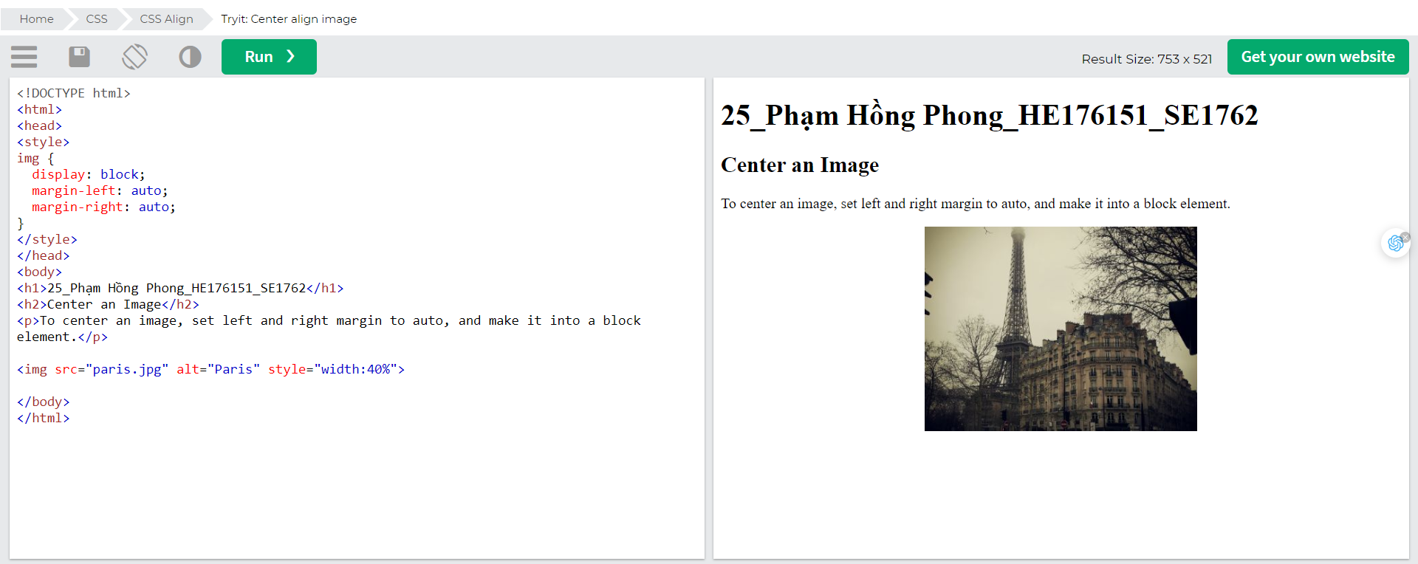

## Left and Right Align - Using position

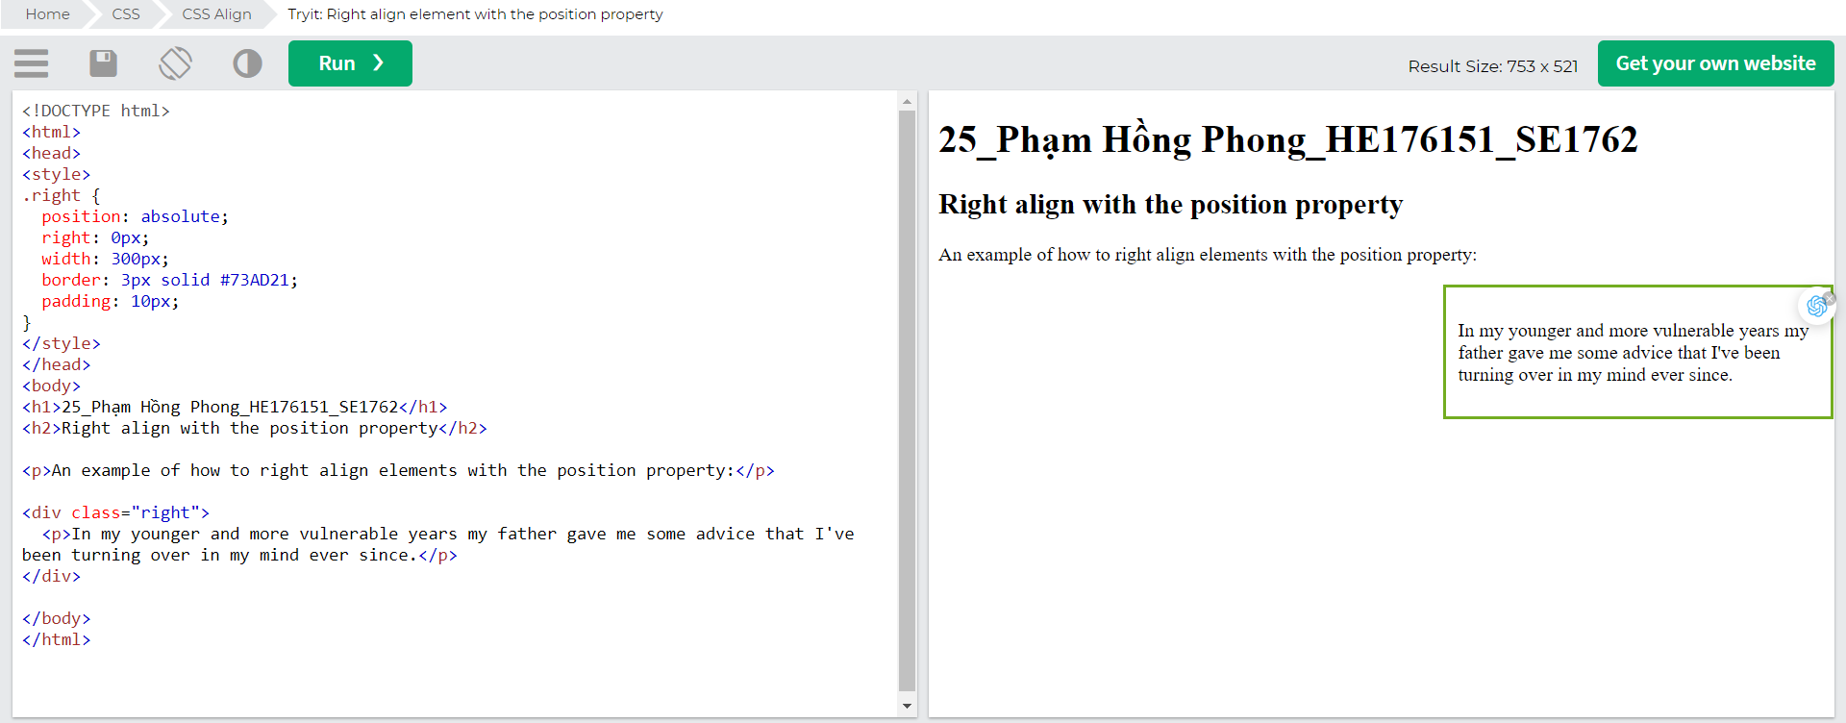

## Left and Right Align - Using float

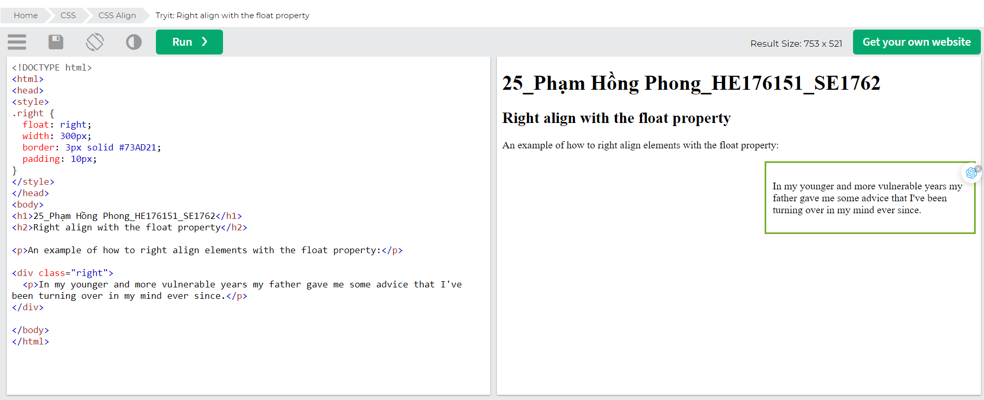

## The clearfix Hack

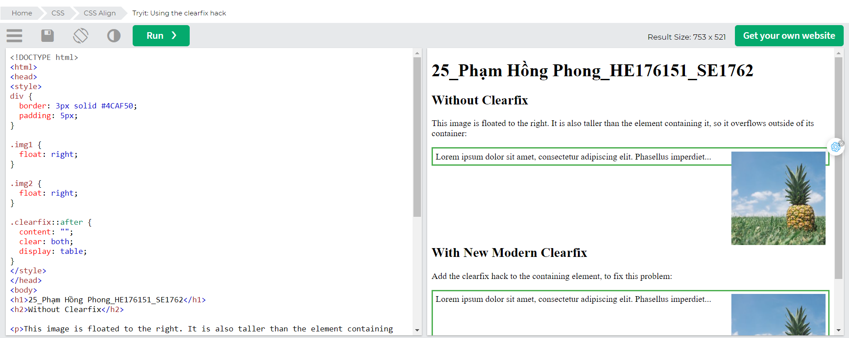

## Center Vertically - Using padding

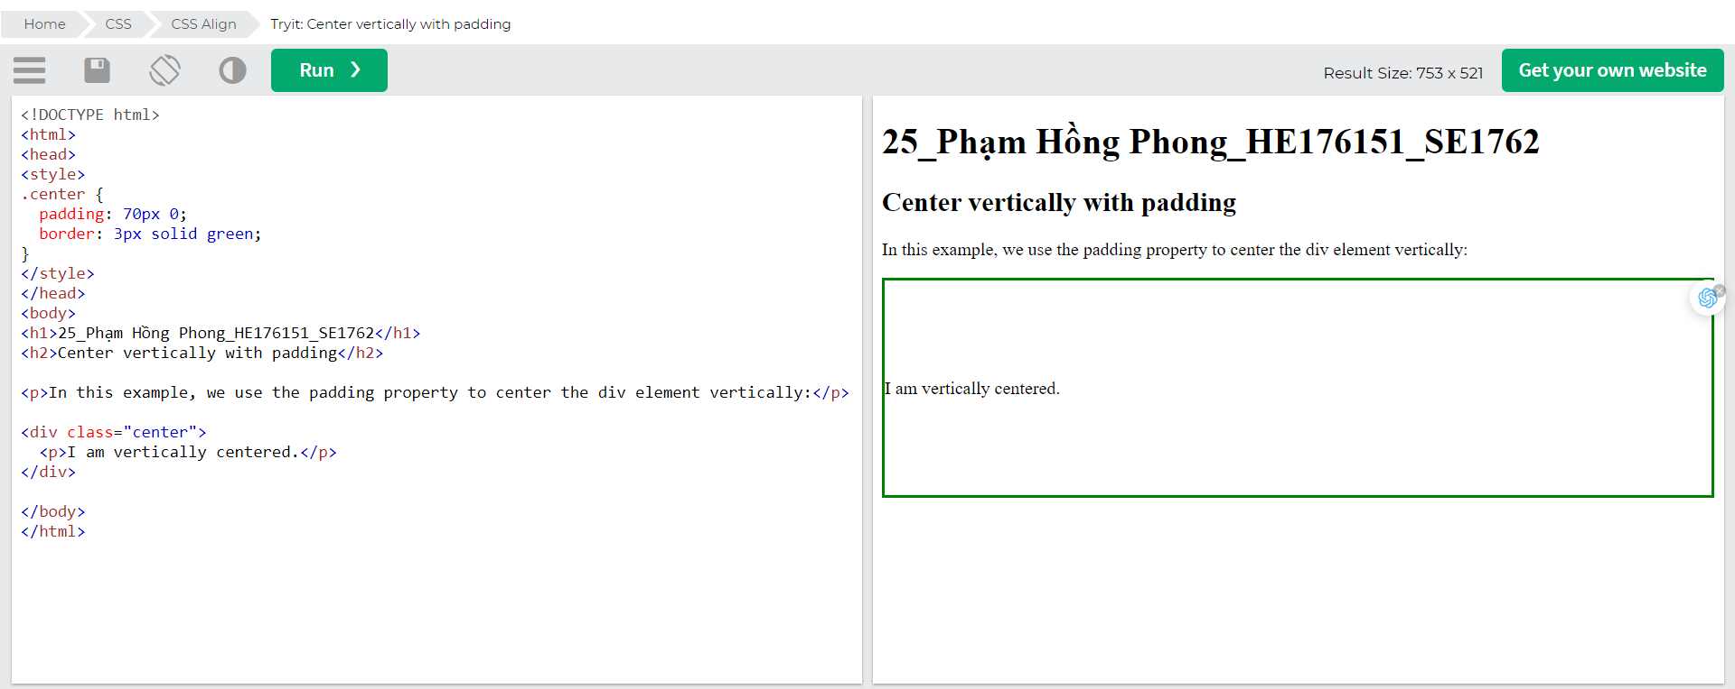To center both vertically and horizontally, use padding and text-align: center: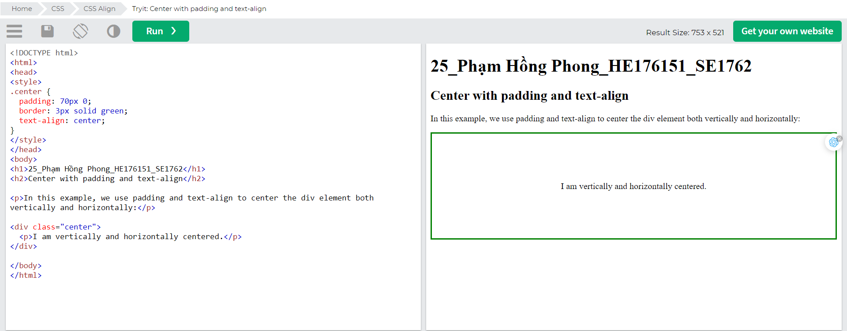

## Center Vertically - Using line-height

Another trick is to use the line-height property with a value that is equal to the height property:

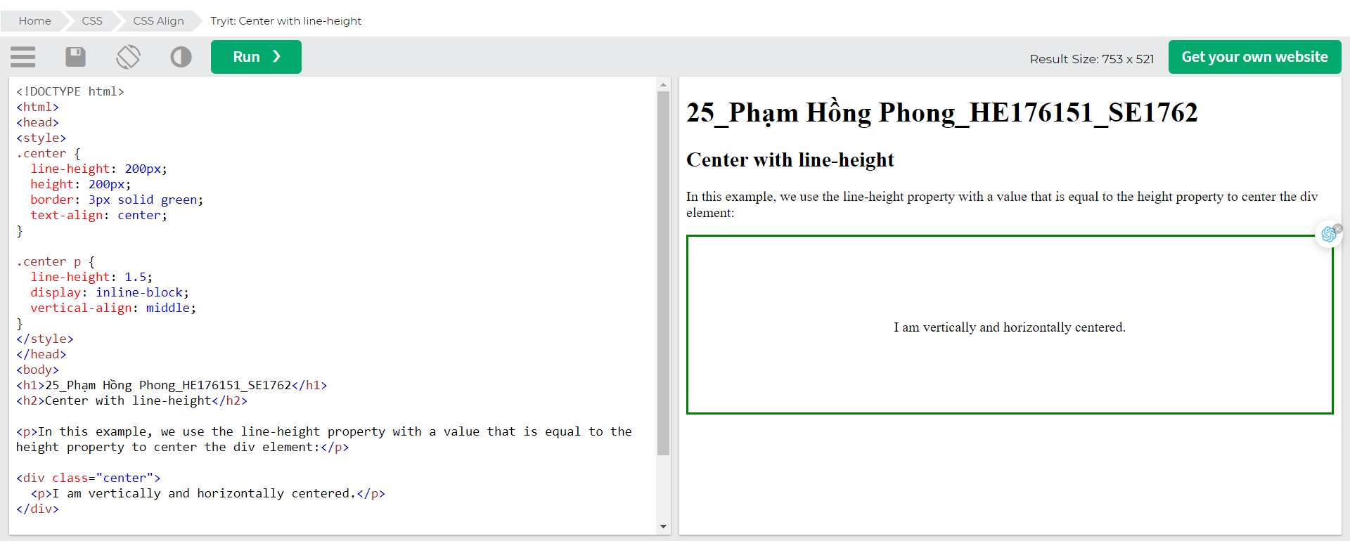

## Center Vertically - Using position & transform

If padding and line-height are not options, another solution is to use positioning and the transform property:

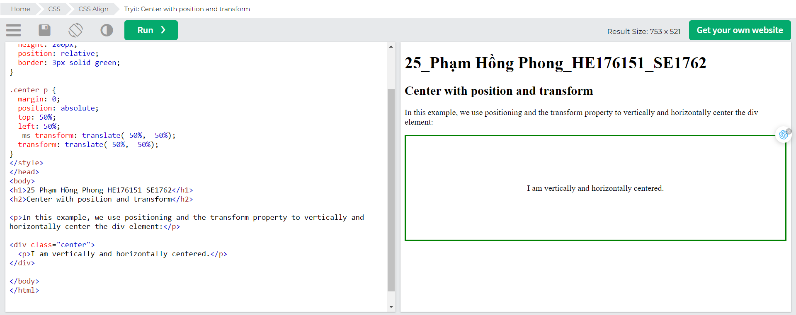

## Center Vertically - Using Flexbox

You can also use flexbox to center things. Just note that flexbox is not supported in IE10 and earlier versions:

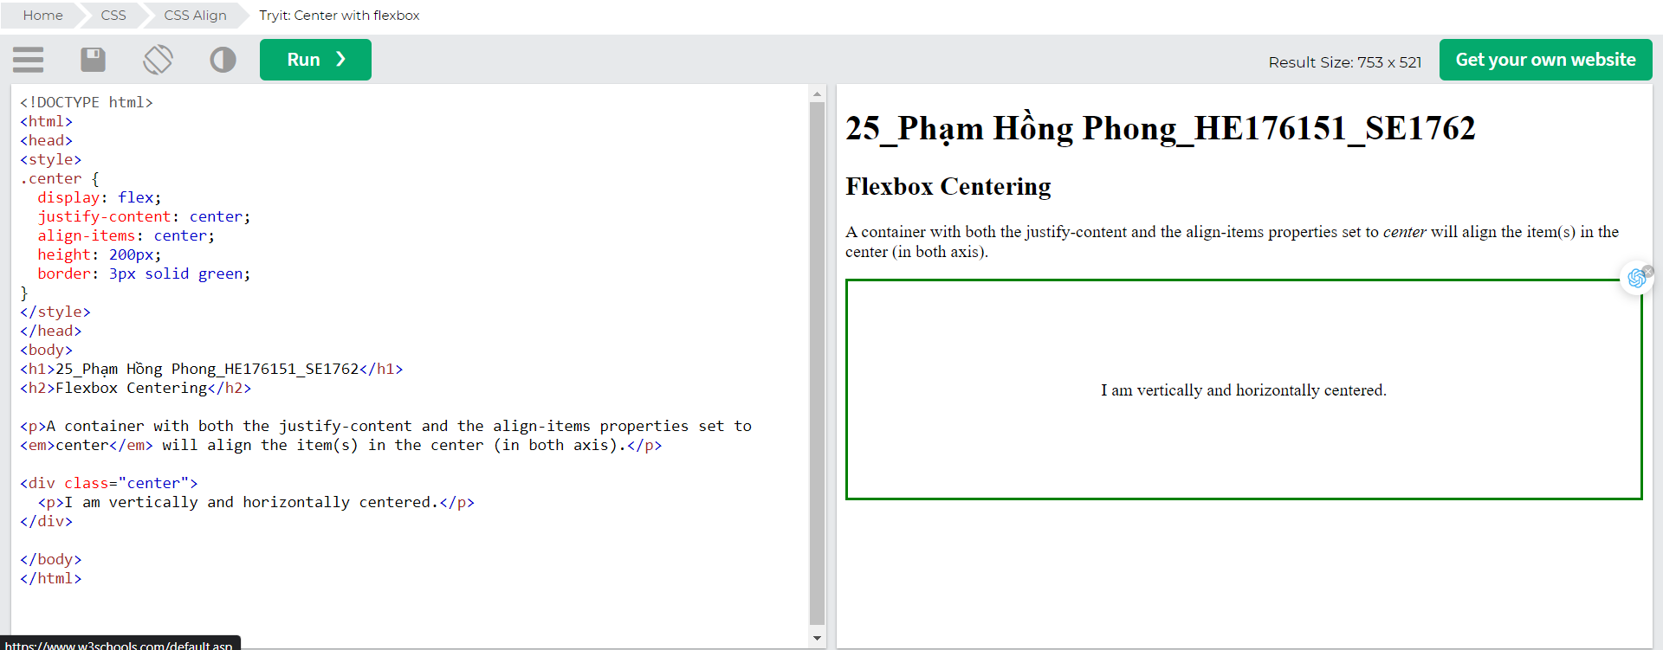

# CSS Combinators

A combinator is something that explains the relationship between the selectors.

A CSS selector can contain more than one simple selector. Between the simple selectors, we can include a combinator.

There are four different combinators in CSS:

* descendant selector (space)
* child selector (>)
* adjacent sibling selector (+)
* general sibling selector (~)

## Descendant Selector

The descendant selector matches all elements that are descendants of a specified element.

The following example selects all <p> elements inside <div> elements: 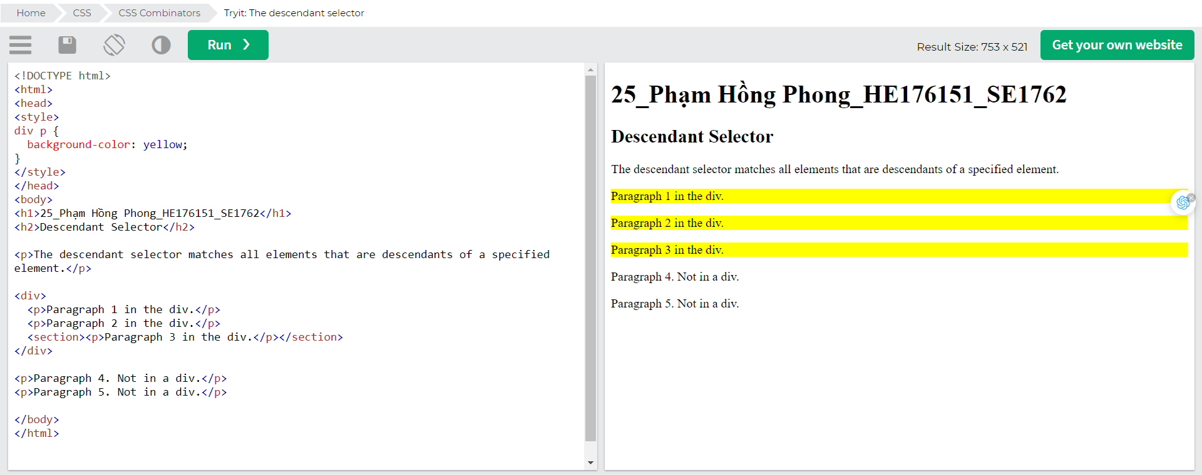

## Child Selector (>)

The child selector selects all elements that are the children of a specified element.

The following example selects all <p> elements that are children of a <div> element: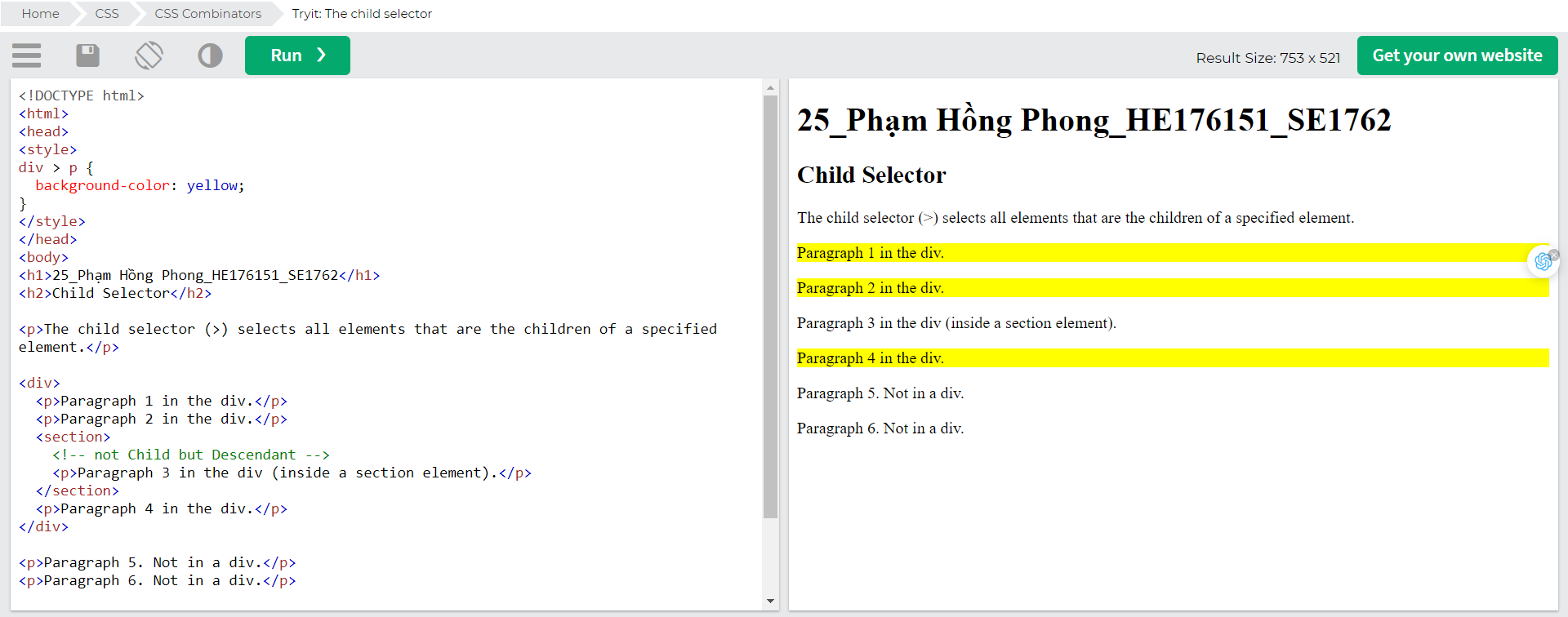

## Adjacent Sibling Selector (+)

The adjacent sibling selector is used to select an element that is directly after another specific element.

Sibling elements must have the same parent element, and "adjacent" means "immediately following".

The following example selects the first <p> element that are placed immediately after <div> elements: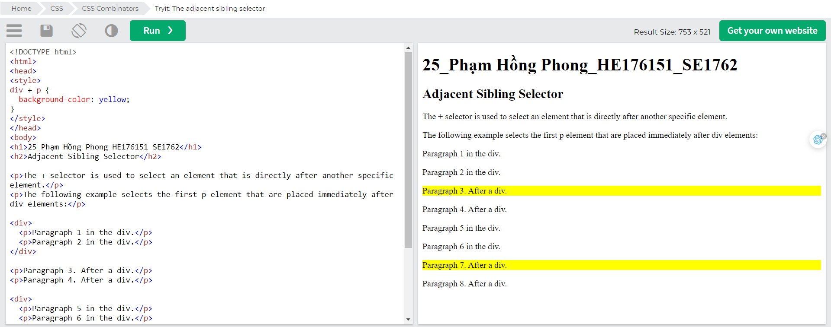

## General Sibling Selector (~)

The general sibling selector selects all elements that are next siblings of a specified element.

The following example selects all <p> elements that are next siblings of <div> elements:

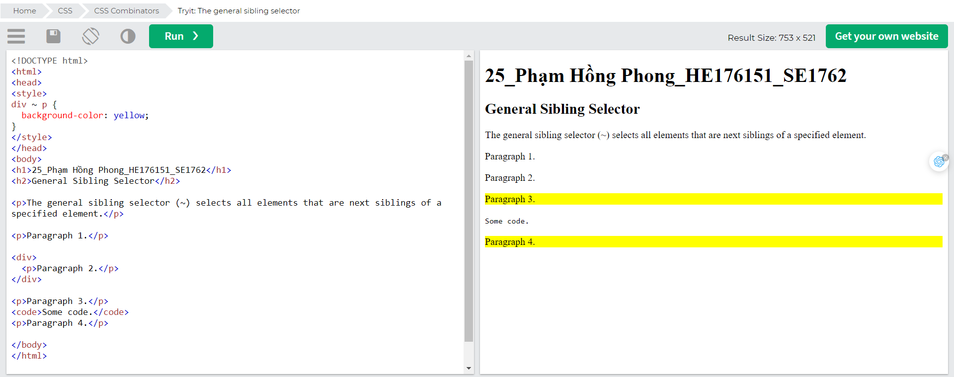

# CSS Pseudo-class

## What are Pseudo-classes?

A pseudo-class is used to define a special state of an element.

For example, it can be used to:

* Style an element when a user mouses over it
* Style visited and unvisited links differently
* Style an element when it gets focus

## Syntax

The syntax of pseudo-classes: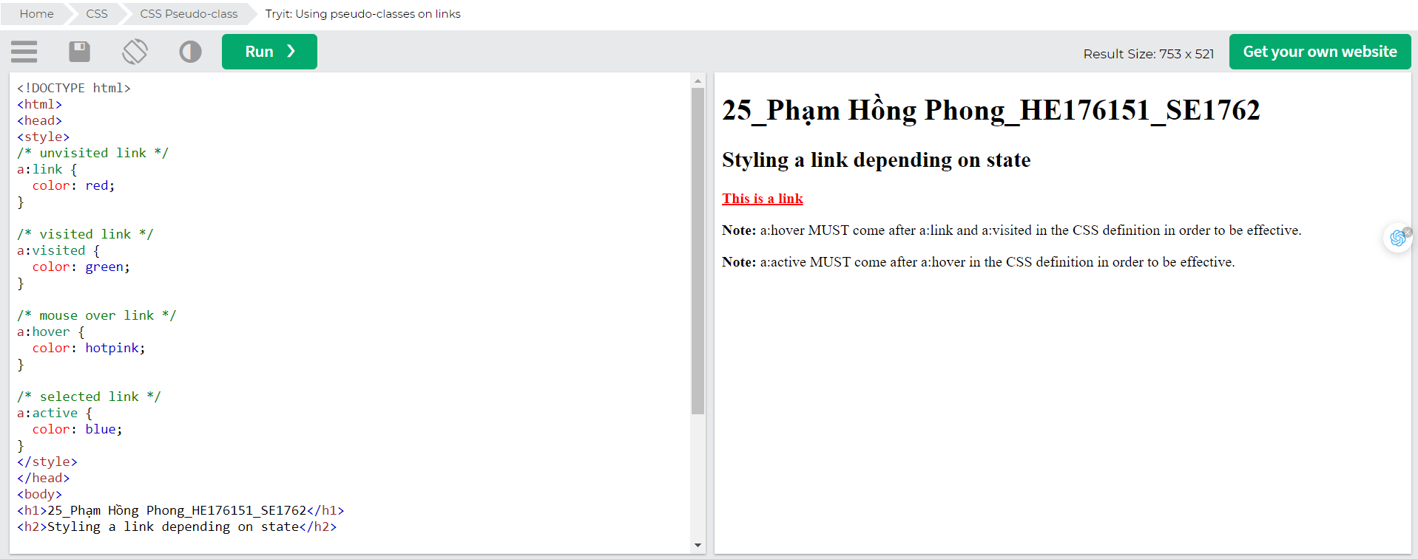

## Pseudo-classes and HTML Classes

Pseudo-classes can be combined with HTML classes:

When you hover over the link in the example, it will change color:

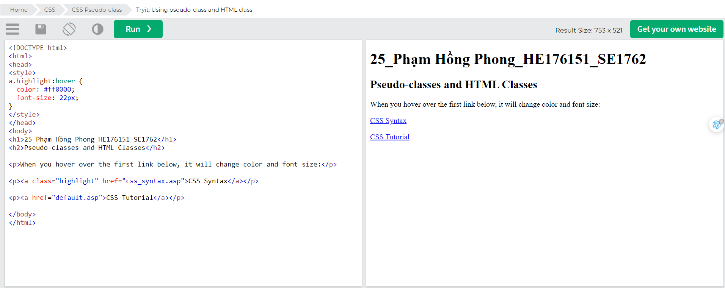

## Hover on <div>

An example of using the :hover pseudo-class on a <div> element:

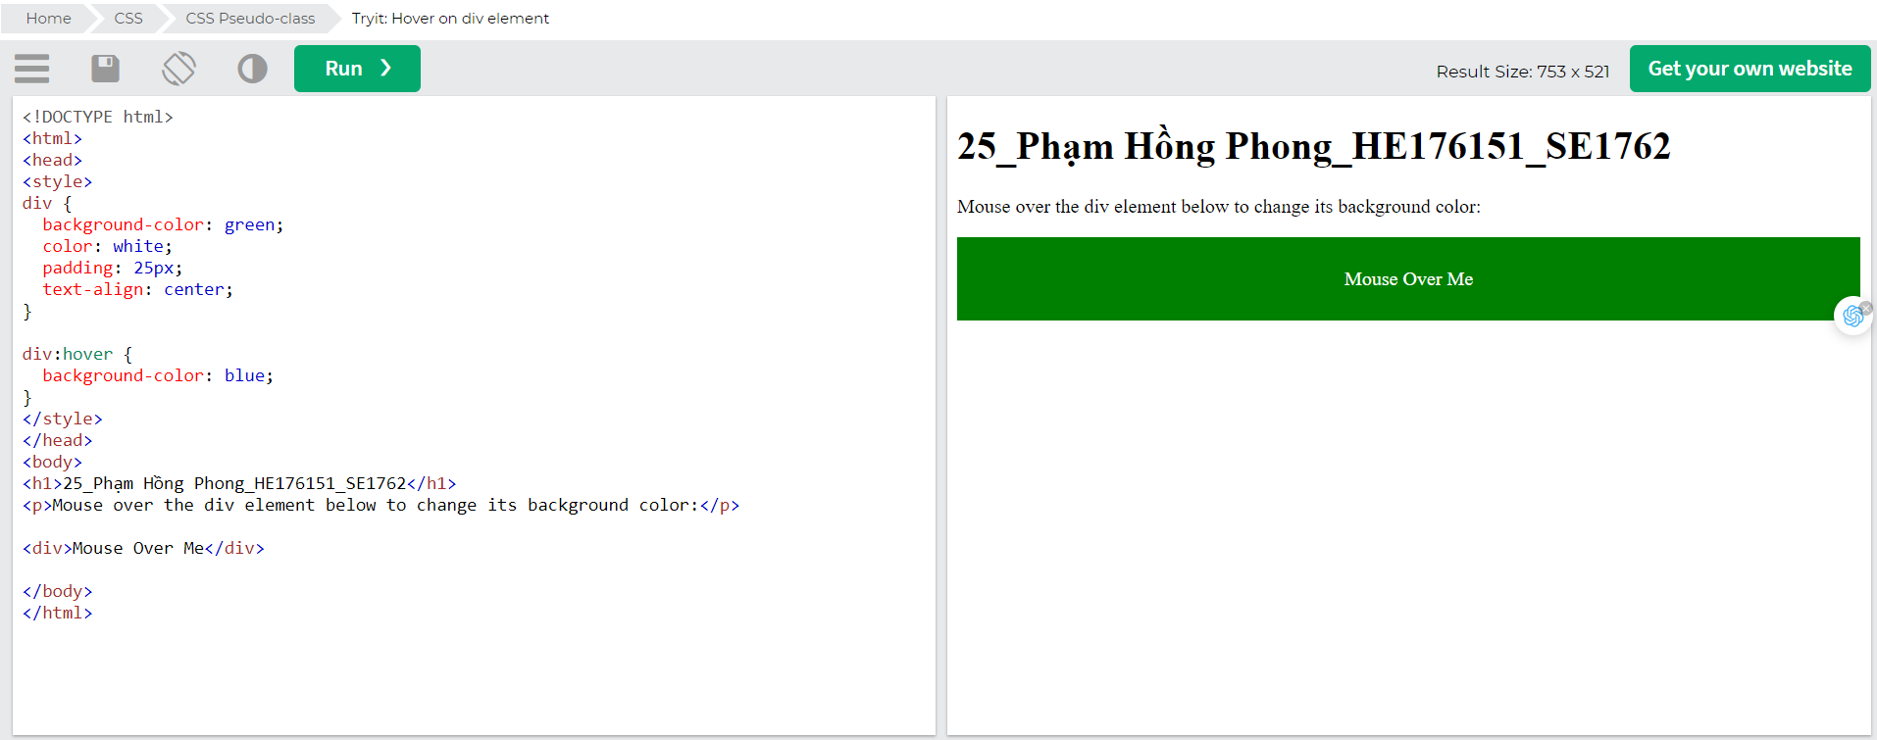

## Simple Tooltip Hover

Hover over a <div> element to show a <p> element (like a tooltip):

Hover over me to show the <p> element.

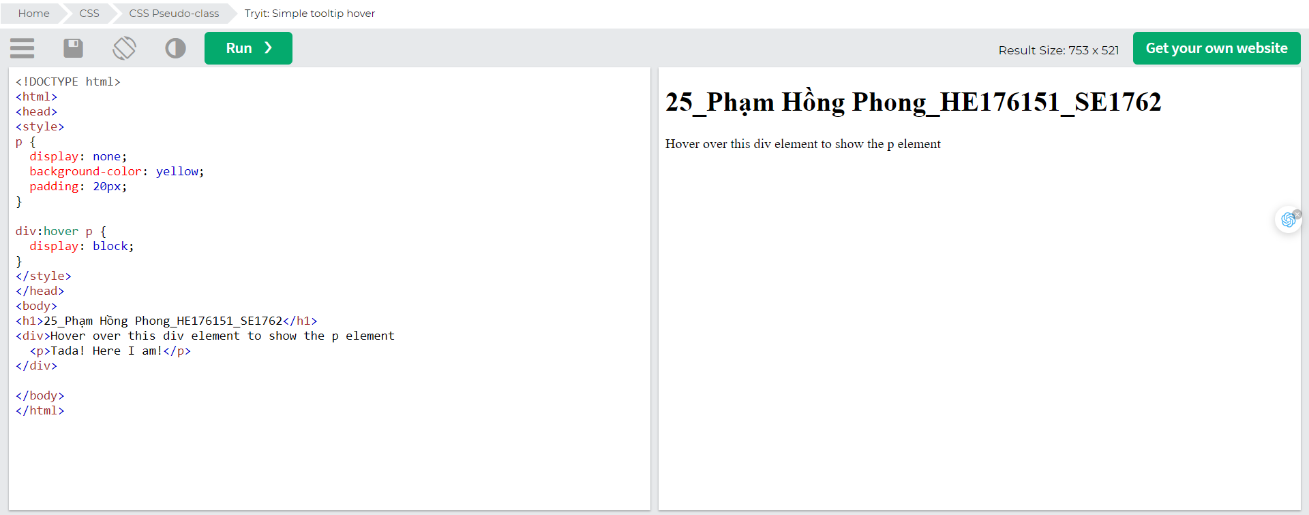

## CSS - The :first-child Pseudo-class

The :first-child pseudo-class matches a specified element that is the first child of another element.

## Match the first <p> element

In the following example, the selector matches any <p> element that is the first child of any element: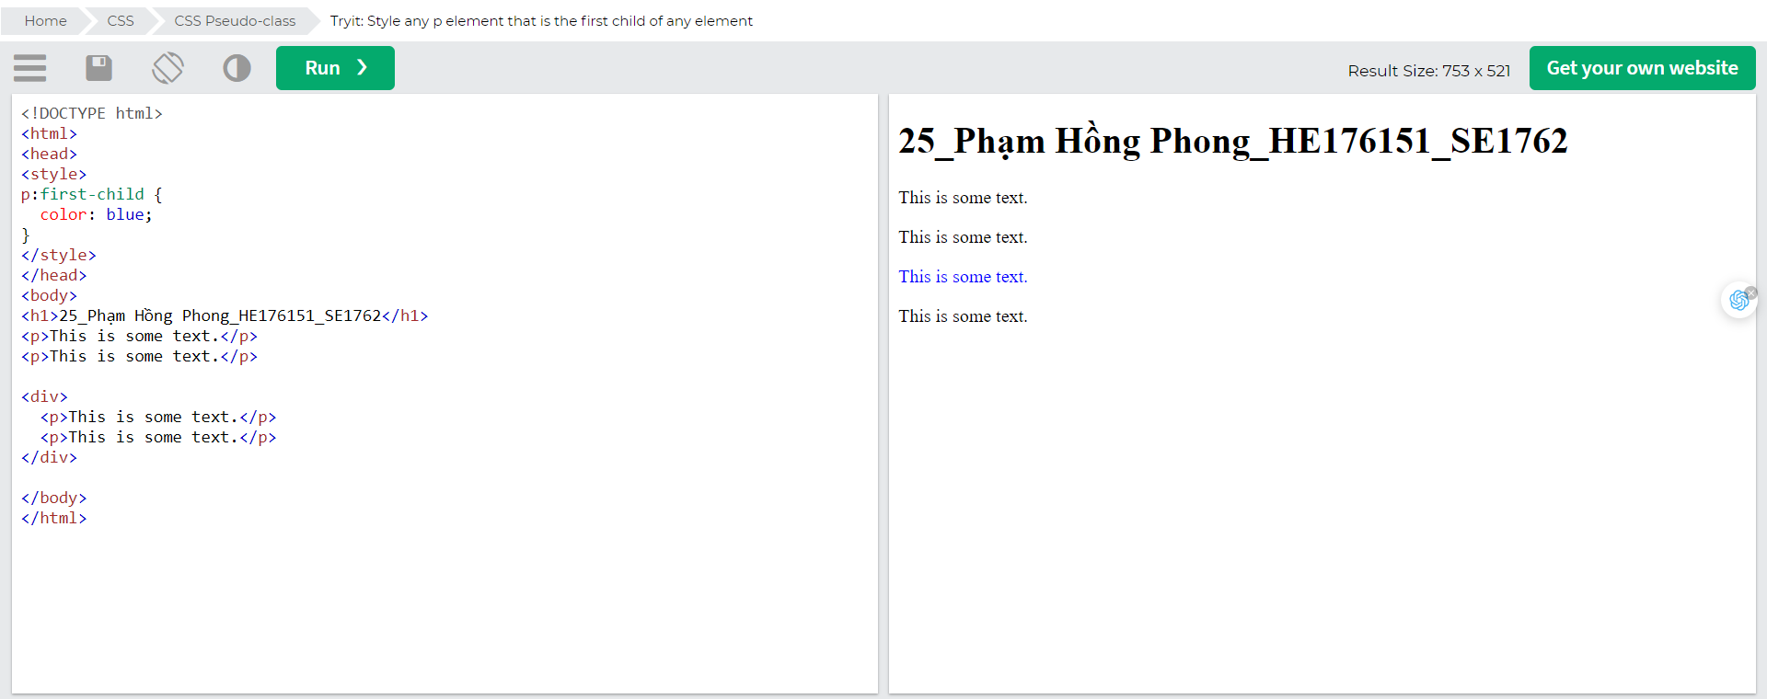

## Match the first <i> element in all <p> elements

In the following example, the selector matches the first <i> element in all <p> elements:

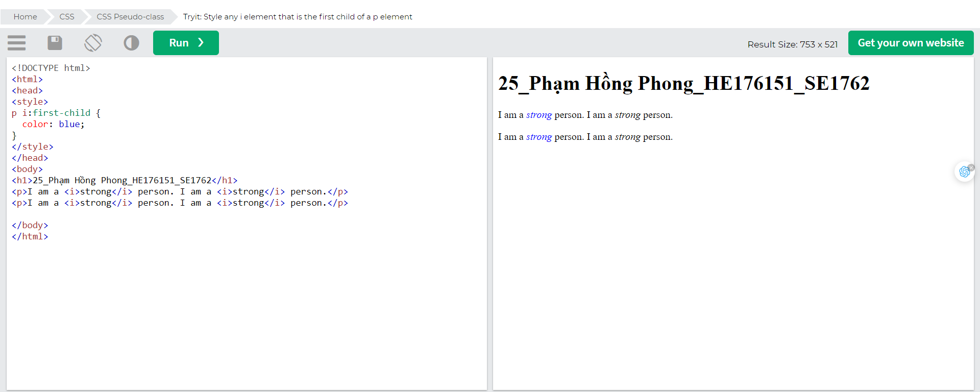

## Match all <i> elements in all first child <p> elements

In the following example, the selector matches all <i> elements in <p> elements that are the first child of another element:

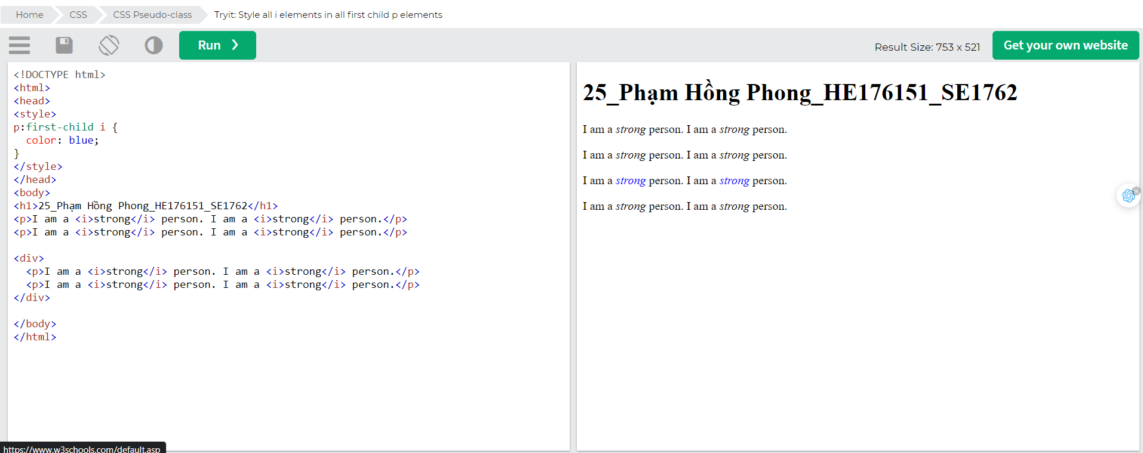

## CSS - The :lang Pseudo-class

The :lang pseudo-class allows you to define special rules for different languages.

In the example below, :lang defines the quotation marks for <q> elements with lang="no":

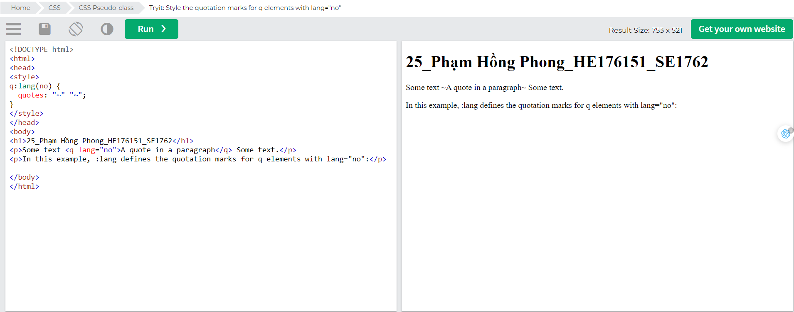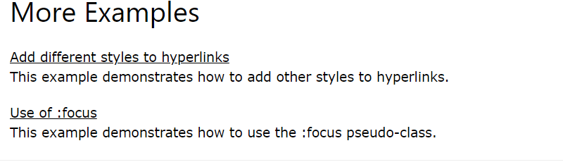

# CSS Pseudo-element

## What are Pseudo-Elements?

A CSS pseudo-element is used to style specified parts of an element.

For example, it can be used to:

* Style the first letter, or line, of an element
* Insert content before, or after, the content of an element

## Syntax

The syntax of pseudo-elements: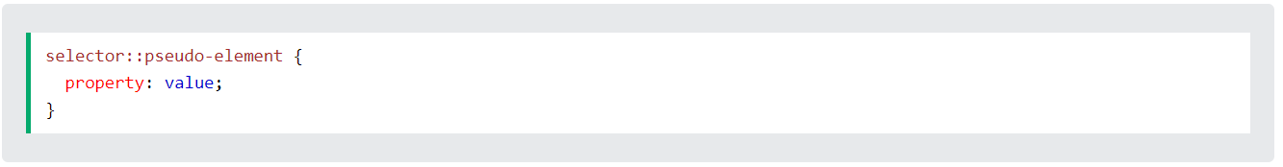

## The ::first-line Pseudo-element

The ::first-line pseudo-element is used to add a special style to the first line of a text.

The following example formats the first line of the text in all <p> elements:

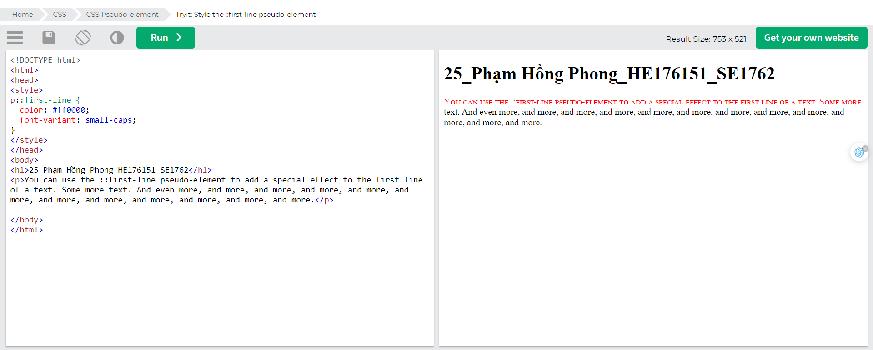

Note: The ::first-line pseudo-element can only be applied to block-level elements.

The following properties apply to the ::first-line pseudo-element:

* font properties
* color properties
* background properties
* word-spacing
* letter-spacing
* text-decoration
* vertical-align
* text-transform
* line-height
* clear

## The ::first-letter Pseudo-element

The ::first-letter pseudo-element is used to add a special style to the first letter of a text.

The following example formats the first letter of the text in all <p> elements:

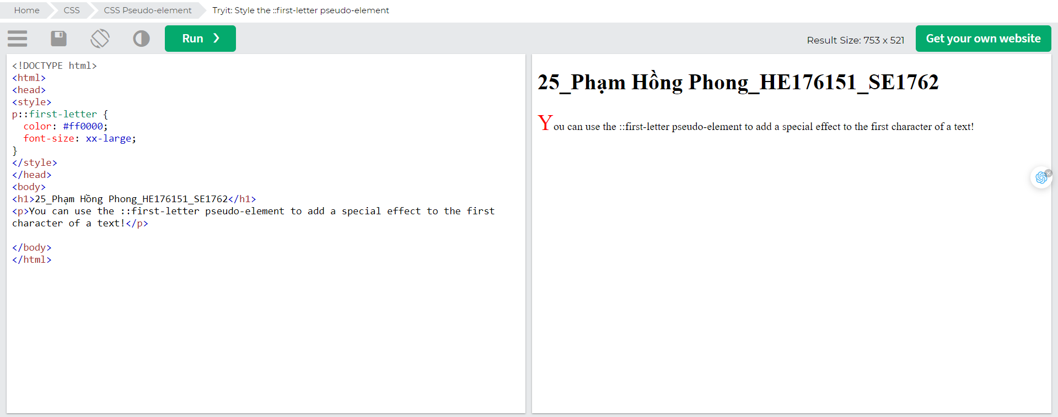

Note: The ::first-letter pseudo-element can only be applied to block-level elements.

The following properties apply to the ::first-letter pseudo- element:

* font properties
* color properties
* background properties
* margin properties
* padding properties
* border properties
* text-decoration
* vertical-align (only if "float" is "none")
* text-transform
* line-height
* float
* clear

## Pseudo-elements and HTML Classes

Pseudo-elements can be combined with HTML classes: 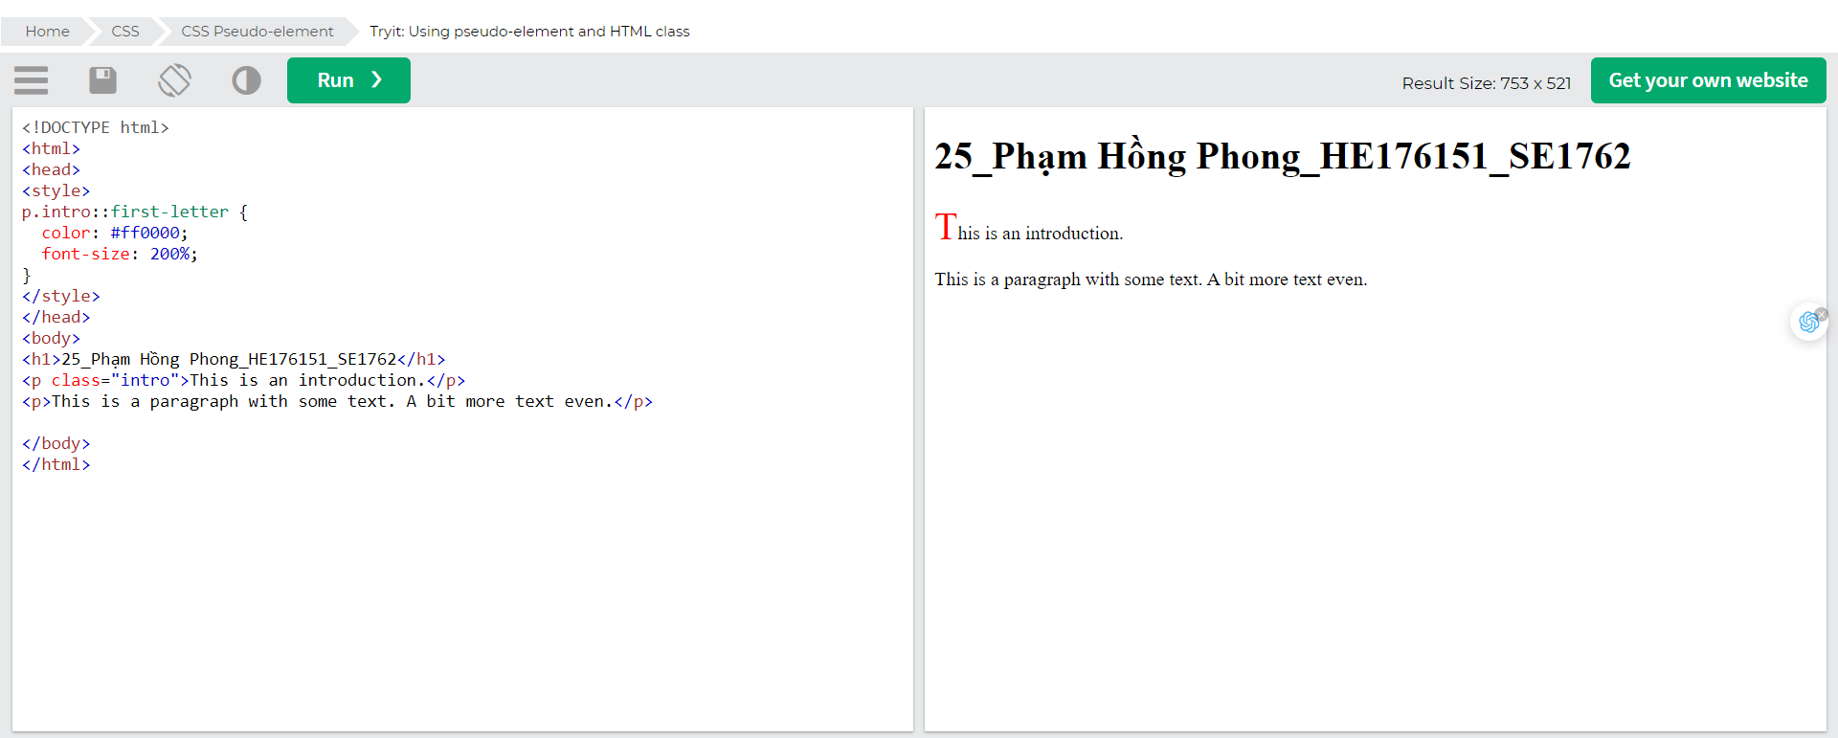The example above will display the first letter of paragraphs with class="intro", in red and in a larger size.

## Multiple Pseudo-elements

Several pseudo-elements can also be combined.

In the following example, the first letter of a paragraph will be red, in an xx-large font size. The rest of the first line will be blue, and in small-caps. The rest of the paragraph will be the default font size and color: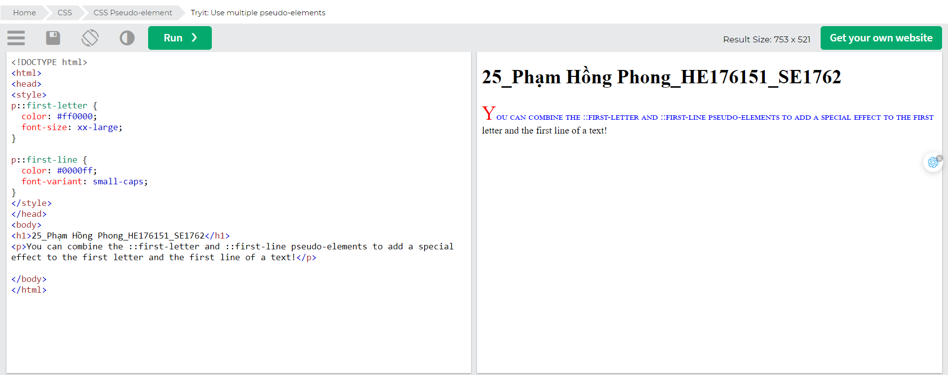

## CSS - The ::before Pseudo-element

The ::before pseudo-element can be used to insert some content before the content of an element.

The following example inserts an image before the content of each <h1> element: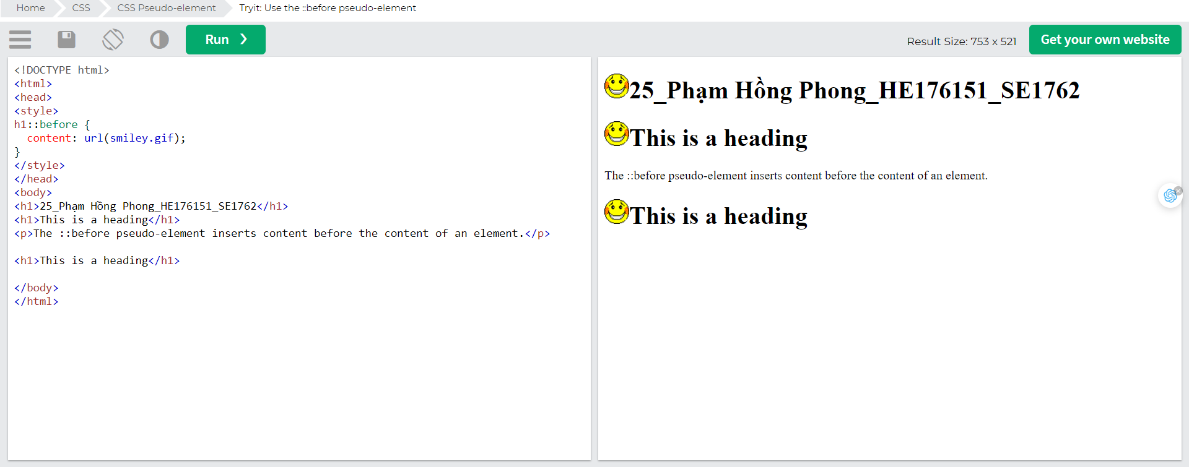

## CSS - The ::after Pseudo-element

The ::after pseudo-element can be used to insert some content after the content of an element.

The following example inserts an image after the content of each <h1> element: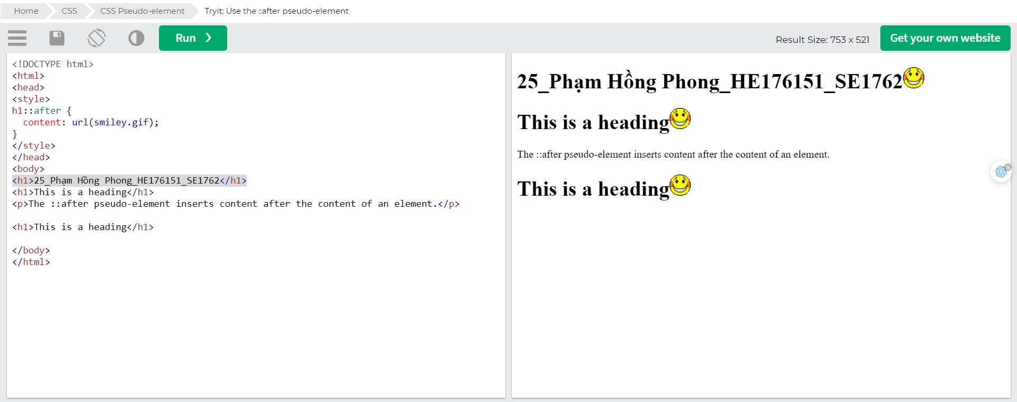

## CSS - The ::marker Pseudo-element

The ::marker pseudo-element selects the markers of list items.

The following example styles the markers of list items: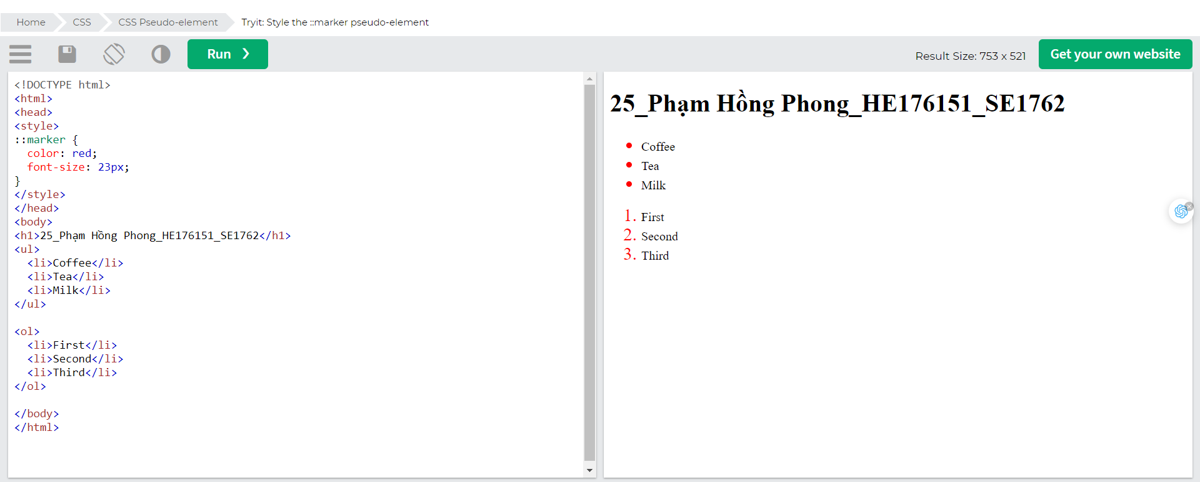

## CSS - The ::selection Pseudo-element

The ::selection pseudo-element matches the portion of an element that is selected by a user.

The following CSS properties can be applied to ::selection: color, background, cursor, and outline.

The following example makes the selected text red on a yellow background:

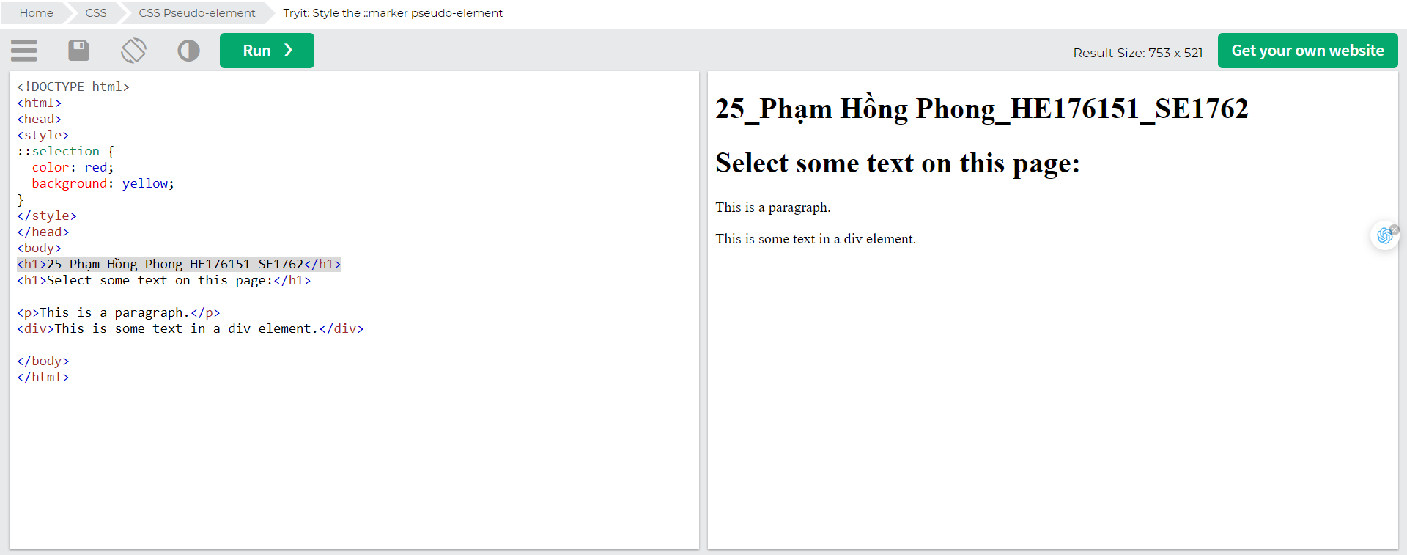

# CSS Opacity/ Transparency

The opacity property specifies the opacity/transparency of an element.

## Transparent Image

The opacity property can take a value from 0.0 - 1.0. The lower the value, the more transparent: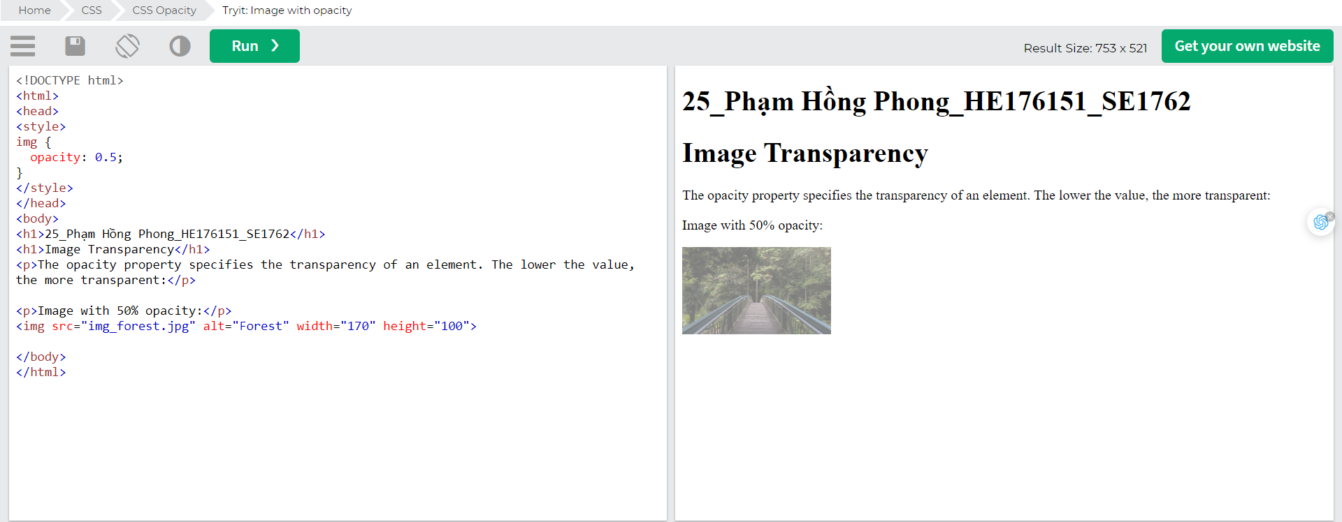

## Transparent Hover Effect

The opacity property is often used together with the :hover selector to change the opacity on mouse-over:

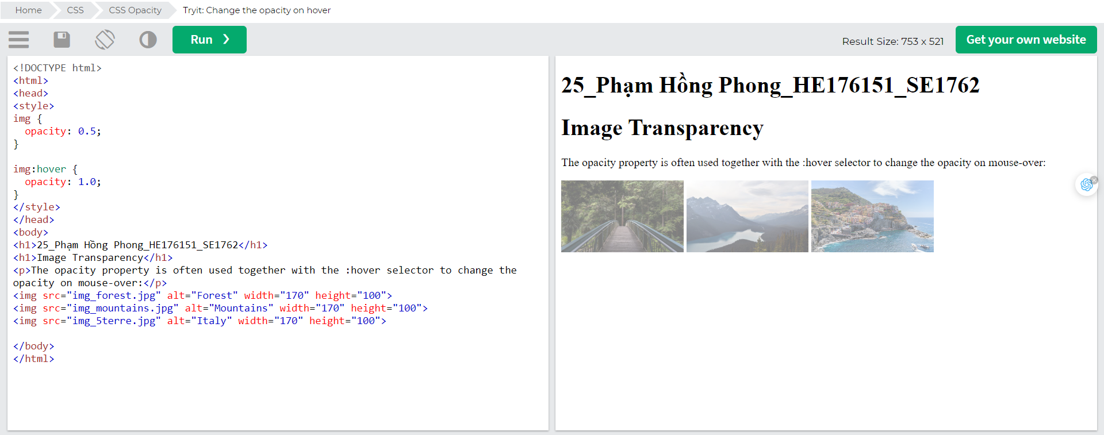

## Example explained

The first CSS block is similar to the code in Example 1. In addition, we have added what should happen when a user hovers over one of the images. In this case we want the image to NOT be transparent when the user hovers over it. The CSS for this is opacity:1;.

When the mouse pointer moves away from the image, the image will be transparent again.

An example of reversed hover effect: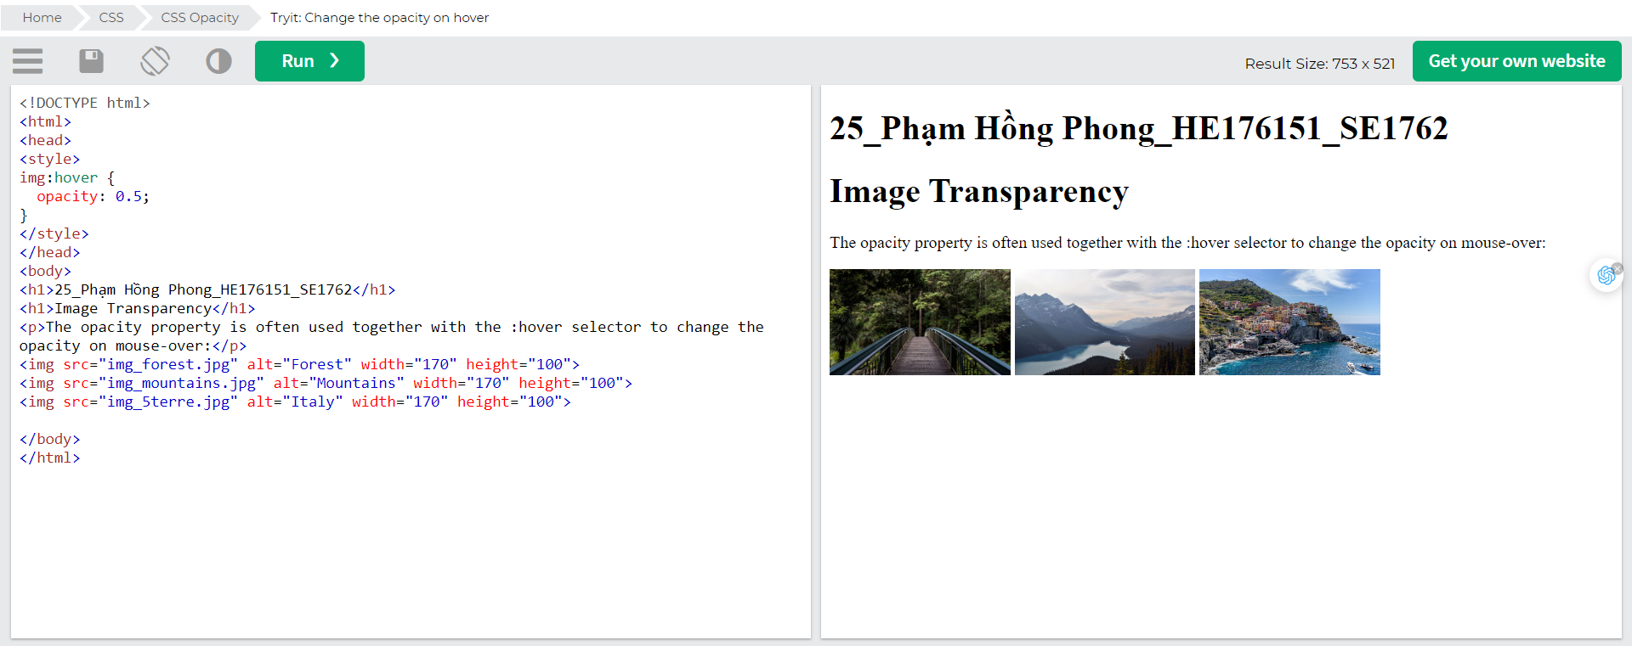

## Transparent Box

When using the opacity property to add transparency to the background of an element, all of its child elements inherit the same transparency. This can make the text inside a fully transparent element hard to read: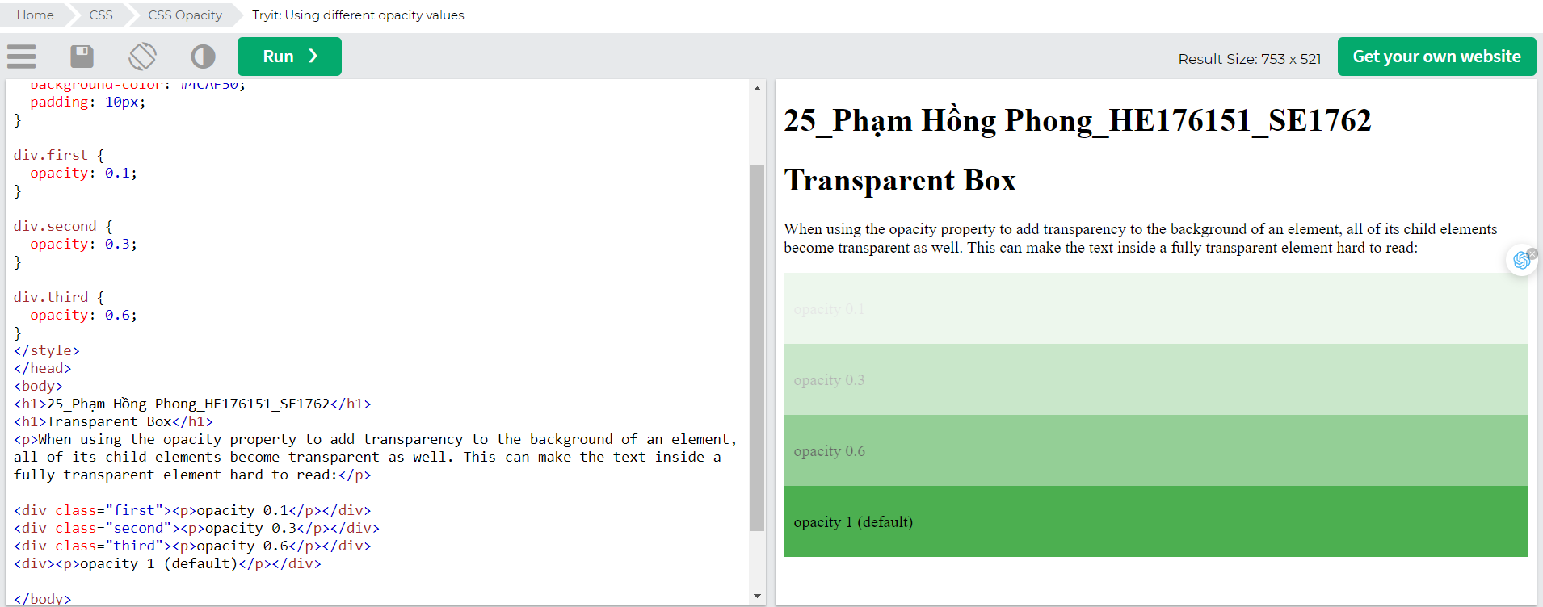

## Transparency using RGBA

If you do not want to apply opacity to child elements, like in our example above, use RGBA color values. The following example sets the opacity for the background color and not the text:

You learned from our [CSS Colors Chapter](https://www.w3schools.com/css/css_colors.asp), that you can use RGB as a color value. In addition to RGB, you can use an RGB color value with an alpha channel (RGBA) - which specifies the opacity for a color.

An RGBA color value is specified with: rgba(red, green, blue, *alpha*). The *alpha* parameter is a number between 0.0 (fully transparent) and 1.0 (fully opaque).

Tip: You will learn more about RGBA Colors in our [CSS Colors Chapter](https://www.w3schools.com/css/css3_colors.asp).

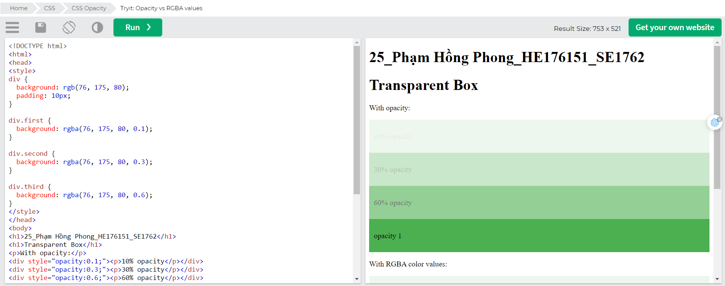

## Text in Transparent Box

## 

## Example explained

First, we create a <div> element (class="background") with a background image, and a border.

Then we create another <div> (class="transbox") inside the first <div>.

The <div class="transbox"> have a background color, and a border - the div is transparent.

Inside the transparent <div>, we add some text inside a <p> element.

# CSS Navigation Bar

## Navbar

### Navigation Bars

Having easy-to-use navigation is important for any web site.

With CSS you can transform boring HTML menus into good-looking navigation bars.

### Navigation Bar = List of Links

A navigation bar needs standard HTML as a base.

In our examples we will build the navigation bar from a standard HTML list.

A navigation bar is basically a list of links, so using the <ul> and <li> elements makes perfect sense: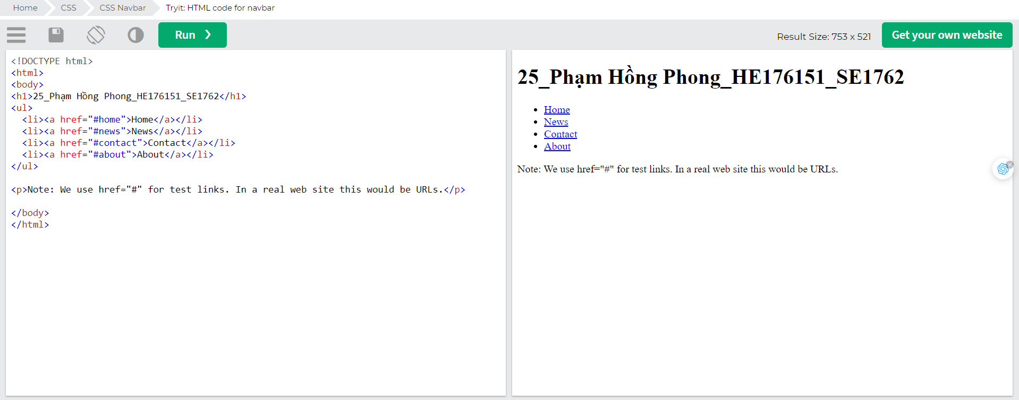Now let's remove the bullets and the margins and padding from the list: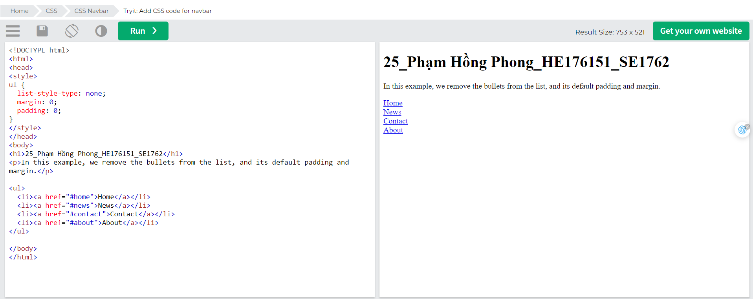Example explained:

* list-style-type: none; - Removes the bullets. A navigation bar does not need list markers
* Set margin: 0; and padding: 0; to remove browser default settings

The code in the example above is the standard code used in both vertical, and horizontal navigation bars, which you will learn more about in the next chapters.

## Vertical Navigation Bar

## 

Example explained:

* display: block; - Displaying the links as block elements makes the whole link area clickable (not just the text), and it allows us to specify the width (and padding, margin, height, etc. if you want)
* width: 60px; - Block elements take up the full width available by default. We want to specify a 60 pixels width

You can also set the width of <ul>, and remove the width of <a>, as they will take up the full width available when displayed as block elements. This will produce the same result as our previous example:

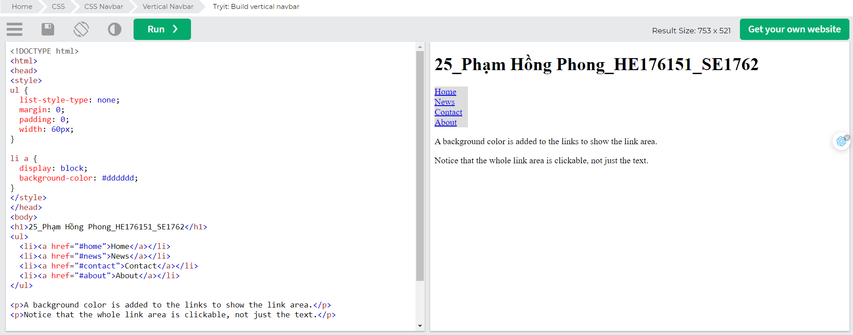

## Vertical Navigation Bar Examples

Create a basic vertical navigation bar with a grey background color and change the background color of the links when the user moves the mouse over them: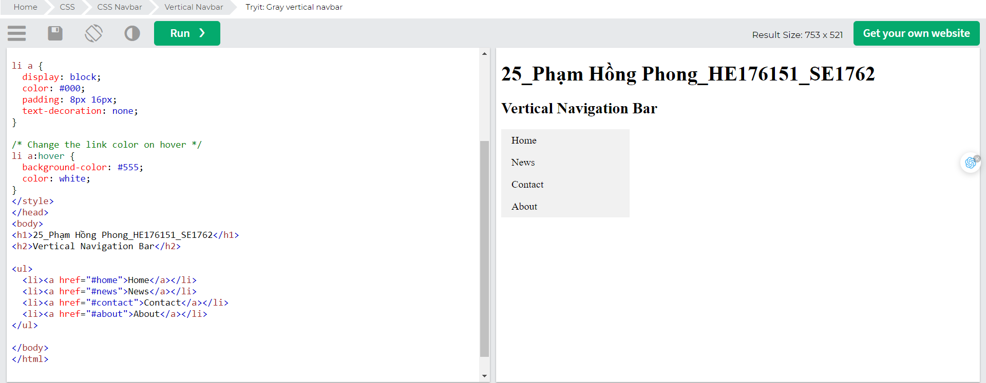

## Active/Current Navigation Link

Add an "active" class to the current link to let the user know which page he/she is on: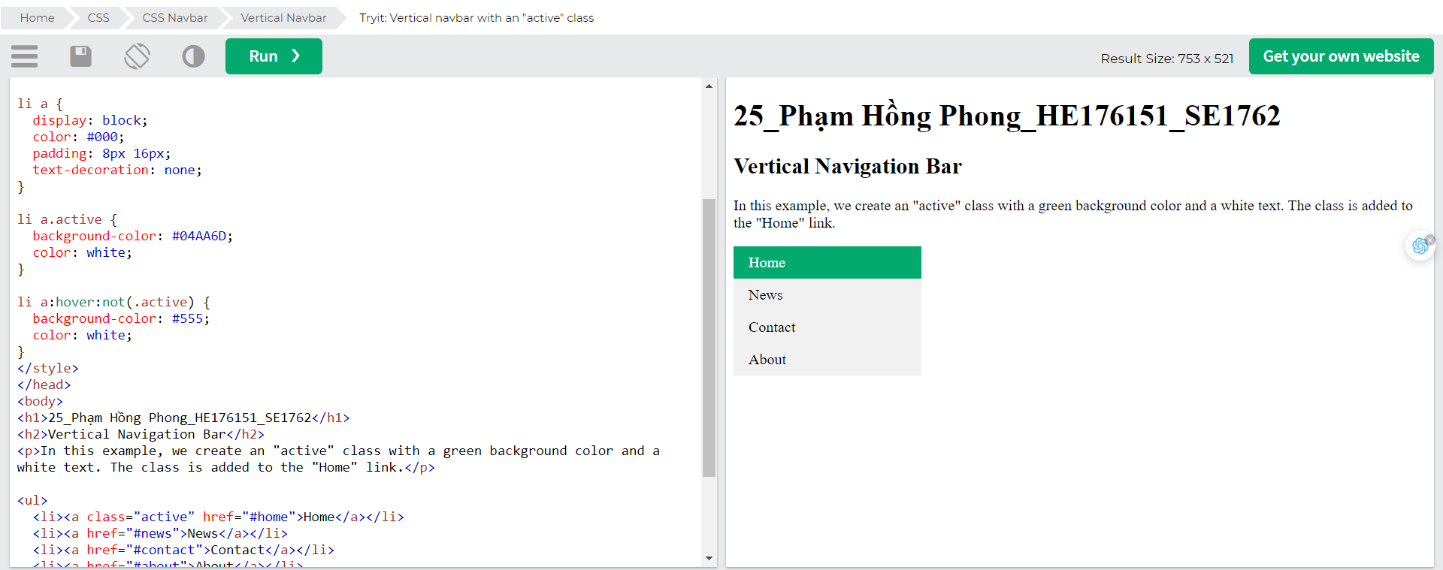

## Center Links & Add Borders

Add text-align:center to <li> or <a> to center the links.

Add the border property to <ul> add a border around the navbar. If you also want borders inside the navbar, add a border-bottom to all <li> elements, except for the last one:

# CSS Dropdowns

Create a hoverable dropdown with CSS.

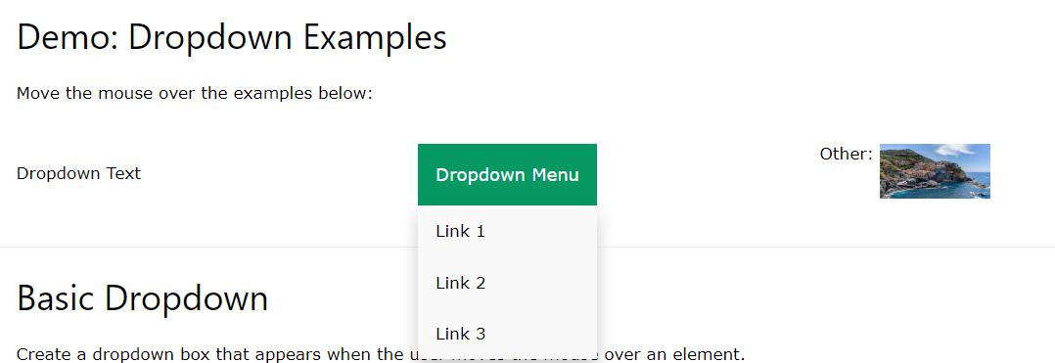

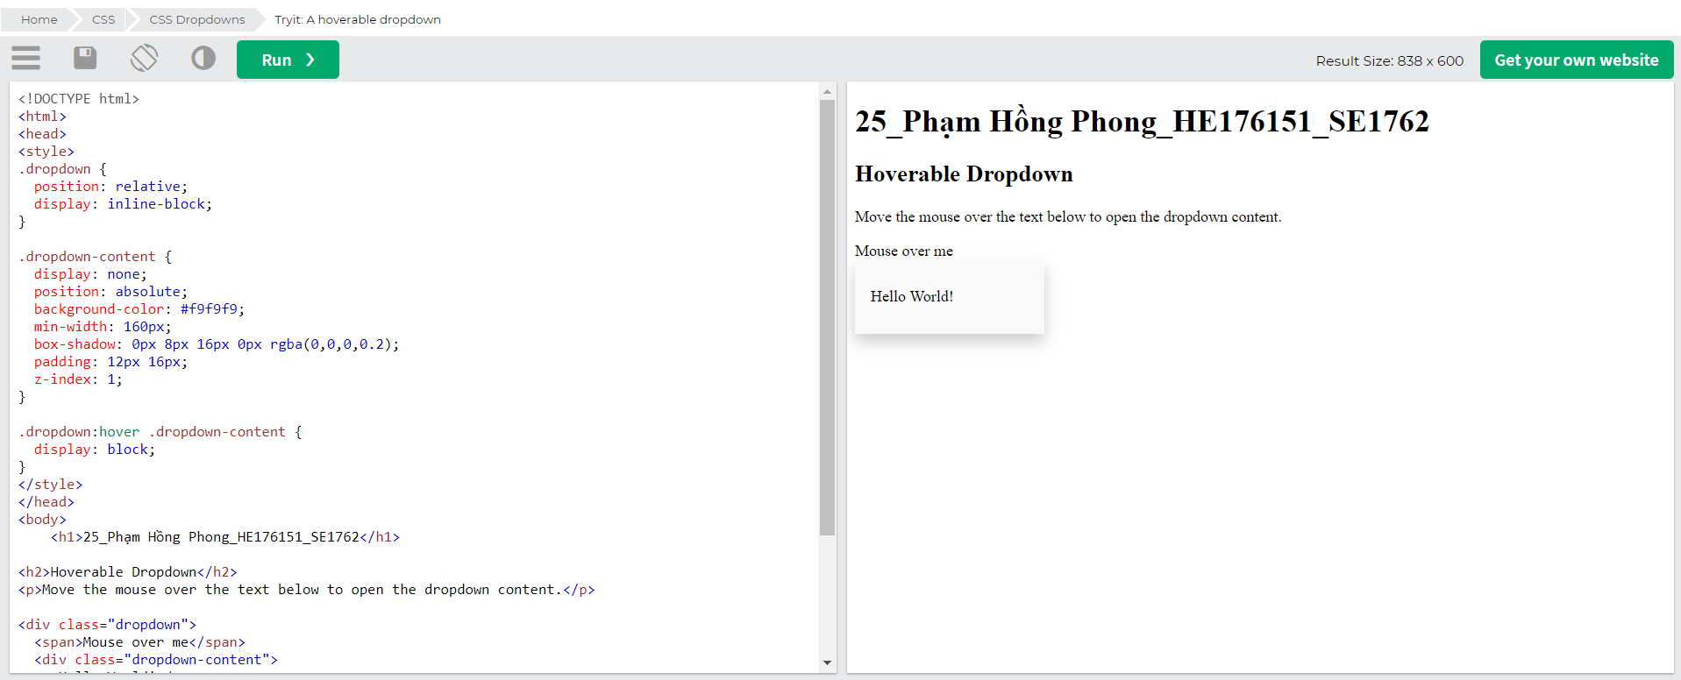

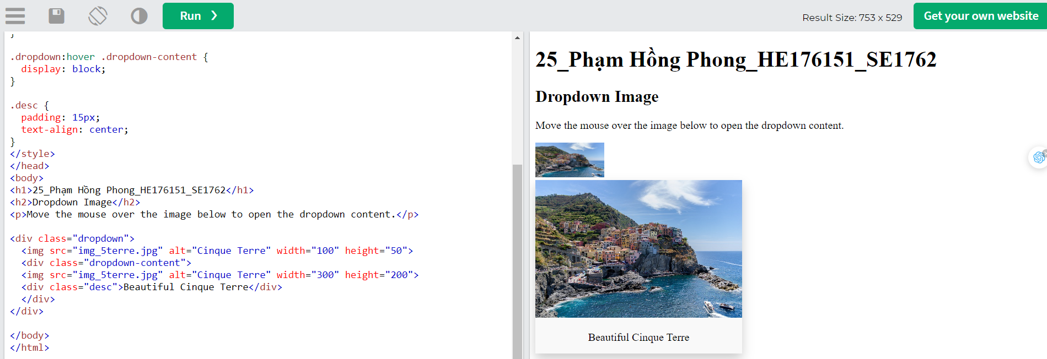

# CSS Image Gallery

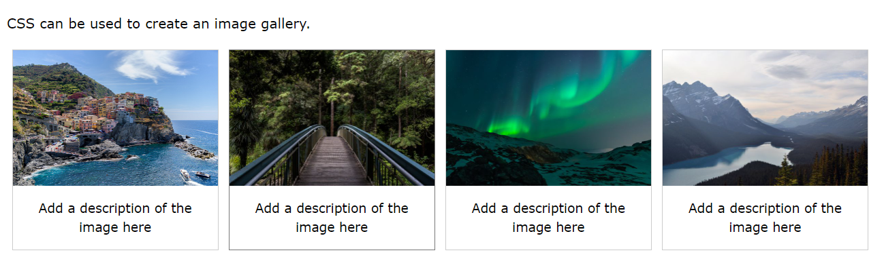

# CSS Image Sprites

## Image Sprites

An image sprite is a collection of images put into a single image.

A web page with many images can take a long time to load and generates multiple server requests.

Using image sprites will reduce the number of server requests and save bandwidth.

## Image Sprites - Simple Example

Instead of using three separate images, we use this single image ("img_navsprites.gif"):

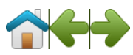

With CSS, we can show just the part of the image we need.

In the following example the CSS specifies which part of the "img_navsprites.gif" image to show:

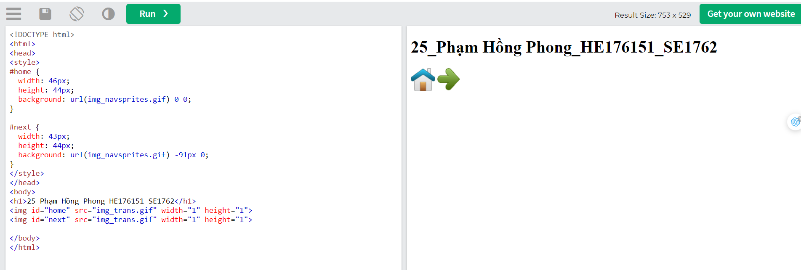

Example explained:

* <img id="home" src="img_trans.gif"> - Only defines a small transparent image because the src attribute cannot be empty. The displayed image will be the background image we specify in CSS
* width: 46px; height: 44px; - Defines the portion of the image we want to use
* background: url(img_navsprites.gif) 0 0; - Defines the background image and its position (left 0px, top 0px)

This is the easiest way to use image sprites, now we want to expand it by using links and hover effects.

# CSS Attr Selector

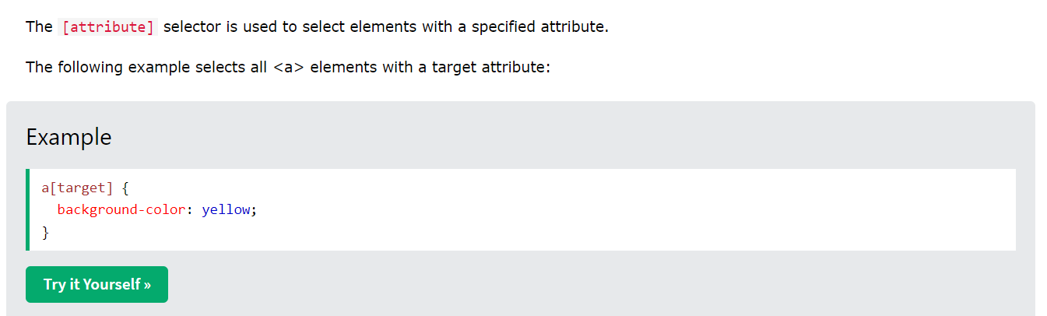

Kết quả: 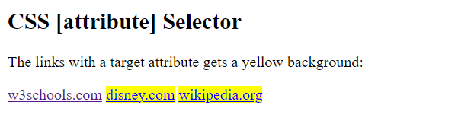

## CSS [attribute="value"] Selector

The [attribute="value"] selector is used to select elements with a specified attribute and value.

## CSS [attribute~="value"] Selector

The [attribute~="value"] selector is used to select elements with an attribute value containing a specified word.

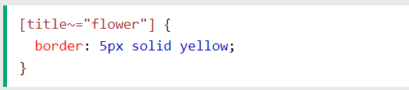

The example above will match elements with title="flower", title="summer flower", and title="flower new", but not title="my-flower" or title="flowers".

## CSS [attribute|="value"] Selector

The [attribute|="value"] selector is used to select elements with the specified attribute, whose value can be exactly the specified value, or the specified value followed by a hyphen (-).

**Note**: The value has to be a whole word, either alone, like class="top", or followed by a hyphen( - ), like class="top-text".

## CSS [attribute^="value"] Selector

The [attribute^="value"] selector is used to select elements with the specified attribute, whose value starts with the specified value.

The following example selects all elements with a class attribute value that starts with "top":

**Note**: The value does not have to be a whole word!

## CSS [attribute$="value"] Selector

The [attribute$="value"] selector is used to select elements whose attribute value ends with a specified value.

The following example selects all elements with a class attribute value that ends with "test":

**Note**: The value does not have to be a whole word!

## CSS [attribute*="value"] Selector

The [attribute*="value"] selector is used to select elements whose attribute value contains a specified value.

The following example selects all elements with a class attribute value that contains "te":

**Note**: The value does not have to be a whole word!

## All CSS Attribute Selectors

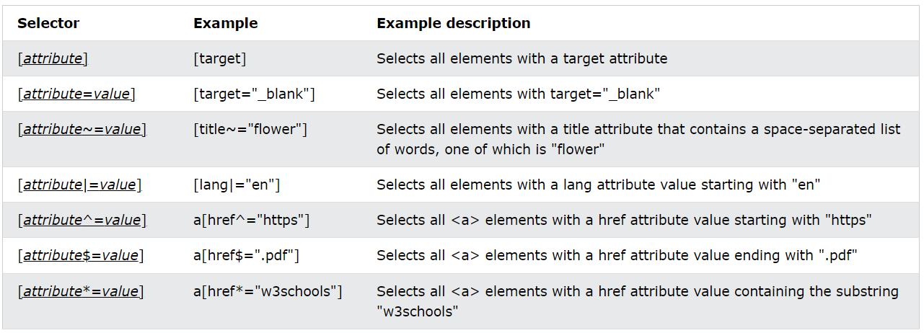

# CSS Forms

## Styling input fields

If you only want to style a specific input type, you can use attribute selectors:

input[type=text] - will only select text fields

input[type=password] - will only select password fields

input[type=number] - will only select number fields

etc..

## Padded Inputs

Use the padding property to add space inside the text field.

Tip: When you have many inputs after each other, you might also want to add some margin, to add more space outside of them:

*Note that we have set the box-sizing property to border-box. This makes sure that the padding and eventually borders are included in the total width and height of the elements.*

*Read more about the box-sizing property in our CSS Box Sizing chapter.*

## Bordered Inputs

Use the border property to change the border size and color, and use the border-radius property to add rounded corners:

If you only want a bottom border, use the border-bottom property:

## Colored Inputs

Use the background-color property to add a background color to the input, and the color property to change the text color:

## Focused Inputs

By default, some browsers will add a blue outline around the input when it gets focus (clicked on). You can remove this behavior by adding outline: none; to the input.

Use the :focus selector to do something with the input field when it gets focus:

## Input with icon/image

If you want an icon inside the input, use the background-image property and position it with the background-position property. Also notice that we add a large left padding to reserve the space of the icon:

## Animated Search Input

In this example we use the CSS transition property to animate the width of the search input when it gets focus. You will learn more about the transition property later, in our CSS Transitions chapter.

## Styling Textareas

Tip: Use the resize property to prevent textareas from being resized (disable the "grabber" in the bottom right corner):

# CSS Counters

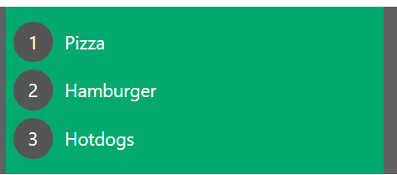

CSS counters are "variables" maintained by CSS whose values can be incremented by CSS rules (to track how many times they are used). Counters let you adjust the appearance of content based on its placement in the document.

## Automatic Numbering With Counters

CSS counters are like "variables". The variable values can be incremented by CSS rules (which will track how many times they are used).

To work with CSS counters we will use the following properties:

* counter-reset - Creates or resets a counter
* counter-increment - Increments a counter value
* content - Inserts generated content
* counter() or counters() function - Adds the value of a counter to an element

To use a CSS counter, it must first be created with counter-reset.

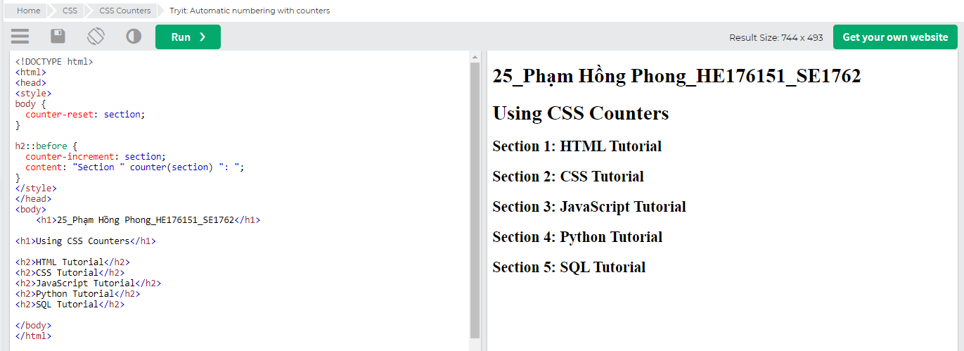

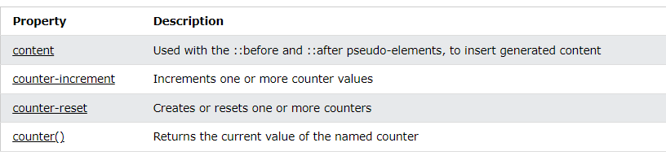

# CSS Units

CSS has several different units for expressing a length.

Many CSS properties take "length" values, such as width, margin, padding, font-size, etc.

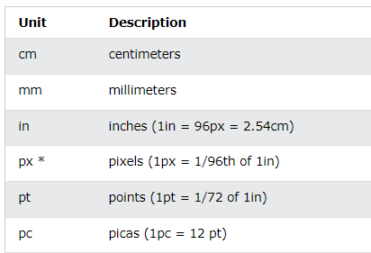

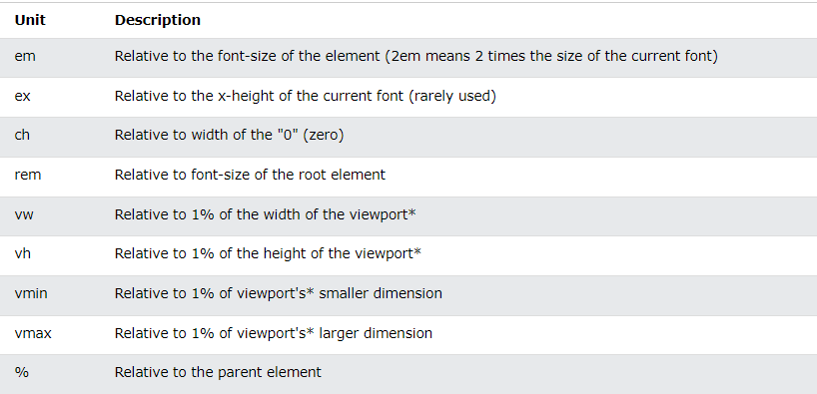

# CSS !important

## What is !important?

The !important rule in CSS is used to add more importance to a property/value than normal.

# CSS Math Functions

## The max() Function

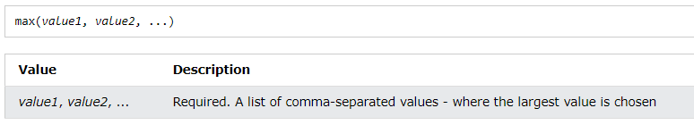

## The min() Function

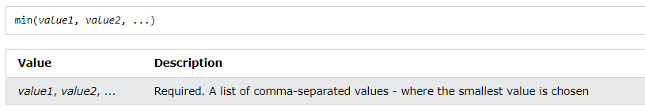

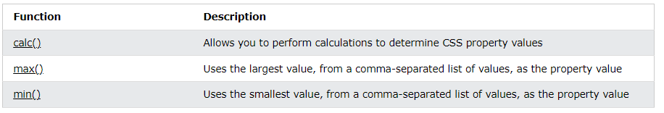

CSS Advanced

# CSS Rounded Corners

## CSS border-radius Property

The CSS border-radius property defines the radius of an element's corners.

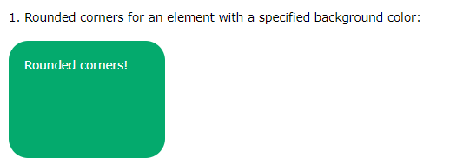

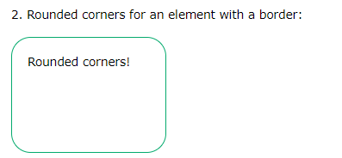

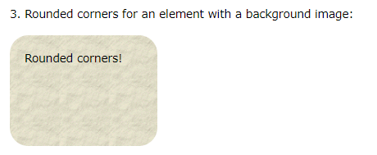

**Tip:** The border-radius property is actually a shorthand property for the border-top-left-radius, border-top-right-radius, border-bottom-right-radius and border-bottom-left-radius properties.

## CSS border-radius - Specify Each Corner

The border-radius property can have from one to four values.

# CSS Border Images

## CSS border-image Property

The CSS border-image property allows you to specify an image to be used instead of the normal border around an element.

The property has three parts:

1. The image to use as the border
2. Where to slice the image
3. Define whether the middle sections should be repeated or stretched

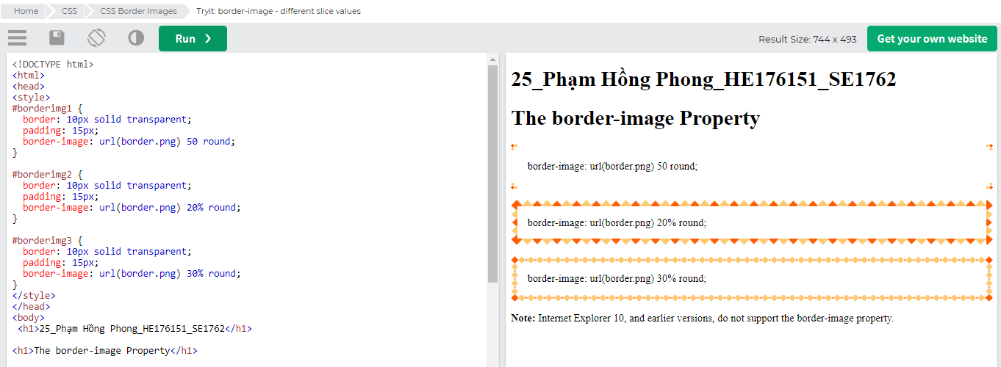

# CSS Backgrounds

* background-size
* background-origin
* background-clip

## Full Size Background Image

Now we want to have a background image on a website that covers the entire browser window at all times.

The requirements are as follows:

* Fill the entire page with the image (no white space)
* Scale image as needed
* Center image on page
* Do not cause scrollbars

## CSS background-clip Property

The CSS background-clip property specifies the painting area of the background.

The property takes three different values:

* border-box - (default) the background is painted to the outside edge of the border
* padding-box - the background is painted to the outside edge of the padding
* content-box - the background is painted within the content box

# CSS Colors

# CSS Color Keywords

# CSS Gradients

CSS gradients let you display smooth transitions between two or more specified colors.

CSS defines three types of gradients:

* Linear Gradients (goes down/up/left/right/diagonally)
* Radial Gradients (defined by their center)
* Conic Gradients (rotated around a center point)

<https://www.w3schools.com/css/css3_gradients.asp>

# CSS Shadows

## CSS Shadow Effects

With CSS you can add shadow to text and to elements.

In these chapters you will learn about the following properties:

* text-shadow
* box-shadow

## CSS Text Shadow

The CSS text-shadow property applies shadow to text.

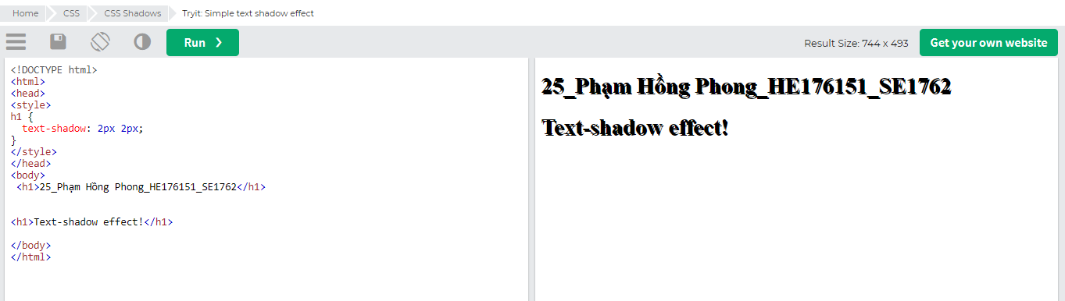

## CSS box-shadow Property

The CSS box-shadow property is used to apply one or more shadows to an element.

## Specify a Horizontal and a Vertical Shadow

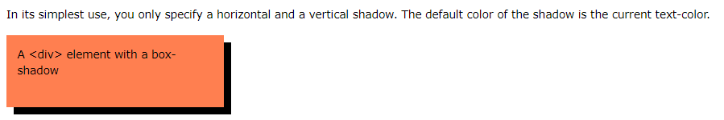

## Specify a Color for the Shadow

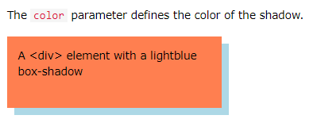

## Add a Blur Effect to the Shadow

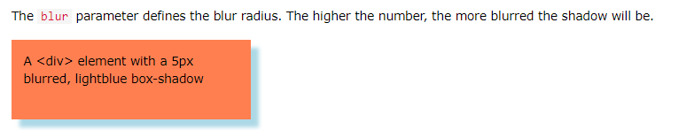

## Set the Spread Radius of the Shadow

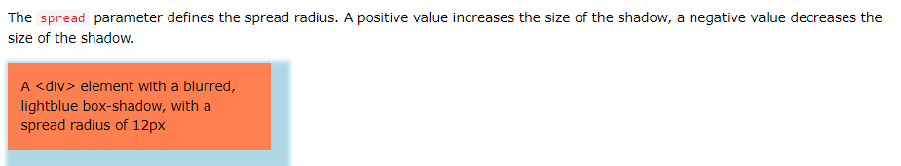

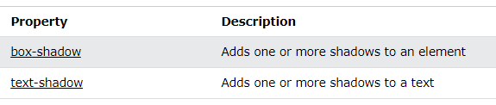

# CSS Text Effects

## CSS Text Overflow, Word Wrap, Line Breaking Rules, and Writing Modes

In this chapter you will learn about the following properties:

* text-overflow
* word-wrap
* word-break
* writing-mode

## CSS Text Overflow

The CSS text-overflow property specifies how overflowed content that is not displayed should be signaled to the user.

It can be clipped:

This is some long text that will not fit in the box

or it can be rendered as an ellipsis (...):

This is some long text that will not fit in the box

The CSS code is as follows:

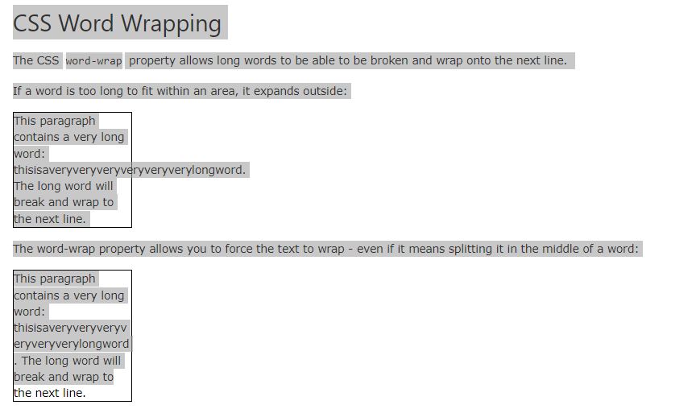

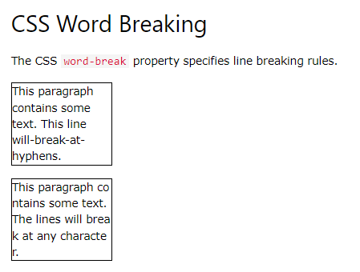

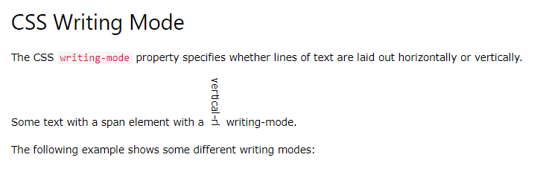

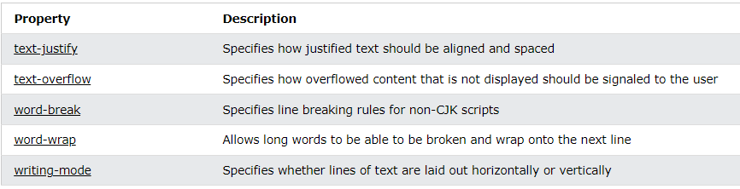

# 

# CSS 2D Transforms

With the CSS transform property you can use the following 2D transformation methods:

* translate()
* rotate()
* scaleX()
* scaleY()
* scale()
* skewX()
* skewY()
* skew()
* matrix()

# CSS 3D Transforms

With the CSS transform property you can use the following 3D transformation methods:

* rotateX()
* rotateY()
* rotateZ()

# CSS Transitions

* transition
* transition-delay
* transition-duration
* transition-property
* transition-timing-function

## How to Use CSS Transitions?

To create a transition effect, you must specify two things:

* the CSS property you want to add an effect to
* the duration of the effect

## Specify the Speed Curve of the Transition

The transition-timing-function property specifies the speed curve of the transition effect.

The transition-timing-function property can have the following values:

* ease - specifies a transition effect with a slow start, then fast, then end slowly (this is default)
* linear - specifies a transition effect with the same speed from start to end
* ease-in - specifies a transition effect with a slow start
* ease-out - specifies a transition effect with a slow end
* ease-in-out - specifies a transition effect with a slow start and end
* cubic-bezier(n,n,n,n) - lets you define your own values in a cubic-bezier function

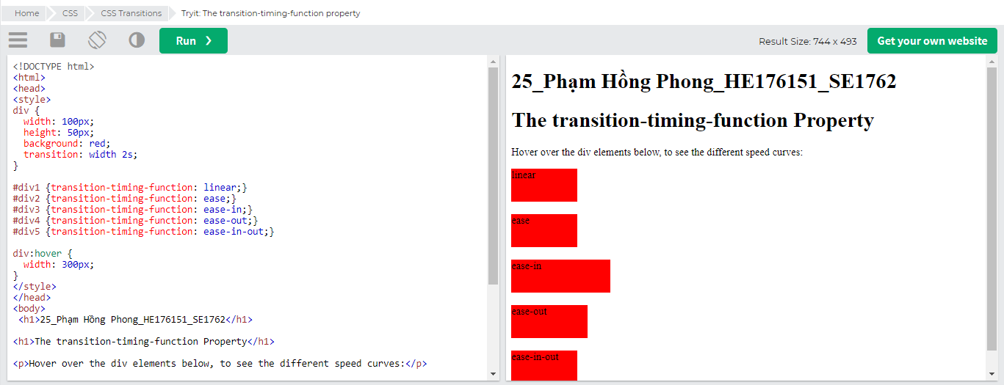

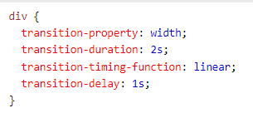- ->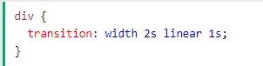

# 

# CSS object-fit

Here is where the object-fit property comes in. The object-fit property can take one of the following values:

* fill - This is default. The image is resized to fill the given dimension. If necessary, the image will be stretched or squished to fit
* contain - The image keeps its aspect ratio, but is resized to fit within the given dimension
* cover - The image keeps its aspect ratio and fills the given dimension. The image will be clipped to fit
* none - The image is not resized
* scale-down - the image is scaled down to the smallest version of none or contain

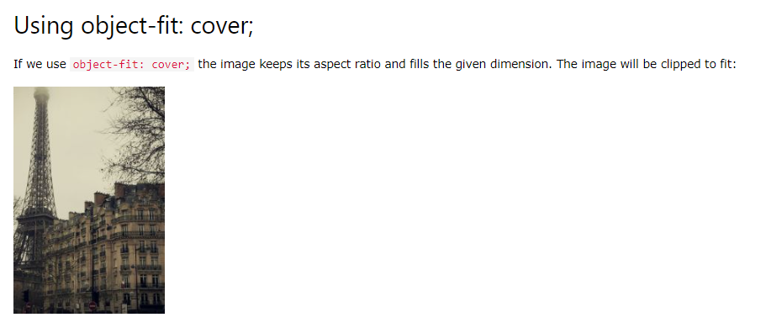

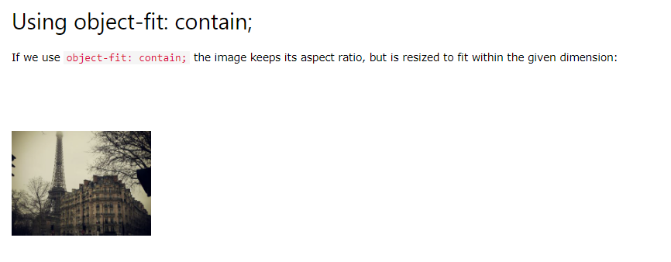

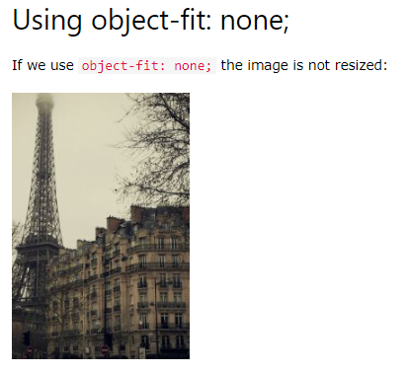

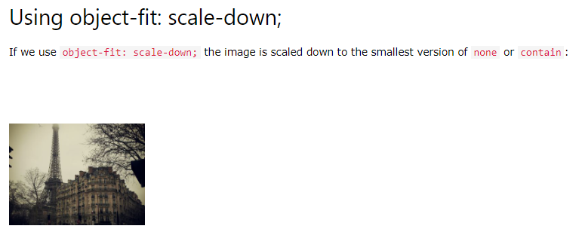

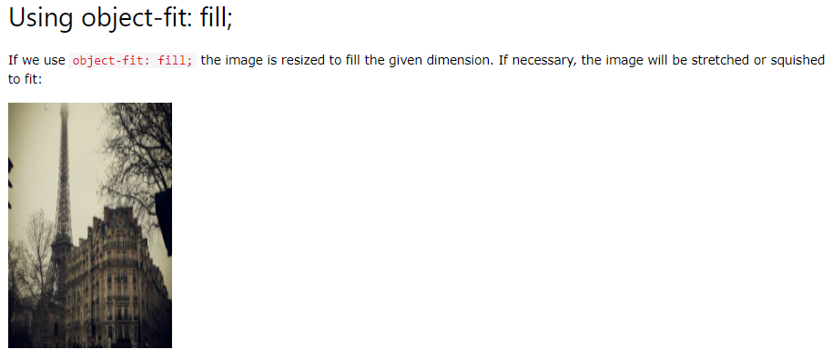

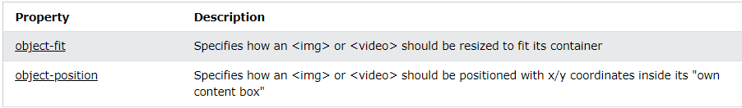

# CSS object-position

## Using the object-position Property

Let's say that the part of the image that is shown, is not positioned as we want. To position the image, we will use the object-position property.

# 

# CSS Pagination

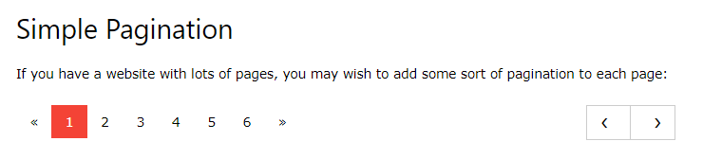

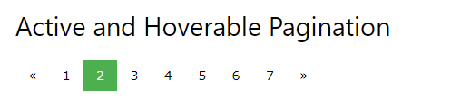

# CSS Multiple Columns

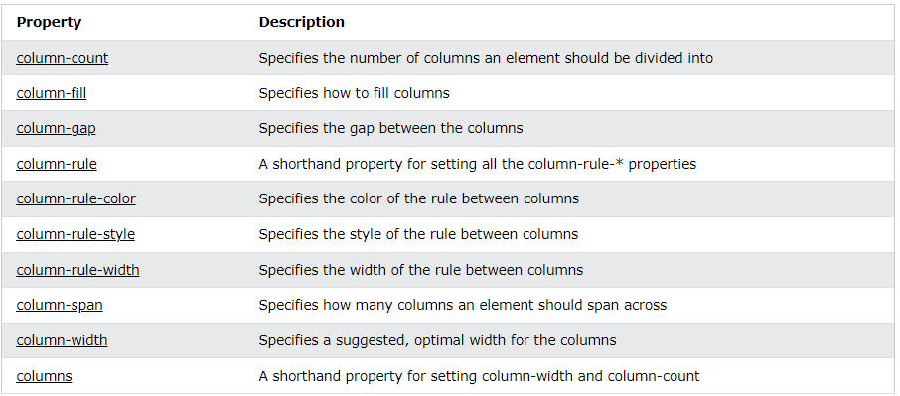

# CSS Box Sizing

The CSS box-sizing property allows us to include the padding and border in an element's total width and height.

## Without the CSS box-sizing Property

By default, the width and height of an element is calculated like this:

width + padding + border = actual width of an element  
height + padding + border = actual height of an element

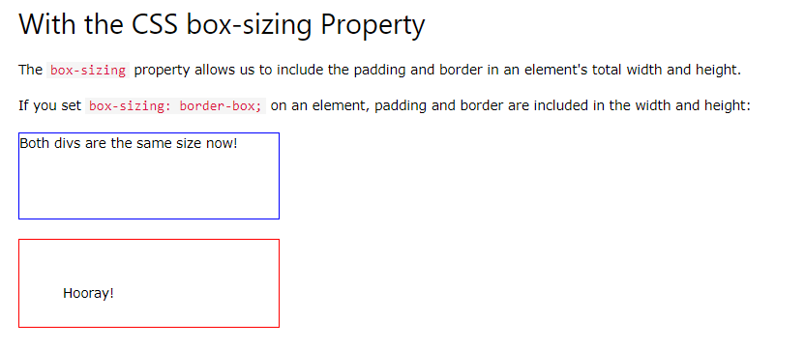

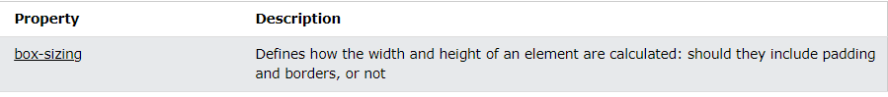

# CSS Flexbox

## CSS Flexbox Layout Module

Before the Flexbox Layout module, there were four layout modes:

* Block, for sections in a webpage
* Inline, for text
* Table, for two-dimensional table data
* Positioned, for explicit position of an element

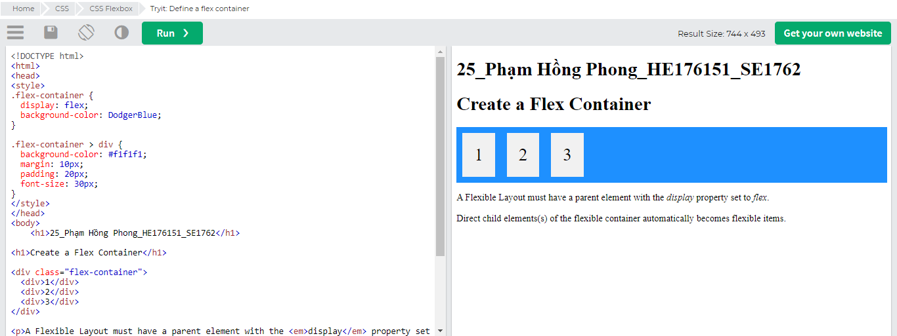

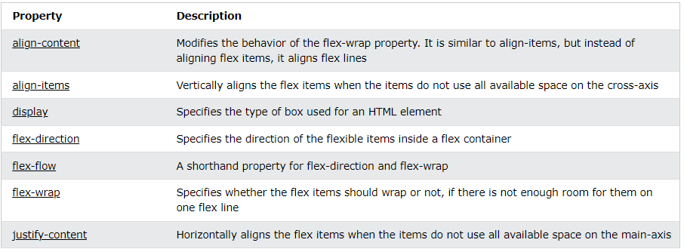

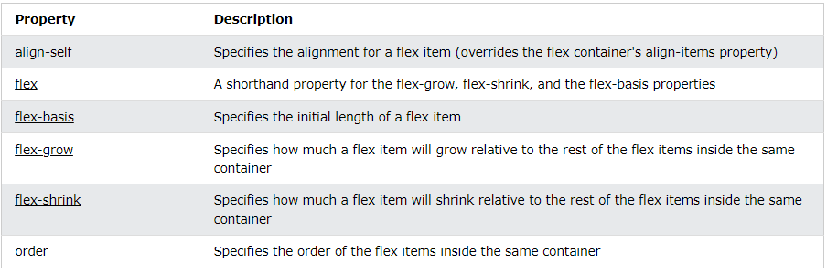

Chơi game với Flexbox: <https://flexboxfroggy.com/#vi>

CSS Grid

# Grid Intro

## Grid Layout

The CSS Grid Layout Module offers a grid-based layout system, with rows and columns, making it easier to design web pages without having to use floats and positioning.

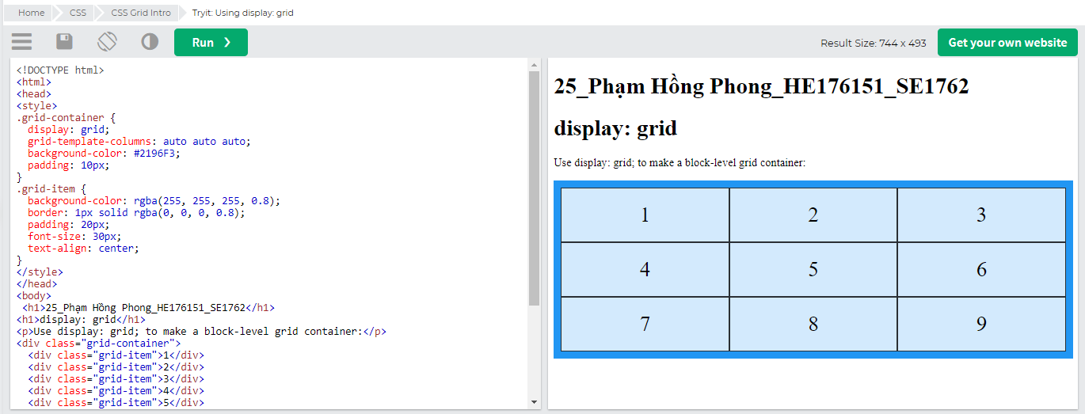

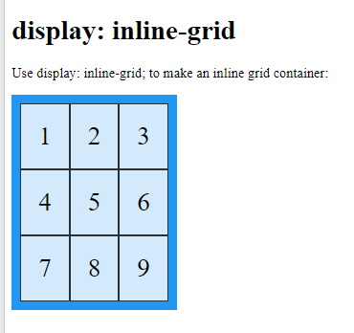

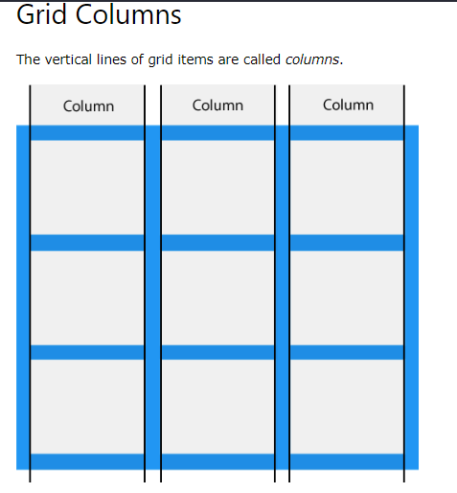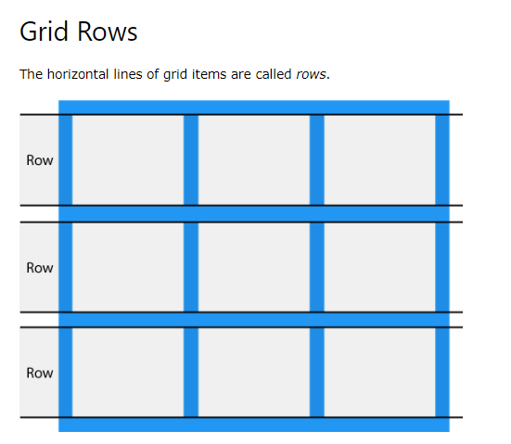

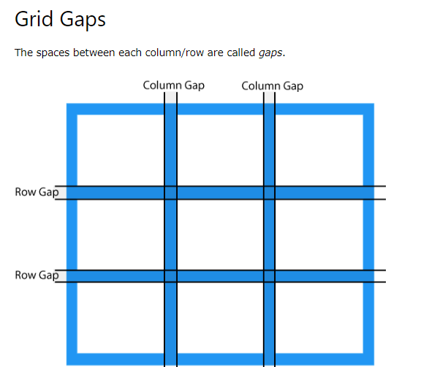

You can adjust the gap size by using one of the following properties:

* column-gap
* row-gap
* Gap

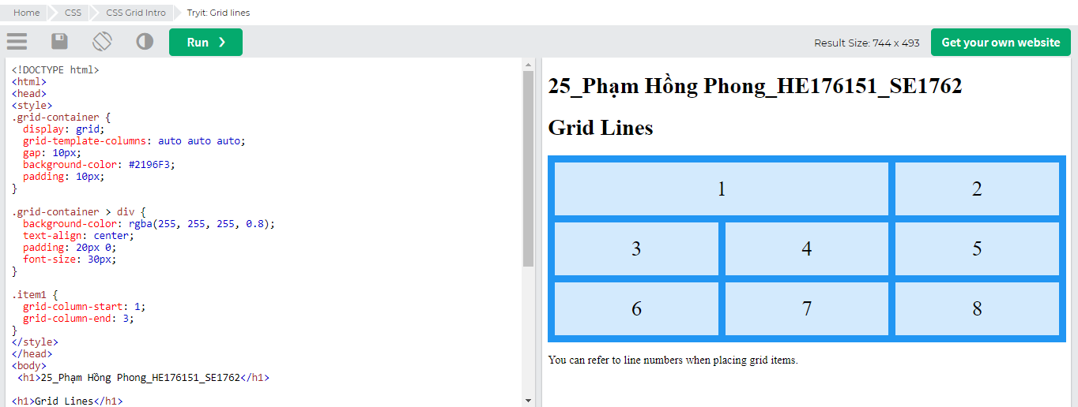

Place a grid item at column line 1, and let it end on column line 3:

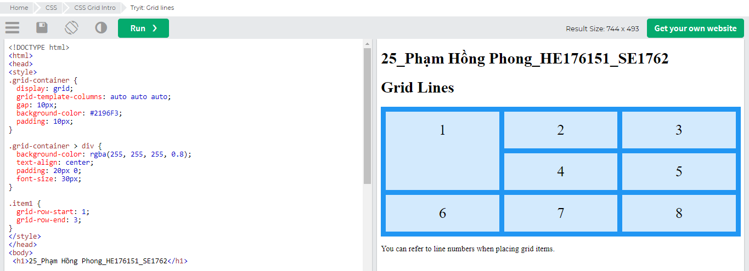

Place a grid item at row line 1, and let it end on row line 3:

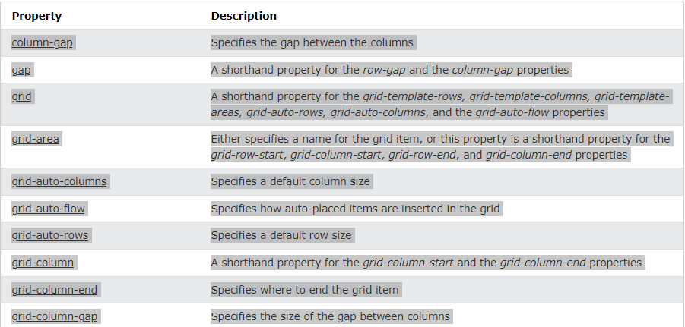

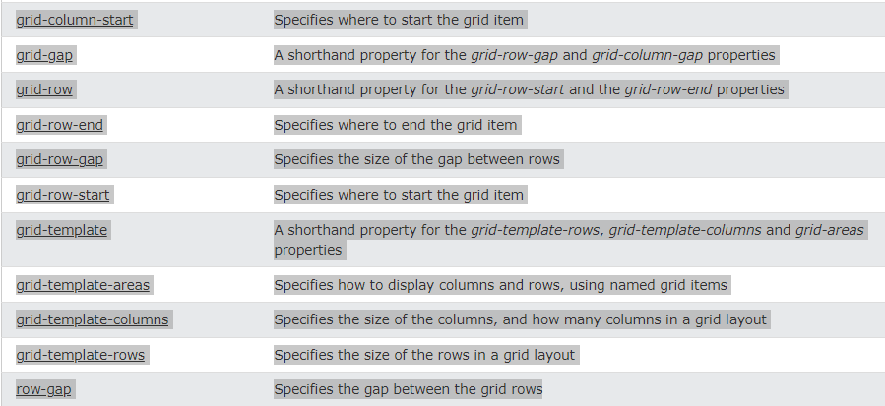

# Grid Container

## Grid Container

To make an HTML element behave as a grid container, you have to set the display property to grid or inline-grid.

Grid containers consist of grid items, placed inside columns and rows.

## The grid-template-columns Property

The grid-template-columns property defines the number of columns in your grid layout, and it can define the width of each column.

The value is a space-separated-list, where each value defines the width of the respective column.

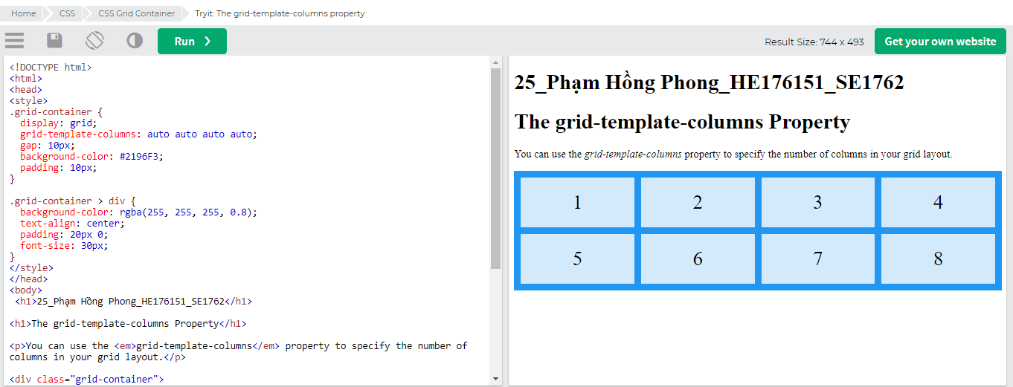

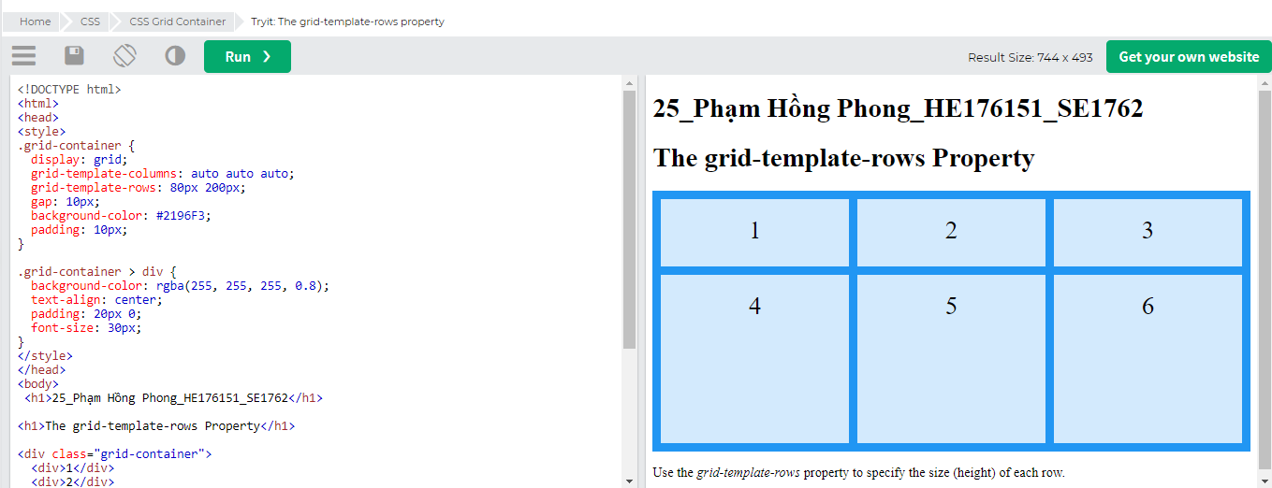

## The justify-content Property

The justify-content property is used to align the whole grid inside the container.

**Note:** The grid's total width has to be less than the container's width for the justify-content property to have any effect.

# Grid Item

## Child Elements (Items)

A grid *container* contains grid *items*.

By default, a container has one grid item for each column, in each row, but you can style the grid items so that they will span multiple columns and/or rows.

# 

**Note:** The grid-column property is a shorthand property for the grid-column-start and the grid-column-end properties.